**The Scottish Road Worker Consultation 2024**

## Consultation Identifier Questions

### Q1. Are you completing this on behalf of yourself or an organisation?

Individual

Organisation

### Q1a. If an organisation, please list below.

### Q2. Which of the following best describes your current role in relation to road works?

Operative  
 Supervisor  
 Administrator  
 Manager (includes senior manager)  
 Other, please use the box below to provide details of your answer

## Questions on using Apparatus Plans

### Q3. In terms of your experience of working on sites, in which sector have you mainly worked in (in any capacity)?

Utility   
Road Authority  
I don’t work onsite

Other, please use the box below to provide details of your answer

### Q4. Have you worked directly on site in the last 5 years? If you answered no, please continue straight onto question 8.

Yes

No

Please use the box below if you wish to provide any additional comments

### Q5. Thinking about your most recent experience with site work, can you tell us how you read the plans onsite when carrying out an excavation? Please select all that apply?

I am not site based/I do not need plans to carry out my role  
 A printed out version of the plans on paper  
 Electronic plans (not accessed through an app)  
 An app which allows you to view underground apparatus plans e.g. The Vault app  
 Other/ (please specify, please use the box below to provide details of your answer

### Q6. If you use an electronic device which allows you to view apparatus information (such as email, the vault app etc.), can you tell us how you access this whilst on site?

Mobile telephone  
Tablet   
Laptop  
I do not use an electronic device  
Other please specify, please use the box below to provide details of your answer

### Q7. Is the device you use to access the plans a company issued device or your own personal device?

Company issued device  
Personal device  
I do not use an electronic device

Other please specify, please use the box below to provide details of your answer

### Q8. When using electronic plans, do you use ‘filters’ that allow you to switch layers on and off? Figure 1 below shows an example that has been taken from the Vault.

Yes  
No  
The electronic plans I use do not have filter functions  
I do not use electronic plans

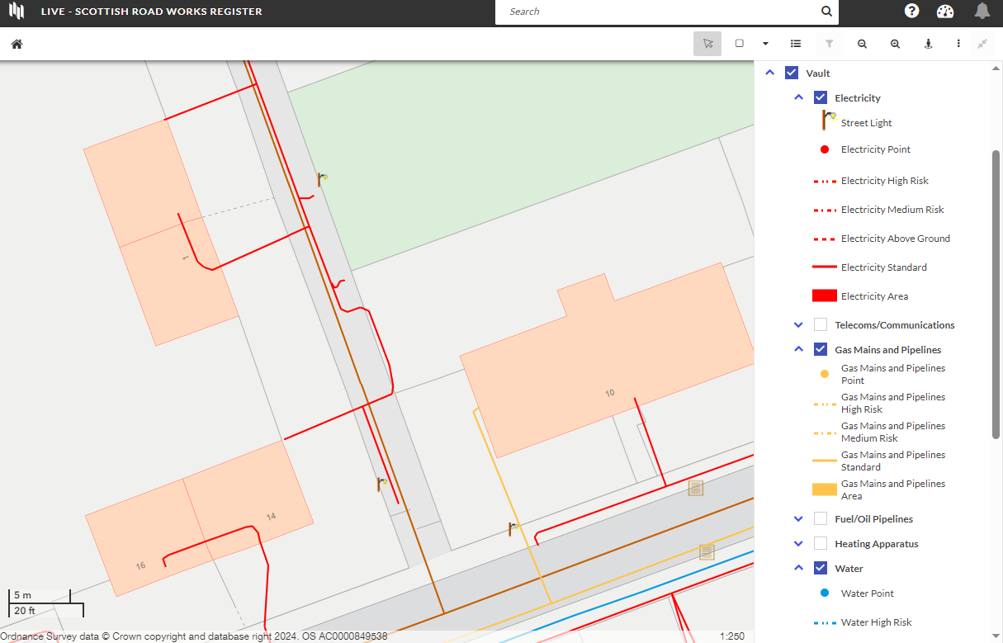 Figure 1 - Image showing the Vault filter menu. The image shows an apparatus map to left and a menu to the right which displays some the options available for switching the layers on and off including electricity, telecoms/communications, fuel/oil pipelines, heating apparatus gas mains and water.

### Q9. When using electronic apparatus information, would you prefer to click on/select individual objects to read more information about them in a separate box, or would you prefer to have all the information (size, owner, pressure etc) about the apparatus on screen by default? Figures 2 and 3 below show the two different formats.

Separate box to pop up when you select/click an item  
All the information on screen by default  
Neither   
I do not use electronic plans

Please use the box below to provide details of your answer, explaining the reasons for your preference.

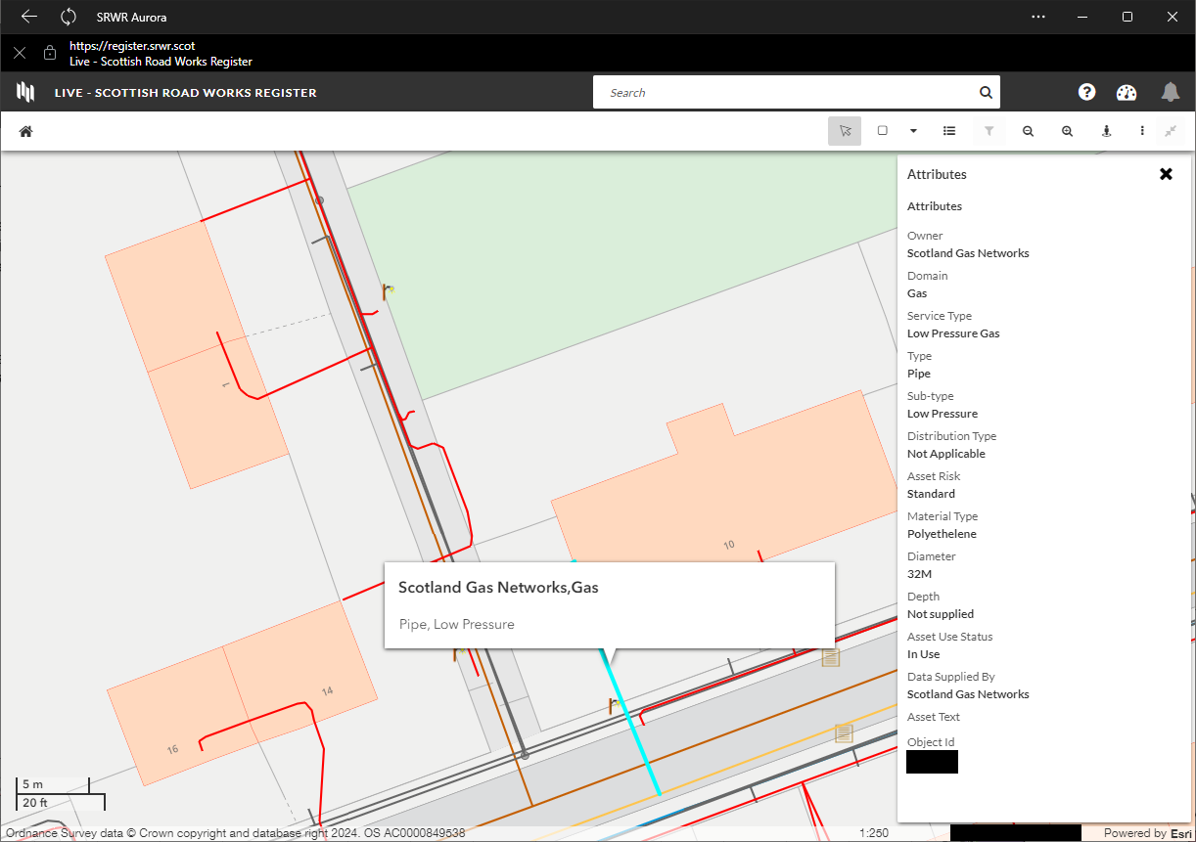

Figure 2 - Image showing separate box to pop up when you select/click an item. The image shows an apparatus map to the left and pop-up box to the right containing attributes of the pipes the user has selected the map.

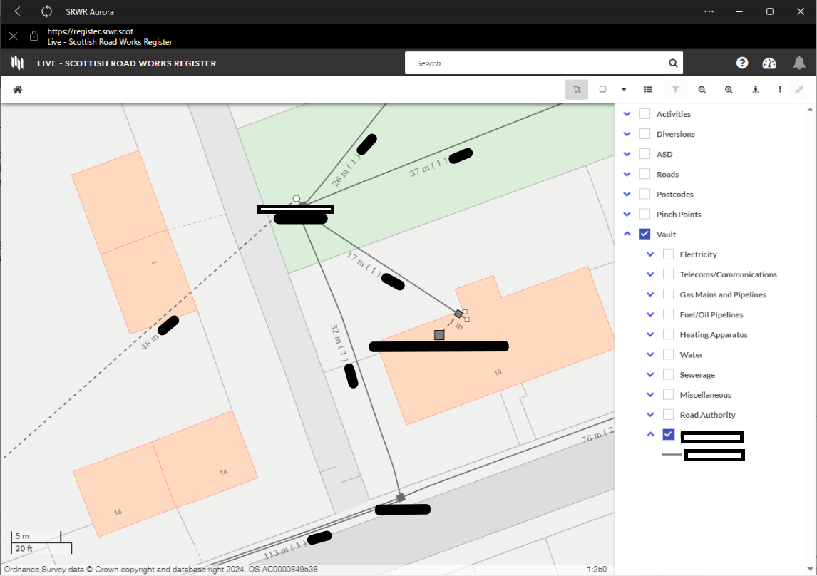

Figure 3 - Image showing all the information on screen by default. The image shows an apparatus map to the left which displays details of the pipes alongside the image of the pipe, and a pop-up box to the right containing Vault filter options.

### Q10. What specific information do you think is key to be able to carry out a road excavation safely? Please tick all that apply.

Ownership (the body that owns the asset)  
Supplier (the person who submitted the data)  
Type of asset e.g. pipe, cable, cabinet etc.  
Material of asset  
Voltage and/or Pressure  
Depth (from the surface level to the crown of the apparatus)  
Asset diameter  
Location (line shown on a map with background showing lateral position)  
Position in the road e.g. under the footway, carriageway, verge  
Position of apparatus when laid within other apparatus.  
Age of asset  
Colour of asset  
Identifier code  
Other not mentioned above, please specify in the box below.

### Q11a. Is the traditional measure of 500 mm an appropriate degree of accuracy for you to feel safe when excavating?

We know 100% accuracy between the recorded position and the actual position of all assets is the most desirable level of accuracy. However, as it’s not always possible to achieve 100% accuracy, we need to provide a ‘grace’ measurement, which has traditionally been 500 mm. Is the traditional measure of 500 mm an appropriate degree of accuracy for you to feel safe when excavating?

Yes

No

Please use the box below if you wish to provide any additional comments

.

### Q11b. In your experience, how common are asset strikes, both minor and serious during site work?

Please note, at the end of this consultation you will be given the opportunity to choose if your response is published or not.

If you select "do not publish" your response will be anonymous.

Frequent  
Now and again

Rarely

Please use the box below if you wish to provide any additional comments

### Q12. Do you think service connections should be included in the plans?

For example, a service pipe or line under 100m that has been installed from gully to a main drainage pipe.

Yes

No

Please use the box below if you wish to provide any additional comments.

# Questions on the Streetworks Qualification

### Q13a. Do you have any views on the current “Street Works Card” or any changes you would make to this?

Please use the box below if you wish to provide any additional comments

### Q13b. Do you have any views on training (for the “Street Works Card”) or any changes you would make to this?

Please use the box below if you wish to provide any additional comments

### Q14. Do you hold a “Street Works card” (any level)? Figure 4 picture below is an example of an operative street works card

Yes

No

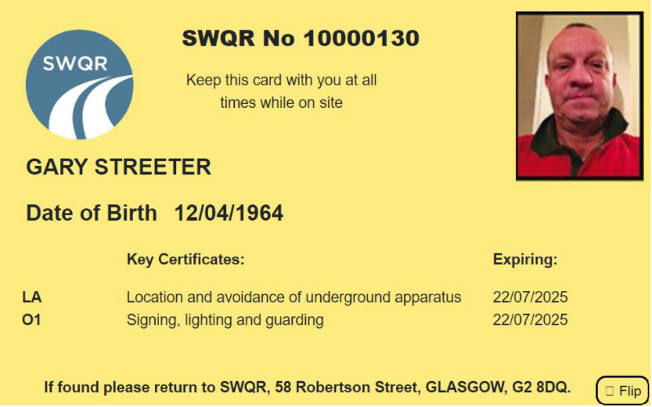

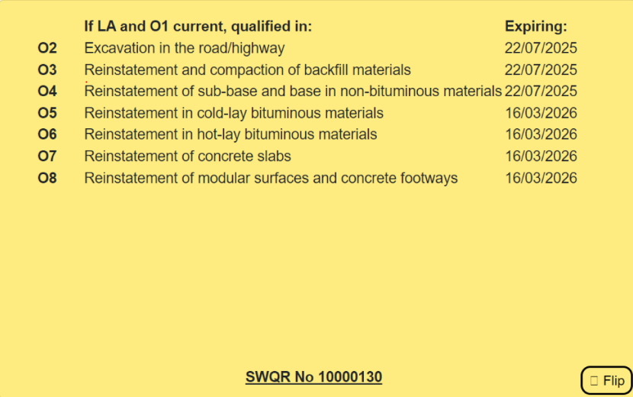

Figure 4 - Image showing the front and back of an operative streetworks card. The image shows a yellow photographic identity card containing the cardholders SWQR number, name, date of birth, the details the key certificates obtained by the card holder the expiry date of each certificate.

Please use the box below if you wish to provide any additional comments.

### Q15. Is it important for you to be able to work anywhere in the UK with your Street Works card?

Yes

No

Please use the box below if you wish to provide any additional comments

### Q16. Are there any other comments you want to make in relation to the road works sector and wish for us to consider in the future?

Please use the box below if you wish to provide any additional comments