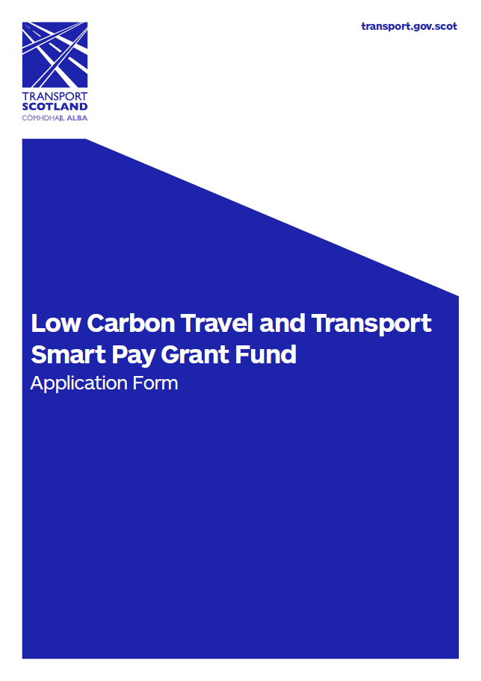

Before completing this application form, please see the SPGF information on the Transport Scotland website (confirm ☐) and read the Guidance document (confirm ☐).

Contents
SECTION 1: ORGANISATION DETAILS 2
SECTION 2: SELF ASSESSMENT CHECKLIST 3
SECTION 3: CURRENT OPERATIONS 4
SECTION 4: PROPOSAL FOR SPGF SUPPORT 5
SECTION 5: TERMS AND CONDITIONS 6
SECTION 6: DECLARATION 7
SECTION 7: SME DECLARATION 8
SECTION 8: SUBMITTING YOUR APPLICATION 9

The Smart Pay Grant fund is supported by the Low Carbon Travel and Transport (LCTT) Programme under the European Development Fund (ERDF).

SECTION 1: ORGANISATION DETAILS

Organisation
Name of organisation
What type of organisation are you | Operator ☐  Local Authority ☐  RTP undertaking functions of a local transport authority ☐  Other RTP ☐  Please describe:
Registered office address or main place of business | Address:  Postcode:
If applicable, Bus Operator ID
Organisation website
Main contact for this application
Name
Applicant’s role/position in organisation
Office address  (if different from above) | Address:  Postcode:
Telephone number
Email address

SECTION 2: SELF ASSESSMENT CHECKLIST

You must complete this checklist before proceeding (click box).

Yes | No | Criteria
☐ | ☐ | Are you a Scottish bus operator of “local services” registered with the Traffic Commissioner for Scotland, or a local authority / regional transport partnership?
☐ | ☐ | Do you provide commercial bus service(s) in Scotland available to the general public?
☐ | ☐ | Do you have a cEMV agreed merchant account or in the process of arranging one?
☐ | ☐ | Are you applying to the fund for a maximum of 250 ETMs?
☐ | ☐ | Have you already ordered the ETMs you are applying to the fund for?
☐ | ☐ | Do you currently operate or are in a position to procure, upgrade, and manage, as per the funding package, ITSO compliant ETM cEMV compatible equipment?
☐ | ☐ | Do you have reliable connectivity at depot or on serviced routes to permit transaction data periodically as a minimum?
☐ | ☐ | Do you agree to provide quarterly smart travel data, reporting smart journeys arising from cEMV, directly to Transport Scotland for European Funding audit purposes?
☐ | ☐ | Are you, or have you been, in receipt of any other European Funding for any purpose?  If YES, please provide as much detail as possible:
☐ | ☐ | Are you able to demonstrate that cEMV will be sustainable on eligible services for a 5 year period from date of receipt of initial funding?*

* Please see Section 3 for additional questions that can help you with considerations for this.

SECTION 3: CURRENT OPERATIONS

Your Current Operations
Do you currently operate ITSO certified ETMs? | Yes ☐  No ☐
How many ETMs do you currently hold?
Who currently supplies your ETMs?  If other, please state | Choose an item.  Other:
Are your ETMs supplied through a Managed Service Provider framework, eg SAM, or direct from supplier? | Managed Service Provider ☐  Direct from Supplier ☐
Are you a member of SAM / SWSAL?  (Smart Applications Management/ South West Smart Applications Ltd) | Yes ☐  No ☐
What is your total annual revenue? | £
What is your annual commercial revenue? | £
What percentage of commercial customers do you estimate will move to cEMV and why? | %
What is your average commercial fare? | £
Date of commencement of transport operations (yyyy)
Number of vehicles in fleet
Number of commercial services operated?
Area of operations by Local Authority | Choose an item.
 | Choose an item.
 | Choose an item.
 | Choose an item.
 | Choose an item.
 | Choose an item.
 | Choose an item.

SECTION 4: PROPOSAL FOR SPGF SUPPORT

Proposal
Have you already started engagement with cEMV Providers? | Yes ☐  No ☐  If YES, please provide details
What is your planned cEMV delivery date? (mm/yy)
When do you propose to go-live with your cEMV service? (mm/yy)
What is the status of your merchant account? | Choose an item.
How many of your current inventory ETMs do you require UPGRADED?
How many REPLACEMENT or NEW cEMV enabled ETMs do you require?
How many REPLACEMENT or NEW cEMV enabled ETMs are Hand Helds?
How many Hand Held ETMs costing less than £1500 do you propose to purchase (Grant Aid = £250)
How many cEMV enabled ETMs in total are you seeking licence / subscription fee support for?
Have you already decided which ITSO certified cEMV ETM provider you wish to contract with?  If YES, which ETM provider? | Yes ☐  No ☐
Do you intend to make any changes to your operating model in the next 3 years?  If YES, what changes do you intend to make? | Yes ☐  No ☐
Any further comments or points of clarification you wish to add:

SECTION 5: TERMS AND CONDITIONS

By applying for this Transport Scotland - ERDF Smart Pay Grant Fund you are agreeing to the following terms and conditions. Please check each box to acknowledge acceptance.

☐ The SPGF can only be drawn upon to support the new procurement of ETMs in order to provide a cEMV payment service to customers.

☐ Funds from the SPGF will only be released to the applicant upon submission of an invoice from the provider and proof of payment from the applicant to the provider to Transport Scotland. Funds will be released within 10 working days of receipt.

☐ SPGF support for the provider’s annual licence or subscription fees will be released with the infrastructure funds in year one and annually, for years 2 and 3, within 10 working days of receipt of invoice and proof of payment from the applicant.

☐ The applicant will provide quarterly cEMV smart journey data on the Transport Scotland template, to be provided, on the first Monday of May, August, November, February for the first 5 years for ERDF auditing purposes.

☐ In the event that the applicant’s organisation ceases to operate within the first 5 years, post drawing on the SPGF, the Transport Scotland SPGF project manager must be informed immediately. The applicant is then required make every reasonable endeavour to ensure that the infrastructure procured with support of the SPGF continues to provide a cEMV payment service, for example reallocation to an alternative operator and the course of action informed to Transport Scotland.

☐ The applicant will inform the Transport Scotland SPGF project manager of any change in circumstances which impacts upon the operation of infrastructure procured with support from the SPGF within the first 5 years.

☐ The applicant may be restricted to access to future ERDF funding by drawing on the SPGF for a period of 3 years.

☐ The applicant will provide project implementation updates and details to the Transport Scotland SPGF project manager.

☐ Please tick if you are content for the above to be used in news releases, publications and other publicity materials. Your approval will be sought prior to any publications.

☐ Transport Scotland may use information provided by the applicant to publish details of the financial support provided to this project. All information will be anonymised.

☐ Transport Scotland may share details from this application or from future assessments to Transport Scotland colleagues and other Scottish Government departments including other grant-making bodies. You will be informed of requests for this information. Any data sharing will be undertaken in accordance with GDPR.

☐ The applicant confirms that they are not in receipt of any other Scottish Government funding being used towards the costs of this equipment, including any emergency Covid Support Grant or Network Support Grant related funds

SECTION 6: DECLARATION

As far as we know and believe, the information in this application form is true and accurate.

We are authorised to allow this project to go ahead.

Applicant declaration
Name:
Position:
Date:
Authoriser endorsement declaration (i.e Managing Director etc if required)
Name:
Position:
Date:

Public Sector Applications Only

☐ Contracts must either be competitively tendered or procured in line with an organisation’s standing orders and/or National Rules Procurement Policy to ensure value for money for Public sector bodies.

Data Protection and Freedom of Information

Applicants to the Smart Pay Grant Fund should be aware that Transport Scotland is subject to the provisions of the Freedom of Information (Scotland) Act 2002, the Environmental Information (Scotland) Regulations 2004, and the General Data Protection Regulations 2018.

Please, therefore, note that information provided, including personal information, will be held, published and disclosed in accordance with this legislation. When submitting an application, please let us know if there are any parts of it which would prejudice your commercial or other interests if they were made public. However, given our obligations, please note we cannot guarantee confidentiality.

Comments:

SECTION 7: SME DECLARATION

Transport Scotland are required to provide a written declaration to the ERDF that Fund recipients are small and medium-sized enterprises (SMEs)

Please provide the information requested in the following table.

We require evidence for turnover and number of employees.
If this is available in the audited account submitted as part of this application then please state this.

Name of Business

Address (of registered office)

Trading Address

Registration or VAT number

Type of Enterprise:
e.g. Sole Trader, LTD, Partnership,

Current Turnover:

Current No. of employees

Date started trading

SECTION 8: SUBMITTING YOUR APPLICATION

Please now attach the following documentation to an email. Note that your application cannot be assessed without the documentation below:

☐ Completed Application Form in Word format
☐ Latest full and signed Annual Accounts, to include Balance Sheet and Income Statement. If the company is exempt from audit, the accounts must be prepared and signed by an accountant
☐ Business Case (template supplied)
☐ If received, ETM supplier quote – not essential for the assessment

Email your application and supporting documentation to SPGF@transport.gov.scot

Once your application is submitted you will receive an acknowledgement email. If you do not, please contact us immediately.

Applications will be assessed on a rolling basis as received. Award will follow successful application and implementation process.

Enquiries

If you have any queries about the Smart Pay Grant Fund or would like to discuss before submitting an application, please send an email to SPGF@transport.gov.scot with an outline of your query and your contact details and a member of the team will get back to you

Or

Visit www.transport.gov.scot/spgf for more information.

Total Annual Revenue being total income to the business regardless of source,
Commercial Revenue being sales of commercial tickets to fare paying passengers only.
You will need to check with your ETM supplier whether your current ETMs can be upgraded to accept cEMV or whether you will require a new ETM suite.
Full T&Cs will be provided upon SPGF award together with a Declaration agreeing to the SPGF T&Cs.

