Appendix H: Detailed Packaging - Appraisal Summary Tables

December 2022
Contents
1. Regional Context 5
1.1. Geographic Context 5
1.2. Social Context 5
1.3. Economic Context 6
1.4. Environmental Context 6
2. Problems and Opportunities 8
2.1. Problems 8
2.2. Opportunities 9
3. Regional Recommendations 10
4. Fit with Established Policy 11
5. STPR2 Transport Planning Objectives (TPOs) Assessment 12
6. STAG Assessment 21
6.1. Environment 21
6.2. Climate Change 22
6.3. Health, Safety & Wellbeing 23
6.4. Economy 25
6.5. Equality & Accessibility 26
7. Deliverability 28
7.1. Feasibility 28
7.2. Affordability 28
7.3. Public Acceptability 28
8. Statutory Impact Assessment Criteria 29
8.1. Strategic Environmental Assessment (SEA) 29
8.2. Equalities Impact Assessment (EqIA) 30
8.3. Island Communities Impact Assessment (ICIA) 30
8.4. Child Rights and Wellbeing Impact Assessment (CRWIA) 31
8.5. Fairer Scotland Duty Assessment (FSDA) 31
Annexes 32
Annex A: NAPTAT Mapping 33
Annex B: Traffic Modelling Outputs 40

Tay Cities Region Appraisal Summary Table
An Appraisal Summary Table (AST) has been developed for each of the eleven STPR2 Regions alongside the National AST. The ASTs are set out to provide:
- Regional Context, Problems and Opportunities – drawing on data presented in the Initial Appraisal: Case for Change reports this summarises geographic, social, economic, environmental and transport matters in the region as well as the identified problems and opportunities. In line with STAG, appraisals are expected to explore location-specific problems and opportunities. Local problems and opportunities have been considered to gain a full understanding of the regional and national issues, however some of these may not be within the scope of this strategic study.
- Regional Recommendations – this presents the package of recommendations that were included in the detailed appraisal for the region.
- Fit with Policy – provides a summary of how well the appraised packages fit with key national policies including the second National Transport Strategy, Climate Change Plan Update, the Revised Draft Fourth National Planning Framework (Revised Draft NPF4) and relevant regional policies.
- Transport Planning Objectives (TPO) Assessment – An assessment against each of the five TPOs is provided with quantified metrics, where appropriate, under the Low growth sensitivity with a 20% reduction policy ambition on car kilometre scenario (hereafter referred to as Low scenario) and High growth sensitivity with no policy ambition on car kilometre scenario (hereafter referred to as High scenario) (further information about these scenarios is provided in Appendix F of the Technical Report). A seven point scoring scale is adopted for each TPO which is:
  - + + + = major positive (3 plus signs)
  - + + = moderate positive
  - + = minor positive
  - 0 = neutral
  - - = minor negative
  - - - = moderate negative
  - - - - = major negative (3 minus signs)
- STAG Criteria assessment – as above for the TPO assessment, key points regarding the performance of the package against each of the STAG criteria are presented with quantified metrics provided where appropriate.
- Deliverability – commentary is provided on the assessment of the package in terms of its feasibility, affordability and public acceptability. Note that due to the nature of a number of the STPR2 interventions, and the stage in the business case process STPR2 is at, it has not been possible to derive cost estimates on a regional basis. However, broad capital spending ranges have been estimated over the period 2022 to 2042 at a national level.
- Statutory Impact Assessment Criteria – a summary of the performance of the packages against the Strategic Environment Assessment (SEA), the Equalities Impact Assessment (EqIA), Island Communities Impact Assessment (ICIA), Fairer Scotland Duty Act (FSDA), and Child Rights and Wellbeing Impact Assessment (CRWIA) is provided. The seven point scoring scale is adopted in these assessments where appropriate.

Summary of Assumptions
Quantification of the costs and benefits in the packages has been provided through a modelling exercise. Further information is provided in Appendix F of the Technical Report on the modelling scenarios that have informed the assessment of the STPR2 interventions. A summary of the key assumptions is provided here:
- Population projections are based on the NRS Population Projections (2018-based).
- Economic projections are a combination of projections by Oxford Economics, 2019, the Scottish Fiscal Commission forecasts and more recently the OBR post-COVID estimates
- Land-use plans are based on data collected for Transport Scotland’s Assembly of Planning Policy Inputs in 2018 from Scotland’s 34 Planning Authorities.
- Permitting of vacant office and retail floorspace to be converted or redeveloped as housing post 2030.
- Working age is taken to be 16-64 (as a constant) to avoid difficulties with changing state pension age (and to reflect non-mandatory retirement)
- The economic results are presented, as is standard within appraisal, as discounted values in 2010 prices.

Modelling Tools
For the purposes of modelling accessibility by public transport, NaPTAT (National Public Transport Accessibility Tool) has been used. This allows an assessment of journey time to be compared between the with and without STPR2 package.
Due to the strategic and national nature of STPR2, the national Transport Model for Scotland (TMfS) has been used. TMfS is a national scale model with a focus on inter-urban trips. As such, whilst TMfS provides a suitable level of robustness at this stage of the appraisal for most of the larger infrastructure based interventions, there are limitations associated with the modelling of smaller/discrete interventions and also some of the larger infrastructure interventions that involve changes to the existing road network and are more urban in nature. Separate forecasts of the potential impacts of active travel recommendations on walking and cycling mode share have therefore been made. As the recommended interventions are developed through the business case process, more detailed modelling will be undertaken using regional and / or local models as appropriate.
When considering the outputs presented in this AST, please note the following metrics with respect to the model outputs:
- CO₂ emissions: Likely to underestimate the benefits associated with public transport interventions due to the more limited representation of transport systems in urban areas and a degree of insensitivity to mode shift in TMfS.
- Mode Share: Likely shift to public transport modes underestimated in urban areas due to the more limited representation of urban transport systems and a degree of insensitivity to mode shift in TMfS.
- Change in vehicle kilometres travelled: Likely to underestimate the benefits of reducing vehicle kilometres travelled particularly for short distance journeys due to the more limited representation of urban transport systems and the relative coarseness of the model zone system.
- Lost Time due to congestion: Likely to underestimate the benefits associated with interventions that would reduce roadspace due to the under-representation of the local/secondary road network in TMfS.
- Change in accidents: Likely to underestimate the benefits associated with mode shift to public transport interventions due to the more limited representation of urban transport systems and a degree of insensitivity to mode shift in TMfS.
- Present Value of Benefits: Likely to underestimate the benefits to public transport users due to the more limited representation of urban transport systems. Likely to overestimate the dis-benefits to car-based trips due to the under-representation of the junctions and local/secondary road network in TMfS.

- Regional Context
  - Geographic Context
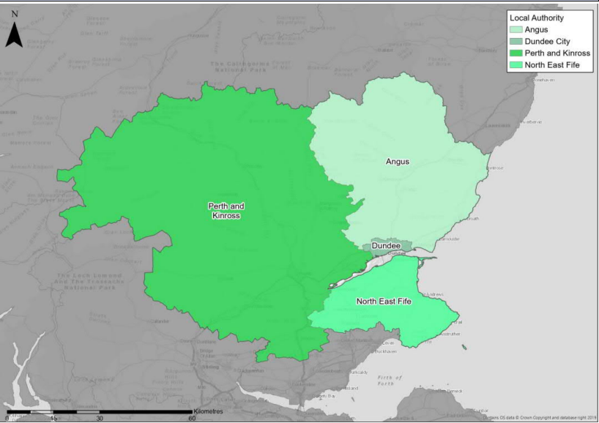
The Tay Cities Region (herein referred to as ‘the Region’) comprises the three local authority areas of Perth & Kinross, Angus and Dundee City, plus the north-east part of Fife (which predominantly looks towards Dundee and/or Perth for major services), and includes a mix of urban and rural settlements and areas.
The Scottish Government Urban Rural Six-Fold Classification identifies the regional population residing in each category as follows: Large Urban Areas (31%), Other Urban Areas (27%), Accessible Small Towns (11%), Remote Small Towns (3%), Accessible Rural (23%) and Remote Rural (4%).
The transport network provides connectivity for the Region and between the Central Belt and the north and northeast of Scotland. It includes a diverse range of off-road and on-road active travel routes and an extensive bus network, although the frequency of service differs widely depending on time and location. There are 20 rail stations in the Region. Rail journey times are competitive compared to the car for some journeys to and within the Region, but on other routes (notably to/from Edinburgh), rail journey times can be long.
The Region has one major port at Dundee. The Region has an extensive trunk road network, including parts of the A9, M90, A90, A92 and A85. Congestion is a frequent peak-time occurrence at some locations, especially around Dundee and Perth. This causes delays and increases traffic levels and pollution on less suitable routes.
  - Social Context
According to the National Records of Scotland’s Mid-year Population Estimates Scotland, the total population of the Region was 493,136 in 2019 (9% of the total Scotland population). The largest settlements within the Region are Dundee (148,280) and Perth (47,430), but much of the Region’s population lives in smaller urban areas. Whilst many of these are located along the Perth-Dundee-Carnoustie-Arbroath-Montrose coastal corridor, the Region also has towns in more rural settings, such as Forfar and Blairgowrie to the north, and Cupar and St Andrews to the south of the Tay. The Region (excluding Dundee City) has a smaller proportional working age population than the Scottish Regional average (61% compared to 63%); there are fewer people aged 15 and under (16% compared to 18%, 2019 mid-year estimate), and more people aged over 65 (23% compared to 19%).
Deprivation levels in Dundee City are nearly twice the national average; 37% of Scottish Index of Multiple Deprivation (SIMD) data zones in Dundee City are in the most deprived quintile nationally. Pockets of significant deprivation also exist outwith Dundee City: parts of Arbroath, Perth and Blairgowrie are in the most deprived 10% of Scottish data zones.
Health outcomes throughout the Region are varied; 37% of data zones in Dundee City are ranked by the SIMD Health rankings in the lowest 20% for health in Scotland, whereas in contrast, North East Fife has 1%, Angus 2% and Perth and Kinross 3%.
According to the 2011 Scottish Government Census, the proportion of households in the Region (excluding Dundee City) with access to one or more cars is higher than the national average (78% compared to 69.5%, based on 2011 Census), and travel to work (excluding Dundee City) by car is the dominant mode with 66% of people commuting by car. In Dundee City, 57% of households have access to one or more cars and travel to work by car is 60%, more than 10% greater than the Scottish Cities benchmark. Bus use for travel to work varies widely throughout the Region with Dundee City having 14.4% mode share while the other parts of the Region (i.e. excluding Dundee City) have 6.1%.
  - Economic Context
Evidence from ONS Regional GDP indicates that Total Gross Value Added (GVA) by the Region in 2018 was £17,047 million, which was 12.0% of Scotland’s GVA (for 14.4% of the country’s population). Regional GVA increased by 9.2% between 2013 and 2018, which was 5.3% less than the national benchmark increase. The average employment rate in Dundee City was 68.6% in 2019, which was 3.9% lower than the Scottish Cities benchmark and noticeably lower than the rest of the Region, which has an employment rate of 76.3%. The Region contributed 9.0% of Scotland’s total benefits claimants in 2019. The number of claimants in the area increased by 21.8% between January 2015 and December 2019.
The on-going redevelopment of the Waterfront in Dundee is classed as a National Development within both the existing National Planning Framework (NPF3) and the Revised Draft NPF4.
  - Environmental Context
According to Historic Environment Scotland, within the Region there are many areas classified as environmentally sensitive, with varying levels of statutory protection. Environmental designations include those for biodiversity, landscape and heritage. In addition, the Region contains a significant number of historic assets, including five Battlefield sites and 1,231 Scheduled Monuments.
Data from the Scottish Government’s Scotland Noise Map shows that the greatest modelled noise levels are located in the east of the Region around Dundee (from road, industry and rail noise sources, as well as Dundee Airport), and those associated with the trunk road, motorway and rail corridors near/through Perth.
There are four Air Quality Management Areas (AQMAs) within the region, located in Dundee, Perth, Crieff and Cupar. Each of these AQMAs has been declared due to concerns regarding emissions of both Nitrogen Dioxide (NO₂) and Particulate Matter (PM10). In 2018, Carbon Dioxide (CO₂) emissions from transport within the Region was 16% of Scotland’s total transport emissions.

- Problems and Opportunities
The following transport-related problems and opportunities have been identified for the Tay Cities region.
  - Problems
- Transport Exclusion: 27% of the population of Scotland does not travel anywhere on any given day. This proportion varies with age; nearly half of Scots aged 80 and over do not travel on any given day. According to the 2017 Scottish Health Survey, more than a quarter of the Region’s population (and nearly a third of that of Dundee City) has a long-term physical or mental health condition. The Region has a higher proportion of older people than the Scottish average, who are more likely to suffer health problems and less able to use all transport options.

- Physical Activity and Health: Physical activity levels of much of the Region’s population fall below recommended guidelines: 34% of adults living in the NHS Tayside area (which excludes north east Fife) do not achieve recommended amounts of physical activity. The proportion of people walking on a regular basis in the Region has been decreasing quickly in recent years.

- Limited Transport Choice: Parts of the Region suffer from relatively poor accessibility: 20% of data zones in Perth & Kinross, 21% in Angus and 18% in north east Fife are within the bottom decile for geographic access (SIMD). 28% of the Region’s households have no access to a car or van.

- Active Travel Infrastructure: The Region’s local authorities are working to improve facilities for walking, wheeling and cycling, but many gaps in provision remain. Cycling Scotland’s research into the barriers to cycling, in which “not safe enough on the roads, bad drivers, etc” was by far the most common reason for not cycling, being quoted as the one main reason by 25% of respondents.

- Air Pollution: Although air quality is good in most of the Region, air pollution from road transport exceeds legal standards near some main roads in Dundee, Perth, Cupar and Crieff, resulting in the declaration of four Air Quality Management Areas (AQMAs).

- Carbon Emissions: Carbon emissions from transport in the Region have been increasing in recent years, broadly in line with national trends. Between 2014 and 2018 inclusive, emissions from transport in the Region increased by 6.2%, similar to the average for Scotland (5.9% increase).

- Freight Movements: The Region’s transport network caters for local and cross-regional freight movements. The Region’s ports are targeting growth, but intermodal transfer facilities in the Region are currently very limited. There are no road/rail or sea/rail freight transhipment facilities in the Region, and rail capacity within the Region constrains the potential opportunity for rail freight.

- Inter-and Cross-Regional Connectivity: Cross-regional movements add to congestion and air pollution levels in the Region.

  - Opportunities
- Technological Opportunities: The Region is showing willingness to respond to new opportunities to promote inclusive, sustainable transport choices, including Dundee City Council’s work to increase electric vehicle use and Tactran’s MaaS Pilot Project ENABLE.

- Behavioural Change: There are good examples of programmes that demonstrate the willingness of the Region’s population to use active and sustainable modes, and are making changes as a result.

- Development of the Active Travel Network: Development of the active travel network was highlighted by stakeholders as a key opportunity for both leisure and functional trips.

- Supporting Economic Change: The Tay Cities Deal aspires for the Region “to be one of the most productive, knowledge-led economies in Europe”. ‘Connected Tay’ is one of the key themes of the Deal, seeking to improve digital and real connectivity of the Region.

- Public Transport Growth: Many residents of the Region state that they could use public transport to commute to work: 59% of residents of Dundee City, along with 49%, 33% and 25% of Fife, Angus and Perth & Kinross respectively. Yet at the 2011 Census, less than 10% of the Region’s employees commuted by public transport. Rail timetable changes have improved both service frequency and passenger capacity in recent years, increasing rail capacity and patronage. This was (pre-Covid) generating growth for demand for rail travel in the region.

- Tourism Growth: The Tay Cities Region’s 2019 Tourism Strategy aspires to deliver approximately 3% growth year on year in the number of overnight stays. The strategy highlights transport’s role in helping deliver this, and particularly the need to facilitate tourist movements by public transport as a greater proportion of visitors seek lower-carbon activities.

- Regional Recommendations
The following is a list of interventions that form a package of recommendations that are relevant to this Region.

Regional Recommendations
- Connected neighbourhoods (Recommendation 1)
- Active freeways and cycle parking hubs (Recommendation 2)
- Village-town active travel connections (Recommendation 3)
- Connecting towns by active travel (Recommendation 4)
- Long-distance active travel network (Recommendation 5)
- Behavioural change initiatives (Recommendation 6)
- Changing road user behaviour (Recommendation 7)
- Increasing active travel to school (Recommendation 8)
- Improving access to bikes (Recommendation 9)
- Expansion of 20mph limits and zones (Recommendation 10)
- Provision of strategic bus priority measures (Recommendation 14)
- Highland Main Line Rail Corridor Enhancements (Recommendation 15)
- Perth-Dundee-Aberdeen Rail Corridor Enhancements (Recommendation 16)
- Edinburgh/Glasgow-Perth/Dundee Rail Corridor Enhancements (Recommendation 17)
- Infrastructure to provide access for all at railway stations (Recommendation 19)
- Investment in Demand Responsive Transport and Mobility as a Service (Recommendation 20)
- Improved public transport passenger interchange facilities (Recommendation 21)
- Framework for the Delivery of Mobility Hubs (Recommendation 22)
- Smart, integrated public transport ticketing (Recommendation 23)
- Decarbonisation of the rail network (Recommendation 25)
- Decarbonisation of the bus network (Recommendation 26)
- Behavioural change and modal shift for freight (Recommendation 27)
- Zero emission vehicles and infrastructure transition (Recommendation 28)
- Trunk road and motorway safety improvements to progress towards ‘Vision Zero’ (Recommendation 30)
- Trunk road and motorway network climate change adaptation and resilience (Recommendation 31)
- Trunk road and motorway network renewal for reliability, resilience and safety (Recommendation 32)
- Future Intelligent Transport Systems (Recommendation 33)
- Traffic Scotland System Renewal (Recommendation 34)
- Intelligent Transport System renewal and replacement (Recommendation 35)
- Strategy for improving rest and welfare facilities for hauliers Recommendation 36)
- Improving active travel on trunk roads through communities (Recommendation 37)
- Speed Management Plan (Recommendation 38)
- Major station masterplans (Recommendation 43)
- Rail freight terminals and facilities (Recommendation 44)

- Fit with Established Policy
The interventions included within this package support a wide range of national, regional and local policy documents in which transport improvements play a key role in both the enabling and delivery of outcomes.
Key policies supported include the Programme for Government, Infrastructure Investment Plan, NTS2, the Climate Change Plan Update 2018 – 2032, Tactran Regional Transport Strategy 2015 (currently being updated), Angus Local Transport Strategy 2010, Shaping Perth’s Transport Future 2010, and Dundee Local Transport Strategy, as well as non-transport-specific plans, such as the TAYplan Strategic Development Plan 2016 and Tay Cities Region Economic Strategy 2019.
The interventions also support the implementation of the Revised Draft NPF4, including the proposed continuing designation of Dundee Waterfront as a national development.
The policy framework for the Region has a strong emphasis on improved connectivity and addressing inequality, to help deliver well-connected, sustainable communities, promote modal shift away from private car, increase walking and cycling opportunities, and provide attractive places for visitors and for businesses to invest and grow. The package therefore closely aligns with established policy directives.

Package Performance Against NTS2 Priorities and Outcomes:

Reduce inequalities
Will provide fair access to services we need: Major Positive
Will be easy to use for all: Major Positive
Will be affordable for all: Minor Positive

Takes climate action
Will help deliver our net-zero target: Minor Positive
Will adapt to the effects of climate change: Minor Positive
Will promote greener, cleaner choices: Major Positive

Helps deliver inclusive economic growth
Will get people and goods where they need to get to: Major Positive
Will be reliable, efficient and high quality: Major Positive
Will use beneficial innovation: Major Positive

Improves our Health and Wellbeing
Will be safe and secure for all: Major Positive
Will enable us to make healthy travel choices: Major Positive
Will help make our communities great places to live: Major Positive
- STPR2 Transport Planning Objectives (TPOs) Assessment

TPO1 A sustainable strategic transport system that contributes significantly to the Scottish Government’s net-zero emissions target

TPO Performance Summary
Carbon dioxide equivalent (CO₂eq) is treated as a nationally important pollutant. As such, although it can be appraised at the national level (commentary below), it has not been appraised for individual regions.
The national and all regional packages overall will contribute significantly to the net-zero emissions target by:
- Enabling more passenger journeys to be made by active modes and public transport.
- Decarbonising most if not all public transport operations.
- Facilitating uptake of electric vehicles.
- Enabling road freight to switch to rail or other low carbon modes.
Further commentary is provided below.
National CO₂eq emissions are forecasted to decrease year-on year. This is due to decreasing vehicle exhaust (non-traded) emissions as the number of internal combustion engine vehicles reduces. This is reflected in the volume of traded grid emissions from charging increased numbers of battery-electric vehicles, and specifically in the Low scenario. It is noted that traded emissions of CO₂eq are associated with electrical generation to supply plug-in vehicles, both BEV (battery electric vehicles) and PHEV (plug-in hybrid vehicles).
The electricity grid is expected to be using predominantly renewable sources in the future and so increasing adoption of electric vehicles and a shift from direct, non-traded, emission to traded grid-based technology (i.e. battery) will support reducing CO₂eq emissions.
Across both Low and High scenarios the interventions would reduce emissions of CO₂eq.
Significantly higher overall emissions are predicted in the High scenario, either with, or without, the national and all regional packages. There is a relatively smaller overall reduction of emissions due to the interventions in the Low scenario due to the lower overall emissions. The economic impacts associated with air quality were assessed using the Department for Environment Food & Rural Affairs (DEFRA) Damage Costs Appraisal Toolkit. The larger economic benefit from the High scenario is due to the greater overall emissions with, or without, the package, although the proportional change is lower.
Overall Scoring:
Low and High Scenarios: Moderate Positive

Metric 1: Change in CO₂eq (non-traded and traded emissions from regional road transport inc. grid emissions from charging light-duty vehicles)- Figures below are a National calculation
Low Scenario Commentary:
- 0.5% decrease (27,700 tonnes CO₂eq) in 2030.
- 2.8% decrease (21,600 tonnes CO₂eq) in 2045.
- 1.3 million tonnes reduction, of which 1.1 million were traded, for the 60-year appraisal period from 2030 to 2089.
- The net economic benefits for the 60-year appraisal period in 2010 prices and values would be in the range £10 million to £25 million for the Low scenario.

High Scenario Commentary:
- 0.4% decerase (31,300 tonnes CO₂eq) in 2030.
- 1.3% decrease (65,300 tonnes CO₂eq) in 2045.
- 3.7 million tonnes reduction, of which 452,000 were traded, for the 60-year appraisal period from 2030 to 2089.
- The net economic benefits for the 60-year appraisal period in 2010 prices and values would be in the range £100 million to £250 million for the High scenario.

Metric 2: Change in mode share by active travel for all journeys
Low and High Scenario Commentary:
- Potential increase in walking from 19% mode share to 24% (5 percentage points).
- Potential increase in cycling from 0.6% mode share to 19% (over 18 percentage points).
The package will increase the proportions of journeys undertaken by active modes. If all the active travel and behaviour change interventions were fully implemented in every relevant location in the Region, mode shares of walking and cycling "with STPR2 package" proportions are shown alongside the mode share without package.
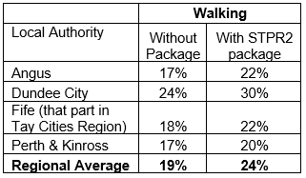
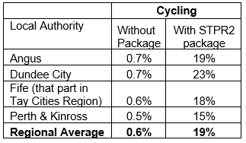
Note that the cycling and walking growth forecasts have been developed independently. Growth in use of one active mode is likely to abstract at least some trips from the other, but this effect is not accounted for within these forecasts.

Metric 3: Change in motorised vehicle kilometres travelled
Low Scenario Commentary:
- Reduction of 80 million motorised vehicle kilometres (3% decrease) (see Annex B).
High Scenario Commentary:
- Reduction of 85 million motorised vehicle kilometres (2% decrease) (see Annex B).

TPO2 An inclusive strategic transport system that improves the affordability and accessibility of public transport

TPO Performance Summary
The package will improve the inclusiveness of the transport system by:
- Improving conditions for people walking, wheeling and cycling, the most inclusive transport modes, with particular benefits for people most often excluded (including children, older and disabled people, and people on low incomes).
- Improving inclusive accessibility to public transport stops/stations.
- Seeking to promote public transport use and reduce operating costs, hence enhancing network sustainability.
Overall Scoring:
Low and High Scenarios: Minor Positive

Metric 1: Change in transport poverty risk
Low and High Scenarios Commentary:
Although the STPR2 interventions do not impact on the direct costs of travel (e.g. fares, fuel price), the package of interventions would see a small reduction in transport poverty, due to the overall improvements to access and connectivity between modes.

Metric 2: Change in Accessibility - population catchments increases to key services by journey time by public transport
Low and High Scenarios Commentary:
The package is forecaste to improve the accessibility to both higher education and accident and emergency hospitals by public transport, whereby an additional 1,700 and 1,300 of the population in the Region would be able to access their nearest site in a journey time of 30 minutes or less by public transport with the STPR2 package compared to the without package assessment. This represents a 0.4 percentage point increase in accessibility levels to higher education from 62.7% in the without package assessment to 63.1% with the package in place. Similarly a 0.3 percentage point increase in accessibility levels to accident and emergency hospitals from 56.1% in the without package assessment to 56.4% with the package in place. These improvements for both destinations were forecast in Perth & Kinross, most specifically in the suburbs and communities around Perth.
In terms of additional destinations (cities, rail stations and airports) considered in the model:
- 2,700 additional people are forecast to be able to access their closest city* within a 60 minute public transport journey, which represents a 0.6 percentage point increase in accessibility levels from 86.3% in the without package to 86.9% with the package in place.
*Note - Dunfermline is also represented in the model as a city destination, in addition to Dundee and Perth.
- 6,000 additional people are forecast to be able to access their closest rail station within a 30 minute public transport journey, which represents a 1.4 percentage point increase in accessibility levels from 61.6% in the without package to 63.0% with the package in place.
- 17,100 additional people are forecast to be able to access their closest international airport (which no longer includes Dundee Airport) within a 90 minute public transport journey, which represents a 4.2 percentage point increase in accessibility levels from 2.5% in the without package to 6.7% with the package in place.
- 53,900 additional people are forecast to be able to access their closest international airport within a 120 minute public transport journey, which represents a 13 percentage point increase in accessibility levels from 19.5% in the without package to 32.5% with the package in place.

Mapping outputs are shown in Annex A.

TPO3 A cohesive strategic transport system that enhances communities as places, supporting health and wellbeing

TPO Performance Summary
The package will improve communities as places, supporting health and wellbeing by enabling more journeys to be made by active and sustainable modes, and by improving road safety. This will:
- Improve many people’s physical health and mental wellbeing, with particular benefits for people most often excluded (including children, older and disabled people, and people on low incomes).
- Reduce the adverse impacts of car use on communities and health (including reduced air pollution, noise, accident risk and perceived road danger).
The analysis shows that, through improved uptake of walking and cycling, there would be a forecast reduction of 24 premature deaths per year due to the health benefits arising from active travel.
Overall Scoring:
Low and High Scenarios: Major Positive

Metric 1 Change in mode share by active travel for all journeys
Low and High Scenarios Commentary:
- Potential increase in walking from 19% mode share to 24% mode share (5 percentage point increase).
- Potential increase in cycling from 0.6% mode share to 19% (over 18 percentage point increase).
These forecasts are subject to all active travel interventions being delivered in all relevant areas of the Region.

Metric 2 Potential for Change in 'Place'
Low and High Scenarios Commentary:
The package will tend to improve the quality of the Region’s places by improving local accessibility and reducing the adverse impacts of road traffic.
Particular benefits may arise through Connected Neighbourhoods where active travel allows easier walking and cycling conditions in more pleasant and secure conditions.

Metric 3 Change in Health Benefits
Low and High Scenarios Commentary:
The health benefits of increased rates of active travel as a result of the package have been quantified using the WHOs Health Economic Assessment Tool (HEAT). HEAT estimates the health and economic impacts of increased walking and cycling, providing assessments of the health and economic impacts of walking and cycling on premature mortality and on exposure to air pollution. Outputs from the tool shows the following benefits by Local Authority, subject to all active travel interventions being delivered in all relevant areas of the Region:
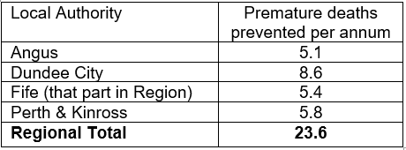

TPO4 An integrated strategic transport system that contributes towards sustainable inclusive growth in Scotland

TPO Performance Summary
The package will contribute to sustainable inclusive growth in Scotland by:
- Improving integration of transport modes (especially between active modes and public transport) and between transport and major developments.
- Improving journey time reliability.
- Enabling more people to travel by improving the accessibility and affordability of the transport system, so enabling more people to access local retail and services, and opportunities for employment and education/training.
Encouraging modal shift to sustainable modes and reducing the volume of vehicles on the road network is anticipated to improve journey time reliability for all vehicles, providing benefits to businesses in the Region and to those elsewhere in Scotland that are reliant on the Region’s transport system.
Overall Scoring:
Low and High Scenarios: Moderate Positive

Metric 1: Increased labour catchment by sustainable travel (Public Transport/Active Travel)
Low and High Scenarios Commentary:
Access to local employment, which represents the accessibility of key employment opportunities located in the surrounding area within a 40 minute public transport journey time, showed small, localised improvements from areas such as Fairmuir, Lochee and Fintry in Dundee; Tayport in Fife and Burghmuir in Perth between the with STPR2 package assessment and without package assessment. This is shown by the map output in Annex A.
Access to regional employment, which represents the accessibility of key employment opportunities located in Dundee, Perth or Aberdeen within a 120 minute journey time using public transport, is forecast to improve in Angus and North Fife within the Region as a result of the package. The modelling shows that the package enabled just over an additional 1,000 jobs to be accessed within two hours’ journey time from both authorities. The improvements were particularly shown in Kirriemuir where an additional 2,700 of existing jobs located in Dundee City could be accessed and Montrose where an additional 4,300 of existing jobs located in Aberdeen City could be accessed, whereas in North Fife particularly so in Freuchie where an additional 19,700 of existing jobs located in Edinburgh City could be accessed. This is shown by the map output in Annex A.
Improvements to active travel infrastructure throughout the Region, however, would enable many more people to access local employment opportunities by low-cost and sustainable means.

Metric 2: Change in lost time due to congestion (for business/ commercial transport)
Low Scenario Commentary:
- 9% decrease (equivalent to reduction of 46,000 hours per annum) in lost time due to congestion.
High Scenario Commentary:
- 7% decrease (equivalanet to reduction of 98,000 hours per annum) in lost time due to congestion.

TPO5 A reliable and resilient strategic transport system that is safe and secure for users

TPO Performance Summary
The package will improve reliability, safety and personal security on the transport system by:
- Improving journey time reliability, including through reduced likelihood of significant network disruptions.
- Reducing the risk of road accidents at hotspot locations on the trunk road and motorway network.
- Reducing perceived risks to road safety and to personal security, so enabling more people (particularly children, women and older people) to travel independently.
- Changing attitudes of road users, through behavioural change campaigns. This is anticipated to increase awareness of interactions with those walking, wheeling and cycling.
- Improving active travel provision and providing more dedicated and segregated routes for walking, cycling and wheeling.
Overall Scoring:
Low and High Scenarios: Moderate Positive

Metric 1 Change in accidents (PIA and ‘damage-only’)
Low Scenario Commentary:
- Accident reduction related to motorised vehicle kilometres is forecast to be 3%.
High Scenario Commentary:
- Accident reduction related to motorised vehicle kilometres is forecast to be 2%.
Low and High Scenarios Commentary:
Whilst the number of accidents involving motorised vehicles is anticipated to reduce following the introduction of the interventions within this package, it is anticipated that the package would increase walking and cycling journeys. The number of accidents involving these modes is therefore anticipated to increase, although each individual journey is anticipated be significantly safer.

Metric 2 Percentage accident change for Targeted Infrastructure Improvements over 60 years, using default accident rate (PIA only)
Low and High Scenarios Commentary:
Accident benefits were estimated using the Department for Transport (DfT) recommended software programme COBA-LT (Cost and Benefit to Accidents – Light Touch) for targeted road safety improvements, based on default parameters, but using Scotland specific accident rates. A range of accident benefits were calculated for the various improvement options being considered. This provided the upper and lower bound of estimated percentage change in accidents, respectively. These ranges are shown below and provide the anticipated upper and lower bounds of impact on accidents that would be anticipated from typical interventions of this type:
- Sections of Realignment/Widening – reduction of 23% to 59%.
- Sections of Overtaking Opportunities – reduction of 35% to 73%.
- Locations of Junction Improvements – change of 42% (increase) to 64% (decrease).
It should be noted that junction accidents are forecast to increase in the event that a junction is upgraded from a priority to a signalised junction. This is due to an increase in the number of slight accidents that are likely to occur as a result of shunts in queuing traffic on the mainline approach to the traffic signals, which could previously travel unopposed. However, the accident severity can be expected to reduce as a result of this type of improvement. Any improvement scheme would be subject to further consideration.

Metric 3 Change in lost time due to congestion
Low Scenario Commentary:
- 12% decrease (170,000 hours) in lost time due to congestion (see Annex B).
High Scenario Commentary:
- 9% decrease (500,000 hours) in lost time due to congestion (see Annex B).

Metric 4 Journey Time Reliability /Availability of alternatives (modes/routes)
Low and High Scenarios Commentary:
This package is forecast to reduce overall motorised vehicle kilometres by 2% and 1% under the Low and High scenarios respectively (see Annex B), hence reduce the risk of accidents occurring as a result of reducing travel, whilst improving resilience by reducing the number of road closures associated with accidents.
Targeted improvements at junctions where safety is a problem is forecast to reduce accidents and associated road closures thereby improving reliability.
Improvements in terms of renewals and climate change adaptation to protect the operation of the trunk road and motorway network would also positively impact on the reliability of the network.
Bus priority interventions are anticipated to provide greater reliability to public transport journeys particularly at peak times when current bus services are often hampered by congestion.
Encouraging modal shift to sustainable modes and reducing the volume of vehicles on the network is anticipated to improve journey time reliability, as indicated by reducing time lost to congestion.

- STAG Assessment
  - Environment

Environment

Air Quality
Performance Summary:
Total emissions of NO_{x} (a group of gases that are mainly formed during the combustion of fossil fuels) were predicted to decrease in future in both the Low and High scenarios.
Total emissions of NO_{x} were predicted to be effectively zero in 2045 in the Low scenario, and 2051 in the High scenario either with, or without, the proposed package. It is the change brought about by the projected transition of the vehicle fleet to zero-emission vehicles that contribute to the majority of air quality benefits, and in this instance outweighs the positive mode change contributions from the regional package.
Total emissions of Particulate Matter (PM), which is made up of a collection of solid and / or liquid materials, were predicted to increase in future predominantly due to non-exhaust emissions from road, tyre and brake-wear.
However, the package will reduce harmful emissions slightly. Over the 60-year appraisal period there was a predicted 100% reduction in NO_{x}, 4.3% reduction in PM10 and 4.5% reduction in PM2.5 in the Low package, and a 4.1% reduction in PM10 and a 4.2% reduction in PM2.5 in the High.
Low Scenario Scoring: Minor Positive
High Scenario Scoring: Minor Positive

Noise and Vibration
Performance Summary:
The anticipated modal shift is also expected to reduce levels of noise and vibration associated with the transport network. There is potential for localised negative effects on noise and vibration due to the construction and operation of specific interventions including north west and north east trunk road improvements and rail improvements, however the magnitude of the effect will depend on the design and location of the interventions.
Low Scenario Scoring: Minor Positive
High Scenario Scoring: Minor Positive

Biodiversity and Habitats: Geology and Soils; Land Use (including Agriculture and Forestry); Water, Drainage and Flooding; Historic Environment; and Landscape
Low and High Scenarios Commentary:
Please refer to SEA performance summary text in the ‘Statutory Impact Assessment Criteria’ section below. Please note the scoring has been based on the SEA methodology for scoring, which has been agreed with the SEA Consultation Authorities.
  - Climate Change

Climate Change

Performance Summary (applicable to all Climate Change Sub-Criteria)
Carbon dioxide equivalent (CO₂eq) is treated as a nationally important pollutant. As such, although it can be appraised at the national level (commentary below), it has not been appraised for individual regions.
National CO₂eq emissions are forecasted to decrease year-on-year, with decreasing direct (non-traded) exhaust emissions and increasing traded grid emissions associated with increased adoption and charging of battery-electric vehicles, and specifically in the Low scenario. It is noted that traded emissions of CO₂eq are associated with electrical generation to supply plug-in vehicles, both BEV (battery electric vehicles) and PHEV (plug-in hybrid vehicles).
Across Low and High scenarios the package will reduce emissions of CO₂eq, although the change is greater in the High scenario due to overall higher emissions.
Key recommendations within the package have a focus on identifying vulnerabilities to the effects of climate change on the transport system, as well as identifying measures to assist in the adaptation to the effects of climate change, including unplanned events, such as flooding, landslides and high winds. Climate change adaptation and network resilience would address existing and predicted climate change impacts and support the changes that are necessary to reach the Scottish Government’s net zero target for greenhouse gas emissions. Improving the climate resilience of the transport network will also align with the Scottish Government’s commitment to develop Scotland’s next statutory climate adaptation programme.
The above summary is applicable across all the sub-criteria, as outlined below. The specific performance against each sub-criteria is scored against both the Low and High scenarios.

Greenhouse Gas Emissions
Low Scenario Scoring: Major Positive
High Scenario Scoring: Major Positive

Vulnerability to Effects of Climate Change
Low Scenario Scoring: Minor Positive
High Scenario Scoring: Minor Positive

Potential to Adapt to Effects of Climate Change
Low Scenario Scoring: Minor Positive
High Scenario Scoring: Minor Positive
  - Health, Safety & Wellbeing

Health, Safety & Wellbeing

Performance Summary (applicable to all Health, Safety & Wellbeing Sub-Criteria)
The package will reduce the number and severity of accidents through targeted infrastructure improvements and, by encouraging modal shift away from private car, resulting in reduced accident risk due to reduced conflicts. Whilst the number of accidents involving motorised vehicles is anticipated to reduce following the introduction of the interventions within this package, it is anticipated that the package would increase walking and cycling journeys. The number of accidents involving these modes is therefore anticipated to increase, although each individual journey is anticipated be significantly safer.
Mode shift to sustainable modes will, by improving natural surveillance, make paths, stops, stations and services, and reduce the perception of isolation and this, accompanied by improved quality of facilities, will improve perceived security.
The package will improve communities as places, supporting health and wellbeing, by encouraging modal shift away from private car and towards active travel. This will improve placemaking through reduced noise and better air quality due to reduced traffic, and reduced accident risk. It will also benefit many people’s physical health and mental wellbeing.

Accidents (PIA and ‘damage-only’)
Low Scenario Commentary:
- Accident reduction related to motorised vehicle kilometres is forecast to be 3%.
High Scenario Commentary:
- Accident reduction related to motorised vehicle kilometres is forecast to be 2%.

Percentage accident change for Targeted Infrastructure Improvements over 60 years using default accident rate (PIA only)
Low and High Scenarios Commentary:
Accident benefits were estimated using the Department for Transport (DfT) recommended software programme COBA-LT (Cost and Benefit to Accidents – Light Touch) for targeted road safety improvements, based on default parameters, but using Scotland specific accident rates. A range of accident benefits were calculated for the various improvement options being considered. This provided the upper and lower bound of estimated percentage change in accidents, respectively. These ranges are shown below and provide the anticipated upper and lower bounds of impact on accidents that would be anticipated from typical interventions of this type:
- Sections of Realignment/Widening – reduction of 23% to 59%.
- Sections of Overtaking Opportunities – reduction of 35% to 73%.
- Locations of Junction Improvements – change of 42% (increase) to 64% (decrease).
It should be noted that junction accidents are forecast to increase in the event that a junction is upgraded from a priority to a signalised junction. This is due to an increase in the number of slight accidents that are likely to occur as a result of shunts in queuing traffic on the mainline approach to the traffic signals, which could previously travel unopposed. However, the accident severity can be expected to reduce as a result of this type of improvement. Any improvement scheme would be subject to further consideration.

Security
Low and High Scenarios Commentary:
The package will, by increasing the number of people travelling actively and by public transport, tend to improve natural surveillance and will, through improvements to lighting and urban realm, reduce the number of locations at which security is a concern.

Health Outcomes
Low and High Scenarios Commentary:
The package will, by increasing rates of active travel and hence physical activity, improve both health and wellbeing outcomes. The estimated value of health benefits to the Region’s population, appraised over a 60-year period, is in the range £1 billion to £5 billion.
The package will also tend, by encouraging car journeys to switch to less polluting modes, to improve local air quality, and hence health outcomes. This would be of particular benefit in those areas with identified AQMAs.

Access to Health and Wellbeing Infrastructure
Low and High Scenarios Commentary:
The package will make minor improvements to public transport and active travel accessibility to some healthcare facilities in the Region.
Modelling suggests an additional 1,300 of the population in the Region would be able to access an accident and emergency hospital under a journey time of 30 minutes by public transport with the package in place compared to the without package assessment. This represents a 0.3 percentage point increase in accessibility levels from 56.1% in the without package assessment to 56.4% with the package in place. These improvements were forecast in Perth & Kinross, most specifically in the suburbs and communities around Perth. This is shown by the map output in Annex A.

Visual Amenity
Low and High Scenarios Commentary:
The package should have a positive impact on visual amenity through improvements to walking and cycling infrastructure and an improved sense of ‘place’. Any infrastructure interventions would be required to be designed to ensure they did not detrimentally impact nearby communities.
  - Economy

Economy

Performance Summary
The majority of economic benefits that accrue are as a result of the sustainable transport interventions in the Region’s package to enable and encourage mode shift to public transport modes. The public transport interventions including Bus Priority Infrastructure, and to a lesser extent the Rail and Interchange interventions, are the main contributors to the public transport user benefits total in the Low scenario. The remainder of the benefits are largely due to the increase in public transport operator revenue as a result of the increased patronage levels arising from the mode shift away from car.
The level of public transport user benefits are reduced in the High scenario. The High scenario also has a reduction in public transport operator revenue. Nevertheless, even under this High scenario the sustainable transport interventions contribute to the majority of user benefits.
In terms of accident savings, the level of benefits is similar in both the Low and High scenarios. This is due to the reduction in road-based vehicle-kilometres travelled in the Region, as a result of the active travel and public transport interventions encouraging a mode shift away from private car.
Note that due to the nature of a number of the STPR2 interventions it has not been possible to derive indicative cost estimates on a regional basis.

User Benefits (2010 prices and values for a 60 year appraisal period)
Low Scenario Commentary:
- Present Value of Benefits (PVB) of approximately £250 million to £500 million.
- Accidents Present Value of Benefits (PVB) of approximately £10 million to £25 million.
High Scenario Commentary:
- Present Value of Benefits (PVB) of approximately £100 million to £250 million.
- Accidents Present Value of Benefits (PVB) of approximately £10 million to £25 million.
  - Equality & Accessibility

Equality & Accessibility

Performance Summary (applicable to all Equality & Accessibility Sub-Criteria)
The package will significantly improve accessibility to public transport by improving the coverage of the walking, cycling and public transport networks. This will provide particular benefits for people often excluded from transport, including older and young people, women, disabled people, and people living in more deprived communities.
The package will also improve affordability by reducing forced car ownership, and situations where taxi is the only viable mode for people without access to a car.
By encouraging modal shift to more sustainable modes, the package has the potential to increase demand for public transport, improving commercial performance/viability, which could indirectly reduce ticket costs.

Public Transport Network Coverage
Low and High Scenarios Commentary:
The package will make improvements to public transport journey time reliability, and modest improvements in network coverage, courtesy of improved journey times. Improved local active travel infrastructure will make more public transport stops/stations accessible to more people.

Active Travel Network Coverage
Low and High Scenarios Commentary:
Improvements to the Region’s active travel network, both within and between settlements, mean that many more people will have convenient, high-quality and safe infrastructure for walking, wheeling and cycling journeys.

Comparative Access by People Group
Low and High Scenarios Commentary:
Improvements to active travel networks and public transport will provide positive impacts for groups who are less likely to have access to car and more likely rely on public transport, walking and cycling for their journeys. This includes women, children and young people, older people, some ethnic minority groups and disabled people.

Comparative Access by Geographic Location
Low and High Scenarios Commentary:
For access to local employment, which represents the accessibility of key employment opportunities located nearby in the surrounding area within a 40 minute public transport journey time, the package is forecast to, on average, enable an additional 300 jobs to be accessed in the Region from areas categorised within the 20% most deprived. Particular improvement was forecast in deprived areas within Dundee, whereby an additional 400 jobs are able to be accessed within 40 minutes by public transport.
No changes in accessibility to accident and emergency hospitals, education, and retail from the most deprived areas were forecast.
All results are shown in the mapping outputs found in Annex A.

Affordability
Low and High Scenarios Commentary:
Although the STPR2 interventions do not impact on the direct costs of travel (e.g. fares, fuel price), the package of interventions would see small reduction in transport poverty, due to the overall improvements to access and connectivity between modes.

- Deliverability
  - Feasibility

Feasibility
Summary Assessment:
The package has been developed with feasibility considerations in mind. The package mostly makes use of existing, proven technology and solutions, and would be expected to largely operate inside existing design standards. Additionally, road space allocation across modes will need consideration if multiple modes are competing for similar road space.
  - Affordability

Affordability
Summary Assessment:
The package would require substantial capital and operational funding. Some aspects of the package may generate revenue, which could be used to offset some of these costs.
  - Public Acceptability

Public Acceptability
Summary Assessment:
Public acceptability of the package is likely to be mixed. The package is expected to improve accessibility, connectivity, and choice and to make transport cleaner, more efficient and more attractive and, as such, would be positively received. There may be concerns in areas of congestion where road space reallocation or priority measures are proposed, however the behavioural change elements of the package should also help to mitigate this. There may also be acceptability concerns where construction works are expected to cause disruption or require land-take.

- Statutory Impact Assessment Criteria
  - Strategic Environmental Assessment (SEA)

SEA
Performance Summary:
The package supports modal shift to more sustainable modes of transport. Improved access to major ports and airports, the creation of mobility hubs/interchanges, improvements to the strategic rail network and the improvements to passengers’ services and facilities seek to encourage modal shift and, as a result, reduce levels of transport related air pollution and carbon emissions. The decarbonisation of the rail and bus network and freight deliveries will also help reduce greenhouse gas emissions and improve air quality.
The package provides an opportunity to adapt the transport network to the predicted effects of climate change, and includes one specific intervention focused on this adaptation, as well as others which promote more sustainable usage of the existing transport network.
Positive effects are anticipated on population and human health due to an expected increase in sustainable access to essential services, increased travel choice and improved connectivity and planning for the future capacity of public transport.
Active travel interventions will also have positive outcomes on health through expected improvements in air quality and increased uptake of physical exercise through walking, wheeling and cycling.
Road interventions are anticipated to have positive effects on safety. Trunk road improvements which are focused on junction improvements, realignment / widening and overtaking opportunities are also not anticipated to have a notable impact on traffic volumes or mode share and subsequently transport-based emissions, in the majority of locations. The construction and operation of these interventions may result in minor negative effects on health with the potential for an increase in noise and vibration during construction and operation. This is dependent on the location and design of individual schemes. There is also potential for a negative effect on material assets due to the use of natural resources.
The freight interventions are anticipated to result in minor negative effects on natural resources as several interventions proposed involve enhancements to rail freight, terminals and facilities and therefore will require the use of natural resources.
Where new infrastructure is required this could result in negative effects on biodiversity, soil, landscape, water, cultural heritage and natural resources, however the magnitude of effect is uncertain at this stage and will be determined by the design (and physical footprint) of the interventions.
As the design and development of interventions in this region progresses, further environmental assessments will determine the magnitude of the different positive and negative environmental effects and mitigation measures will be developed where appropriate.

  - Equalities Impact Assessment (EqIA)

EqIA
Performance Summary:
The package would improve public transport and active travel accessibility to key destinations and services for people living in the area. This will have a major positive impact on certain protected characteristic groups who are less likely to have access to a car and more likely to depend on public transport and active travel to make their journeys. This includes women, children and young people, older people, disabled people and people from certain ethnic minority groups.
By encouraging modal shift to more sustainable modes, this package could also contribute to improving local air quality. Improved health outcomes as a result of better air quality are of particular benefit to those who are more vulnerable to air pollution, including children, older people, disabled people and pregnant women.
The package will reduce the severity of accidents through targeted infrastructure improvements and by encouraging modal shift away from private car, resulting in reduced accident risk due to reduced conflicts. Some protected characteristic groups are more likely to be involved in road accidents, for example, children as pedestrian casualties and young males involved as car drivers and, as such, the package would have positive impacts on these groups.
Mode shift to sustainable modes will make paths, stops, stations and services less isolated and this, accompanied by improved quality of facilities, will improve perceived security. This is likely to provide some benefit to those for whom security is of particular concern including women, the LGBTQ+ community and those from religious backgrounds most subject to hate crime.
The package would therefore be anticipated to have a moderate positive impact on this criterion.
  - Island Communities Impact Assessment (ICIA)

ICIA
Performance Summary:
The package is not relevant to islands and would therefore have a negligible impact on this criterion.
  - Child Rights and Wellbeing Impact Assessment (CRWIA)

CRWIA
Performance Summary:
By encouraging modal shift to more sustainable modes, this package would contribute to improving local air quality. Improved health outcomes as a result of better air quality are of particular benefit to those who are more vulnerable to air pollution, including children.
The package would also improve public transport and active travel accessibility to higher education institutions and employment opportunities for young people living in the area.
Safety is a key issue for children with regards to transport with child pedestrian casualties recorded in Scotland in 2019, accounting for 44% of all pedestrian casualties. In particular children from deprived areas and certain ethnic groups are more at risk. The package will reduce the severity of accidents through targeted infrastructure improvements and, by encouraging modal shift away from private car, result in reduced accident risk due to reduced conflicts.
The package would therefore be anticipated to have a minor positive impact on this criterion
  - Fairer Scotland Duty Assessment (FSDA)

FSDA
Performance Summary:
Deprivation levels in Dundee City are nearly twice the national average; 37% of Scottish Index of Multiple Deprivation (SIMD) data zones in Dundee City are in the most deprived quintile nationally. Pockets of significant deprivation also exist outwith Dundee City: parts of Arbroath, Perth and Blairgowrie are in the most deprived 10% of Scottish data zones.
The package has the potential to improve public transport connectivity, including through strategic rail corridor enhancements, and can therefore support regeneration and economic development and reduce inequalities caused by socio-economic disadvantage by improving accessibility for deprived communities or communities where transport options are limited.
The package would therefore be expected to have a minor positive impact on this criterion.

Annexes

Annex A: NAPTAT Mapping
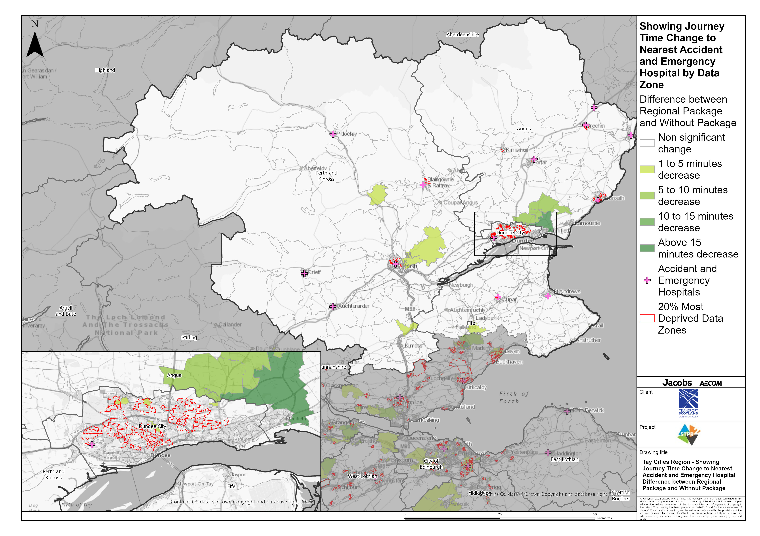
Tay Cities Region – Showing Journey Time Change to Nearest Accident and Emergency Hospital Difference between Regional Package and Without Package
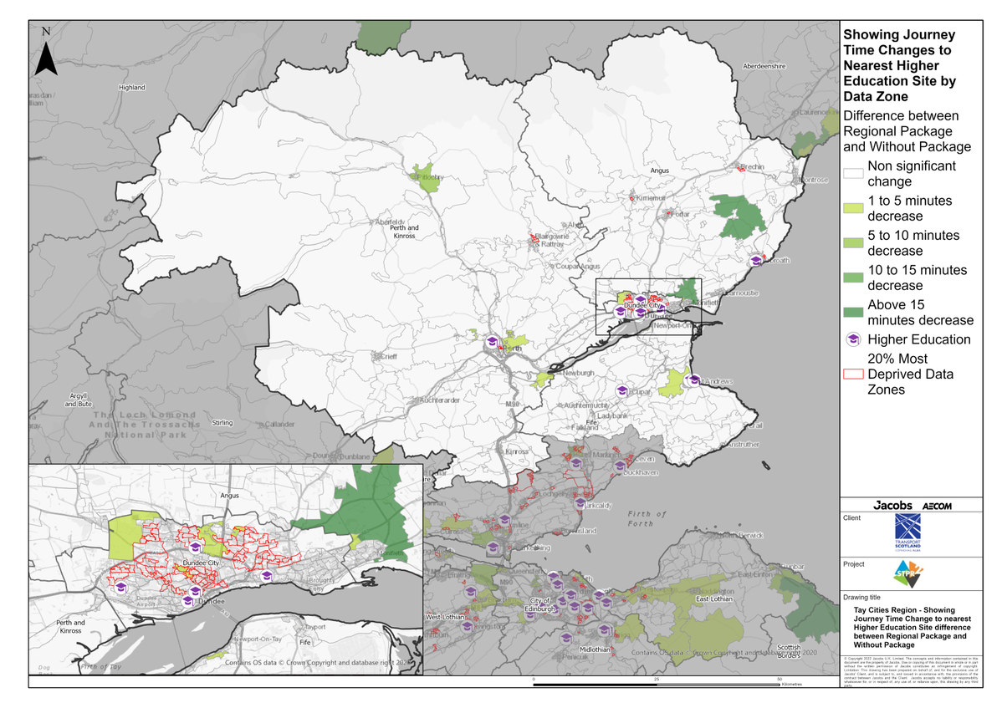
Tay Cities Region – Showing Journey Time Change to Nearest Higher Education Site Difference between Regional Package and Without Package
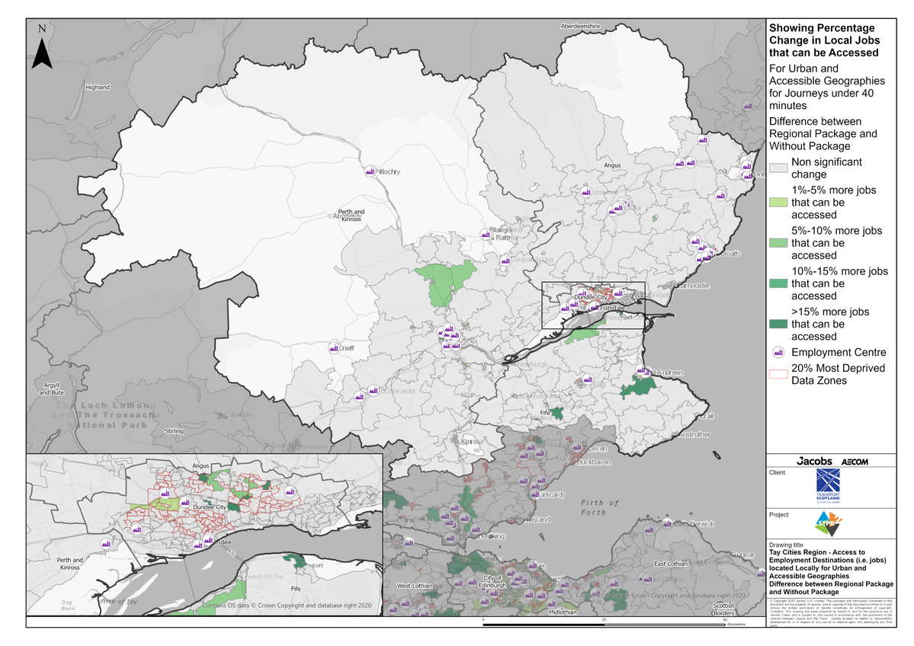
Tay Cities Region – Access to Employment Destinations (i.e. jobs) located Locally for Urban and Accessible Geographies for journeys under 40 minutes Difference between Regional Package and Without Package
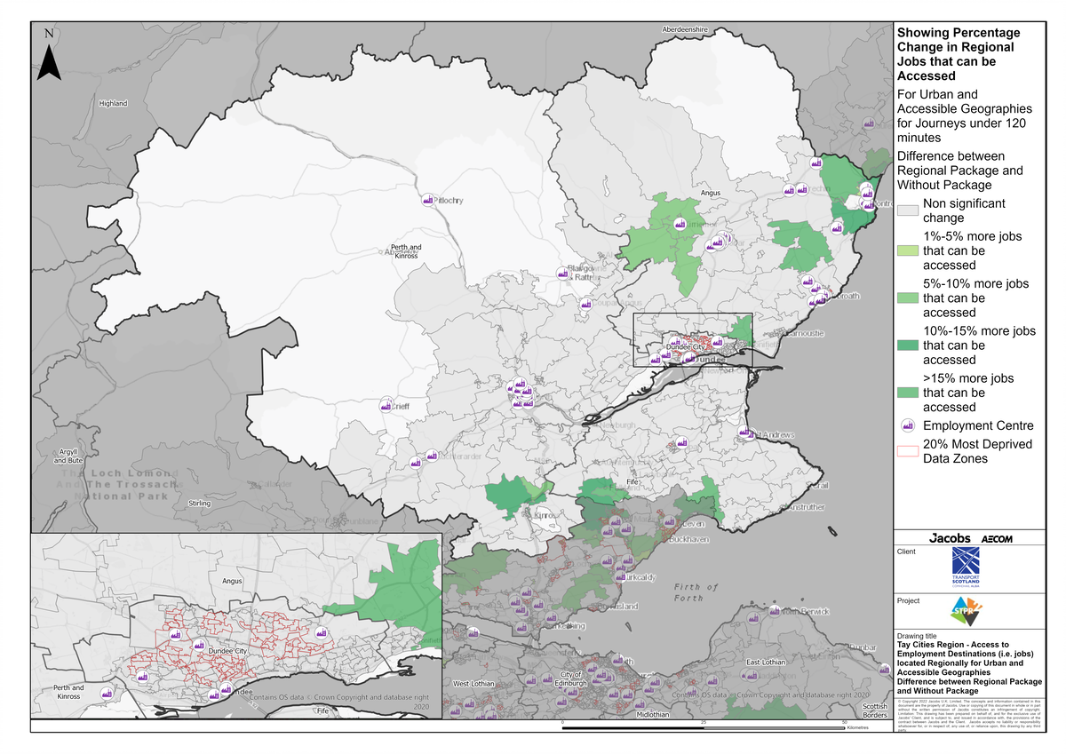
Tay Cities Region – Access to Employment Destinations (i.e. jobs) located Regionally for Urban and Accessible Geographies for journeys under 120 minutes Difference between Regional Package and Without Package
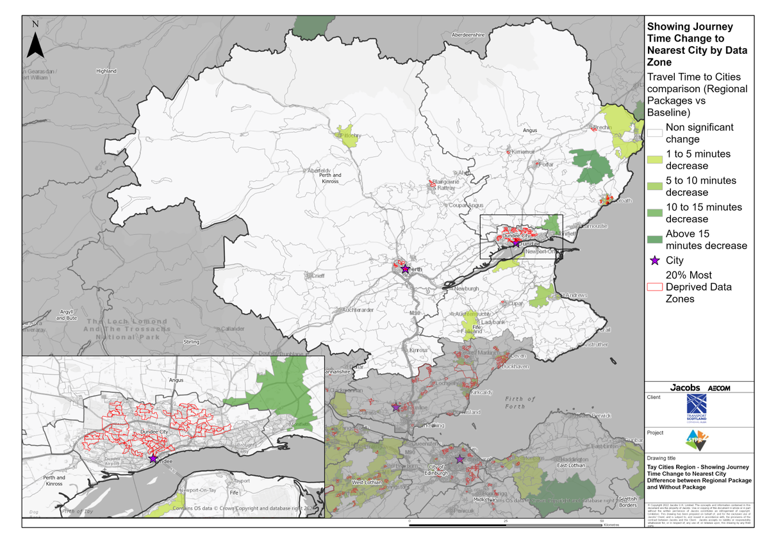
Tay Cities Region – Showing Journey Time Change to Nearest City Difference between Regional Package and Without Package
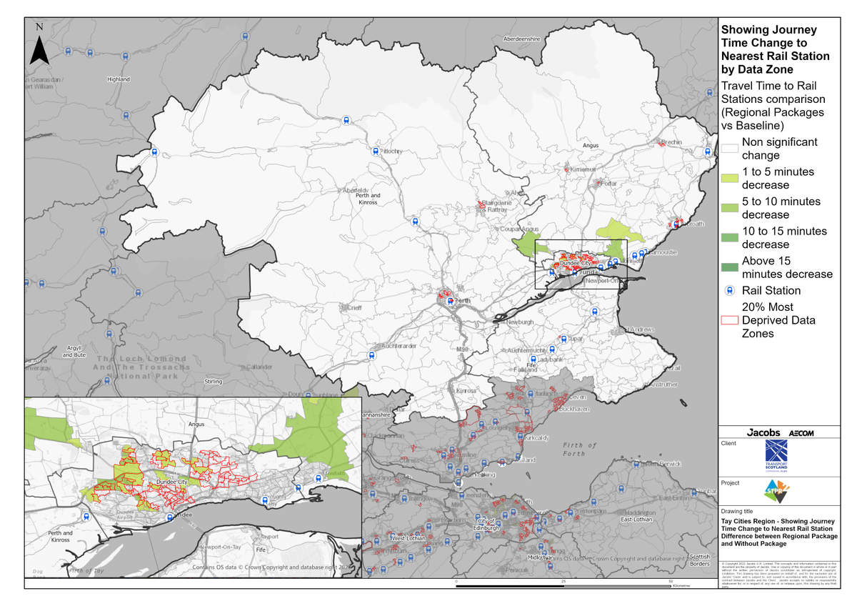
Tay Cities Region – Showing Journey Time Change to Nearest Rail Station Difference between Regional Package and Without Package
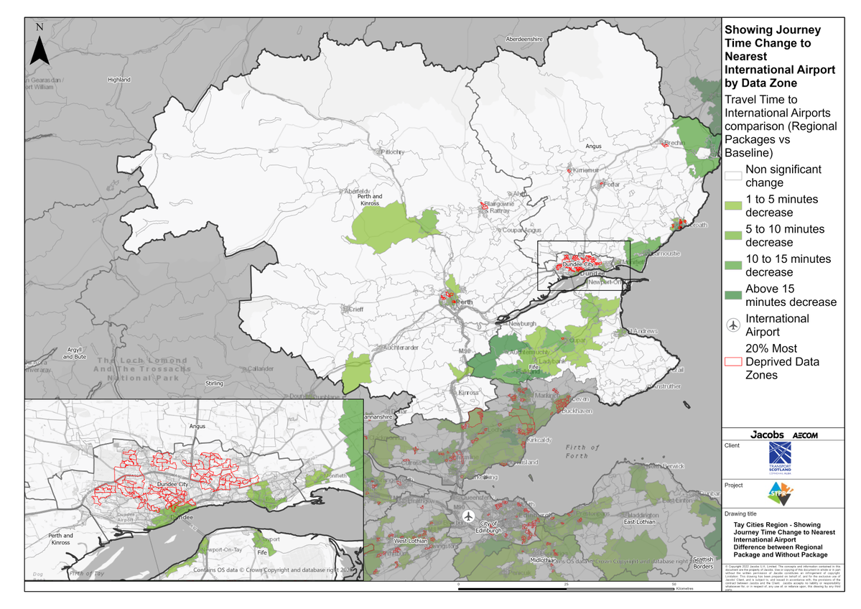
Tay Cities Region – Showing Journey Time Change to Nearest International Airport Difference between Regional Package and Without Package

Annex B: Traffic Modelling Outputs
