Appendix H: Detailed Packaging - Appraisal Summary Tables

December 2022

Contents
1. Regional Context 5
1.1. Geographic Context 5
1.2. Social Context 6
1.3. Economic Context 6
1.4. Environmental Context 7
2. Problems and Opportunities 8
2.1. Problems 8
2.2. Opportunities 9
3. Regional Recommendations 11
4. Fit with Established Policy 12
5. STPR2 Transport Planning Objectives (TPOs) Assessment 13
6. STAG Assessment 22
6.1. Environment 22
6.2. Climate Change 23
6.3. Health, Safety & Wellbeing 24
6.4. Economy 26
6.5. Equality & Accessibility 27
7. Deliverability 29
7.1. Feasibility 29
7.2. Affordability 29
7.3. Public Acceptability 29
8. Statutory Impact Assessment Criteria 30
8.1. Strategic Environmental Assessment (SEA) 30
8.2. Equalities Impact Assessment (EqIA) 31
8.3. Island Communities Impact Assessment (ICIA) 32
8.4. Child Rights and Wellbeing Impact Assessment (CRWIA) 32
8.5. Fairer Scotland Duty Assessment (FSDA) 32
Annexes 33
Annex A: NAPTAT Mapping 34
Annex B: Traffic Modelling Outputs 39

South West Scotland Region Appraisal Summary Table
An Appraisal Summary Table (AST) has been developed for each of the eleven STPR2 Regions alongside the National AST. The ASTs are set out to provide:
- Regional Context, Problems and Opportunities – drawing on data presented in the Initial Appraisal: Case for Change reports, this summarises geographic, social, economic, environmental and transport matters in the Region as well as the identified problems and opportunities. In line with STAG, appraisals are expected to explore location-specific problems and opportunities. Local problems and opportunities have been considered to gain a full understanding of the regional and national issues, however some of these may not be within the scope of this strategic study.
- Regional Recommendations – this presents the package of recommendations that were included in the detailed appraisal for the Region.
- Fit with Policy – provides a summary of how well the appraised packages fit with key national policies including the second National Transport Strategy, Climate Change Plan Update, the Revised Draft Fourth National Planning Framework (Revised Draft NPF4) and relevant regional policies.
- Transport Planning Objectives (TPO) Assessment – An assessment against each of the five TPOs is provided with quantified metrics, where appropriate, under the Low growth sensitivity with a 20% reduction policy ambition on car kilometres scenario (hereafter referred to as Low scenario) and High growth sensitivity with no policy ambition on car kilometres scenario (hereafter referred to as High scenario) (further information about these scenarios is provided in Appendix F of the Technical Report). A seven point scoring scale is adopted for each TPO which is:
  - + + + = major positive (3 plus signs)
  - + + = moderate positive
  - + = minor positive
  - 0 = neutral
  - - = minor negative
  - - - = moderate negative
  - - - - = major negative (3 minus signs)
- STAG Criteria assessment – as above for the TPO assessment, key points regarding the performance of the package against each of the STAG criteria is presented with quantified metrics provided where appropriate.
- Deliverability – commentary is provided on the assessment of the package in terms of its feasibility, affordability and public acceptability. Note that due to the nature of a number of the STPR2 interventions, and the stage in the business case process STPR2 is at, it has not been possible to derive cost estimates on a regional basis. However, broad capital spending ranges have been estimated over the period 2022 to 2042 at a national level.
- Statutory Impact Assessment Criteria– a summary of the performance of the packages against the Strategic Environment Assessment (SEA), the Equalities Impact Assessment (EqIA), Island Communities Impact Assessment (ICIA), Fairer Scotland Duty Act (FSDA) and Child Rights and Wellbeing Impact Assessment (CRWIA) is provided. The seven point scoring scale is adopted in these assessments where appropriate.

Summary of Assumptions
Quantification of the costs and benefits in the packages has been provided through a modelling exercise. Further information is provided in Appendix F of the Technical Report on the modelling scenarios that have informed the assessment of the STPR2 interventions. A summary of the key assumptions is provided here:
- Population projections are based on the NRS Population Projections (2018-based).
- Economic projections are a combination of projections by Oxford Economics, 2019, the Scottish Fiscal Commission forecasts and more recently the OBR post-COVID estimates.
- Land-use plans are based on data collected for Transport Scotland’s Assembly of Planning Policy Inputs in 2018 from Scotland’s 34 Planning Authorities.
- Permitting of vacant office and retail floorspace to be converted or redeveloped as housing post 2030.
- Working age is taken to be 16-64 (as a constant) to avoid difficulties with changing state pension age (and to reflect non-mandatory retirement).
- The economic results are presented, as is standard within appraisal as discounted values in 2010 prices.

Modelling Tools
For the purposes of modelling accessibility by public transport, NaPTAT (National Public Transport Accessibility Tool) has been used. This allows an assessment of journey time to be compared between the with and without STPR2 package.
Due to the strategic and national nature of STPR2, the national Transport Model for Scotland (TMfS) has been used. TMfS is a national scale model with a focus on inter-urban trips. As such, whilst TMfS provides a suitable level of robustness at this stage of the appraisal for most of the larger infrastructure based interventions, there are limitations associated with the modelling of smaller/discrete interventions and also some of the larger infrastructure interventions that involve changes to the existing road network and are more urban in nature. Separate forecasts of the potential impacts of active travel recommendations on walking and cycling mode share have therefore been made. As the recommended interventions are developed through the business case process, more detailed modelling will be undertaken using regional and / or local models as appropriate.
When considering the outputs presented in this AST, please note the following metrics with respect to the model outputs:
- CO₂ emissions: Likely to underestimate the benefits associated with public transport interventions due to the more limited representation of transport systems in urban areas and a degree of insensitivity to mode shift in TMfS.
- Mode Share: Likely shift to public transport modes underestimated in urban areas due to the more limited representation of urban transport systems and a degree of insensitivity to mode shift mode in TMfS.
- Change in vehicle kilometres travelled: Likely to underestimate the benefits of reducing vehicle kilometres travelled, particularly for short distance journeys due to the more limited representation of urban transport systems and the relative coarseness of the model zone system.
- Lost time due to congestion: Likely to underestimate the benefits associated with interventions that would reduce roadspace due to the under-representation of the local/secondary road network in TMfS.
- Change in accidents: Likely to underestimate the benefits associated with mode shift to public transport interventions due to the more limited representation of urban transport systems and a degree of insensitivity to mode shift in TMfS.
- Present Value of Benefits: Likely to underestimate the benefits to public transport users due to the more limited representation of urban transport systems. Likely to overestimate the dis-benefits to car-based trips due to the under-representation of the junctions and local/secondary road network in TMfS.

- Regional Context
  - Geographic Context
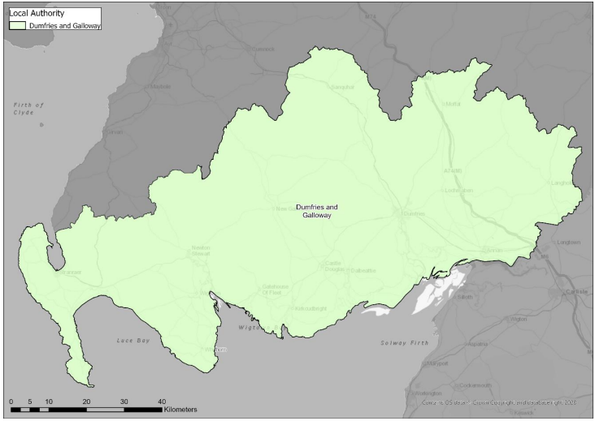
The South West Scotland region (herein referred to as “The Region”) is one of three ‘advanced regions’ to have had their Case for Change studies undertaken ahead of STPR2. In these regions the Case for Change was established based on Pre/Initial appraisal studies, which included identification of problems and opportunities as well as option generation and sifting (which were informed by significant stakeholder engagement and data analysis). To ensure consistency with the other Case for Change exercises, the option sifting exercise for the three ‘advanced regions’ was revisited in 2020 through the STPR2 option sifting framework to cross-check the results; this confirmed broadly the same list of options to be recommended for further appraisal through STPR2. To assist with this further appraisal, the baseline data gathered during the ‘advanced studies’ was updated to match that used for all other regions for STPR2. In order to align with the wider process for establishing the Case for Change across Scotland, and to update the context for the Region, this Appraisal Summary Table therefore refers to some of this more recent data – this does not, however, affect the problems and opportunities established, or options generated and sifted, during the ‘advanced studies’.
The South West Scotland region comprises the local authority area of Dumfries and Galloway. The South West Scotland Transport Study covered most of Dumfries and Galloway (excluding the easternmost part around Langholm) and the southern parts of South Ayrshire and East Ayrshire (broadly south of Ayr). As such, this covered an area larger than the South West Region defined in this AST. Further details are available in the South West Scotland Transport Study Report. The Region is primarily rural but there are urban areas with the Scottish Government Urban Rural Six-Fold Classification showing the following breakdown in the Region: Other Urban Areas (30%), Accessible Small Towns (17%), Remote Small Towns (8%), Accessible Rural (24%) and Remote Rural (21%).
With regards to the Region’s transport network, there are several National Cycle Network routes, while the public transport network is fairly limited; the most populated network is in and around Dumfries, with frequency much lower in rural parts of the Region. The rail network includes connections from Stranraer north to Glasgow where interchange with other services is possible, while stations in the east, including Dumfries, are served by services to Northern England and Glasgow. The West Coast Mainline connecting Scotland to England also passes through the Region. Dumfries and Galloway is home to Scotland’s only Northern Ireland ferry ports at Cairnryan, offering regular connections to Belfast and Larne. The ports at Cairnryan have also been identified as major ports for the purposes of STPR2. Trunk road connections in the Region are provided by the A75 Gretna to Stranraer and the A77 south of Ayr provides connections to Stranraer from the north; both of these routes provide access to the ports at Cairnryan. Other trunk roads include the A76 Dumfries to Cumnock, A701 Dumfries to Moffat and A74(M).
  - Social Context
In 2019, the Region had a population of 148,860 (3% of the total Scotland population) which was a decrease of 1.6% from 2011; this compares to an increase across Scotland of 3.2% over the same period. In 2016, the largest settlement was Dumfries with 34,230, followed by Stranraer with 9,852 residents, according to the National Records of Scotland Mid-2016 Population Estimates for Settlements and Localities in Scotland. The Region’s population is spread over a large geographic area, resulting in low population density which can make provision of viable public transport services challenging and lead to higher levels of car dependency. Access to a car or van is high across the Region, with only 21.9% of households having no access in 2011 compared to the national average of 30.5%. This is indicative of a high degree of car dependence in more rural areas. While car dependency across the Region as a whole is high, there are several locations where the proportion of households with no car is above the national average, including Annan (31.9%) and Stranraer (33.9%). At a regional level, driving a car or van is the most common mode of travel to work or study (64.8%); this is followed by ‘Works mainly from home’ (16%) and ‘On Foot’ (12.8%). Overall, public transport use for travel to work is lower than the Scotland average across the Region.
Data from the Scottish Index of Multiple Deprivation (SIMD) shows that 9.5% of all data zones in the Region (equating to 19 data zones) in the 2020 release were within the 20% most deprived in Scotland. The main pockets of deprivation are most evident within Dumfries (9 data zones) and Stranraer (5 data zones), though there are also deprived data zones in Annan and the Kirkconnel area.
  - Economic Context
The Region is heavily dependent on Dumfries and Locharbriggs as a centre for employment, with a quarter of people employed in the health industry, which is concentrated around Dumfries and Galloway Royal Infirmary. This contributes to an above average dependence on the public sector for employment in the Region. With regards to workplace based employment growth, the Oxford Economics International Research on Regional Economics Implications For Delivering Inclusive Growth in Scotland report states this increased in Dumfries and Galloway by 1.0% per year between 2013 and 2018, which is a faster rate than Scotland as a whole for the same period (0.7%). Data in the same report also shows that over the ten year period 2008-2018, Gross Value Added (GVA) increased in the South of Scotland area (which includes Dumfries and Galloway and Scottish Borders) by approximately 17%, which is a higher rate than Scotland as a whole.
  - Environmental Context
Within the Region, there are many areas classified as environmentally sensitive, with varying levels of statutory protection. The Region contains a significant number of designated areas, including Galloway Forest Park which is a Gold-tier Dark Skies Park, and many Sites of Special Scientific Interest (SSSIs), including Flow of Dergoals and Carlingwark Loch which are adjacent to the A75. There are also areas of Ancient Woodland, particularly in the south and east of the Region. The key conservation areas in the Region are located in Annan, Stranraer and Dumfries, close to potential transport corridors. Furthermore, there are large Garden and Designed Landscape (GDL) areas throughout the Region, including Castle Kennedy to the south of Cairnryan, Cally Palace and Threave Gardens along the A75 between Gatehouse of Fleet and Castle Douglas, Kinmount House near Annan and Drumlanrig Castle to the north of Thornhill. There are no Air Quality Management Areas (AQMAs) in the Region.

- Problems and Opportunities
The following transport-related problems and opportunities have been identified for the South West Scotland region.
  - Problems
- Barriers to Active Travel Facilities and Infrastructure: there is a perception that active travel facilities at interchange points (including bus and rail stations), and infrastructure to these points, are limited. For example, overall there is a mix of traffic free and on road routes (NCN7) between Gretna and Gretna Green Rail Station and some on road routes in the vicinity of Annan, Dumfries, Lockerbie and Stranraer Stations, however, these NCN routes do not link directly to the stations. There is also a lack of (safe) off-road cycle routes alongside the trunk road routes, offering limited active travel accessibility across the Region.

- Public Transport Connectivity and Frequency: there is a lack of overall public transport connectivity across the Region to enable effective access to employment, education, healthcare, retail and social opportunities and city and town centres. With regards to employment, analysis undertaken for the South West Scotland Transport Study found that Dumfries and the south east of the Region close to the border with England are the most well connected to employment by public transport and the areas to the south of the A75 are the most poorly connected. Frequency of bus and rail services was also identified as a problem, with large gaps in bus and rail timetables in some parts of the Region. Other problems identified related to public transport include high fares and reliability of services.

- Vehicle Platooning: there is a mix of local and strategic traffic on the A75, with a high proportion of HGVs and platooning (or convoys) of vehicles. Surveys demonstrated that a significant proportion of platoons were formed by five or more vehicles, including at the A75 Castle Douglas westbound. Vehicle platooning contributes towards limited overtaking opportunities, which in turn contributes to driver frustration.

- Slow Journey Times: average speeds on the A75 are slower compared to other strategic routes at 45 mph; this is compared to 52 mph on the A9 Perth – Inverness and 56 mph on the A74(M) Glasgow – Carlisle. This results in longer average journey times.

- Journey Time Competitiveness: analysis considered typical average road speeds for the ‘last 100 miles’ of journeys to Irish Sea ports: Cairnryan (from Gretna) - 44 mph; Heysham (from M6 north) - 55 mph; Liverpool Stena Terminal (from M6 north) - 51 mph; and Holyhead (from M56/M6) - 58 mph. On this basis, travelling the last 100 miles to Cairnryan (from Gretna) takes up to 30 minutes longer than the equivalent trip to Holyhead. This level of road connectivity could further affect the choice of Irish Sea route, and potentially undermine the competitive position of the ports at Cairnryan. It is noted that Heysham, Liverpool Stena Terminal and Holyhead each benefit from direct connections to high standard roads, while differing HGV speed limits may also be a factor in the journey time results.

- Long Diversionary Routes: although journey times on the A75 can be longer compared to similar distances on other routes, journey times are generally reliable. However, network incidents and resulting lengthy diversions can impact journey times and reliability. For example, journey times increase by around 2 hrs 20 mins in the event of A75 closure at Cardoness Castle.

- Accident Severity: accident analysis showed that overall accident rates in the Region (2012 to 2016) are lower than the Scottish national rate, but when accidents do happen they tend to be more serious in nature (e.g. accident breakdown by severity shows that the proportion of killed or seriously injured (KSI) is higher than the equivalent national rate).

- Public/Stakeholder Dissatisfaction: an online survey undertaken as part of the South West Scotland Transport Study in 2018 and completed by over 3,100 respondents identified high levels of dissatisfaction with aspects of the road network in the Region, including:
  - Over 80% dissatisfied with quality of road surfacing;
  - Over 70% with overtaking opportunities;
  - Over 60% dissatisfied with road safety.

  - Opportunities
- Encouraging Inward Investment: improvements to the overall accessibility of the area, by all modes, has the potential to encourage inward investment to the Region; this could also help to stimulate investment at the ports with associated positive impacts on the local economy.

- Supporting Tourism: the Region has a strong tourism offering with a long coastline, forests and green spaces, but poor connectivity and long journey times have been cited as inhibiting the Region’s tourism potential. Sustainable tourism can be promoted through better public transport connections and ensuring active travel is accommodated as part of the strategic sustainable transport network.

- Promoting Rail Freight: the timber industry is highly active in the Region and there is an opportunity to move timber more sustainably by rail if suitable road-to-rail facilities were available.

- Realising Development Opportunities: relocation of the ferry port from Stranraer to Cairnryan in 2011 has resulted in vacant land and an opportunity for redevelopment of Stranraer Waterfront. Stakeholder engagement has noted that for any development to be a success, good transport infrastructure and strong connectivity is required. The inactive Ministry of Defence site at Eastriggs and the former nuclear power station at Chapelcross both offer development opportunities, with their potential better realised if easier and better accessibility to the sites were enabled.

- Growth Deal: specific projects and activities to be supported as part of the Borderlands Growth Deal are broadly outlined in an agreement signed in March 2021. The aforementioned redevelopment of the Chapelcross former power station has been included as a project which encourages green growth within the Deal. Chapelcross is also identified as a national development site in the Revised Draft Fourth National Planning Framework (Revised Draft NPF4), alongside Stranraer Gateway which supports the regeneration of Stranraer.

- Increased Electric Vehicle Use: an increase in the availability of electric vehicle charging infrastructure has the potential to increase accessibility to sustainable vehicles throughout the Region, providing environmental benefits through reduced emissions.

- Regional Recommendations
The following is a list of interventions that form a package of recommendations that are relevant to this Region.

Regional Recommendations
- Connected neighbourhoods (Recommendation 1)
- Village-town active travel connections (Recommendation 3)
- Connecting towns by active travel (Recommendation 4)
- Long-distance active travel network (Recommendation 5)
- Behavioural change initiatives (Recommendation 6)
- Changing road user behaviour (Recommendation 7)
- Increasing active travel to school (Recommendation 8)
- Improving access to bikes (Recommendation 9)
- Expansion of 20mph limits and zones (Recommendation 10)
- Provision of strategic bus priority measures (Recommendation 14)
- Supporting integrated journeys at ferry terminals (Recommendation 18)
- Infrastructure to provide access for all at railway stations (Recommendation 19)
- Investment in Demand Responsive Transport and Mobility as a Service (Recommendation 20)
- Improved public transport passenger interchange facilities (Recommendation 21)
- Framework for the delivery of mobility hubs (Recommendation 22)
- Smart, integrated public transport ticketing (Recommendation 23)
- Decarbonisation of the rail network (Recommendation 25)
- Decarbonisation of the bus network (Recommendation 26)
- Behavioural change and modal shift for freight (Recommendation 27)
- Zero emission vehicles and infrastructure transition (Recommendation 28)
- Trunk road and motorway safety improvements to progress towards ‘Vision Zero’ (Recommendation 30)
- Trunk road and motorway network climate change adaptation and resilience (Recommendation 31)
- Trunk road and motorway network renewal for reliability, resilience and safety (Recommendation 32)
- Future Intelligent Transport Systems (Recommendation 33)
- Traffic Scotland System Renewal (Recommendation 34)
- Intelligent Transport System renewal and replacement (Recommendation 35)
- Strategy for improving rest and welfare facilities for hauliers (Recommendation 36)
- Improving active travel on trunk roads through communities (Recommendation 37)
- Speed Management Plan (Recommendation 38)
- Access to Stranraer and the ports at Cairnryan (Recommendation 40)
- Rail freight terminals and facilities (Recommendation 44)
- High speed and cross-border rail enhancements (Recommendation 45)

- Fit with Established Policy
The interventions included within this package support a wide range of national, regional and local policy documents in which transport improvements play a key role in both the enabling and delivery of outcomes.
Key policies supported include the Programme for Government, Infrastructure Investment Plan, NTS2, the Climate Change Plan Update 2018-2032 and SWestrans Regional Transport Strategy as well as non-transport-specific plans, such as the Dumfries and Galloway Regional Economic Strategy and Borderlands Inclusive Growth Deal.
Interventions included in this package will also support more resilient connections to the Revised Draft NPF4 national developments at Stranraer Gateway, Chapelcross Power Station Redevelopment and the ports at Cairnryan.
The policy framework for the Region has a strong emphasis on delivering strengthened connectivity to support a sustainable economy. This includes providing travel choices which promote equality and social inclusion and which promote modal shift away from private car, increase walking and cycling opportunities, and provide an attractive place for visitors and businesses to invest and grow; the package therefore closely aligns with established policy directives.

Package Performance Against NTS2 Priorities and Outcomes:

Reduce inequalities
Will provide fair access to services we need: Moderate Positive
Will be easy to use for all: Major Positive
Will be affordable for all: Minor Positive

Takes climate action
Will help deliver our net-zero target: Major Positive
Will adapt to the effects of climate change: Minor Positive
Will promote greener, cleaner choices: Major Positive

Helps deliver inclusive economic growth
Will get people and goods where they need to get to: Major Positive
Will be reliable, efficient and high quality: Major Positive
Will use beneficial innovation: Major Positive

Improves our Health and Wellbeing
Will be safe and secure for all: Major Positive
Will enable us to make healthy travel choices: Moderate Positive
Will help make our communities great places to live: Major Positive
- STPR2 Transport Planning Objectives (TPOs) Assessment

TPO1 A sustainable strategic transport system that contributes significantly to the Scottish Government’s net-zero emissions target

TPO Performance Summary
Carbon dioxide equivalent (CO₂eq) is treated as a nationally important pollutant. As such, although it can be appraised at the national level (commentary below), it has not been appraised for individual regions.
The national and all regional packages overall will contribute significantly to the net-zero emissions target by:
- Enabling more passenger journeys to be made by active modes and public transport.
- Decarbonising most if not all public transport operations.
- Facilitating uptake of electric vehicles.
- Enabling road freight to switch to rail or other low carbon modes.
Further commentary is provided below.
National CO₂eq emissions are forecasted to decrease year-on year. This is due to decreasing vehicle exhaust (non-traded) emissions as the number of internal combustion engine vehicles reduces. This is reflected in the volume of traded grid emissions from charging increased numbers of battery-electric vehicles, and specifically in the Low scenario. It is noted that traded emissions of CO₂eq are associated with electrical generation to supply plug-in vehicles, both BEV (battery electric vehicles) and PHEV (plug-in hybrid vehicles).
The electricity grid is expected to be using predominantly renewable sources in the future and so increasing adoption of electric vehicles and a shift from direct, non-traded, emission to traded grid-based technology (i.e. battery) will support reducing CO₂eq emissions.
Across both Low and High scenarios the interventions would reduce emissions of CO₂eq.
Significantly higher overall emissions are predicted in the High scenario, either with, or without, the national and all regional packages. There is a relatively smaller overall reduction of emissions due to the interventions in the Low scenario due to the lower overall emissions. The economic impacts associated with air quality were assessed using the Department for Environment Food & Rural Affairs (DEFRA) Damage Costs Appraisal Toolkit. The larger economic benefit from the High scenario is due to the greater overall emissions with, or without, the package, although the proportional change is lower.
Overall Scoring:
Low and High Scenarios: Moderate Positive

Metric 1: Change in CO₂eq (non-traded and traded emissions from regional road transport inc. grid emissions from charging light-duty vehicles) - Figures below are a National calculation
Low Scenario Commentary:
- 0.5% decrease (27,700 tonnes CO₂eq) in 2030.
- 2.8% decrease (21,600 tonnes CO₂eq) in 2045.
- 1.3 million tonnes reduction, of which 1.1m were traded, for the 60-year appraisal period from 2030 to 2089.
- The net economic benefits for the 60-year appraisal period in 2010 prices and values would be in the range £10 million to £25 million for the Low scenario.

High Scenario Commentary:
- 0.4% decrease (31,300 tonnes CO₂eq) in 2030.
- 1.3% decrease (65,300 tonnes CO₂eq) in 2045.
- 3.7 million tonnes reduction, of which 452,000 were traded, for the 60-year appraisal period from 2030 to 2089.
- The net economic benefits for the 60-year appraisal period in 2010 prices and values would be in the range £100 million to £250 million for the High scenario.

Metric 2: Change in mode share by active travel for all journeys
Low and High Scenario Commentary:
- Potential increase in walking from 17% mode share to 20% mode share (3 percentage points).
- Potential increase in cycling from 0.9% mode share to 13% mode share (12 percentage points).
The package will increase the proportions of journeys undertaken by active modes. If all the active travel and behaviour change interventions were fully implemented in every relevant location in the Region, mode shares of walking and cycling "with STPR2 package" proportions are shown alongside the mode share without package.
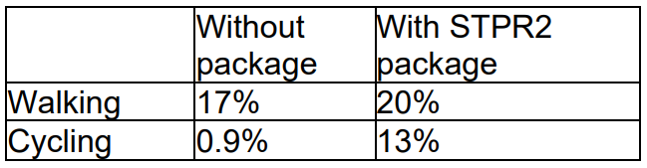
Note that the cycling and walking growth forecasts have been developed independently. Growth in use of one active mode is likely to abstract at least some trips from the other, but this effect is not accounted for within these forecasts.

Metric 3: Change in motorised vehicle kilometres travelled
Low Scenario Commentary:
- Reduction of 26.1 million motorised vehicle kilometres (1% decrease) (see Annex B).
High Scenario Commentary:
- Reduction of 22.9 million motorised vehicle kilometres (1% decrease) (see Annex B).

TPO2 An inclusive strategic transport system that improves the affordability and accessibility of public transport

TPO Performance Summary
The package will improve the inclusiveness of the transport system by:
- Improving conditions for people walking, wheeling and cycling, the most inclusive transport modes, with particular benefits for people most often excluded (including children, older and disabled people, and people on low incomes).
- Improving inclusive accessibility to public transport stops/stations.
- Seeking to promote public transport use and reduce operating costs, hence enhancing network sustainability.
Overall Scoring:
Low and High Scenarios: Minor Positive

Metric 1: Change in transport poverty risk
Low and High Scenarios Commentary:
Although the STPR2 interventions do not impact on the direct costs of travel (e.g. fares, fuel price), the package of interventions would see a small reduction in transport poverty, due to the overall improvements in public transport availability.

Metric 2: Change in Accessibility - population catchment increases to key services by journey time by public transport
Low and High Scenarios Commentary:
The largest change in population accessibility of all the destination types considered was to accident and emergency hospitals, whereby an additional 2,700 of the population in the Region are forecast to be able to access the nearest site in a journey time of 30 minutes or less by public transport compared to the without package. This represents a 1.8 percentage point increase in accessibility levels from 29.8% in the without package assessment to 31.6% with the package in place. The improvements are all forecast in Dumfries. This is shown by the map output in Annex A.
There are also minor population accessibility improvements forecast in the Region for accessing key destinations within the same time period (under 30 minutes) using public transport, which included higher education and secondary schools. The accessibility improvements and the corresponding additional population that are forecast to be able to access those destinations in the with STPR2 package assessment compared to the without package assessment are summarised below:
- 600 additional people are forecast to be able to access the nearest higher education site, as shown by the map output in Annex A, which represents a 0.4 percentage point increase in accessibility levels from 28.5% in the without package assessment to 28.9% with the package in place.
- 100 additional children (aged 11 to 18) are forecast to be able to access a secondary school, which represents a 0.7 percentage point increase in accessibility levels from 60.2% in the without package assessment to 60.9% with the package in place.
In terms of additional destinations (cities, rail stations and airports) considered in the model:
- 1,400 additional people are forecast to be able to access the closest city within a two hour public transport journey, which represents a 0.9 percentage point increase in accessibility levels from 24.7% in the without package to 25.6% with the package in place.
- 500 additional people are forecast to be able to access their closest rail station within a 30 minute public transport journey, which represents a 0.4 percentage point increase in accessibility levels from 52.0% in the without package to 52.4% with the package in place.
- 2,400 additional people are forecast to be able to access their closest international airport within a 60 minute public transport journey, which represents a 1.6 percentage point increase in accessibility levels from 1.0% in the without package to 2.6% with the package in place.
- 3,800 additional people are forecast to be able to access their closest international airport within a 120 minute public transport journey, which represents a 2.5 percentage point increase in accessibility levels from 17.9% in the without package to 20.4% with the package in place.

Mapping outputs are shown in Annex A.

TPO3 A cohesive strategic transport system that enhances communities as places, supporting health and wellbeing

TPO Performance Summary
The package will improve communities as places, supporting health and wellbeing by enabling more journeys to be made by active and sustainable modes, and by improving road safety. This will:
- Improve many people’s physical health and mental wellbeing, with particular benefits for people most often excluded (including children, older and disabled people, and people on low incomes).
- Reduce the adverse impacts of car use on communities and health (including reduced air pollution, noise, accident risk and perceived road danger).
The analysis shows that through improved uptake of walking and cycling, there would be a forecast reduction of approximately 4 premature deaths per annum due to the health benefits arising from active travel.
Overall Scoring:
Low and High Scenarios: Moderate Positive

Metric 1 Change in mode share by active travel for all journeys
Low and High Scenarios Commentary:
- Potential increase in walking from 17% mode share to 20% mode share (3 percentage points).
- Potential increase in cycling from 0.9% mode share to 13% mode share (12 percentage points).
These forecasts are subject to all active travel interventions being delivered in all relevant areas of the Region.
Cycling and walking growth forecasts have been developed independently. Growth in use of one active mode is likely to abstract at least some trips from the other, but this effect is not accounted for within these forecasts.

Metric 2 Potential for Change in 'Place'
Low and High Scenarios Commentary:
The package will tend to improve the quality of the Region’s places by improving local accessibility and reducing the adverse impacts of road traffic.
Particular benefits may arise in towns and villages in the Region where interventions reduce the impact of road traffic through settlements.

Metric 3 Change in Health Benefits
Low and High Scenarios Commentary:
The health benefits of increased rates of active travel as a result of the package have been quantified using the WHOs Health Economic Assessment Tool (HEAT). HEAT estimates the health and economic impacts of increased walking and cycling, providing assessments of the health and economic impacts of walking and cycling on premature mortality and on exposure to air pollution. Outputs from the tool show that approximately 4 premature deaths would be prevented per annum.

TPO4 An integrated strategic transport system that contributes towards sustainable inclusive growth in Scotland

TPO Performance Summary
The package will contribute to sustainable inclusive growth in Scotland by:
- Improving integration of transport modes (especially between active modes and public transport) and between transport and major developments.
- Improving journey time reliability.
- Enabling more people to travel by improving the accessibility and affordability of the transport system, through greater mode choice and reduced reliance on the private car. This enables more people to access local retail and services, and opportunities for employment and education/training. This is particularly relevant in the less rural areas of the Region.
Encouraging modal shift to sustainable modes and reducing the volume of vehicles on the road network is anticipated to marginally improve journey time reliability for all vehicles, providing benefits to businesses across the Region. A reduction in lost vehicle hours of between 14,000 and 18,000 hours is anticipated in the respective growth scenarios for business and commercial travel, contributing towards sustainable inclusive growth in Scotland.
Overall Scoring:
Low and High Scenarios: Moderate Positive

Metric 1: Increased labour catchment by sustainable travel (PT/Active Travel)
Low and High Scenarios Commentary:
The package would create small benefits for accessibility to employment opportunities in some parts of the Region.
Access to local employment, which represents accessibility of key employment opportunities located in the surrounding area of an origin within a 40 minute public transport journey time, showed a minor improvement between the with STPR2 package assessment and without package assessment in Heathhall, which lies on the outskirts of Dumfries.
Access to regional employment, which represents the accessibility of key employment opportunities located in Ayr, Dumfries and Stranraer within a 60 minute journey time using public transport, showed forecasted minor improvements but predominately in South Ayrshire. The modelling shows that the package on average enables an additional 900 existing jobs to be accessed in South Ayrshire within an hours’ journey time by public transport, which is largely found in Maybole and Carrick.

Metric 2: Change in lost time due to congestion (for business/ commercial transport)
Low Scenario Commentary:
- 4% decrease (equivalent to reduction of 14,200 hours) in lost time due to congestion.
High Scenario Commentary:
- 3% decrease (equivalent to reduction of 18,100 hours) in lost time due to congestion.

TPO5 A reliable and resilient strategic transport system that is safe and secure for users

TPO Performance Summary
The package will improve reliability, safety and personal security on the transport system by:
- Improving journey time reliability, including through reduced likelihood of significant network disruptions.
- Reducing the risk of road accidents at hotspot locations on the trunk road network e.g. through targeted infrastructure improvements on the A75 and A77 such as carriageway realignment and widening, the provision of overtaking opportunities and junction improvements (it should be noted that replacing a priority junction with a signalised junction could increase the overall number of accidents, however the severity of accidents occurring should reduce).
- Reducing perceived risks to road safety and to personal security, so enabling more people (particularly children, women and older people) to travel independently.
- Changing attitudes of road users, through behavioural change campaigns. This is anticipated to increase awareness of interactions with those walking, wheeling and cycling.
- Improving active travel provision and providing more dedicated and segregated routes for walking, cycling and wheeling.

Whilst the number of accidents involving motorised vehicles is anticipated to reduce following the introduction of the interventions within this package, it is anticipated that it would increase walking and cycling journeys. The number of accidents involving these modes is therefore anticipated to increase, although each individual journey is anticipated to be significantly safer.
Overall Scoring:
Low and High Scenarios: Moderate Positive

Metric 1 Change in accidents (PIA and ‘damage-only’)
Low Scenario Commentary:
- Accident reduction related to motorised vehicle kilometres is forecast to be 2%.
High Scenario Commentary:
- Accident reduction related to motorised vehicle kilometres is forecast to be 2%.
Low and High Scenario Commentary:
Whilst the number of accidents involving motorised vehicles is anticipated to reduce following the introduction of the interventions within this package, it is anticipated that the package would increase walking and cycling journeys. The number of accidents involving these modes is therefore anticipated to increase, although each individual journey is anticipated to be significantly safer.

Metric 2 Percentage accident change for Targeted Infrastructure Improvements over 60 years, using default accident rate (PIA only)
Low and High Scenarios Commentary:
Accident benefits were estimated using the Department for Transport (DfT) recommended software programme COBA-LT (Cost and Benefit to Accidents – Light Touch) for targeted road safety improvements, based on default parameters, but using Scotland specific accident rates. A range of accident benefits were calculated for the various improvement options being considered. This provided the upper and lower bound of estimated percentage change in accidents, respectively. These ranges are shown below and provide the anticipated upper and lower bounds of impact on accidents that would be anticipated from typical interventions of this type:
- Sections of Realignment/Widening – reduction of 23% to 59%.
- Sections of Overtaking Opportunities – reduction of 35% to 73%.
- Locations of Junction Improvements – change of 42% (increase) to 64% (decrease).
It should be noted that junction accidents are forecast to increase in the event that a junction is upgraded from a priority to a signalised junction. This is due to an increase in the number of slight accidents that are likely to occur as a result of shunts in queuing traffic on the mainline approach to the traffic signals, which could previously travel unopposed. However, the accident severity can be expected to reduce as a result of this type of improvement. Any improvement scheme would be subject to further consideration.

Metric 3 Change in lost time due to congestion
Low Scenario Commentary:
- 5% decrease (37,500 hours) in lost time due to congestion (see Annex B).
High Scenario Commentary:
- 4% decrease (61,100 hours) in lost time due to congestion (see Annex B).

Metric 4 Journey Time Reliability / Availability of alternatives (modes/routes)
Low and High Scenarios Commentary:
This package is forecast to reduce overall motorised vehicle kilometres by 2% under the Low and High scenarios respectively, thus reducing the risk of accidents occurring as a result of travel reductions, whilst improving resilience by reducing the number of road closures associated with accidents.
Targeted improvements, such as carriageway realignment and widening and the provision of overtaking opportunities, are designed to improve journey time reliability, reduce driver frustration and the risk of accidents, which can impact route resilience. Improvements in terms of renewals and climate change adaptation to protect the operation of the trunk road and motorway network would also positively impact on the reliability of the network.
Encouraging modal shift to sustainable modes and reducing the volume of vehicles on the network is anticipated to improve journey time reliability, as indicated by reducing time lost to congestion by 37,500 and 61,100 hours in the Low and High scenarios respectively.

- STAG Assessment
  - Environment

Environment

Air Quality
Performance Summary:
Total emissions of NO_{x} (a group of gases that are mainly formed during the combustion of fossil fuels) were predicted to decrease in future in both the High and Low scenarios.
Total emissions of NO_{x} were predicted to be effectively zero in 2045 in the Low scenario, and by 2052 in the High scenario either with, or without, the proposed package. It is the change brought about by the projected transition of the vehicle fleet to zero-emission vehicles that contribute to the majority of air quality benefits, and in this instance outweighs the positive mode change contributions from the regional package.
Total emissions of Particulate Matter (PM), which is made up of a collection of solid and / or liquid materials, were predicted to increase in future predominantly due to non-exhaust emissions from road, tyre and brake-wear.
However, the package will reduce harmful emissions slightly. Over the 60-year appraisal period, there was a predicted 100% reduction in NO_{x}, 3% reduction in PM10 and 3.1% reduction in PM2.5 in the Low scenario, and a 2.7% reduction in PM10 and a 2.8% reduction in PM2.5 in the High scenario.
Low Scenario Scoring: Minor Positive
High Scenario Scoring: Minor Positive

Noise and Vibration
Performance Summary:
The anticipated modal shift is expected to reduce levels of noise and vibration associated with the transport network. There is potential for localised negative effects on noise and vibration due to the construction and operation of specific interventions including road and rail improvements and High Speed Rail, however the magnitude of effect will depend on the design and location of the interventions.
Low Scenario Scoring: Minor Positive
High Scenario Scoring: Minor Positive

Biodiversity and Habitats: Geology and Soils; Land Use (including Agriculture and Forestry); Water, Drainage and Flooding; Historic Environment; and Landscape
Low and High Scenarios Commentary:
Please refer to SEA performance summary text in the ‘Statutory Impact Assessment Criteria’ section below. Please note the scoring has been based on the SEA methodology for scoring, which has been agreed with the SEA Consultation Authorities.
  - Climate Change

Climate Change

Performance Summary (applicable to all Climate Change Sub-Criteria)
Carbon dioxide equivalent (CO₂eq) is treated as a nationally important pollutant. As such, although it can be appraised at the national level (commentary below), it has not been appraised for individual regions.
National CO₂eq emissions are forecasted to decrease year-on year, with decreasing direct (non-traded) exhaust emissions and increasing traded grid emissions associated with increased adoption and charging of battery-electric vehicles, and specifically in the Low scenario. It is noted that traded emissions of CO₂eq are associated with electrical generation to supply plug-in vehicles, both BEV (battery electric vehicles) and PHEV (plug-in hybrid vehicles).
Across Low and High scenarios, the package will reduce emissions of CO₂eq, although the change is greater in the High scenario due to overall higher emissions.
Key recommendations within the package have a focus on identifying vulnerabilities to the effects of climate change on the transport system, as well as identifying measures to assist in the adaptation to the effects of climate change, including unplanned events, such as flooding, landslides and high winds. Climate change adaptation and network resilience would address existing and predicted climate change impacts and support the changes that are necessary to reach the Scottish Government’s net zero target for greenhouse gas emissions. Improving the climate resilience of the transport network will also align with the Scottish Government’s commitment to develop Scotland’s next statutory climate adaptation programme.
The above summary is applicable across all the sub-criteria, as outlined below. The specific performance against each sub-criteria is scored against both the Low and High scenarios.

Greenhouse Gas Emissions
Low Scenario Scoring: Major Positive
High Scenario Scoring: Major Positive

Vulnerability to Effects of Climate Change
Low Scenario Scoring: Minor Positive
High Scenario Scoring: Minor Positive

Potential to Adapt to Effects of Climate Change
Low Scenario Scoring: Minor Positive
High Scenario Scoring: Minor Positive
  - Health, Safety & Wellbeing

Health, Safety & Wellbeing

Performance Summary (applicable to all Health, Safety & Wellbeing Sub-Criteria)
The package will reduce the number and severity of accidents through targeted infrastructure improvements and by encouraging modal shift away from private car, resulting in reduced accident risk due to reduced conflicts. Improvements, such as carriageway realignment and widening, the provision of overtaking opportunities and junction improvements are anticipated to reduce the number and severity of accidents on the trunk road network in the Region. Whilst the number of accidents involving motorised vehicles is anticipated to reduce following the introduction of the interventions within this package, it is anticipated that the package would increase walking and cycling journeys. The number of accidents involving these modes is therefore anticipated to increase, although each individual journey is anticipated be significantly safer.
Mode shift to sustainable modes will, by improving natural surveillance, make paths, bus stops, interchanges, and services safer, reduce the perception of isolation and this, accompanied by improved quality of facilities will improve perceived security.
The package will improve communities as places, supporting health and wellbeing, by encouraging modal shift away from private car and towards active travel. This will improve placemaking through reduced noise and better air quality due to reduced traffic, and reduced accident risk. It will also benefit many people’s physical health and mental wellbeing.

Accidents (PIA and ‘damage-only’)
Low Scenario Commentary:
- Accident reduction related to motorised vehicle kilometres is forecast to be 2%.
High Scenario Commentary:
- Accident reduction related to motorised vehicle kilometres is forecast to be 2%.

Percentage accident change for Targeted Infrastructure Improvements over 60 years using default accident rate (PIA only)
Low and High Scenarios Commentary:
Accident benefits were estimated using the Department for Transport (DfT) recommended software programme COBA-LT (Cost and Benefit to Accidents – Light Touch) for targeted road safety improvements, based on default parameters, but using Scotland specific accident rates. A range of accident benefits were calculated for the various improvement options being considered. This provided the upper and lower bound of estimated percentage change in accidents, respectively. These ranges are shown below and provide the anticipated upper and lower bounds of impact on accidents that would be anticipated from typical interventions of this type:
- Sections of Realignment/Widening – reduction of 23% to 59%.
- Sections of Overtaking Opportunities – reduction of 35% to 73%.
- Locations of Junction Improvements – change of 42% (increase) to 64% (decrease).
It should be noted that junction accidents are forecast to increase in the event that a junction is upgraded from a priority to a signalised junction. This is due to an increase in the number of slight accidents that are likely to occur as a result of shunts in queuing traffic on the mainline approach to the traffic signals, which could previously travel unopposed. However, the accident severity can be expected to reduce as a result of this type of improvement. Any improvement scheme would be subject to further consideration.

Security
Low and High Scenarios Commentary:
The package will, by increasing the number of people travelling actively, tend to improve natural surveillance and will, through improvements to lighting and urban realm, tend to reduce the number of locations at which security is a concern. Options related to improving public transport passenger facilities and enhancing stations, such as improvements to waiting facilities, would consider security as part of interventions.

Health Outcomes
Low and High Scenarios Commentary:
The package will, by increasing rates of active travel and hence physical activity, improve both health and wellbeing outcomes. The estimated value of health benefits to the Region’s population, appraised over a 60-year period, is in the range £100 million to £250 million.
The package will also tend, by encouraging car journeys to switch to less polluting modes, to improve local air quality, and hence health outcomes.

Access to Health and Wellbeing Infrastructure
Low and High Scenarios Commentary:
An additional 2,700 of the population in the Region are forecast to be able to access an accident and emergency hospital in a journey time of under 30 minutes by public transport with the STPR2 package in place compared to the without package assessment. The most significant reduction was in Dumfries, particularly to the south and east of the town compared to without package assessment. This represents a 1.8 percentage point increase in accessibility levels from 29.8% in the without package assessment to 31.6% with the package in place. This is shown by the map output in Annex A.
These accessibility to accident and emergency hospital improvements forecast were predominantly observed in Dumfries, with most parts of the town reporting a reduction in journey times.

Visual Amenity
Low and High Scenarios Commentary:
The package should have a positive impact on visual amenity through improvements to walking and cycling infrastructure and an improved sense of ‘place’.
  - Economy

Economy

Performance Summary
The modest economic benefits that accrue are as a result of the sustainable transport interventions in the Region’s package to enable and encourage mode shift to public transport modes. The public transport interventions and to a lesser extent the Rail and Interchange interventions, are the main contributors to the public transport user benefits total in the Low scenario. The remainder of the benefits are largely due to the increase in public transport operator revenue as a result of the increased patronage levels arising from the mode shift away from car.
The level of public transport user benefits reduces slightly in the High scenario, although this is partially offset by an increase in road user benefits. Nevertheless, even under this scenario, the sustainable transport interventions contribute to the majority of user benefits.
In terms of accident savings, the level of benefits is similar in both the Low and High scenarios. This is due to the reduction in road-based vehicle-kilometres travelled in the Region, as a result of the active travel and public transport interventions encouraging a mode shift away from private car.
Note that due to the nature of a number of the STPR2 interventions, it has not been possible to derive indicative cost estimates on a regional basis.

User Benefits (2010 prices and values for a 60 year appraisal period)
Low Scenario Commentary:
- Present Value of Benefits (PVB) of approximately £50 million to £100 million.
- Accidents Present Value of Benefits (PVB) of approximately £1 million to £10 million.
High Scenario Commentary:
- Present Value of Benefits (PVB) of approximately £50 million to £100 million.
- Accidents Present Value of Benefits (PVB) of approximately £1 million to £10 million.
  - Equality & Accessibility

Equality & Accessibility

Performance Summary (applicable to all Equality & Accessibility Sub-Criteria)
The package will improve accessibility to public transport by improving the coverage of the walking, cycling and public transport networks. This will provide particular benefits for people often excluded from transport, including older and young people, women, disabled people, and people living in more deprived communities.
The package will also improve affordability by reducing forced car ownership, and situations where taxi is the only viable mode for people without access to a car.

Public Transport Network Coverage
Low and High Scenarios Commentary:
Improving the active travel network and interchanges may provide users with access to a wider public transport network, by enabling easier access to multi-modal trips.

Active Travel Network Coverage
Low and High Scenarios Commentary:
Improvements to the Region’s active travel network, both within and between settlements, mean that many more people will have convenient, high-quality and safe infrastructure for walking, wheeling and cycling journeys.

Comparative Access by People Group
Low and High Scenarios Commentary:
Improvements to active travel networks and public transport will provide positive impacts on groups who are less likely to have access to car and more likely rely on public transport, walking and cycling for their journeys. This includes women, children and young people, older people, some ethnic minority groups and disabled people.

Comparative Access by Geographic Location
Low and High Scenarios Commentary:
For deprived areas in the Region, (identified as part of the 20% most deprived areas in Scotland), an additional 900 people would be forecast to be able to access the nearest accident and emergency hospital in under 30 minutes by public transport in the STPR 2 package assessmentnt compared to that in the without package. This represents a 3.0-percentage point increase in accessibility levels from 21.1% in the without package assessment to 24.1% with the package in place.
For access to local employment, which represents the accessibility of key employment opportunities located nearby in the surrounding area within a 40 minute public transport journey time, the package is forecast to, on average, enable an additional 100 existing jobs to be accessed in the Region from areas categorised within the 20% most deprived. Particular improvement was observed in deprived areas within Ayr, whereby an additional 800 existing jobs are forecast to be able to be accessed within 40 minutes by public transport.
The access to regional employment, which represents the accessibility of key employment opportunities located in Ayr, Dumfries and Stranraer within a 60 minute journey time using public transport, is forecast to improve from deprived areas (20% most deprived in Scotland). The package is forecast to, on average, enable an additional 100 existing jobs to be accessed. There were significant improvements forecast in access to additional existing jobs by public transport in Annan, whereby an additional 700 existing jobs are forecast to be able to be accessed within 60 minutes journey time by public transport.
All results are shown in the mapping outputs found in Annex A.

Affordability
Low and High Scenarios Commentary:
Although the STPR2 interventions do not impact on the direct costs of travel (e.g. fares, fuel price), the package of interventions would see a small reduction in transport poverty, due to the overall improvements to access and connectivity between modes.

- Deliverability
  - Feasibility

Feasibility
Summary Assessment:
The package has been developed with feasibility considerations in mind. The package mostly makes use of existing, proven technology and would generally be expected to largely operate inside existing design standards. There will be further work required on the feasibility of larger infrastructure provision including road improvements.
  - Affordability

Affordability
Summary Assessment:
The package would require substantial capital and operational funding. Some aspects of the package may generate revenue, which could be used to offset some of these costs.
  - Public Acceptability

Public Acceptability
Summary Assessment:
The package is expected to improve accessibility, connectivity, choice and make transport cleaner, more efficient and more attractive across the Region, which would be positively received. Enhancements to improve safety and journey times on the trunk road network would also be supported. There may be concerns associated with interventions where major construction works are expected to cause disruption or require land-take.

- Statutory Impact Assessment Criteria
  - Strategic Environmental Assessment (SEA)

SEA
Performance Summary:
The package supports modal shift to more sustainable modes of transport. The enhanced rail network, the creation of mobility hubs/interchanges and the improvements to passengers’ services and facilities seeks to encourage modal shift, and, as a result, reduce levels of transport related air pollution and carbon emissions. The decarbonisation of the rail and bus network and freight deliveries will also help reduce greenhouse gas emissions and improve air quality.
The package provides an opportunity to adapt the transport network to the predicted effects of climate change, with one intervention focused on this adaptation, and promotes more sustainable usage of the existing transport network.
Positive effects are anticipated on population and human health due to an expected increase in sustainable access to essential services, increased travel choice and improved connectivity and planning for the future capacity of public transport. Active travel interventions will have positive outcomes for health - for example through expected improvements in air quality and increased uptake of physical exercise through walking, wheeling and cycling.
Road interventions are anticipated to have positive effects on safety. Trunk road improvements which are focused on junction improvements, realignment/widening and overtaking opportunities are also not anticipated to have a notable impact on traffic volumes or mode share and subsequently transport-based emissions in the majority of locations. The construction and operation of these interventions may result in minor negative effects on population and human health with the potential for an increase in noise and vibration during construction and operation. This is dependent on the location and design of individual schemes. There is also potential for a negative effect on natural resource requirements.
There is potential for negative environmental effects during construction and operation of the rail network enhancement and High Speed Rail interventions on the population and human health (noise and vibration, public realm, safety), the water environment, biodiversity, soil, cultural heritage and landscape and visual amenity. In addition, significant quantities of materials and construction related trips would be required. Depending on the source and type of materials/natural resources used, there is the potential for negative effects on natural resources.
The Freight interventions are anticipated to result in minor negative effects on natural resources as several interventions proposed involve enhancements to rail freight, terminals and facilities and therefore will require the use of natural resources.
Where any new infrastructure is required, this could result in negative effects on biodiversity, soil, landscape, water, cultural heritage and natural resources, however the magnitude of effect is uncertain at this stage and will be determined by the design (and physical footprint) of the interventions.
As the design and development of interventions in this region progresses, further environmental assessments will determine the magnitude of the different positive and negative environmental effects and mitigation measures will be developed where appropriate.
  - Equalities Impact Assessment (EqIA)

EqIA
Performance Summary:
The package could improve public transport and active travel accessibility to key destinations and services including employment, education, healthcare and shopping for people living in the area. This will have a major positive impact on certain protected characteristic groups who are less likely to have access to a car and more likely to depend on public transport and active travel to make their journeys. This includes women, children and young people, older people, disabled people and people from certain ethnic minority groups.
By encouraging modal shift to more sustainable modes, this package could also contribute to improving local air quality. Improved health outcomes as a result of better air quality are of particular benefit to those who are more vulnerable to air pollution, including children, older people, disabled people and pregnant women.
The package will reduce the severity of accidents through targeted infrastructure improvements and by encouraging modal shift away from private car, resulting in reduced accident risk due to reduced conflicts. Some protected characteristic groups are more likely to be involved in road accidents, for example, children as pedestrian casualties and young males involved as car drivers, and as such would have positive impacts on these groups.
Mode shift to sustainable modes will reduce the perception of isolation on paths, bus stops, stations and services, and this, accompanied by improved quality of facilities will improve perceived security. This is likely to provide some benefit to those for whom security is of particular concern including women, the LGBTQ+ community and those from religious backgrounds most subject to hate crime.
The package would therefore be anticipated to have a minor positive impact on this criterion overall.
  - Island Communities Impact Assessment (ICIA)

ICIA
Performance Summary:
The package is not relevant to islands and would therefore have a negligible impact on this criterion. However, there could be a minor positive impact for those from island communities visiting the mainland for services through improved accessibility to key services within the Region.
  - Child Rights and Wellbeing Impact Assessment (CRWIA)

CRWIA
Performance Summary:
By encouraging modal shift to more sustainable modes, this package could contribute to improving local air quality. Improved health outcomes as a result of better air quality are of particular benefit to those who are more vulnerable to air pollution, including children.
The package could also improve public transport and active travel accessibility to higher education institutions and employment opportunities for young people living in the area.
Safety is a key issue for children with regards to transport, with child pedestrian casualties recorded in Scotland in 2019 accounting for 44% of all pedestrian casualties. In particular children from deprived areas and certain ethnic groups are more at risk.
The package will reduce the severity of accidents through targeted infrastructure improvements and by encouraging modal shift away from private car, resulting in reduced accident risk due to reduced conflicts.
The package would therefore be anticipated to have a minor positive impact on this criterion overall.
  - Fairer Scotland Duty Assessment (FSDA)

FSDA
Performance Summary:
The main pockets of deprivation are most evident within Dumfries (9 data zones) and Stranraer (5 data zones), though there are also deprived data zones in Annan and the Kirkconnel area. The package has the potential to improve public transport connectivity through rail corridor enhancements and High Speed Rail and can therefore support regeneration and economic development and reduce inequalities caused by socio-economic disadvantage by improving accessibility for deprived communities or communities where transport options are limited.
The package would therefore be expected to have a minor positive impact on this criterion overall.

Annexes

Annex A: NAPTAT Mapping
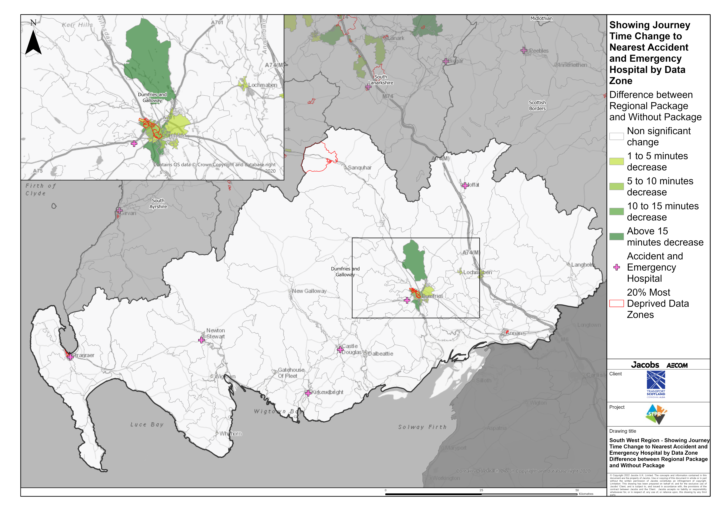
South West Scotland Region – Showing Journey Time Change to Nearest Accident and Emergency Hospital Difference between Regional Package and Without Package
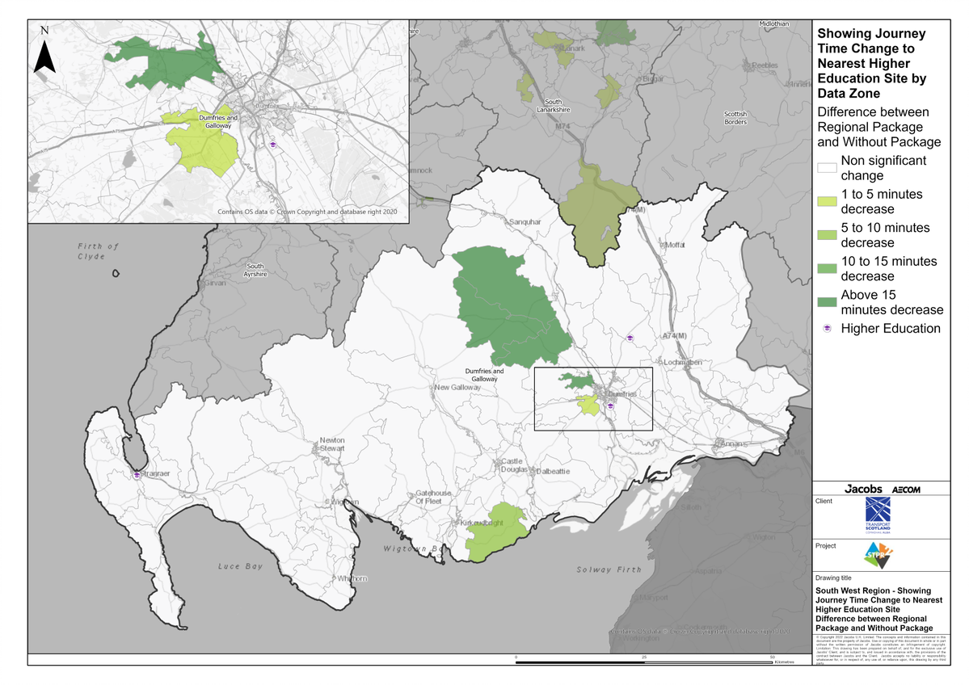
South West Scotland Region – Showing Journey Time Change to Nearest Higher Education Site Difference between Regional Package and Without Package
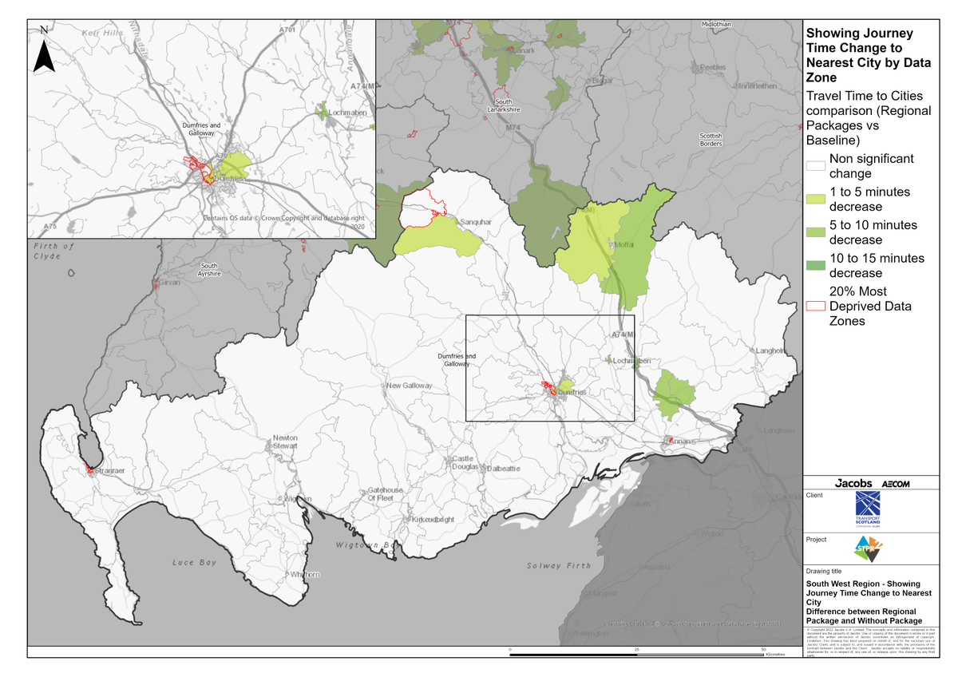
South West Scotland Region – Showing Journey Time Change to Nearest City Difference between Regional Package and Without Package
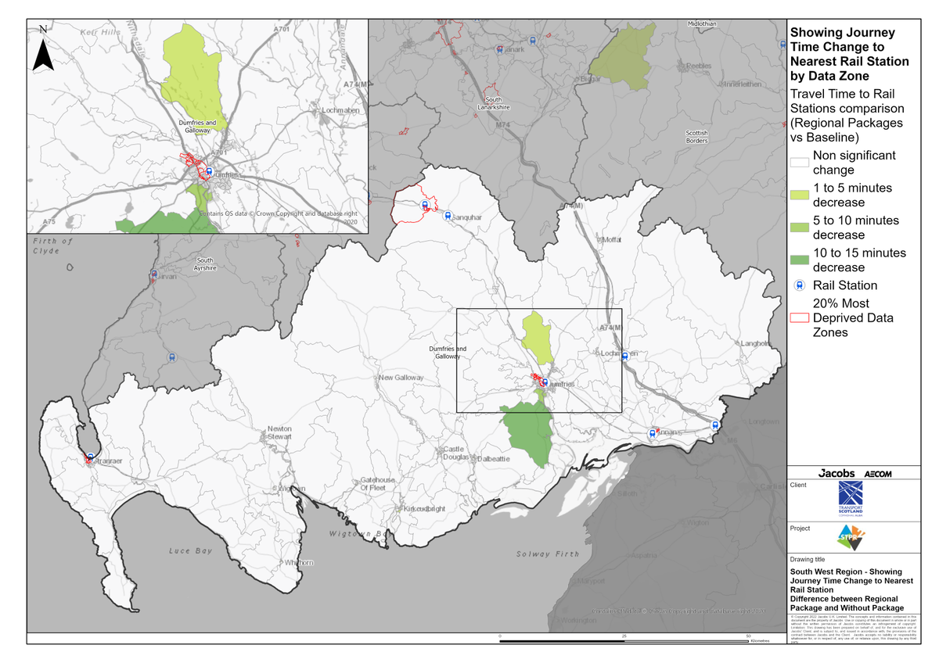
South West Scotland Region – Showing Journey Time Change to Nearest Rail Station Difference between Regional Package and Without Package

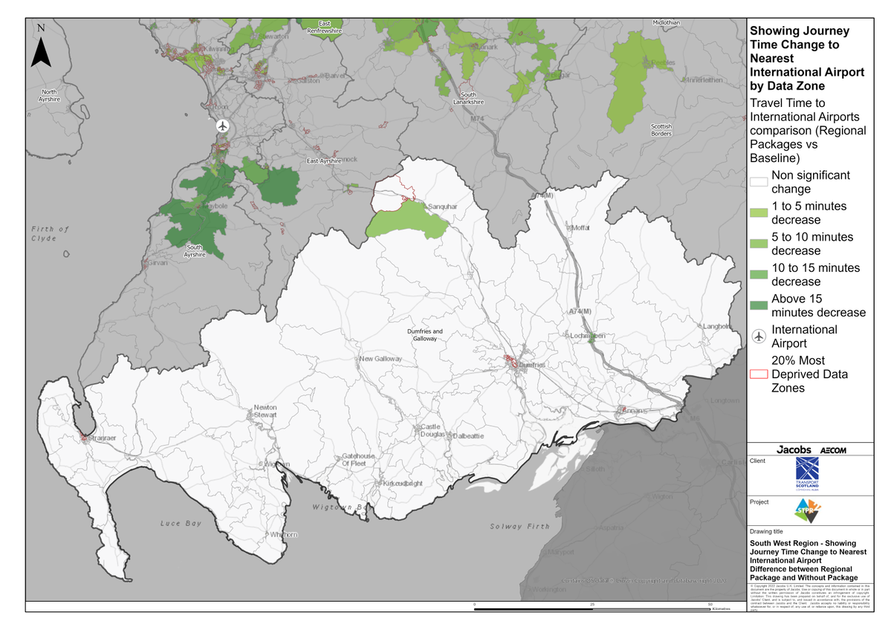
South West Scotland Region – Showing Journey Time Change to Nearest International Airport Difference between Regional Package and Without Package

Annex B: Traffic Modelling Outputs

