Appendix H: Detailed Packaging - Appraisal Summary Tables

December 2022
Contents
1. Regional Context 5
1.1. Geographical Context 5
1.2. Social Context 6
1.3. Economic Context 6
1.4. Environmental Context 7
2. Problems and Opportunities 8
2.1. Problems 8
2.2. Opportunities 8
3. Regional Recommendations 10
4. Fit with Established Policy 11
5. STPR2 Transport Planning Objectives (TPOs) Assessment 13
6. STAG Assessment 21
6.1. Environment 21
6.2. Climate Change 22
6.3. Health, Safety & Wellbeing 23
6.4. Economy 25
6.5. Equality & Accessibility 25
7. Deliverability 27
7.1. Feasibility 27
7.2. Affordability 27
7.3. Public Acceptability 27
8. Statutory Impact Assessment Criteria 28
8.1. Strategic Environmental Assessment (SEA) 28
8.2. Equalities Impact Assessment (EqIA) 29
8.3. Island Communities Impact Assessment (ICIA) 29
8.4. Child Rights and Wellbeing Impact Assessment (CRWIA) 30
8.5. Fairer Scotland Duty Assessment (FSDA) 30
Annexes 31
Annex A: NAPTAT Mapping 32
Annex B: Traffic Modelling Outputs 38

Scottish Borders Region Appraisal Summary Table
An Appraisal Summary Table (AST) has been developed for each of the eleven STPR2 Regions alongside the National AST. The ASTs are set out to provide:
- Regional Context, Problems and Opportunities – drawing on data presented in the Initial Appraisal: Case for Change reports this summarises geographic, social, economic, environmental and transport matters in the region as well as the identified problems and opportunities. In line with STAG, appraisals are expected to explore location-specific problems and opportunities. Local problems and opportunities have been considered to gain a full understanding of the regional and national issues, however some of these may not be within the scope of this strategic study.
- Regional Recommendations – this presents the package of recommendations that were included in the detailed appraisal for the region.
- Fit with Policy – provides a summary of how well the appraised packages fit with key national policies including the second National Transport Strategy, Climate Change Plan Update, the Revised Draft Fourth National Planning Framework (Revised Draft NPF4) and relevant regional policies.
- Transport Planning Objectives (TPO) Assessment – An assessment against each of the five TPOs is provided with quantified metrics, where appropriate, under the Low growth sensitivity with a 20% reduction policy ambition on car kilometres scenario (hereafter referred to as Low scenario) and High growth sensitivity with no policy ambition on car kilometres scenario (hereafter referred to as High scenario) (further information about these scenarios is provided in Appendix F of the Technical Report). A seven point scoring scale is adopted for each TPO which is:
  - + + + = major positive (3 plus signs)
  - + + = moderate positive
  - + = minor positive
  - 0 = neutral
  - - = minor negative
  - - - = moderate negative
  - - - - = major negative (3 minus signs)
- STAG Criteria assessment – as above for the TPO assessment, key points regarding the performance of the package against each of the STAG criteria is presented with quantified metrics provided where appropriate.
- Deliverability – commentary is provided on the assessment of the package in terms of its feasibility, affordability and public acceptability. Note that due to the nature of a number of the STPR2 interventions, and the stage in the business case process STPR2 is at, it has not been possible to derive cost estimates on a regional basis. However, broad capital spending ranges have been estimated over the period 2022 to 2042 at a national level.
- Statutory Impact Assessment Criteria – a summary of the performance of the packages against the Strategic Environment Assessment (SEA), the Equalities Impact Assessment (EqIA), Island Communities Impact Assessment (ICIA), Fairer Scotland Duty Act (FSDA) and, Child Rights and Wellbeing Impact Assessment (CRWIA) is provided. The seven point scale scoring is adopted in these assessments where appropriate.

Summary of Assumptions
Quantification of the costs and benefits in the packages has been provided through a modelling exercise. Further information is provided in Appendix F of the Technical Report on the modelling scenarios that have informed the assessment of the STPR2 interventions. A summary of the key assumptions is provided here:
- Population projections are based on the NRS Population Projections (2018-based).
- Economic projections are a combination of projections by Oxford Economics, 2019, the Scottish Fiscal Commission forecasts and more recently the OBR post-COVID estimates.
- Land-use plans are based on data collected for Transport Scotland’s Assembly of Planning Policy Inputs in 2018 from Scotland’s 34 Planning Authorities.
- Permitting of vacant office and retail floorspace to be converted or redeveloped as housing post 2030.
- Working age is taken to be 16-64 (as a constant) to avoid difficulties with changing state pension age (and to reflect non-mandatory retirement).
- The economic results are presented, as is standard within appraisal as discounted values in 2010 prices.

Modelling Tools
For the purposes of modelling accessibility by public transport, NaPTAT (National Public Transport Accessibility Tool) has been used. This allows an assessment of journey time to be compared between the with and without STPR2 package.
Due to the strategic and national nature of STPR2, the national Transport Model for Scotland (TMfS) has been used. TMfS is a national scale model with a focus on inter-urban trips. As such, whilst TMfS provides a suitable level of robustness at this stage of the appraisal for most of the larger infrastructure based interventions, there are limitations associated with the modelling of smaller/discrete interventions and also some of the larger infrastructure interventions that involve changes to the existing road network and are more urban in nature. Separate forecasts of the potential impacts of active travel recommendations on walking and cycling mode share have therefore been made. As the recommended interventions are developed through the business case process, more detailed modelling will be undertaken using regional and / or local models as appropriate.
When considering the outputs presented in this AST, please note the following metrics with respect to the model outputs:
- CO₂emissions: Likely to underestimate the benefits associated with public transport interventions due to the more limited representation of transport systems in urban areas and a degree of insensitivity to mode shift in TMfS.
- Mode Share: Likely shift to public transport modes underestimated in urban areas due to the more limited representation of urban transport systems and a degree of insensitivity to mode shift in TMfS.
- Change in vehicle kilometres travelled: Likely to underestimate the benefits of reducing vehicle kilometres travelled particularly for short distance journeys due to the more limited representation of urban transport systems and the relative coarseness of the model zone system.
- Lost time due to congestion: Likely to underestimate the benefits associated with interventions that would reduce roadspace due to the under-representation of the local/secondary road network in TMfS.
- Change in accidents: Likely to underestimate the benefits associated with mode shift to public transport interventions due to the more limited representation of urban transport systems and a degree of insensitivity to mode shift in TMfS.
- Present Value of Benefits: Likely to underestimate the benefits to public transport users due to the more limited representation of urban transport systems. Likely to overestimate the dis-benefits to car-based trips due to the under-representation of the junctions and local/secondary road network in TMfS.

- Regional Context

  - Geographical Context
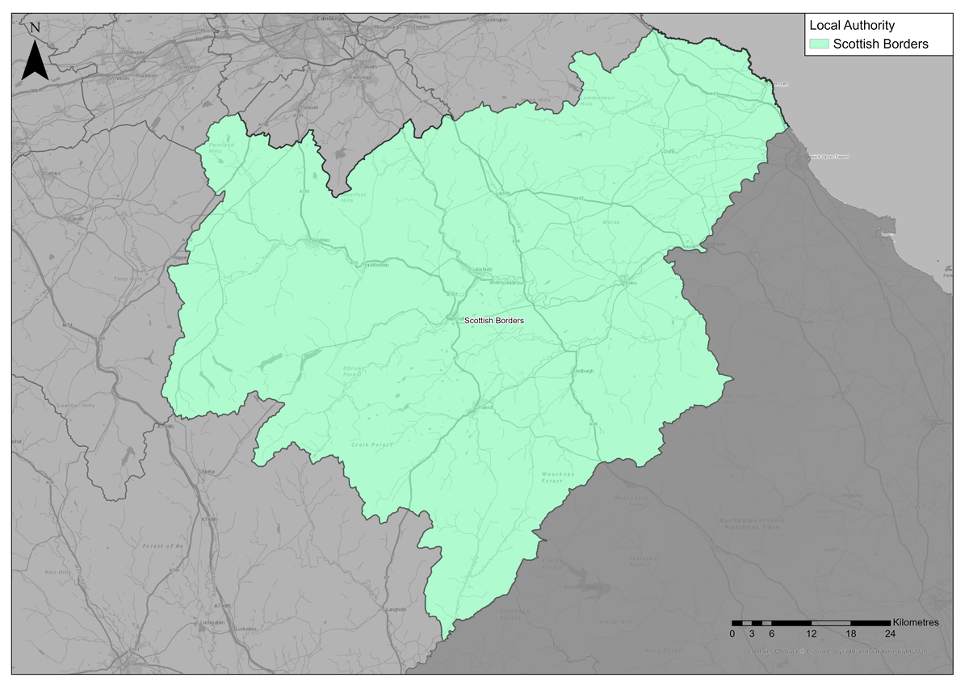
The Borders Region (herein referred to as “The Region”) is one of three ‘advanced regions’ to have had their Case for Change studies undertaken ahead of STPR2. In these regions the Case for Change was established based on Pre/Initial Appraisal studies, which included identification of problems and opportunities as well as option generation and sifting (which were informed by significant stakeholder engagement and data analysis). To ensure consistency with the other Case for Change exercises, the option sifting exercise for the three ‘advanced regions’ was revisited in 2020 through the STPR2 option sifting framework to cross-check the results; this confirmed broadly the same list of options to be recommended for further appraisal through STPR2. To assist with this further appraisal, the baseline data gathered during the ‘advanced studies’ was updated to match that used for all other regions for STPR2. In order to align with the wider process for establishing the Case for Change across Scotland, and to update the context for the Region, this Appraisal Summary Table therefore refers to some of this more recent data – this does not, however, affect the problems and opportunities established, or options generated and sifted, during the ‘advanced studies’.
The Borders Region covers the Scottish Borders Local Authority area, and is a mix of urban and rural settlements and rural areas. The Scottish Government Urban Rural Six-Fold Classification identifies the regional population residing in each category as follows: Other Urban Areas (25%), Accessible Small Towns (22%), Remote Small Towns (6%), Accessible Rural (36%) and Remote Rural (11%). Larger settlements within the Region include Hawick, Galashiels and Tweedbank. The Region contains areas of geographical remoteness and of rural nature. A number of ‘accessible small towns’ are spread across the Region, for example Innerleithen, Peebles, Melrose, Selkirk, Kelso and Eyemouth.
The Region’s transport offering comprises active travel, bus, rail and road networks - with the main strategic corridors being those served by the A1, A68 and A7 trunk roads; The East Coast Mainline (construction started on a new station at Reston in 2021) and the Borders Railway with stations located at Tweedbank, Galashiels and Stow.

  - Social Context
According to the National Records of Scotland’s Mid-year Population Estimates Scotland, the total population in the Borders Region was 115,510 in 2019 (2.2% of the total Scotland population). The Region‘s population has increased by 1.4% since 2011 Scottish Government Census. The largest settlements are Galashiels and Hawick. In terms of age structure (2019 mid-year estimate), 16% of regional residents were children (15 and under), 59% were of working age (aged 16 to 64), and 25% were 65 and over. The proportion of people aged 65 and over within the Region was 6% higher than the national benchmark as stated in the National Records of Scotland’s Mid-year Population Estimates Scotland 2019, whilst the proportion of people within working age (assumed here to be 16 – 64, in line with census) was 5% lower than the national benchmark.
Performance against socio-economic indicators varies across the Region. Overall, the proportion of households with access to a car is higher in the Region compared to Scotland as a whole (79.5% compared to 69.4%, based on 2011 Census), and travel to work by car is the dominant mode with 65.2% of people commuting by car. Bus carries a total of 3.2% of commuting trips, and rail carries 0.6%, whilst 13.4% of people walk and less than 2% of people cycle. Further data in the 2011 Census shows the majority of travel for work in the Borders Region is within the Scottish Borders local authority area; and the majority of movements out with the Region are to the City of Edinburgh and the Lothians. It should be noted these values are obtained from 2011 census (which is the latest census data available) and, as such, will not include any impacts resulting from the Borders Railway which opened to passengers in 2015 (analysis of the Borders Railway can be found in Transport Scotland and Jacobs’ Borders Transport Corridors Pre-Apprasial).
Within the Region, 8.2% of people had no qualifications in 2019; which was 1.6% lower than the national benchmark stated in NOMIS Local Authority Profile. The Region has the eighth equal lowest share of the most-deprived data zones. There are small pockets of deprivation across the Region, most notably around Galashiels, Selkirk and Hawick. Within the Region 6% of SIMD data zones are within the 20% most deprived and 2% are within the 10% most deprived. SIMD Health rankings indicate that 9% of data zones in the Borders Region are ranked within the lowest quintile (20% most deprived) for health in Scotland.
  - Economic Context
Economic activity refers to an estimation of whether usual residents aged 16 to 64 were in work or actively looking for work. ONS Regional Gross Domestic Product: Local Authorities 2019 data shows the Borders Region makes up 2.2% of the Scottish population and contributes approximately 1.6% of the Scottish Gross Value Added (GVA). The Region benefits from a lower number of benefit claimants, higher educational attainment and higher levels of economic activity compared to other regions. Economic activity was 78.8% in 2019, compared to 77.5% nationally, and the Region had a slightly lower rate of unemployment (3.0% compared to 3.5% nationally). The Region accounted for 1.6% of Scotland’s total benefits claimants (based on NOMIS Local Authority Profile 2019 data). Scottish Borders Council Economic Profile in 2013 highlights the Region’s economy has a wide spread of activity with high levels of employment in health, manufacturing, retail, and accommodation and food services.
  - Environmental Context
Within the Region, there are many areas classified as environmentally sensitive, with varying levels of statutory protection. Environmental designations within the Region include biodiversity, landscape and heritage designations which fall either wholly or partly within the Region. In addition, the Region contains as large number of Category A-C Listed buildings. The Scottish Government’s Scotland Noise Map shows the greatest noise levels in the Region are primarily associated with the main road corridors, such as the A1, A68, A7, A6091, A72 and A707. Settlements at greatest risk of coastal flooding are located along the coastline to the northeast of the Region. Areas at medium and high risk of river flooding include those located in the vicinity of the River Tweed, St Mary’s Loch, Kale Water and Gala Water. Areas at high and medium risk of surface water flooding are scattered throughout the Region. There are no Air Quality Management Areas (AQMAs) within the Borders Region. In 2018 data from HM Government’s UK local authority and regional carbon dioxide emissions national statistics notes, CO₂ emissions from transport within the Borders Region equated to 2.4% of Scotland’s total transport emissions overall.
Linked to the above context and extensive stakeholder engagement exercise undertaken for the Borders Transport Corridors Study in 2017, the following key problems and opportunities were identified for the Region. As highlighted earlier, the Region’s Case for Change was undertaken in advance of STPR2, and therefore in advance of the full scope of STPR2 being known. Therefore some of the problems and opportunities identified for the Region are out with the scope of STPR2 but repeated here for consistency.

- Problems and Opportunities
The following transport-related problems and opportunities have been identified for the Scottish Borders Region.
  - Problems
- Public Transport: limited accessible public transport service provision, a large geographic rural area makes efficient coverage of the Region a challenge. Lack of rail capacity, services perceived to be busy and desire to see frequencies increased against a backdrop of capacity constraints on the Borders Rail Line. Local geography constrains the ability to create efficient transport system overall, lack of public transport ticket integration and interchange opportunities.

- Road: network resilience, incidents and accidents on key routes can cause significant disruption and long diversionary routes can be exacerbated by a lack of high quality standard of roads; away from the trunk routes roads many roads are considered poor which can be a challenge particularly when there are incidents on main routes causing diversion via secondary routes. High volume of goods vehicles can cause journey time and journey time reliability issues, particularly where routes pass through urban areas.

- Connectivity: lack of internal connectivity between key settlements throughout the Region and lack of east-west connectivity, both by road and rail. A lack of access to digital and internet services and the high cost of travelling, as perceived against other regions of Scotland due to typically longer journey distances.

- Socio-economic: the socio-economic problems in the Region are largely interlinked, with the main problems relating to the high number of people travelling out with the Scottish Borders to work and study – mostly to Edinburgh. This is believed to impact on the amount of employment opportunities available due to perceived ‘brain-drain’ and resulting social and economic deprivation as less money and funding available in the area.

- Active Travel: lack of active travel infrastructure provision; whilst there are examples of very high standard facilities these are often associated with tourism infrastructure rather than coverage for everyday trips across the Region. Also local geography can be rural and hilly which makes it a challenge to provide an efficient transport network. A perceived lack of safety measures, particularly across more secondary roads throughout the Region.

  - Opportunities
- Socio-political: high quality of life in the Scottish Borders, collaboration and co-operation and external funding opportunities.

- Accessibility and Connectivity: increased interest in rail infrastructure/service improvements, build upon Borders Railway success and digital connectivity.

- Leisure and Tourism: Scottish Borders is attractive for active travel and tourism. There is a high quality of life in the Scottish Borders and scope to significantly develop the tourism market.

- Economy and Development: neighbouring employment opportunities, Local Development Plan aspirations, skilled local workforce and recent private investment in the bus network.

- Regional Recommendations
The following is a list of interventions that form a package of recommendations that are relevant to this Region.

Regional Recommendations
- Connected neighbourhoods (Recommendation 1)
- Village-town active travel connections (Recommendation 3)
- Connecting towns by active travel (Recommendation 4)
- Long-distance active travel network (Recommendation 5)
- Behavioural change initiatives (Recommendation 6)
- Changing road user behaviour (Recommendation 7)
- Increasing active travel to school (Recommendation 8)
- Improving access to bikes (Recommendation 9)
- Expansion of 20mph limits and zones (Recommendation 10)
- Provision of strategic bus priority measures (Recommendation 14)
- Infrastructure to provide access for all at railway stations (Recommendation 19)
- Investment in Demand Responsive Transport and Mobility as a Service (Recommendation 20)
- Improved public transport passenger interchange facilities (Recommendation 21)
- Framework for the delivery of mobility hubs (Recommendation 22)
- Smart, integrated public transport ticketing (Recommendation 23)
- Decarbonisation of the rail network (Recommendation 25)
- Decarbonisation of the bus network (Recommendation 26)
- Behavioural change and modal shift for freight (Recommendation 27)
- Zero emission vehicles and infrastructure transition (Recommendation 28)
- Trunk road and motorway safety improvements to progress towards ‘Vision Zero’ (Recommendation 30)
- Trunk road and motorway network climate change adaptation and resilience (Recommendation 31)
- Trunk road and motorway network renewal for reliability, resilience and safety (Recommendation 32)
- Future Intelligent Transport Systems (Recommendation 33)
- Traffic Scotland System Renewal (Recommendation 34)
- Intelligent Transport System renewal and replacement (Recommendation 35)
- Strategy for improving rest and welfare facilities for hauliers (Recommendation 36)
- Improving active travel on trunk roads through communities (Recommendation 37)
- Speed Management Plan (Recommendation 38)
- Rail freight terminals and facilities (Recommendation 44)
- High speed and cross-border rail enhancements (Recommendation 45)

- Fit with Established Policy
The interventions included within this package support a wide range of national, regional and local policy documents in which transport improvements play a key role in both the enabling and delivery of outcomes.
Key policies supported include the Programme for Government, Infrastructure Investment Plan, NTS2, the Climate Change Plan Update 2018 - 2032, SEStran’s Regional Transport Strategy, the SESPlan Strategic Development Plan, the Scottish Borders Local Access and Transport strategy, as well as non-transport-specific plans, such as the Scottish Borders Economic strategy and Borderlands Inclusive Growth Deal.
The Revised Draft NPF4 includes the Region within the Southern Action Area (with Dumfries and Galloway) with priorities including creating liveable and connected places which benefit from further investment and innovation. This has the potential to link with the Borderlands Inclusive Growth Deal which involves English local authorities close to the border and the Revised Draft NPF4 aims to bring these visions together to set out a coherent plan that addresses the collective strengths and challenges for the area and set out strategic priorities of national significance.
The policy framework for the Region has a strong emphasis on improved connectivity, addressing inequality, and addressing barriers to employment, to help deliver well-connected, sustainable communities, promote modal shift away from private car, increase walking and cycling opportunities, and provide an attractive place for visitors and for businesses to invest and grow; the package therefore closely aligns with established policy directives.

Package Performance Against NTS2 Priorities and Outcomes:

Reduce inequalities
Will provide fair access to services we need: Moderate Positive
Will be easy to use for all: Moderate Positive
Will be affordable for all: Minor Positive

Takes climate action
Will help deliver our net-zero target: Moderate Positive
Will adapt to the effects of climate change: Minor Positive
Will promote greener, cleaner choices: Major Positive

Helps deliver inclusive economic growth
Will get people and goods where they need to get to: Moderate Positive
Will be reliable, efficient and high quality: Major Positive
Will use beneficial innovation: Major Positive

Improves our Health and Wellbeing
Will be safe and secure for all: Major Positive
Will enable us to make healthy travel choices: Moderate Positive
Will help make our communities great places to live: Major Positive

- STPR2 Transport Planning Objectives (TPOs) Assessment

TPO1 A sustainable strategic transport system that contributes significantly to the Scottish Government’s net-zero emissions target

TPO Performance Summary
Carbon dioxide equivalent (CO₂eq) is treated as a nationally important pollutant. As such, although it can be appraised at the national level (commentary below), it has not been appraised for individual regions.
The national and all regional packages overall will contribute significantly to the net-zero emissions target by:
- Enabling more passenger journeys to be made by active modes and public transport.
- Decarbonising most if not all public transport operations.
- Facilitating uptake of electric vehicles.
- Enabling road freight to switch to rail or other low carbon modes.
Further commentary is provided below.
National CO₂eq emissions are forecasted to decrease year-on year. This is due to decreasing vehicle exhaust (non-traded) emissions as the number of internal combustion engine vehicles reduces. This is reflected in the volume of traded grid emissions from charging increased numbers of battery-electric vehicles, and specifically in the Low scenario. It is noted that traded emissions of CO₂eq are associated with electrical generation to supply plug-in vehicles, both BEV (battery electric vehicles) and PHEV (plug-in hybrid vehicles).
The electricity grid is expected to be using predominantly renewable sources in the future and so increasing adoption of electric vehicles and a shift from direct, non-traded, emission to traded grid-based technology (i.e. battery) will support reducing CO₂eq emissions.
Across both Low and High scenarios the interventions would reduce emissions of CO₂eq.
Significantly higher overall emissions are predicted in the High scenario, either with, or without, the national and all regional packages. There is a relatively smaller overall reduction of emissions due to the interventions in the Low scenario due to the lower overall emissions. The economic impacts associated with air quality were assessed using the Department for Environment Food & Rural Affairs (DEFRA) Damage Costs Appraisal Toolkit. The larger economic benefit from the High scenario is due to the greater overall emissions with, or without, the package, although the proportional change is lower.
Overall Scoring:
Low and High Scenarios: Moderate Positive

Metric 1: Change in CO₂eq (non-traded and traded emissions from regional road transport inc. grid emissions from charging light-duty vehicles)- Figures below are a National calculation
Low Scenario Commentary:
- 0.5% decrease (27,700 tonnes CO₂eq) in 2030.
- 2.8% decrease (21,600 tonnes CO₂eq) in 2045.
- 1.3 million tonnes reduction, of which 1.1 million were traded, for the 60-year appraisal period from 2030 to 2089.
- The net economic benefits for the 60-year appraisal period in 2010 prices and values would be in the range £10 million to £25 million for the Low scenario.
High Scenario Commentary:
- 0.4% decrease (31,300 tonnes CO₂eq) in 2030.
- 1.3% decrease (65,300 tonnes CO₂eq) in 2045.
- 3.7 million tonnes reduction, of which 452,000 were traded, for the 60-year appraisal period from 2030 to 2089.
- The net economic benefits for the 60-year appraisal period in 2010 prices and values would be in the range £100 million to £250 million for the High scenario.

Metric 2: Change in mode share by active travel for all journeys
Low and High Scenarios Commentary:
The package will increase the proportions of journeys undertaken by active modes. If all the active travel and behaviour change interventions were fully implemented in every relevant location in the Region, mode shares of walking and cycling "with STPR2 package" proportions are shown alongside the mode share without package.
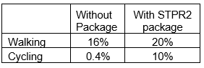
Note that the cycling and walking growth forecasts have been developed independently of each other. Growth in use of one active mode is likely to abstract at least some trips from the other, but this effect is not accounted for within these forecasts.

Metric 3: Change in motorised vehicle kilometres travelled
Low Scenario Commentary:
- Reduction of 8 million motorised vehicle kilometres (1% decrease) (see Annex B).
High Scenario Commentary:
- Reduction of 9 million motorised vehicle kilometres (1% decrease) (see Annex B).

TPO2 An inclusive strategic transport system that improves the affordability and accessibility of public transport

TPO Performance Summary
Interventions included in this package will improve the overall inclusiveness of the transport system by:
- Improving conditions for people walking, wheeling and cycling, the most inclusive transport modes, with particular benefits for people most often excluded (including children, older and disabled people, and people on low incomes).
- Improving inclusive accessibility to public transport stops/stations.
- Seeking to promote public transport use and reduce operating costs, hence enhancing network sustainability.
Overall Scoring:
Low and High Scenarios: Major Positive

Metric 1: Change in transport poverty risk
Low and High Scenarios Commentary:
Although the STPR2 interventions do not impact on the direct costs of travel (e.g. fares, fuel price), the package of interventions would see a small reduction in transport poverty, due to the overall improvements to access and connectivity between modes.

Metric 2: Change in Accessibility - population catchments increases to key services by journey time by public transport
Low and High Scenarios Commentary:
The package is forecast to improve the accessibility to both higher education and accident and emergency hospitals (key hospitals) sites by public transport, whereby an additional 650 in the Region would be able to access the nearest higher education site in 90 minutes and hospital in under a journey time of 30 minutes by public transport with the STPR2 package in place compared to without the package. This represents a 0.7 percentage point increase in accessibility levels to higher education from 77.6% in the without package assessment to 78.3% with the package in place, similarly a 0.6 percentage point increase in accessibility levels to accident and emergency hospital sites from 52.6% in the without package assessment to 53.2% with the package in place.

In terms of additional destinations (cities, rail stations and airports) considered in the model:
- 600 additional people are able to access their closest city within a 60 minute public transport journey, which represents a 0.7 percentage point increase in accessibility levels from 2.7% in the without package to 3.4% with the package in place.
- 3,300 additional people are able to access their closest city within a 120 minute public transport journey, representing a 3.3 percentage point increase in accessibility levels from 56.9% in the without package to 60.2% with the package in place.
- No significant change was observed in relation to the number of people who are able to access their closest rail station within the modelled time period.
- 600 additional people are able to access their closest international airport within a 90 minute public transport journey, which represents a 0.6 percentage point increase in accessibility levels from 0.8% in the without package to 1.4% with the package in place.
- 4,100 additional people are able to access their closest international airport within a 120 minute public transport journey, which represents a 4.1 percentage point increase in accessibility levels from 23.4% in the without package to 27.5% with the package in place.

Results are shown in the mapping outputs found in Annex A.

TPO3 A cohesive strategic transport system that enhances communities as places, supporting health and wellbeing

TPO Performance Summary
The package will improve communities as places, supporting health and wellbeing by enabling more journeys to be made by active and sustainable modes, and by improving road safety. This will:
- Improve many people’s physical health and mental wellbeing, with particular benefits for people most often excluded (including children, older and disabled people, and people on low incomes).
- Reduce the adverse impacts of car use on communities and health (including reduced air pollution, noise, accident risk and perceived road danger).

The analysis shows that through improved uptake of walking and cycling, there would be a forecast reduction of 3 premature deaths per annum due to the health benefits arising from active travel.
Overall Scoring:
Low and High Scenarios: Moderate Positive

Metric 1 Change in mode share by active travel for all journeys
Low and High Scenarios Commentary:
- Potential increase in working 16% mode share to 20% mode share (4 percentage points).
- Potential increase in cycling from 0.4% mode share to 10% mode share (over 9 percentage points).

These forecasts are subject to all active travel interventions being delivered in all relevant areas of the Region.
Cycling and walking growth forecasts have been developed independently. Growth in use of one active mode is likely to abstract at least some trips from the other, but this effect is not accounted for within these forecasts.

Metric 2 Potential for Change in 'Place'
Low and High Scenarios Commentary:
The package will tend to improve the quality of the Region’s places by improving local accessibility and reducing the adverse impacts of road traffic.
Particular benefits may arise in increasing the number of residents travelling actively throughout the Region. This will reduce the visual impact from vehicles and improve the overall perception of Place.

Metric 3 Change in Health Benefits
Low and High Scenarios Commentary:
The health benefits of increased rates of active travel as a result of the package have been quantified using the WHOs Health Economic Assessment Tool (HEAT). HEAT estimates the health and economic impacts of increased walking and cycling, providing assessments of the health and economic impacts of walking and cycling on premature mortality and on exposure to air pollution. Outputs from the tool shows that approximately 3 premature deaths would be prevented per annum.

TPO4 An integrated strategic transport system that contributes towards sustainable inclusive growth in Scotland

TPO Performance Summary
The package will contribute to sustainable inclusive growth in Scotland by:
- Improving integration of transport modes (especially between active modes and public transport) and between transport and major developments.
- Improving journey time reliability.
- Enabling more people to travel by improving the accessibility and affordability of the transport system, so enabling more people to access local retail and services, and opportunities for employment and education/training.
Encouraging modal shift to sustainable modes and reducing the volume of vehicles on the road network is anticipated to improve journey time reliability for all vehicles, providing benefits to businesses across the regions. A reduction in vehicles hours of between 3,400 and 3,800 hours is anticipated in the respective growth scenarios for business and commercial travel, contributing towards sustainable inclusive growth in Scotland.
Overall Scoring:
Low Scenario: Minor Positive
High Scenario: Moderate Positive

Metric 1: Increased labour catchment by sustainable travel (PT/Active Travel)
Low and High Scenarios Commentary:
The package is forecast to create small benefits for accessibility to key employment opportunities located nearby by public transport in some parts of the Region.
Local employment accessibility, which represents the accessibility of key employment opportunities located in the surrounding area of an origin within a 40 minute public transport journey time, is forecast to see minor localised improvements. The model showed an improvement in areas such as Selkirk with the package enabling on average an additional 400 of existing jobs to be accessed under 40 minutes by public transport. This is shown by the map output in Annex A.
Access to regional employment, which represents the accessibility of key employment opportunities within a 120 minute journey time using public transport modelling showed that the package would enable an additional 1,400 jobs to be accessed within a two hour journey time by public transport. This is shown by the map output in Annex A.
The rural population is forecast to see little change in journey times to the nearest employment site by public transport, when compared to that in the without Package.

Metric 2: Change in lost time due to congestion (for business/ commercial transport)
Low Scenario Commentary:
- 3% decrease (equivalent to reduction of approximately 3,000 hours) in lost time due to congestion.
High Scenario Commentary:
- 3% decrease (equivalent to reduction of approximately 4,000 hours) in lost time due to congestion.

TPO5 A reliable and resilient strategic transport system that is safe and secure for users

TPO Performance Summary
The package will improve reliability, safety and personal security on the transport system by:
- Improving journey time reliability, including through reduced likelihood of significant network disruptions.
- Reducing the risk of road accidents at hotspot locations on the trunk road network.
- Reducing perceived risks to road safety and to personal security, so enabling more people (particularly children, women and older people) to travel independently.
- Improving active travel provision and providing more dedicated and segregated routes for walking, cycling and wheeling.
Overall Scoring:
Low and High Scenarios: Moderate Positive

Metric 1 Change in accidents (PIA and ‘damage-only’)
Low Scenario Commentary:
- Accident reduction related to motorised vehicle kilometres is forecast to be 1%.
High Scenario Commentary:
- Accident reduction related to motorised vehicle kilometres is forecast to be 1%.
Low and High Scenarios Commentary:
Whilst the number of accidents involving motorised vehicles is anticipated to reduce following the introduction of the interventions within this package, it is anticipated that it would increase walking and cycling journeys. The number of accidents involving these modes is therefore anticipated to increase, although each individual journey is anticipated to be significantly safer.

Metric 2 Percentage accident change for Targeted Infrastructure Improvements over 60 years, using default accident rate (PIA only)
Low and High Scenarios Commentary:
Accident benefits were estimated using the Department for Transport (DfT) recommended software programme COBA-LT (Cost and Benefit to Accidents – Light Touch) for targeted road safety improvements, based on default parameters, but using Scotland specific accident rates. A range of accident benefits were calculated for the various improvement options being considered. This provided the upper and lower bound of estimated percentage change in accidents, respectively. These ranges are shown below and provide the anticipated upper and lower bounds of impact on accidents that would be anticipated from typical interventions of this type:
- Sections of Realignment/Widening – reduction of 23% to 59%.
- Sections of Overtaking Opportunities – reduction of 35% to 73%.
- Locations of Junction Improvements – change of 42% (increase) to 64% (decrease).
It should be noted that junction accidents are forecast to increase in the event that a junction is upgraded from a priority to a signalised junction. This is due to an increase in the number of slight accidents that are likely to occur as a result of shunts in queuing traffic on the mainline approach to the traffic signals, which could previously travel unopposed. However, the accident severity can be expected to reduce as a result of this type of improvement. Any improvement scheme would be subject to further consideration.

Metric 3 Change in lost time due to congestion
Low Scenario Commentary:
- 3% decrease (6,000 hours) in lost time due to congestion (see Annex B).
High Scenario Commentary:
- 3% decrease (11,000 hours) in lost time due to congestion (see Annex B).

Metric 4 Journey Time Reliability /Availability of alternatives (modes/routes)
Targeted road infrastructure improvements at key ‘issue points’ on the trunk road network will improve journey time reliability. Undertaken across the three trunk roads in the Region this will improve resilience and availability of alternative routes should incidents occur. However it is not within the remit of STPR2 to improve non-trunk routes of which there is wide coverage across the Region.

- STAG Assessment
  - Environment

Environment

Air Quality
Performance Summary:
Total emissions of NO_{X} (a group of gases that are mainly formed during the combustion of fossil fuels) were predicted to decrease in future in both the High and Low scenario.
Total emissions of NO_{X} were predicted to be effectively zero in 2045 in the Low scenario, and 2051 in the High scenario either with, or without, the proposed package. It is the change brought about by the projected transition of the vehicle fleet to zero-emission vehicles that contribute to the majority of air quality benefits, and in this instance outweighs the positive mode change contributions from the regional package.
Total emissions of Particulate Matter (PM), which is made up of a collection of solid and / or liquid materials, were predicted to increase in future predominantly due to non-exhaust emissions from road, tyre and brake-wear.
However, the package will reduce harmful emissions slightly. Over the 60-year appraisal period there was a predicted 100% reduction in NO_{X}, 2.3% reduction in PM10 and 2.5% reduction in PM2.5 in the Low scenario, and a 2.5% reduction in PM10 and a 2.7% reduction in PM2.5 in the High scenario.
Low Scenario Scoring: Minor Positive
High Scenario Scoring: Minor Positive

Noise and Vibration
Performance Summary:
The anticipated modal shift is also expected to reduce levels of noise and vibration associated with the transport network. There is potential for a localised negative effects on noise and vibration due to the construction and operation of specific interventions including rail, however the magnitude of effect will depend on the design and location of the intervention.
Low Scenario Scoring: Minor Positive
High Scenario Scoring: Minor Positive

Biodiversity and Habitats: Geology and Soils; Land Use (including Agriculture and Forestry); Water, Drainage and Flooding; Historic Environment; and Landscape
Low and High Scenarios Commentary:
Please refer to SEA performance summary text in the ‘Statutory Impact Assessment Criteria’ section below. Please note the scoring has been based on the SEA methodology for scoring, which has been agreed with the SEA Consultation Authorities.
  - Climate Change

Climate Change

Performance Summary (applicable to all Climate Change Sub-Criteria)
Carbon Dioxide equivalence (CO₂eq) is treated as a nationally important pollutant. As such, although it can be appraised at the national level (commentary below), it has not been appraised for individual regions.
National CO₂eq emissions are forecasted to decrease year-on year, with decreasing direct (non-traded) exhaust emissions and increasing traded grid emissions associated with increased adoption and charging of battery-electric vehicles, and specifically in the Low scenario. It is noted that traded emissions of CO₂eq are associated with electrical generation to supply plug-in vehicles, both BEV (battery electric vehicles) and PHEV (plug-in hybrid vehicles).
Across Low and High scenarios the package will reduce emissions of CO₂eq, although the change is greater in the High scenario due to overall higher emissions.
Key recommendations within the package have a focus on identifying vulnerabilities to the effects of climate change on the transport system, as well as identifying measures to assist in the adaptation to the effects of climate change, including unplanned events, such as flooding, landslides and high winds. Climate change adaptation and network resilience would address existing and predicted climate change impacts and support the changes that are necessary to reach the Scottish Government’s net zero target for greenhouse gas emissions. Improving the climate resilience of the transport network will also align with the Scottish Government’s commitment to develop Scotland’s next statutory climate adaptation programme.
The above summary is applicable across all the sub-criteria, as outlined below. The specific performance against each sub-criteria is scored against both the Low and High scenarios.

Greenhouse Gas Emissions
Low Scenario Scoring: Major Positive
High Scenario Scoring: Major Positive

Vulnerability to Effects of Climate Change
Low Scenario Scoring: Minor Positive
High Scenario Scoring: Minor Positive

Potential to Adapt to Effects of Climate Change
Low Scenario Scoring: Minor Positive
High Scenario Scoring: Minor Positive
  - Health, Safety & Wellbeing

Health, Safety & Wellbeing

Performance Summary (applicable to all Health, Safety & Wellbeing Sub-Criteria)
The package will reduce the number and severity of accidents through targeted infrastructure improvements and by encouraging modal shift away from private car, resulting in reduced accident risk due to reduced conflicts. Whilst the number of accidents involving motorised vehicles is anticipated to reduce following the introduction of the interventions within this package, it is anticipated that the package would increase walking and cycling journeys. The number of accidents involving these modes is therefore anticipated to increase, although each individual journey is anticipated be significantly safer.
Mode shift to sustainable modes will, by improving natural surveillance, make paths, stops, stations and services less isolated and this, accompanied by improved quality of facilities will improve perceived security.
The package will improve communities as places, supporting health and wellbeing, by encouraging modal shift away from private car and towards active travel. This will improve placemaking through reduced noise and better air quality due to reduced traffic, and reduced accident risk. It will also benefit many people’s physical health and mental wellbeing.

Accidents (PIA and ‘damage-only’)
Low Scenario Commentary:
- Accident reduction related to motorised vehicle kilometres is forecast to be 1%.
High Scenario Commentary:
- Accident reduction related to motorised vehicle kilometres is forecast to be 1%.

Percentage accident change for Targeted Infrastructure Improvements over 60 years using default accident rate (PIA only)
Low and High Scenarios Commentary:
Accident benefits were estimated using the Department for Transport (DfT) recommended software programme COBA-LT (Cost and Benefit to Accidents – Light Touch) for targeted road safety improvements, based on default parameters, but using Scotland specific accident rates. A range of accident benefits were calculated for the various improvement options being considered. This provided the upper and lower bound of estimated percentage change in accidents, respectively. These ranges are shown below and provide the anticipated upper and lower bounds of impact on accidents that would be anticipated from typical interventions of this type:
- Sections of Realignment/Widening – reduction of 23% to 59%.
- Sections of Overtaking Opportunities – reduction of 35% to 73%.
- Locations of Junction Improvements – change of 42% (increase) to 64% (decrease).
It should be noted that junction accidents are forecast to increase in the event that a junction is upgraded from a priority to a signalised junction. This is due to an increase in the number of slight accidents that are likely to occur as a result of shunts in queuing traffic on the mainline approach to the traffic signals, which could previously travel unopposed. However, the accident severity can be expected to reduce as a result of this type of improvement. Any improvement scheme would be subject to further consideration.

Security
Low and High Scenarios Commentary:
The package will, by increasing the number of people travelling actively, tend to improve natural surveillance and will, through improvements to lighting and urban realm, tend to reduce the number of locations at which security is a concern.

Health Outcomes
Low and High Scenarios Commentary:
The package will, by increasing rates of active travel and hence physical activity, improve both health and wellbeing outcomes. The estimated value of health benefits to the Region’s population, appraised over a 60-year period, is in the range £100 million to £250 million.

Access to Health and Wellbeing Infrastructure
Low and High Scenarios Commentary:
The package will make minor improvements to public transport and active travel accessibility to some healthcare facilities in the Region.
An additional 650 of the population in the Region are forecast to be able to access an accident and emergency hospital under a journey time of 30 minutes by public transport with the STPR2 package in place compared to the without package assessment. This represents a 0.6 percentage point increase in accessibility levels from 52.6% in the without package assessment to 53.2% with the package in place. These improvements were observed in Selkirk. This is shown by the map output in Annex A.

Visual Amenity
Low and High Scenarios Commentary:
The package should have a positive impact on visual amenity through improvements to walking and cycling infrastructure and an improved sense of ‘place’. Care would be required in the development of any rail freight facilities to ensure they did not detrimentally impact nearby communities.
  - Economy

Economy

Performance Summary
The relatively modest economic benefits that accrue are as a result of the sustainable transport interventions in the Region’s package to enable and encourage mode shift to public transport modes. The Bus Priority Infrastructure intervention, and to a lesser extent the Interchange intervention, are the main contributors to the public transport user benefits in the Low scenario. These are however offset by a slight disbenefit to road users. The remainder of the benefits are largely due to the increase in public transport operator revenue as a result of the increased patronage levels arising from the mode shift away from car.
The level of public transport user benefits are reduced slightly in the High scenario, and this is accompanied by a larger disbenefit to road users due to the higher levels of car-based demand. Nevertheless, even under the High scenario the sustainable transport interventions contribute to the majority of user benefits.
In terms of accident savings, the level of benefits is similar in both the Low and High scenarios. This is due to the reduction in road-based vehicle kilometres travelled in the Region, as a result of the active travel and public transport interventions encouraging a mode shift away from private car.
Note that due to the nature of a number of the STPR2 interventions it has not been possible to derive indicative cost estimates on a regional basis.

User Benefits (2010 prices and values for a 60 year appraisal period)
Low Scenario Commentary:
- Present Value of Benefits (PVB) of approximately £25 million to £50 million.
- Accidents Present Value of Benefits (PVB) of approximately £1 million to £10 million.
High Scenario Commentary:
- Present Value of Benefits (PVB) of approximately £10 million to £25 million.
- Accidents Present Value of Benefits (PVB) of approximately £1 million to £10 million.
  - Equality & Accessibility

Equality & Accessibility

Performance Summary (applicable to all Equality & Accessibility Sub-Criteria)
The package will improve accessibility to public transport by improving the coverage of the walking, cycling and public transport networks. This will provide particular benefits for people often excluded from transport, including older and young people, women, disabled people, and people living in more deprived communities.
The package will also improve affordability by reducing forced car ownership, and situations where taxi is the only viable mode for people without access to a car.
By encouraging modal shift to more sustainable modes, the package has the potential to increase demand for public transport, improving commercial performance/viability, which could indirectly reduce ticket costs.

Public Transport Network Coverage
Low and High Scenarios Commentary:
The Region is expected to see minor benefits from public transport coverage; providing improvements to key services such as hospitals, higher education, as well as better connections to employment. Improving the active travel network and interchanges may provide users with access to a wider public transport network, by enabling easier access to multimodal trips.

Active Travel Network Coverage
Low and High Scenarios Commentary:
Improvements to the Region’s active travel network, both within and between settlements, mean that many more people will have more convenient, high-quality and safe infrastructure for walking, wheeling and cycling journeys.

Comparative Access by People Group
Low and High Scenarios Commentary:
Improvements to active travel networks and public transport will provide positive impacts on groups who are less likely to have access to car and more likely rely on public transport, walking and cycling for their journeys. This includes women, children and young people, older people, some ethnic minority groups and disabled people.

Comparative Access by Geographic Location
Low and High Scenarios Commentary:
For access to local employment, which represents the accessibility of key employment opportunities located nearby in the surrounding area within a 40 minute public transport journey time, the package is forecast to, on average, enable an additional 100 of existing jobs to be accessed in the Region from areas categorised within the 20% most deprived in Scotland. Particular improvement was forecast in deprived areas within Selkirk, whereby an additional 900 of existing jobs are forecast to be accessible within 40 minutes by public transport.
No changes in accessibility to accident and emergency hospitals, education, and retail from the most deprived areas were observed.
All results are shown in the mapping outputs found in Annex A.

Affordability
Low and High Scenarios Commentary:
Although the STPR2 interventions do not impact on the direct costs of travel (e.g. fares, fuel price), the package of interventions would see a small reduction in transport poverty, due to the overall improvements to access and connectivity between modes.

- Deliverability
  - Feasibility

Feasibility
Summary Assessment:
The package has been developed with feasibility considerations in mind. The package mostly makes use of existing, proven technology and would generally be expected to largely operate inside existing design standards.
  - Affordability

Affordability
Summary Assessment:
The package would require substantial capital and operational funding. Some aspects of the package may generate revenue, which could be used to offset some of these costs.
  - Public Acceptability

Public Acceptability
Summary Assessment:
Public acceptability of the package is likely to be mixed. The package is expected to improve accessibility, connectivity, choice and make transport cleaner, more efficient and more attractive, which would be positively received. There may be concerns in areas of congestion where road space reallocation or priority measures are proposed, particularly in urban areas, however the behavioural change elements of the package should also help to mitigate this. There may also be acceptability concerns or where construction works are expected to cause disruption or require land-take.

- Statutory Impact Assessment Criteria
  - Strategic Environmental Assessment (SEA)

SEA
Performance Summary:
The package supports modal shift to more sustainable modes of transport. Enhanced rail network and the creation of mobility hubs/interchanges and the improvements to passengers’ services and facilities seeks to encourage modal shift, and, as a result, reduce levels of transport related air pollution and carbon emissions. The decarbonisation of the rail and bus network and freight deliveries will also help reduce greenhouse gas emissions and improve air quality.
The package provides an opportunity to adapt the transport network to the predicted effects of climate change, with one intervention focused on this adaptation and promotes a more sustainable usage of the existing transport network.
Positive effects are anticipated on population and human health due to an expected increase in sustainable access to essential services, increased travel choice and improved connectivity and planning for the future capacity of public transport. Active travel interventions will have positive outcomes for health - for example through expected improvements in air quality and increased uptake of physical exercise through walking, wheeling and cycling.
Road interventions are anticipated to have positive effects on safety. Trunk road improvements which are focused on junction improvements, realignment / widening and overtaking opportunities are also not anticipated to have a notable impact on traffic volumes or mode share and subsequently transport-based emissions in the majority of locations. The construction and operation of these interventions may result in result in minor negative effects on population and human health with the potential for in an increase in noise and vibration during construction and operation. This is dependent on the location and design of individual schemes. There is also potential for a negative effect on material assets due to the use of natural resources.
There is potential for negative environmental effects during construction and operation of the rail network enhancement including Borders Railway Extension and High Speed Rail interventions on the population and human health (noise and vibration, public realm, safety), the water environment, biodiversity, soil, historic environment and landscape and visual amenity. In addition, significant quantities of materials and construction related trips would be required. Depending on the source and type of materials/natural resources used, there is the potential for negative effects on natural resource requirements.
The freight interventions are anticipated to result in minor negative effects on natural resources as several interventions proposed involve enhancements to rail freight, terminals and facilities and therefore will require the use of natural resources.
Where any new infrastructure is required this could result in negative effects on biodiversity, soil, landscape, water, cultural heritage and natural resources, however the magnitude of effect is uncertain at this stage and will be determined by the design (and physical footprint) of the interventions.
As the design and development of interventions in this region progresses, further environmental assessments will determine the magnitude of the different positive and negative environmental effects and mitigation measures will be developed where appropriate.
  - Equalities Impact Assessment (EqIA)

EqIA
Performance Summary:
The package will improve public transport and active travel accessibility to key destinations and services including employment, education, healthcare and shopping for people living in the area. This will have a major positive impact on certain protected characteristic groups who are less likely to have access to a car and more likely to depend on public transport and active travel to make their journeys. This includes women, children and young people, older people, disabled people and people from certain ethnic minority groups.
By encouraging modal shift to more sustainable modes, this package could also contribute to improving local air quality. Improved health outcomes as a result of better air quality are of particular benefit to those who are more vulnerable to air pollution, including children, older people, disabled people and pregnant women. The package will reduce the severity of accidents through targeted infrastructure improvements and by encouraging modal shift away from private car, resulting in reduced accident risk due to reduced conflicts. Some protected characteristic groups are more likely to be involved in road accidents, for example, children as pedestrian casualties and young males involved as car drivers and as such would have positive impacts on these groups.
Mode shift to sustainable modes will reduce the perception of isolation on paths, bus stops, stations and services, and this, accompanied by improved quality of facilities will improve perceived security. This is likely to provide some benefit to those for whom security is of particular concern including women, the LGBTQ+ community and those from religious backgrounds most subject to hate crime.
The package would therefore be anticipated to have a minor positive impact on this criterion.
  - Island Communities Impact Assessment (ICIA)

ICIA
Performance Summary:
The package is not relevant to islands and would therefore have a negligible impact on this criterion.
  - Child Rights and Wellbeing Impact Assessment (CRWIA)

CRWIA
Performance Summary:
By encouraging modal shift to more sustainable modes, this package could contribute to improving local air quality. Improved health outcomes as a result of better air quality are of particular benefit to those who are more vulnerable to air pollution, including children.
The package will also improve public transport and active travel accessibility to higher education institutions and employment opportunities for young people living in the area.
Safety is a key issue for children with regards to transport with child pedestrian casualties recorded in Scotland in 2019, accounting for 44% of all pedestrian casualties. In particular children from deprived areas and certain ethnic groups are more at risk.
The package will reduce the severity of accidents through targeted infrastructure improvements and by encouraging modal shift away from private car, resulting in reduced accident risk due to reduced conflicts.
The package would therefore be anticipated to have a minor positive impact on this criterion.
  - Fairer Scotland Duty Assessment (FSDA)

FSDA
Performance Summary:
The package will improve public transport connectivity including through rail corridor enhancements and High Speed Rail. This could help to support regeneration and economic development and reduce inequalities caused by socio-economic disadvantage by improving accessibility to employment and other services for deprived communities or communities where transport options are limited. Modelling shows that in terms of population accessibility to key destinations by public transport, no change was observed between the without and regional packages for the 20% most deprived areas in Scotland located in the Scottish Borders. Deprived areas located in Selkirk were largely the only to indicate an increase in the number of jobs in the Region, whereby an additional 900 local job could be accessed within a 40 minute public transport journey with the regional package in place.
The package would therefore be expected to have a moderate positive impact on this criterion.

Annexes

Annex A: NAPTAT Mapping
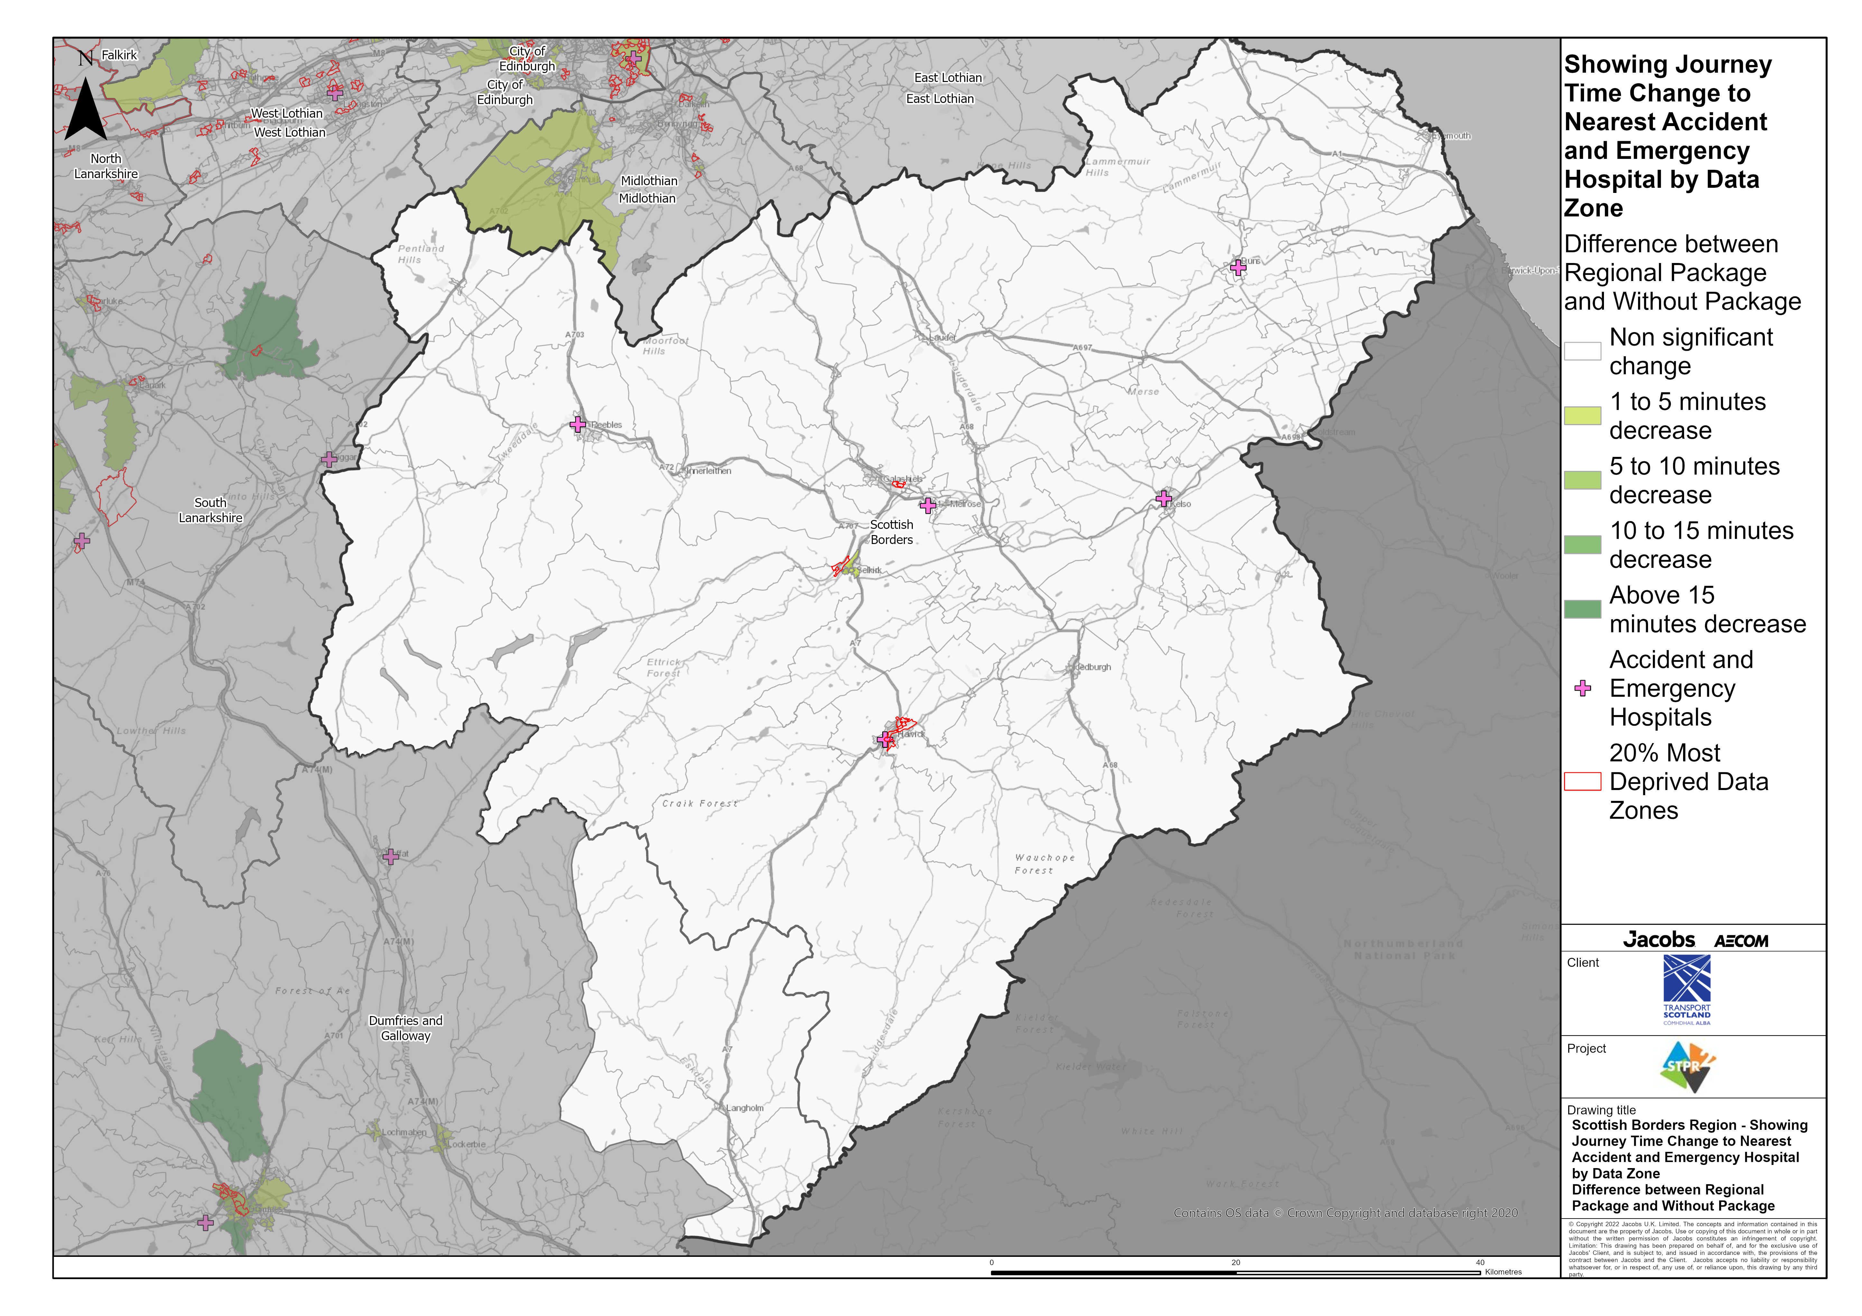
Scottish Borders Region – Showing Journey Time Change to Nearest Accident and Emergency Hospital Difference between Regional Package and Without Package
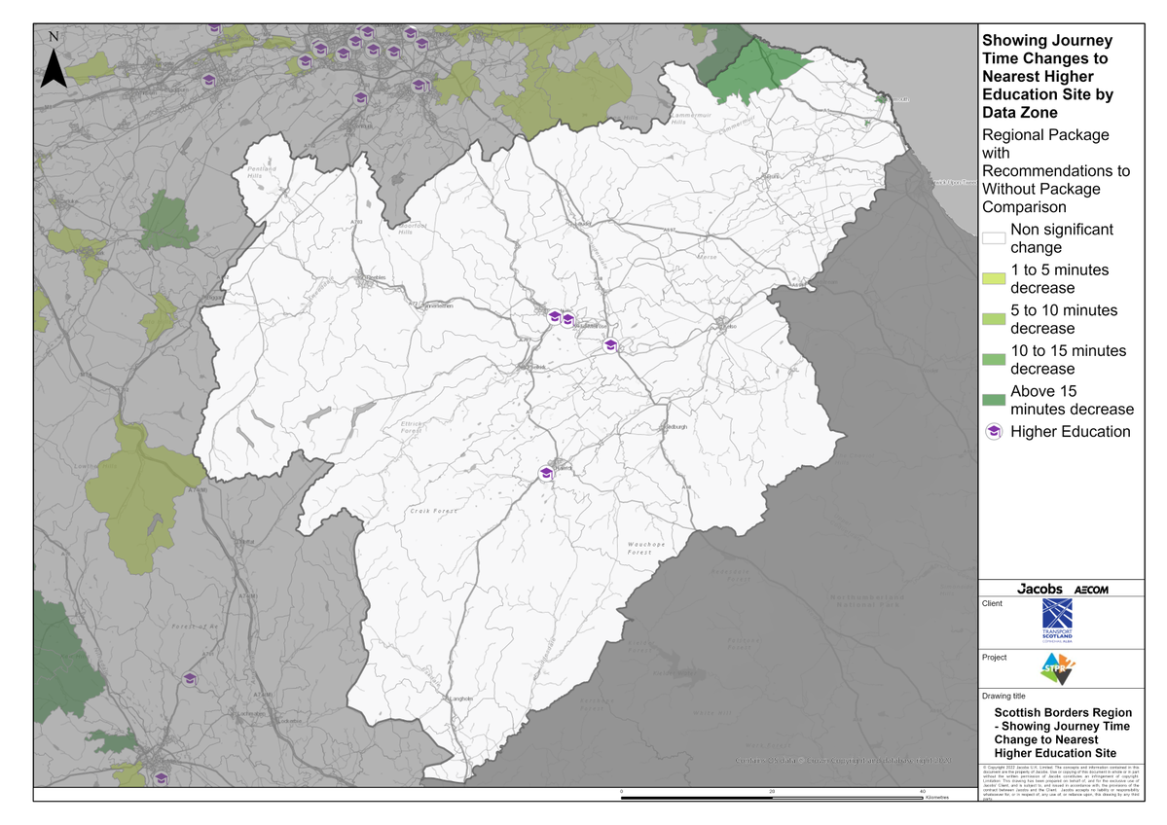
Scottish Borders Region – Showing Journey Time Change to Nearest Higher Education Site Difference between Regional Package and Without Package
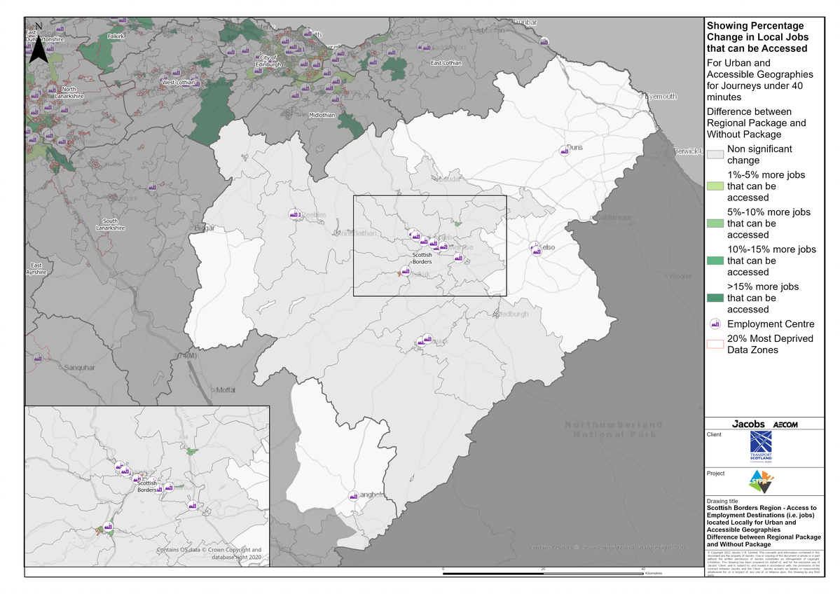
Scottish Borders Region – Access to Employment Destinations (i.e. jobs) located Locally for Urban and Accessible Geographies for journeys under 40 minutes Difference between Regional Package and Without Package
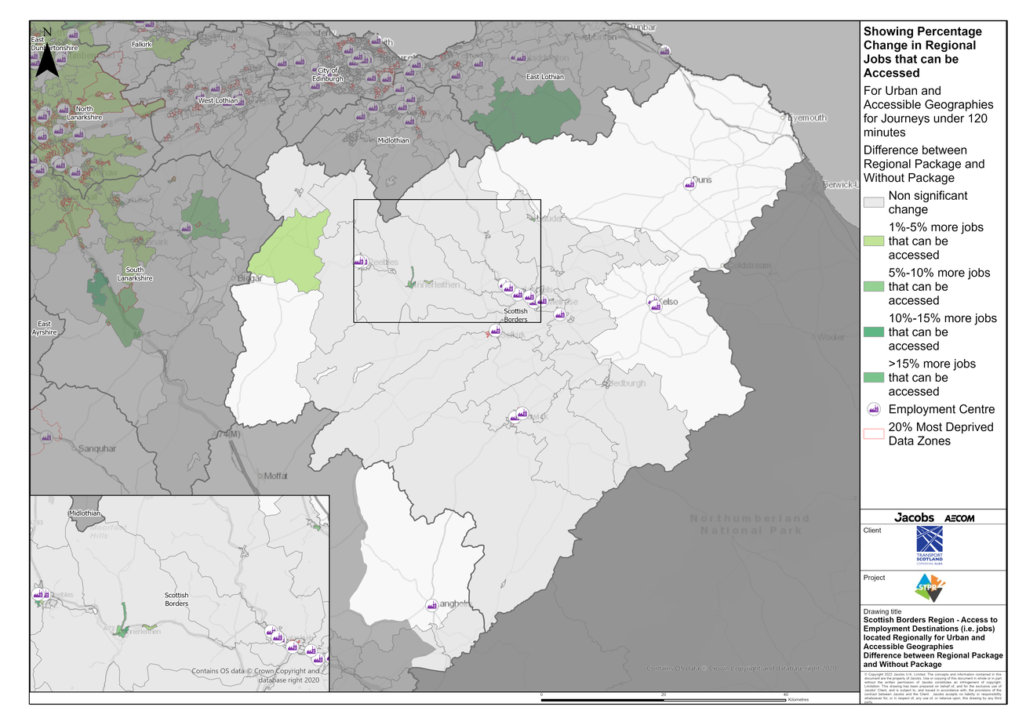
Scottish Borders Region – Access to Employment Destinations (i.e. jobs) located Regionally for Urban and Accessible Geographies for journeys under 120 minutes Difference between Regional Package and Without Package
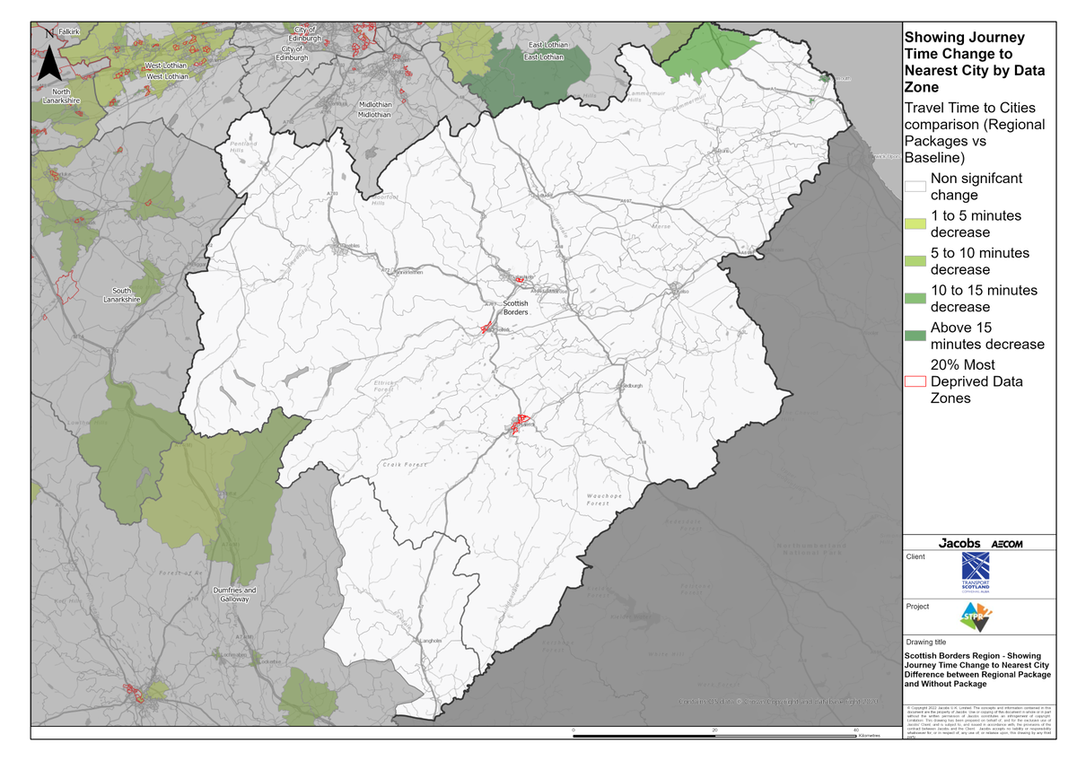
Scottish Borders Region – Showing Journey Time Change to Nearest City Difference between Regional Package and Without Package
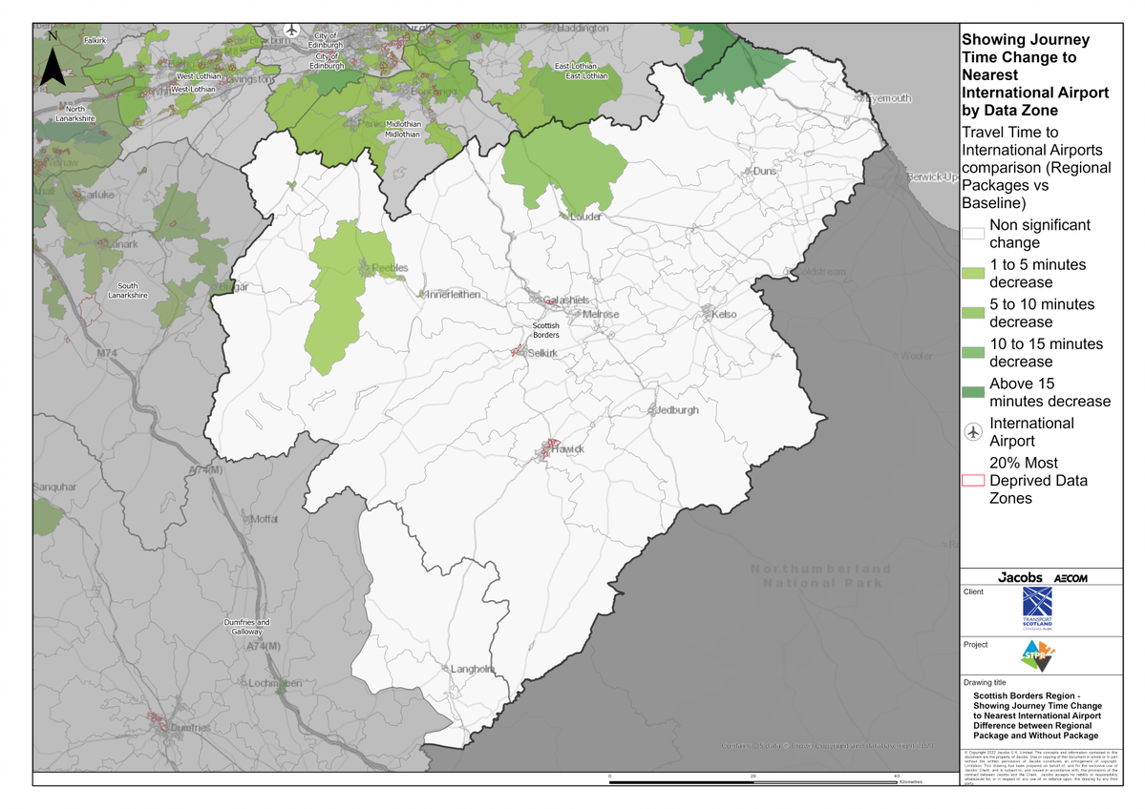
Scottish Borders Region – Showing Journey Time Change to Nearest International Airport Difference between Regional Package and Without Package

Annex B: Traffic Modelling Outputs
