Appendix H: Detailed Packaging - Appraisal Summary Tables

December 2022
Contents
1. Regional Context 5
1.1. Geographic Context 5
1.2. Social Context 5
1.3. Economic Context 6
1.4. Environmental Context 7
2. Problems and Opportunities 8
2.1. Problems 8
2.2. Opportunities 9
3. Regional Recommendations 10
4. Fit with Established Policy 12
5. STPR2 Transport Planning Objectives (TPOs) Assessment 13
6. STAG Assessment 22
6.1. Environment 22
6.2. Climate Change 23
6.3. Health, Safety & Wellbeing 24
6.4. Economy 26
6.5. Equality & Accessibility 26
7. Deliverability 28
7.1. Feasibility 28
7.2. Affordability 28
7.3. Public Acceptability 28
8. Statutory Impact Assessment Criteria 29
8.1. Strategic Environmental Assessment (SEA) 29
8.2. Equalities Impact Assessment (EqIA) 30
8.3. Island Communities Impact Assessment (ICIA) 31
8.4. Child Rights and Wellbeing Impact Assessment (CRWIA) 31
8.5. Fairer Scotland Duty Assessment (FSDA) 32
Annexes 33
Annex A: NAPTAT Mapping 34
Annex B: Traffic Modelling Outputs 42

Highlands and Islands Region Appraisal Summary Table
An Appraisal Summary Table (AST) has been developed for each of the eleven STPR2 Regions alongside the National AST. The ASTs are set out to provide:
- Regional Context, Problems and Opportunities – drawing on data presented in the Initial Appraisal: Case for Change reports this summarises geographic, social, economic, environmental and transport matters in the region as well as the identified problems and opportunities. In line with STAG, appraisals are expected to explore location specific problems and opportunities. Local problems and opportunities have been considered to gain a full understanding of the regional and national issues, however some of these may not be within the scope of this strategic study.
- Regional Recommendations – this presents the package of recommendations that were included in the detailed appraisal for the region.
- Fit with Policy – provides a summary of how well the appraised packages fit with key national policies including the second National Transport Strategy, Climate Change Plan Update, the Revised Draft Fourth National Planning Framework (Revised Draft NPF4) and relevant regional policies.
- Transport Planning Objectives (TPO) Assessment – An assessment against each of the five TPOs is provided with quantified metrics , where appropriate, under the Low growth sensitivity with a 20% reduction policy ambition on car kilometre scenario (hereafter referred to as Low scenario) and High growth sensitivity with no policy ambition car kilometre scenario (hereafter referred to as High scenario) (further information about these scenarios is provided in Appendix F of the Technical Report). A seven point scoring scale is adopted for each TPO which is:
  - + + + = major positive (3 plus signs)
  - + + = moderate positive
  - + = minor positive
  - 0 = neutral
  - - = minor negative
  - - - = moderate negative
  - - - - = major negative (3 minus signs)
- STAG Criteria assessment – as above for the TPO assessment, key points regarding the performance of the package against each of the STAG criteria is presented with quantified metrics provided where appropriate.
- Deliverability – commentary is provided on the assessment of the package in terms of its feasibility, affordability and public acceptability. Note that due to the nature of a number of the STPR2 interventions, and the stage in the business case process STPR2 is at, it has not been possible to derive cost estimates on a regional basis. However, broad capital spending ranges have been estimated over the period 2022 to 2042 at a national level.
- Statutory Impact Assessment Criteria – a summary of the performance of the packages against the Strategic Environment Assessment (SEA), the Equalities Impact Assessment (EqIA), Island Communities Impact Assessment (ICIA), Fairer Scotland Duty Act (FSDA) and Child Rights and Wellbeing Impact Assessment (CRWIA) is provided. The seven point scoring scale is adopted in these assessments where appropriate.

Summary of Assumptions
Quantification of the costs and benefits in the packages has been provided through a modelling exercise. Further information is provided in Appendix F of the Technical Report on the modelling scenarios that have informed the assessment of the STPR2 interventions. A summary of the key assumptions is provided here:
- Population projections are based on the NRS Population Projections (2018-based).
- Economic projections are a combination of projections by Oxford Economics, 2019, the Scottish Fiscal Commission forecasts and more recently the OBR post-COVID estimates.
- Land-use plans are based on data collected for Transport Scotland’s Assembly of Planning Policy Inputs in 2018 from Scotland’s 34 Planning Authorities.
- Permitting of vacant office and retail floorspace to be converted or redeveloped as housing post 2030.
- Working age is taken to be 16-64 (as a constant) to avoid difficulties with changing state pension age (and to reflect non-mandatory retirement).
- The economic results are presented as discounted values in 2010 prices, as is standard within appraisal.

Modelling Tools
For the purposes of modelling accessibility by public transport, NaPTAT (National Public Transport Accessibility Tool) has been used. This allows an assessment of journey time to be compared between the with and without STPR2 package.
Due to the strategic and national nature of STPR2, the national Transport Model for Scotland (TMfS) has been used. TMfS is a national scale model with a focus on inter-urban trips. As such, whilst TMfS provides a suitable level of robustness at this stage of the appraisal for most of the larger infrastructure based interventions, there are limitations associated with the modelling of smaller/discrete interventions and also some of the larger infrastructure interventions that involve changes to the existing road network and are more urban in nature. Separate forecasts of the potential impacts of active travel recommendations on walking and cycling mode share have therefore been made. As the recommended interventions are developed through the business case process, more detailed modelling will be undertaken using regional and / or local models as appropriate.
When considering the outputs presented in this AST, please note the following metrics with respect to the model outputs:
- CO₂ emissions: Likely to underestimate the benefits associated with public transport interventions due to the more limited representation of transport systems in urban areas and a degree of insensitivity to mode shift in TMfS.
- Mode Share: Likely shift to public transport modes underestimated in urban areas due to the more limited representation of urban transport systems and a degree of insensitivity to mode shift in TMfS.
- Change in vehicle kilometres travelled: Likely to underestimate the benefits of reducing vehicle kilometres travelled particularly for short distance journeys due to the more limited representation of urban transport systems and the relative coarseness of the model zone system.
- Lost Time due to congestion: Likely to underestimate the benefits associated with interventions that would reduce roadspace due to the under-representation of the local/secondary road network in TMfS.
- Change in accidents: Likely to underestimate the benefits associated with mode shift to public transport interventions due to the more limited representation of urban transport systems and a degree of insensitivity to mode shift in TMfS.
- Present Value of Benefits: Likely to underestimate the benefits to public transport users due to the more limited representation of urban transport systems. Likely to overestimate the dis-benefits to car-based trips due to the under-representation of the junctions and local/secondary road network in TMfS.

- Regional Context
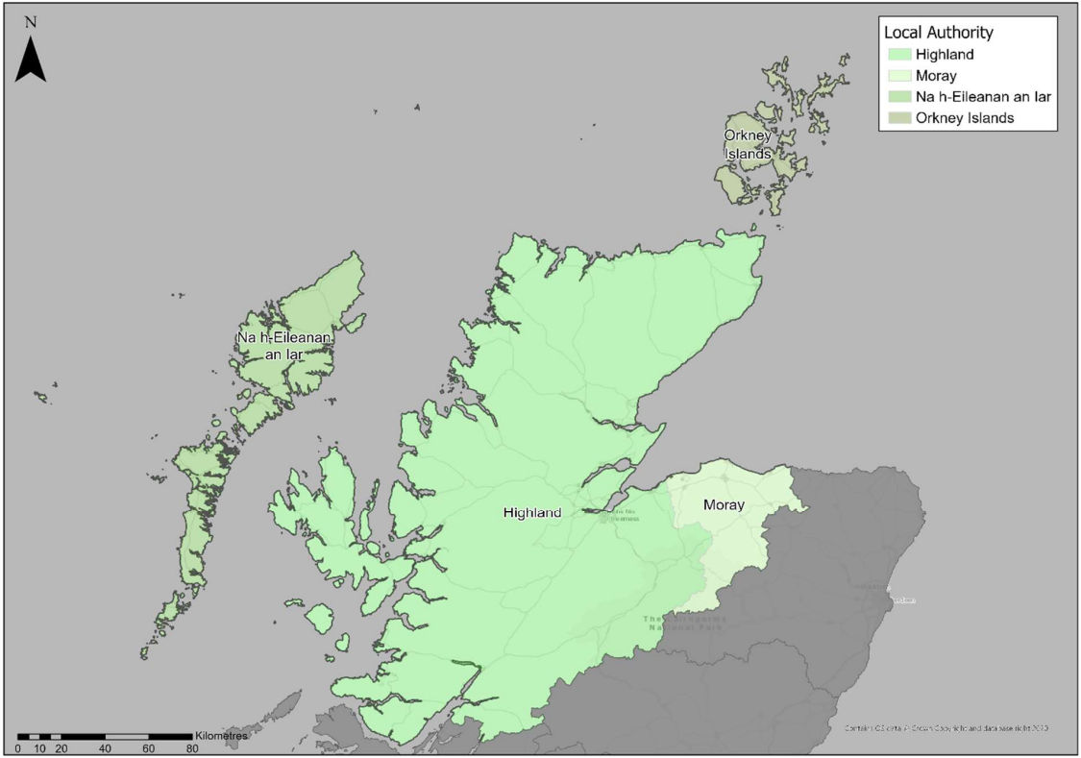
  - Geographic Context
The Highlands and Islands Region (herein referred to as ‘the Region’) comprises the four local authorities of The Highland Council, Comhairle nan Eilean Siar (CnES), Moray Council and Orkney Islands Council. The majority of the Region is classified as remote rural. The Scottish Government Urban Rural Six-Fold Classification identifies the regional population residing in each category as a mix of Remote Rural (35%); Other Urban Areas (28%); Remote Small Towns (18%); Accessible Rural (14%); and Accessible Small Towns (5%). The largest ‘Other Urban Areas’ include Inverness, Fort William, Forres, Elgin and Keith. Furthermore, the majority of ‘accessible small towns’ are located around Inverness; Fort William; and along the A96 corridor.
The Region has a wide-ranging transport network including active travel, bus, rail and road networks; as well as ferry connections to and between the islands. For the purposes of STPR2, major ports in the Region are considered to be Ullapool, Stornoway, Scrabster, Nether Lochaber, Invergordon, Ardgour, Kirkwall and Scapa Flow. For many on the islands, ferries are the most frequently used mode of public transport and often provide a lifeline service. Ferry services operating in the Region connect the Inner and Outer Hebrides with Ullapool, Uig and Mallaig; and Orkney with Scrabster, John O’Groats, Aberdeen and Lerwick. Furthermore, there are a number of services connecting peninsulas with other locations on the mainland.
  - Social Context
According to the National Records of Scotland’s Mid-year Population Estimates Scotland, the total population in the Region was 380,640 in 2019 (7% of the total Scotland population), of which 62% lived within The Highland Council local authority area. The most populated settlement in the Region is Inverness, with a population of around 63,000 in 2016. Of the top 10 most populous settlements in the Region, 7 increased in population between 2012 and 2016, with Thurso, Fort William and Stornoway reducing in population size. The largest population growth was in Elgin (+8%), with the largest decline in Thurso (-2%). Within the more remote areas of the Region, population decline is regarded as a major issue and between 2011 and 2018 the population of Caithness and Sutherland and Eilean Siar decreased by 3.9% and 3.1% respectively.
In terms of age structure, the number of working age population is decreasing in the Highlands and Islands, whilst it remains stable in Scotland as a whole. There has also been a significant decrease in the number of people aged 15 and under within the Region, and a significant increase in those aged 65 and over. This highlights the ageing population in the Region and indicates that the number of working age population is set to decrease further in the future.
Performance against socio-economic indicators varies across the Region. Overall, the proportion of households with access to a car is higher in the Region compared to the national average (80% compared to 69.5%, based on 2011 Census) which reflects the rurality and longer travel distances to access key services in the Region. Also captured in the 2011 Census, travel to work by car is also the dominant mode (62%); with bus accounting for a total of 4% of commuting trips; rail accounting for 2%; and 13% of people commuting by active modes (11% walking and 2% cycling). In terms of travel to work distances within the Region, the proportion of people who commute less than 2 kilometres is approximately 5 percentage points higher than the national average (18.1% compared to 13.1%), while the proportion of people who travel distances greater than 60 kilometres to work is also higher than the national average (13.3% compared to 10.9%).
There are pockets of deprivation across the Region, most notably in Eilean Siar and areas in the north of the Highlands. Access to healthcare is limited in these more rural areas, with accessibility to existing healthcare services restricted to larger settlements, contributing to the low Scottish Index of Multiple Deprivation (SIMD 2020) accessibility score. In addition to the locations detailed above, there are also areas of deprivation located within Elgin and Inverness. Furthermore, within the Region 7% of people had no qualifications in 2019, which was 2.8 percentage points lower than the national benchmark (9.8%). In terms of health, the proportion of adults in the Region with a long term physical or mental health condition is generally higher than the Scottish average of 30%.
  - Economic Context
In terms of percentage change in Gross Value Added (GVA), data evidenced from ONS Regional GDP shows that between 2009 and 2016, The Highland Council economy grew at a faster rate than the Scottish economy as a whole. However, whilst the percentage change in GVA continued to increase across the Scottish economy between 2016 and 2017, there was a reduction in the GVA output within The Highland Council area for the same period. Overall, the ten-year growth between 2008 and 2018 is in line with Scotland as a whole. The economies of Eilean Siar and Orkney Islands tend not to mirror overall economic trends at a national level; exemplifying this, the index of GVA in Scotland found the ‘Islands’ – which constituted Western Isles, the Shetland Islands and the Orkney Islands – were the only region that didn’t observe a contraction in economic output during the 2008 to 2009 recession. Notwithstanding that, overall GVA on the Islands has fallen in 4 out of 7 years since 2011, despite steady growth across Scotland.
Moray Council’s economic performance has diverged from the national trend over the previous decade, with its economy contracting between 2011 and 2016. Whilst there was an increase in the percentage of GVA output between 2016 and 2018, overall, in the decade between 2008 and 2018, the economy of Moray has contracted.
Within the Region, the largest industry employer (in 2018) was Human Health & Social Work, which employed 15.5% of the working population, followed by Wholesale & Retail Trade at 13.3%. Mining and quarrying employed the lowest percentage of the working population (0.4%). Economic activity refers to an estimation of whether usual residents aged 16 to 64 were in work or actively looking for work. Despite the lower proportion of people of working age in the Region, economic activity is high at 80.9% (3.4 percentage points higher than the national average). In 2018 earnings are lower, however, with the average annual pay (£24,809) below the national average of £28,955. In terms of transport spend, the rural nature of the Region and long travel distances mean that transport costs can comprise a large proportion of income for residents. Linked to this, there are large parts of the Region which experience transport poverty, as 58% of data zones are classified as being at high risk of transport poverty, which is considerably higher than the national figure (38%).
  - Environmental Context
Within the Region, there are many areas classified as environmentally sensitive, with varying levels of statutory protection. Environmental designations include biodiversity, landscape, and heritage designations, which fall either wholly or partly within the Region. Information from Historic Environment Scotland shows that there are designated environmentally sensitive sites located throughout the Region, with particularly high concentrations on the coastal areas and the islands. In addition, the Region contains a significant number of historic assets, including two designated World Heritage Sites (St. Kilda in the Hebridean Islands and The Heart of Neolithic Orkney) and 7,362 Category A-C listed buildings; with high concentrations of listed buildings in and around Inverness and on the north-east coast.
Noise modelling, from Scottish Government’s Scotland Noise Map,highlights limited noise sources in the Region due to its rural nature, with the only notable areas of noise located in the east of the Region, primarily associated with the trunk road network into Inverness (i.e., the A82, A9 and A96), together with the rail corridor through Inverness.
There are a high number of areas at risk of coastal flooding throughout the Region. Mainland settlements at greatest risk of coastal flooding include Inverness, Nairn, Cromarty, Golspie, Thurso, Lochinver and Fort William, in addition to Wick Airport. Coastal island communities are also affected, including the northern coast of the Isle of Skye and communities within the Outer Hebrides and Orkney Islands. Areas of Thurso, Alness, Kinlochewe, Wick and Dingwall and the surrounding rural areas are at the highest risk of river flooding within the Region.
There is one Air Quality Management Area (AQMA) designated in the Region, located in Inverness City Centre. CO₂ emissions from transport within the Region equated to 7.8% of Scotland’s total transport emissions overall.
- Problems and Opportunities
The following transport-related problems and opportunities have been identified for the Highlands and Islands region.
  - Problems
- Connectivity: Poor connectivity, both within the Region and to the rest of Scotland, was frequently raised through stakeholder engagement for the study, with one third of data zones in the Region ranked in the lowest 10% in Scotland in terms of accessibility (SIMD). The difficulties of completing a viable and affordable working day in Glasgow, Edinburgh, Aberdeen and Inverness were highlighted during stakeholder engagement, with the availability and timing of public transport services said to impact connectivity and therefore opportunities for those living and working in the Region. The cost of travel to the Scottish Mainland from the island communities was regarded by a number of stakeholders as prohibitive and is acting as a barrier to travel, particularly by air.

- Transport Poverty: Overall, households within the Region spend a high proportion of their household budget on transport expenditure, with the majority of data zones spending between 17% and 18% of their budget on transport, compared to the national average of 14%. Households in rural areas spend the highest proportion of their budget on transport costs, with the proportion of spend lower within the main settlements. Young people can be particularly affected, with studies highlighting transport as a barrier to employment, particularly for those in more rural communities. The cost of rail journeys has also been highlighted as an issue for both everyday journeys and for longer distance journeys, for example to the Central Belt.

- Capacity Constraints: Ferry passenger numbers (and particularly an increase in utilisation of vehicle lane metres) on the Ullapool - Stornoway ferry service have increased since the introduction of the Road Equivalent Tariff (RET) to the route. There are reported difficulties for residents and businesses, due to the increased demand during the busy summer period, particularly when travelling with a vehicle. Capacity issues for residents and businesses wishing to travel to and from Orkney on the NorthLink services were also reported, as well as capacity issues for freight. Air services were also said to be at capacity, with a 19% increase in passenger numbers since 2012. Seasonal congestion on the road network can also impact on journey times, particularly in Fort William on the A82 and A830, with concerns also raised regarding the impact that seasonal traffic has on the road quality and condition.

- Journey Times: Journey times by road, bus and rail have been described as long by stakeholders. This is partly due to the longer distances between origins and destinations but also due to constraints in the transport network. In terms of road journey times, there is a perceived lack of safe overtaking opportunities on sections of the trunk road network, considered to be as a result of carriageway standard and the mix and composition of vehicles. Rail is generally considered an unattractive alternative to the car due to uncompetitive journey times. Long journey times were also noted to be an issue that affects island communities.

- Resilience: The resilience of the trunk road network was highlighted as a problem during stakeholder engagement, due to the lack of alternative options which can result in long diversion routes in the event of road closure. Information contained within the Train Time Reliability by station list highlighted journey time reliability issues, while a number of sections of the rail network are prone to closure during periods of adverse weather. There is limited resilience in the Ullapool - Stornoway ferry provision should there be a breakdown or delay, with 2 passenger services operating each day and a freight service at night. Furthermore, stakeholder engagement frequently highlighted ferry and air service cancellations as being an issue which affects island life.

- Public Transport Frequency and Integration: The lack of, and limited frequency of, public transport, in particular bus services, is a problem especially in rural areas. Bus services do not operate at desired times such as early enough to make rail connections or late enough in the evenings to allow for activities to be undertaken after school/work or to access shift work. TRACC analysis – a multimodal accessibility and journey time analysis tool - highlights that large areas in the north and west of the Scottish mainland, and a high proportion of island residents, have no access to the key employment centres (selected for analysis) within a 2 hour journey time by public transport.

- Dependence on Private Car: The geography of the area, the centralisation of key services, and the lack of frequent public transport access means that many in the Region are dependent on cars and often dependent on more than one car per household. Most data zones (76%) have less than 30% of households with no car or van available, highlighting the high car availability in the Region.

  - Opportunities
- Economic Growth: There are a number of strong growth sectors within the Region, with the aquaculture sector expected to grow by 50% by 2035. Tourism is another sector in the Region that is anticipated to grow, attracting over 500,000 international visitors in 2017, with a key attractor being the North Coast 500. There is an opportunity in the Region to increase the number of tourists using sustainable modes of travel.

- Progression Towards Carbon Neutrality: There are opportunities arising from the Island’s Growth Deal for the Region in this regard including the Islands Hub for Net Zero, a Revised Draft NPF4 National Development. Another growth sector for the Region is the energy sector, with particular opportunities in renewable energy to draw on transferrable skills from the oil and gas sector, as renewable sources become more prevalent, securing future employment opportunities.

- Digital Connectivity: Technological opportunities include understanding how future technologies could impact transport, how technology could be used to improve transport, and how to future-proof transport by taking steps now to prevent problems in the future.

- Regional Recommendations
The following is a list of interventions that form a package of recommendations that are relevant for this Region.

Regional Recommendations
- Connected neighbourhoods (Recommendation 1)
- Active freeways and cycle parking hubs (Recommendation 2)
- Village-town active travel connections (Recommendation 3)
- Connecting towns by active travel (Recommendation 4)
- Long-distance active travel network (Recommendation 5)
- Behavioural change initiatives (Recommendation 6)
- Changing road user behaviour (Recommendation 7)
- Increasing active travel to school (Recommendation 8)
- Improving access to bikes (Recommendation 9)
- Expansion of 20mph limits and zones (Recommendation 10)
- Provision of strategic bus priority measures (Recommendation 14)
- Highland Main Line Rail Corridor Enhancements (Recommendation 15)
- Supporting integrated journeys at ferry terminals (Recommendation 18)
- Infrastructure to provide access for all at railway stations (Recommendation 19)
- Investment in Demand Responsive Transport and Mobility as a Service (Recommendation 20)
- Improved public transport passenger interchange facilities (Recommendation 21)
- Framework for the Delivery of Mobility Hubs (Recommendation 22)
- Smart, integrated public transport ticketing (Recommendation 23)
- Ferry vessel renewal and replacement and progressive decarbonisation (Recommendation 24)
- Decarbonisation of the rail network (Recommendation 25)
- Decarbonisation of the bus network (Recommendation 26)
- Behavioural change and modal shift for freight (Recommendation 27)
- Zero emission vehicles and infrastructure transition (Recommendation 28)
- Trunk road and motorway safety improvements to progress towards ‘Vision Zero’ (Recommendation 30)
- Trunk road and motorway network climate change adaptation and resilience (Recommendation 31)
- Trunk road and motorway network renewal for reliability, resilience and safety (Recommendation 32)
- Future Intelligent Transport Systems (Recommendation 33)
- Traffic Scotland System Renewal (Recommendation 34)
- Intelligent Transport System renewal and replacement (Recommendation 35)
- Strategy for improving rest and welfare facilities for hauliers (Recommendation 36)
- Improving active travel on trunk roads through communities (Recommendation 37)
- Speed Management Plan (Recommendation 38)
- Potential sound of Harris, sound of Barra fixed link and fixed link between Mull and Scottish mainland (Recommendation 41)
- Investment in port infrastructure to support vessel renewal and replacement, and progressive decarbonisation (Recommendation 42)
- Major station masterplans (Recommendation 43)
- Rail freight terminals and facilities (Recommendation 44)
- Fit with Established Policy
The interventions included within this package support a wide range of national, regional and local policies in which transport improvements play a key role in both the enabling and delivery of outcomes.
Key policies supported include the Programme for Government, Infrastructure Investment Plan, NTS2, the Climate Change Plan update 2018-2022, HITRANS Regional Transport Strategy and various Local Transport Strategies (The Highland Council, Moray Council, Orkney Council and Comhairle nan Eilean Siar).
Interventions included in this package will also support more resilient connections to the Revised Draft Fourth National Planning Framework (Revised Draft NPF4) Islands Hub for Net Zero and Pumped Hydro Storage national development.
The policy framework for the Highlands and Islands Region has a strong emphasis on creating a prosperous economy and on inclusive, connected, and healthy communities which promote modal shift away from private car, increase walking and cycling opportunities, and provide an attractive place for visitors and for businesses to invest and grow; the package therefore closely aligns with established policy directives.

Package Performance Against NTS2 Priorities and Outcomes:

Reduce inequalities
Will provide fair access to services we need: Major Positive
Will be easy to use for all: Major Positive
Will be affordable for all: Minor Positive

Takes climate action
Will help deliver our net-zero target: Major Positive
Will adapt to the effects of climate change: Minor Positive
Will promote greener, cleaner choices: Major Positive

Helps deliver inclusive economic growth
Will get people and goods where they need to get to: Major Positive
Will be reliable, efficient and high quality: Major Positive
Will use beneficial innovation: Major Positive

Improves our Health and Wellbeing
Will be safe and secure for all: Major Positive
Will enable us to make healthy travel choices: Major Positive
Will help make our communities great places to live: Major Positive

- STPR2 Transport Planning Objectives (TPOs) Assessment

TPO1 A sustainable strategic transport system that contributes significantly to the Scottish Government’s net-zero emissions target

TPO Performance Summary
Carbon dioxide equivalent (CO₂eq) is treated as a nationally important pollutant. As such, although it can be appraised at the national level (commentary below), it has not been appraised for individual regions.
The national and all regional packages overall will contribute significantly to the net-zero emissions target by:
- Enabling more passenger journeys to be made by active modes and public transport.
- Decarbonising most if not all public transport operations.
- Facilitating uptake of electric vehicles.
- Enabling road freight to switch to rail or other low carbon modes.
Further commentary is provided below.
National CO₂eq emissions are forecasted to decrease year-on year. This is due to decreasing vehicle exhaust (non-traded) emissions as the number of internal combustion engine vehicles reduces. This is reflected in the volume of traded grid emissions from charging increased numbers of battery-electric vehicles, and specifically in the Low scenario. It is noted that traded emissions of CO₂eq are associated with electrical generation to supply plug-in vehicles, both BEV (battery electric vehicles) and PHEV (plug-in hybrid vehicles).
The electricity grid is expected to be using predominantly renewable sources in the future and so increasing adoption of electric vehicles and a shift from direct, non-traded, emission to traded grid-based technology (i.e. battery) will support reducing CO₂eq emissions.
Across both Low and High scenarios the interventions would reduce emissions of CO₂eq.
Significantly higher overall emissions are predicted in the High scenario, either with, or without, the national and all regional packages. There is a relatively smaller overall reduction of emissions due to the interventions in the Low scenario due to the lower overall emissions. The economic impacts associated with air quality were assessed using the Department for Environment Food & Rural Affairs (DEFRA) Damage Costs Appraisal Toolkit. The larger economic benefit from the High scenario is due to the greater overall emissions with, or without, the package, although the proportional change is lower.
Overall Scoring:
Low and High Scenarios: Moderate Positive

Metric 1: Change in CO₂eq (non-traded and traded emissions from regional road transport inc. grid emissions from charging light-duty vehicles)-Figures below are a National calculation
Low Scenario Commentary:
- 0.5% decrease (27,700 tonnes CO₂eq) in 2030.
- 2.8% decrease (21,600 tonnes CO₂eq) in 2045.
- 1.3 million tonnes reduction, of which 1.1 million were traded, for the 60-year appraisal period from 2030 to 2089.
- The net economic benefits for the 60-year appraisal period in 2010 prices and values would be in the range £10 million to £25 million for the Low scenario.
High Scenario Commentary:
- 0.4% decrease (31,300 tonnes CO₂eq) in 2030.
- 1.3% decrease (65,300 tonnes CO₂eq) in 2045.
- 3.7 million tonnes reduction, of which 452,000 were traded, for the 60-year appraisal period from 2030 to 2089.
- The net economic benefits for the 60-year appraisal period in 2010 prices and values would be in the range £100 million to £250 million for the High scenario

Metric 2: Change in mode share by active travel for all journeys
Low and High Scenarios Commentary:
- Potential increase in walking from 17% mode share to 20% mode share (3 percentage points).
- Potential increase in cycling from 0.7% mode share to 10% (9.3 percentage points).
The package will increase the proportions of journeys undertaken by active modes. If all the active travel and behaviour change interventions were fully implemented in every relevant location in the Region, mode shares of walking and cycling "with STPR2 package" proportions are shown alongside the mode share without package.
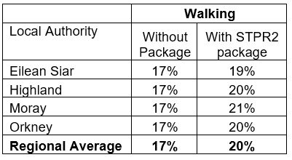
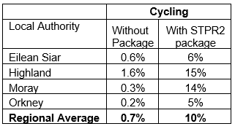
Note that the cycling and walking growth forecasts have been developed independently of each other. Growth in use of one active mode is likely to abstract at least some trips from the other, but this effect is not accounted for within these forecasts.

Metric 3: Change in motorised vehicle kilometres travelled
Low Scenario Commentary:
- Reduction of 47.6 million motorised vehicle kilometres (2% decrease) (see Annex B).
High Scenario Commentary:
- Reduction in 44.4 million motorised vehicle kilometres (1% decrease) (see Annex B).

TPO2 An inclusive strategic transport system that improves the affordability and accessibility of public transport

TPO Performance Summary
The package will improve the inclusiveness of the transport system by:
- Improving conditions for people walking, wheeling, and cycling, the most inclusive transport modes, with particular benefits for people most often excluded (including children, older and disabled people, and people on low incomes).
- Improving active travel connections between settlements.
- Improving inclusive accessibility to public transport stops/stations.
- Seeking to promote public transport use and reduce operating costs, hence enhancing network sustainability.
- Improving ferry connectivity between the Region and mainland Scotland.
Overall Scoring:
Low and High Scenarios: Minor Positive

Metric 1: Change in transport poverty risk
Low and High Scenarios Commentary:
Although the STPR2 interventions do not impact on the direct costs of travel (e.g. fares, fuel price), the package of interventions would see a small reduction in transport poverty, due to the overall improvements to access to transport services and connectivity between modes.

Metric 2: Change in Accessibility - population catchments increases to key services by journey time by public transport
Low and High Scenarios Commentary:
The largest forecast change in population accessibility of all the destination types considered was to major shopping centres, whereby an additional 7,300 of the population in the Region would be able to access the nearest site in a journey time of 90 minutes or less by public transport with the STPR2 package in place compared to without. This represents a 2.3 percentage point increase in accessibility levels from 49.0% in the without package assessment to 51.3% with the package in place. The improvements were observed largely in Aviemore. This is shown by the map output in Annex A.
There are also population accessibility improvements forecast in the Region for accessing key destinations in under 90 minutes using public transport, which included higher education and large food stores. The accessibility improvements and the corresponding additional population that are able to access those destinations within a journey time of 90 minutes compared to the without package assessment are summarised below:
- 5,600 additional people are able to access the nearest higher education site by public transport, as shown by the map output in Annex A, which represents a 1.8 percentage point increase in accessibility levels from 71.2% in the without package assessment to 73.0% with the package in place.
- 5,400 additional people are able to access a large food store by public transport, which represents a 1.7 percentage point increase in accessibility levels from 81.3% in the without package assessment to 83.0% with the package in place.
Other destinations that showed a forecast minor increase in population accessibility included access to accident and emergency hospitals and secondary schools, whereby an additional 600 people and 200 children (aged 11 to 18), respectively, in the Region would be able to access the nearest site by public transport in under 60 minutes or less. This represents a 0.1 and 0.5 percentage points increase compared to that in the without package assessment, respectively.
In terms of additional destinations (cities, rail stations and airports) considered in the model:
- 2,300 additional people are able to access their closest city within a 60 minute public transport journey, which represents a 0.7 percentage point increase in accessibility levels from 30.6% in the without package to 31.3% with the package in place;
- 13,400 additional people are able to access their closest city within a 90 minute public transport journey, representing a 4.2 percentage point increase in accessibility levels from 41.0% in the without package to 45.2% with the package in place.
- 1,800 additional people are able to access their closest rail station within a 30 minute public transport journey, which represents a 0.6 percentage point increase in accessibility levels from 49.3% in the without package to 49.9% with the package in place.
- 2,900 additional people are able to access their closest regional airport within a 60 minute public transport journey, which represents a 0.9 percentage point increase in accessibility levels from 23.6% in the without package to 24.5% with the package in place.
- 3,100 additional people are able to access their closest regional airport within a 90 minute public transport journey, which represents a 1.0 percentage point increase in accessibility levels from 38.4% in the without package to 39.4% with the package in place.

Mapping outputs are shown in in Annex A.

TPO3 A cohesive strategic transport system that enhances communities as places, supporting health and wellbeing

TPO Performance Summary
The package will improve communities as places, supporting health and wellbeing by enabling more journeys to be made by active and sustainable modes, and by improving road safety. This will:
- Improve many people’s physical health and mental wellbeing, with particular benefits for people most often excluded (including children, older and disabled people, and people on low incomes).
- Reduce the adverse impacts of car use on communities and health (including reduced air pollution, noise, accident risk and perceived road danger).
The analysis shows that through improved uptake of walking and cycling, there would be a forecast annual reduction of around 15 premature deaths due to the health benefits arising from active travel.
Overall Scoring:
Low and High Scenarios: Moderate Positive

Metric 1 Change in mode share by active travel for all journeys
Low and High Scenarios Commentary:
- Potential increase in walking from 17% mode share to 20% mode share (3 percentage points).
- Potential increase in cycling from 0.7% mode share to 10% (9.3 percentage points).
These forecasts are subject to all active travel interventions being delivered in all relevant areas of the Region.
Cycling and walking growth forecasts have been developed independently. Growth in use of one active mode is likely to abstract at least some trips from the other, but this effect is not accounted for within these forecasts.

Metric 2 Potential for Change in 'Place'
Low and High Scenarios Commentary:
The package will tend to improve the quality of the Region’s places by improving local accessibility and reducing the adverse impacts of road traffic.
Particular benefits may arise in locations where active travel allows easier walking and cycling conditions such as in Inverness, Fort William, Elgin, Stornoway and Kirkwall.

Metric 3 Change in Health Benefits
Low and High Scenarios Commentary:
The health benefits of increased rates of active travel as a result of the package have been quantified using the World Health Organisation’s (WHO) Health Economic Assessment Tool (HEAT). HEAT estimates the health and economic impacts of increased walking and cycling, providing assessments of the health and economic impacts of walking and cycling on premature mortality and on exposure to air pollution. Outputs from the tool shows the following benefits by Local Authority:
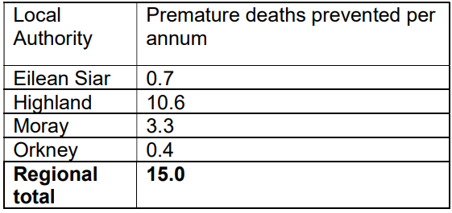

TPO4 An integrated strategic transport system that contributes towards sustainable inclusive growth in Scotland

TPO Performance Summary
The package will contribute to sustainable inclusive growth in Scotland by:
- Improving integration of transport modes (especially between active modes and public transport) and between transport and major developments, particularly in the towns and cities.
- Improving journey time reliability.
- Enabling more people to travel by improving the accessibility and affordability of the transport system, through greater mode choice and reduced reliance on the private car. This enables more people to access local retail and services, and opportunities for employment and education/training. This is particularly relevant in the less rural areas of the Region.
Encouraging modal shift to sustainable modes and reducing the volume of vehicles on the road network is anticipated to improve journey time reliability for all vehicles, providing benefits to businesses across the Region. A reduction in vehicles hours of between 9,000 and 16,000 hours is anticipated in the respective growth scenarios for business and commercial travel, contributing towards sustainable inclusive growth in Scotland.
Overall Scoring:
Low and High Scenarios: Moderate Positive

Metric 1: Increased labour catchment by sustainable travel (PT/Active Travel)
Low and High Scenarios Commentary:
Access to local employment, which represents accessibility of key employment opportunities located in the surrounding area within a 40 minute public transport journey time is forecast to have improvements in parts of the Region, particularly in and around Inverness in the with STPR2 package assessment compared to without package. From Westhill (Highland), the package would enable on average an additional 7,000 of existing jobs located in the surrounding area to be accessed by public transport. This is shown by the map output in Annex A.

Access to regional employment, which represents the accessibility of key employment opportunities located in Inverness and Fort William within a 60 minute journey time using public transport is forecast to have minor improvements in the Region. There were improvements forecast in some settlements in Highland, whereby the modelling showed that the package would enable an additional 2,000 jobs to be accessed from Nairn to employment opportunities located in Inverness City within an 60 minutes by public transport. This is shown by the map output in Annex A.

Within the rural areas of the Region, access to the nearest key employment opportunity is forecast to increase by 0.4 percentage points, whereby an additional 700 of the population would be able to reach the nearest employment site within 30 minutes.

Metric 2: Change in lost time due to congestion (for business/ commercial transport)
Low Scenario Commentary:
- 5% decrease (equivalent to reduction of 9,800 hours) in lost time due to congestion.
High Scenario Commentary:
- 5% decrease (equivalent to reduction of 15,400 hours) in lost time due to congestion.

TPO5 A reliable and resilient strategic transport system that is safe and secure for users

TPO Performance Summary
The package will improve reliability, safety and personal security on the transport system by:
- Improving journey time reliability, including through reduced likelihood of significant network disruptions.
- Reducing the risk of road accidents at hotspot locations on the trunk road network e.g. through targeted infrastructure improvements such as carriageway realignment and widening, the provision of overtaking opportunities and junction improvements. (It should be noted that replacing a priority junction with a signalised junction could increase the overall number of accidents, however the severity of accidents occurring should reduce).
- Reducing perceived risks to road safety and to personal security, enabling more people (particularly children, women and older people) to travel independently.
- Changing attitudes of road users through behavioural change campaigns. This is anticipated to increase awareness of interactions with those walking, wheeling and cycling.
- Improving active travel provision and providing more dedicated and segregated routes for walking, cycling and wheeling.
Overall Scoring:
Low and High Scenarios: Major Positive

Metric 1 Change in accidents (PIA and ‘damage-only’)
Low and High Scenarios Commentary:
- Accident reduction related to motorised vehicle kilometres is forecast to be 2%.
Whilst the number of accidents involving motorised vehicles is anticipated to reduce following the introduction of the interventions within this package, it is anticipated that walking and cycling journeys would increase. The number of accidents involving these modes is therefore anticipated to increase, although each individual journey is anticipated be significantly safer.

Metric 2 Percentage accident change for Targeted Infrastructure Improvements over 60 years, using default accident rate (PIA only)
Low and High Scenarios Commentary:
Accident benefits were estimated using the Department for Transport (DfT) recommended software programme COBA-LT (Cost and Benefit to Accidents – Light Touch) for targeted road safety improvements, based on default parameters, but using Scotland specific accident rates. A range of accident benefits were calculated for the various improvement options being considered. This provided the upper and lower bound of estimated percentage change in accidents, respectively. These ranges are shown below and provide the anticipated upper and lower bounds of impact on accidents that would be anticipated from typical interventions of this type:
- Sections of Realignment/Widening – reduction of 23% to 59%.
- Sections of Overtaking Opportunities – reduction of 35% to 73%.
- Locations of Junction Improvements – change of 42% (increase) to 64% (decrease).

It should be noted that junction accidents are forecast to increase in the event that a junction is upgraded from a priority to a signalised junction. This is due to an increase in the number of slight accidents that are likely to occur as a result of shunts in queuing traffic on the mainline approach to the traffic signals, which could previously travel unopposed. However, the accident severity can be expected to reduce as a result of this type of improvement. Any improvement scheme would be subject to further consideration.

Metric 3 Change in lost time due to congestion
Low Scenario Commentary:
- 9% decrease (52,700 hours) in lost time due to congestion (see Annex B).
High Scenario Commentary:
- 8% decrease (107,000 hours) in lost time due to congestion (see Annex B).

Metric 4 Journey Time Reliability /Availability of alternatives (modes/routes)
This package is forecast to reduce overall motorised vehicle kilometres by 2% and 1% under the Low and High Scenarios respectively, reduces the risk of accidents occurring as a result of reducing travel, whilst improving resilience by reducing the number of road closures associated with accidents.Targeted improvements on the trunk road network where safety is a problem is forecast to reduce accidents and the associated reduction in road closures from such incidents would also help improve reliability. Improvements in terms of renewals and climate change adaptation to protect the operation of the trunk road network would also positively impact on the reliability of the network. Encouraging modal shift to sustainable modes and reducing the volume of vehicles on the network is anticipated to improve journey time reliability, as indicated by reducing time lost to congestion of 52,700 and 107,000 hours in the Low and High scenarios respectively.
- STAG Assessment
  - Environment

Environment

Air Quality
Performance Summary:
Total emissions of NO_{X} (a group of gases that are mainly formed during the combustion of fossil fuels) were predicted to be effectively zero in 2045 in the Low scenario, and 2051 in the High scenario either with, or without, the proposed package. It is the change brought about by the projected transition of the vehicle fleet to zero-emission vehicles that contribute to the majority of air quality benefits, and in this instance outweighs the positive mode change contributions from the regional package.
Total emissions of Particulate Matter (PM), which is made up of a collection of solid and / or liquid materials, were predicted to increase in future predominantly due to non-exhaust emissions from road, tyre and brake-wear.
However, the package will reduce harmful emissions slightly. Over the 60-year appraisal period there was a predicted 100% reduction in NO_{X}, 2.8% reduction in PM10 and 2.9% reduction in PM2.5 in the Low scenario, and a 3.1% reduction in PM10 and a 3.3% reduction in PM2.5 in the High scenario.
Low Scenario Scoring: Minor Positive
High Scenario Scoring: Minor Positive

Noise and Vibration
Performance Summary:
The anticipated modal shift is expected to reduce levels of noise and vibration associated with the transport network.
There is potential for a localised negative effects on noise and vibration due to the construction and operation of specific interventions including rail, road and fixed links however the magnitude of effect will depend on the design and location of the intervention.
Low Scenario Scoring: Minor Positive
High Scenario Scoring: Minor Positive

Biodiversity and Habitats: Geology and Soils; Land Use (including Agriculture and Forestry); Water, Drainage and Flooding; Historic Environment; and Landscape
Low and High Scenarios Commentary:
Please refer to SEA performance summary text in the ‘Statutory Impact Assessment Criteria’ section below. Please note the scoring has been based on the SEA methodology for scoring, which has been agreed with the SEA Consultation Authorities.

  - Climate Change

Climate Change

Performance Summary (applicable to all Climate Change Sub-Criteria)
Carbon dioxide equivalent (CO₂eq) is treated as a nationally important pollutant. As such, although it can be appraised at the national level (commentary below), it has not been appraised for individual regions.
National CO₂eq emissions are forecasted to decrease year-on-year, with decreasing direct (non-traded) exhaust emissions and increasing traded grid emissions associated with increased adoption and charging of battery-electric vehicles, and specifically in the Low Scenario. It is noted that traded emissions of CO₂eq are associated with electrical generation to supply plug-in vehicles, both BEV (battery electric vehicles) and PHEV (plug-in hybrid vehicles).
Across both scenarios the package will reduce emissions of CO₂eq, although the change is greater in the High Scenario due to overall higher emissions.
Key recommendations within the package have a focus on identifying vulnerabilities to the effects of climate change on the transport system, as well as identifying measures to assist in the adaptation to the effects of climate change, including unplanned events, such as flooding, landslides and high winds. Climate change adaptation and network resilience would address existing and predicted climate change impacts and support the changes that are necessary to reach the Scottish Government’s net zero target for greenhouse gas emissions. Improving the climate resilience of the transport network will also align with the Scottish Government’s commitment to develop Scotland’s next statutory climate adaptation programme.
The above summary is applicable across all the sub-criteria, as outlined below. The specific performance against each sub-criteria is scored against both the Low and High Scenarios.

Greenhouse Gas Emissions
Low Scenario Scoring: Major Positive
High Scenario Scoring: Major Positive

Vulnerability to Effects of Climate Change
Low Scenario Scoring: Minor Positive
High Scenario Scoring: Minor Positive

Potential to Adapt to Effects of Climate Change
Low Scenario Scoring: Minor Positive
High Scenario Scoring: Minor Positive
  - Health, Safety & Wellbeing

Health, Safety & Wellbeing

Performance Summary (applicable to all Health, Safety & Wellbeing Sub-Criteria)
The package will reduce the number and severity of accidents through targeted infrastructure improvements and by encouraging modal shift away from private car, resulting in reduced accident risk due to reduced conflicts. Whilst the number of accidents involving motorised vehicles is anticipated to reduce following the introduction of the interventions within this package, it is anticipated that the package would increase walking and cycling journeys. The number of accidents involving these modes is therefore anticipated to increase, although each individual journey is anticipated be significantly safer.
Mode shift to sustainable modes will, by improving natural surveillance, make paths, stops, stations and services less isolated and this, accompanied by improved quality of facilities will improve perceived security.
The package will improve communities as places, supporting health and wellbeing, by encouraging modal shift away from private car and towards active travel. This will improve placemaking through reduced noise and better air quality due to reduced traffic, and reduced accident risk. It will also benefit many people’s physical health and mental wellbeing.

Accidents (PIA and ‘damage-only’)
Low and High Scenarios Commentary:
- Accident reduction related to motorised vehicle kilometres is forecast to be 2%.

Percentage accident change for Targeted Infrastructure Improvements over 60 years using default accident rate (PIA only)
Low and High Scenarios Commentary:
Accident benefits were estimated using the Department for Transport (DfT) recommended software programme COBA-LT (Cost and Benefit to Accidents – Light Touch) for targeted road safety improvements, based on default parameters, but using Scotland specific accident rates. A range of accident benefits were calculated for the various improvement options being considered. This provided the upper and lower bound of estimated percentage change in accidents, respectively. These ranges are shown below and provide the anticipated upper and lower bounds of impact on accidents that would be anticipated from typical interventions of this type:
- Sections of Realignment/Widening – reduction of 23% to 59%.
- Sections of Overtaking Opportunities – reduction of 35% to 73%.
- Locations of Junction Improvements – change of 42% (increase) to 64% (decrease).

It should be noted that junction accidents are forecast to increase in the event that a junction is upgraded from a priority to a signalised junction. This is due to an increase in the number of slight accidents that are likely to occur as a result of shunts in queuing traffic on the mainline approach to the traffic signals, which could previously travel unopposed. However, the accident severity can be expected to reduce as a result of this type of improvement. Any improvement scheme would be subject to further consideration.

Security
Low and High Scenarios Commentary:
The package will, by increasing the number of people travelling actively, tend to improve natural surveillance and will, through improvements to lighting and urban realm, tend to reduce the number of locations at which security is a concern.

Health Outcomes
Low and High Scenarios Commentary:
The package will, by increasing rates of active travel and hence physical activity, improve both health and wellbeing outcomes. The estimated value of health benefits to the Region’s population, appraised over a 60-year period, is in the range £500 million to £1 billion.
The package will also tend, by encouraging car journeys to switch to less polluting modes, to improve local air quality, and hence health outcomes. This could be of particular benefit to the AQMA in Inverness.

Access to Health and Wellbeing Infrastructure
Low and High Scenarios Commentary:
An additional 600 of the population in the Region are forecast to be able to access an accident and emergency hospital in a journey time of under 60 minutes by public transport with the STPR2 package in place compared to the without package assessment. This represents a 0.1 percentage point increase in accessibility levels from 76.7% in the without package assessment to 76.8% with the package in place. This is shown by the map output in Annex A.

Visual Amenity
Low and High Scenarios Commentary:
The package should have a positive impact on visual amenity through improvements to walking and cycling infrastructure and an improved sense of ‘place’. Care would be required in the development of rail freight facilities to ensure they did not detrimentally impact nearby communities.
  - Economy

Economy

Performance Summary
The majority of economic benefits that accrue are as a result of the sustainable transport interventions in the Region’s package to enable and encourage mode shift to public transport modes. The public transport interventions including Bus Priority Infrastructure, and to a lesser extent the Rail and Interchange interventions, are the main contributors to the public transport user benefits total in the Low scenario. The remainder of the benefits are largely due to the increase in public transport operator revenue as a result of the increased patronage levels arising from the mode shift away from car.
The level of public transport user benefits are reduced in the High scenario. Nevertheless, even under this scenario the sustainable transport interventions contribute to the majority of user benefits.
In terms of accident savings, the level of benefits is similar in both the Low and High scenarios. This is due to the reduction in road-based vehicle kilometres travelled in the Region, as a result of the active travel and public transport interventions encouraging a mode shift away from private car.
Note that due to the nature of a number of the STPR2 interventions it has not been possible to derive indicative cost estimates on a regional basis.

User Benefits (2010 prices and values for a 60 year appraisal period)
Low Scenario Commentary:
- Present Value of Benefits (PVB) of approximately £100 million to £250 million.
- Accidents Present Value of Benefits (PVB) of approximately £10 million to £25 million.
High Scenario Commentary:
- Present Value of Benefits (PVB) of approximately £100 million to £250 million.
- Accidents Present Value of Benefits (PVB) of approximately £10 million to £25 million.
  - Equality & Accessibility

Equality & Accessibility

Performance Summary (applicable to all Equality & Accessibility Sub-Criteria)
The package will improve accessibility to public transport by improving the coverage of the walking, cycling and public transport networks. This will provide particular benefits for people often excluded from transport, including older and young people, women, disabled people, and people living in more deprived communities.
The package will also improve affordability by reducing forced car ownership, and situations where taxi is the only viable mode for people without access to a car or suitable public transport services.

Public Transport Network Coverage
Low and High Scenarios Commentary:
The Region is expected to see minor benefits from public transport coverage; however, this will generally be in the less rural areas. Improving the active travel network and interchanges may provide users with access to a wider public transport network, by enabling easier access to multi-modal trips.

Active Travel Network Coverage
Low and High Scenarios Commentary:
Improvements to the Region’s active travel network, both within and between settlements, mean that many more people will have convenient, high-quality and safe infrastructure for walking, wheeling and cycling journeys.

Comparative Access by People Group
Low and High Scenarios Commentary:
Improvements to active travel networks and public transport will provide positive impacts on groups who are less likely to have access to car and more likely rely on public transport, walking and cycling for their journeys. This includes women, children and young people, older people, some ethnic minority groups and disabled people.

Comparative Access by Geographic Location
Low and High Scenarios Commentary:
For deprived areas in the Region, identified as part of the 20% most deprived areas in Scotland, an additional 100 children (aged 11 to 18) are forecast to be able to access the nearest secondary school in under 60 minutes by public transport with the STPR2 pacakage compared to that in the without package. This represents a 5.2 percentage point increase in accessibility levels from 91.7% in the without package assessment to 96.9% with the package in place.
For access to local employment, which represents the accessibility of key employment opportunities located nearby in the surrounding area within a 40 minute public transport journey time, the package is forecast to, on average, enable an additional 100 existing jobs to be accessed in the Region from areas categorised within the 20% most deprived in Scotland. Particular improvements were observed in deprived areas within Inverness.
All results are shown in the mapping outputs found in Annex A.

Affordability
Low and High Scenarios Commentary:
Although the STPR2 interventions do not impact on the direct costs of travel (e.g. fares, fuel price), the package of interventions would see a small reduction in transport poverty, due to the overall improvements to access and connectivity between modes.

- Deliverability
  - Feasibility

Feasibility
Summary Assessment:
The package has been developed with feasibility considerations in mind. The package mostly makes use of existing, proven technology and would generally be expected to largely operate inside existing design standards. However, further work is required to understand the feasibility of decarbonising the ferry network and how this would be achieved over a number of years, so this intervention may be less feasible than others included within this package.
  - Affordability

Affordability
Summary Assessment:
The package would require substantial capital and operational funding. Some aspects of the package may generate revenue, which could be used to offset some of these costs.
  - Public Acceptability

Public Acceptability
Summary Assessment:
Public acceptability of the package is likely to be mixed. The package is expected to improve accessibility, connectivity, choice and make transport cleaner, more efficient and more attractive which would be positively received. There may be acceptability concerns in areas of congestion where road space reallocation or bus priority interventions are proposed, however the behavioural change elements of the package should help to mitigate this. There may also be acceptability concerns where construction works are expected to cause disruption or require land-take.

- Statutory Impact Assessment Criteria
  - Strategic Environmental Assessment (SEA)

SEA
Performance Summary:
The package supports modal shift to more sustainable modes of transport. Improved sustainable access to major ports and airports, the creation of mobility hubs/interchanges, strategic rail improvements and the improvements to passengers’ services and facilities seeks to encourage modal shift, and, as a result, reduce levels of transport related air pollution and carbon emissions. The decarbonisation of the ferry, rail and bus network and freight deliveries will also help reduce greenhouse gas emissions and improve air quality.
The package provides an opportunity to adapt the transport network to the predicted effects of climate change, with one intervention focused on this adaptation, promoting more sustainable usage of the existing transport network.
Positive effects are anticipated on population and human health due to an expected increase in sustainable access to essential services, increased travel choice and improved connectivity and planning for the future capacity of public transport.
Active travel interventions will have positive outcomes for health - for example, through expected improvements in air quality and increased uptake of physical exercise through walking, wheeling and cycling.
Road interventions are anticipated to have positive effects on safety. Trunk road improvements which are focused on junction improvements, realignment / widening and overtaking opportunities are also not anticipated to have a notable impact on traffic volumes or mode share and subsequently transport-based emissions, in the majority of locations. The construction and operation of these interventions may result in minor negative effects on population and human health with the potential for an increase in noise and vibration during construction and operation. This is dependent on the location and design of individual schemes. There is also potential for a negative effect on material assets due to the use of natural resources in construction.
The freight interventions are anticipated to result in minor negative effects on material assets as several interventions proposed involve enhancements to rail freight, terminals and facilities and therefore will require the use of natural resources.
The creation of fixed links will help adapt the transport network to the direct / indirect risks associated with climate change and maintain / improve access to and within isolated island communities at risk from climate change effects, however it is anticipated that there is the potential for negative effects on biodiversity, soil, landscape, water, cultural heritage and material assets.
Where other new infrastructure is required, including, harbour upgrade requirements and road and rail interventions this could result in negative effects on biodiversity, soil, landscape, water, cultural heritage and natural resources, however the magnitude of the effect is uncertain at this stage and will be determined by the design (and physical footprint) of the interventions.
As the design and development of interventions in this region progresses, further environmental assessments will determine the magnitude of the different positive and negative environmental effects and mitigation measures will be developed where appropriate.
  - Equalities Impact Assessment (EqIA)

EqIA
Performance Summary:
The package could improve public transport and active travel accessibility to key destinations and services including employment, education, healthcare and shopping for people living in the Region. This will have a major positive impact on certain protected characteristic groups who are less likely to have access to a car and more likely to depend on public transport and active travel to make their journeys. This includes women, children and young people, older people, disabled people and people from certain ethnic minority groups.
By encouraging modal shift to more sustainable modes, this package could also contribute to improving local air quality. Improved health outcomes as a result of better air quality are of particular benefit to those who are more vulnerable to air pollution, including children, older people, disabled people and pregnant women.
The package will reduce the severity of accidents through targeted infrastructure improvements and by encouraging modal shift away from private car, resulting in reduced accident risk due to reduced conflicts. Some protected characteristic groups are more likely to be involved in road accidents, for example, children as pedestrian casualties and young males involved as car drivers and as such would have positive impacts on these groups.
Mode shift to sustainable modes will reduce the perception of isolation on paths, bus stops, stations and services, and this, accompanied by improved quality of facilities will improve perceived security. This is likely to provide some benefit to those for whom security is of particular concern including women, the LGBTQ+ community and those from religious backgrounds most subject to hate crime.
The package would therefore be anticipated to have a minor positive impact on this criterion.
  - Island Communities Impact Assessment (ICIA)

ICIA
Performance Summary:
In addition to the overall benefits of the package, the investment into ferry vessel renewal and replacement and decarbonisation of the ferry network would drive island connectivity improvements across the CHFS and NIFS Ferry Networks leading to a beneficial impact on island communities served by these routes. This could lead to a reduction in poor air quality for island communities within close proximity to ports and harbours. Further benefits may be realised through the procurement of new ferry vessels and infrastructure which would potentially be designed to increased accessibility standards than currently.
The implementation of fixed links between islands will increase connectivity and access to services as well as potentially supporting job growth on the islands. This would have a significant positive impact by improving connectivity and accessibility and reducing reliance on the CHFS network. The potential for capital funding investment into DRT would be likely to have a positive impact on island communities by providing more flexible public transport services meeting the needs of dispersed and remote island communities.
This package could provide a moderate positive impact for island communities located within the Region.
  - Child Rights and Wellbeing Impact Assessment (CRWIA)

CRWIA
Performance Summary:
By encouraging modal shift to more sustainable modes, this package could contribute to improving local air quality. Improved health outcomes as a result of better air quality are of particular benefit to those who are more vulnerable to air pollution, including children.
The package could also improve public transport and active travel accessibility to higher education institutions and employment opportunities for young people living in the Region.
Safety is a key issue for children with regards to transport with child pedestrian casualties recorded in Scotland in 2019, accounting for 44% of all pedestrian casualties. The package will reduce overall motorised vehicle kilometres by 2% and 1% under the Low and High scenarios respectively, reducing the risk of accidents occurring as a result of reducing travel.
The package would therefore be anticipated to have a minor positive impact on this criterion.
  - Fairer Scotland Duty Assessment (FSDA)

FSDA
Performance Summary:
There are pockets of deprivation across the Region, most notably in Eilean Siar and areas in the north of the Highlands. Access to healthcare is limited in these more rural areas, with accessibility to existing healthcare services restricted to larger settlements, contributing to the low Scottish Index of Multiple Deprivation (SIMD) accessibility score. In addition to the locations detailed above, there are also areas of deprivation located within Elgin and Inverness. The package has the potential to improve public transport connectivity to healthcare and other services such as employment and education and can therefore reduce inequalities caused by socioeconomic disadvantage by improving accessibility for communities where transport options are limited.
The package would therefore be expected to have a minor positive impact on this criterion.

Annexes

Annex A: NAPTAT Mapping
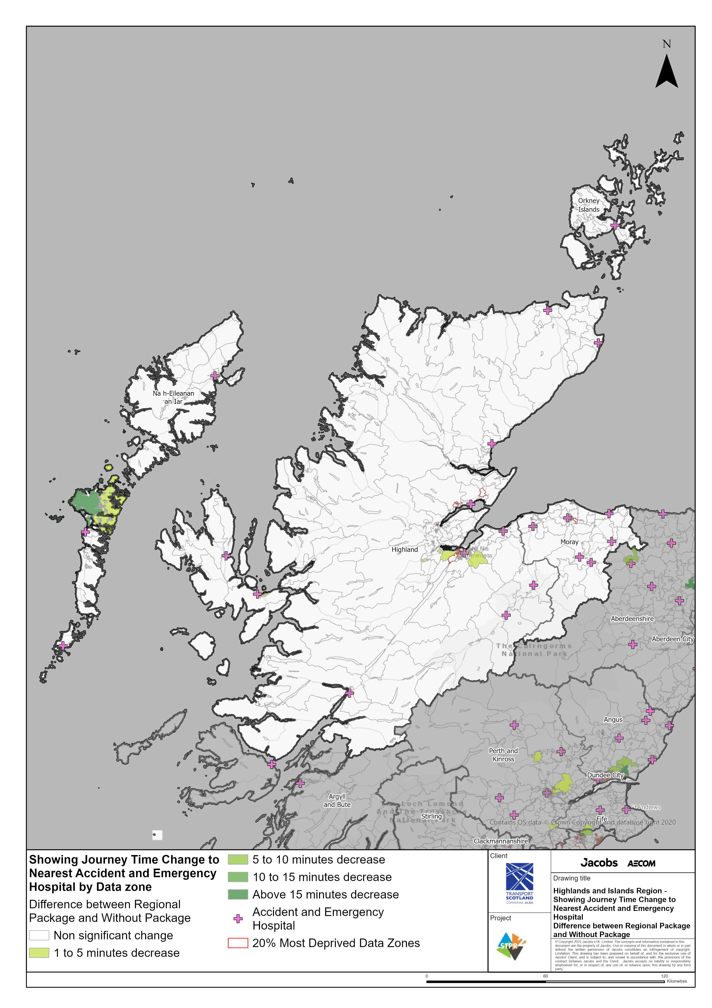
Highlands and Islands Region – Showing Journey Time Change to Nearest Accident and Emergency Hospital Difference between Regional Package and Without Package
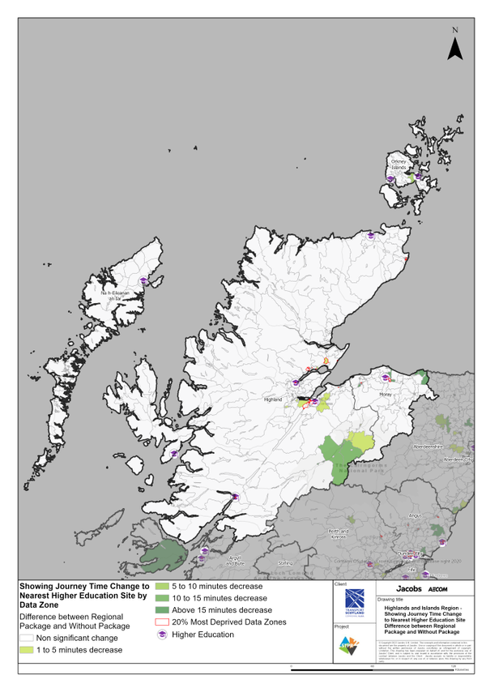
Highlands and Islands Region – Showing Journey Time Change to Nearest Higher Education Site Difference between Regional Package and Without Package
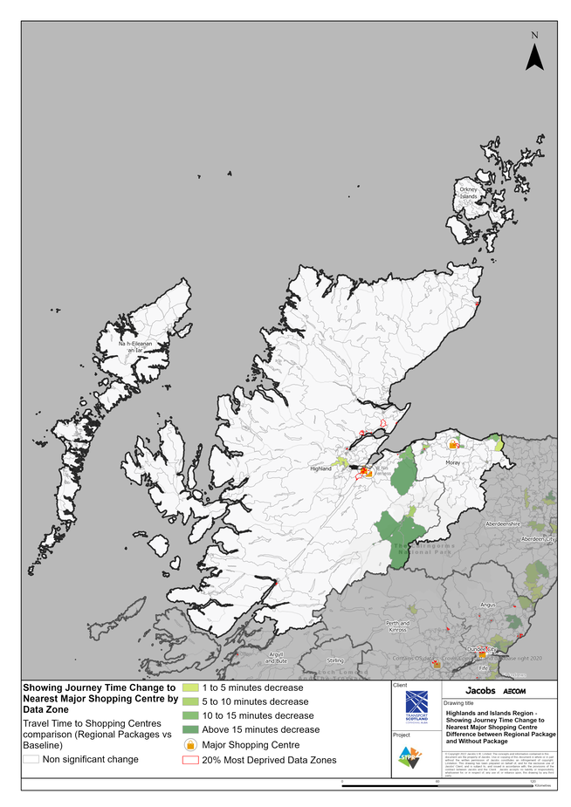
Highlands and Islands Region – Showing Journey Time Change to Nearest Major Shopping Centre Difference between Regional Package and Without Package

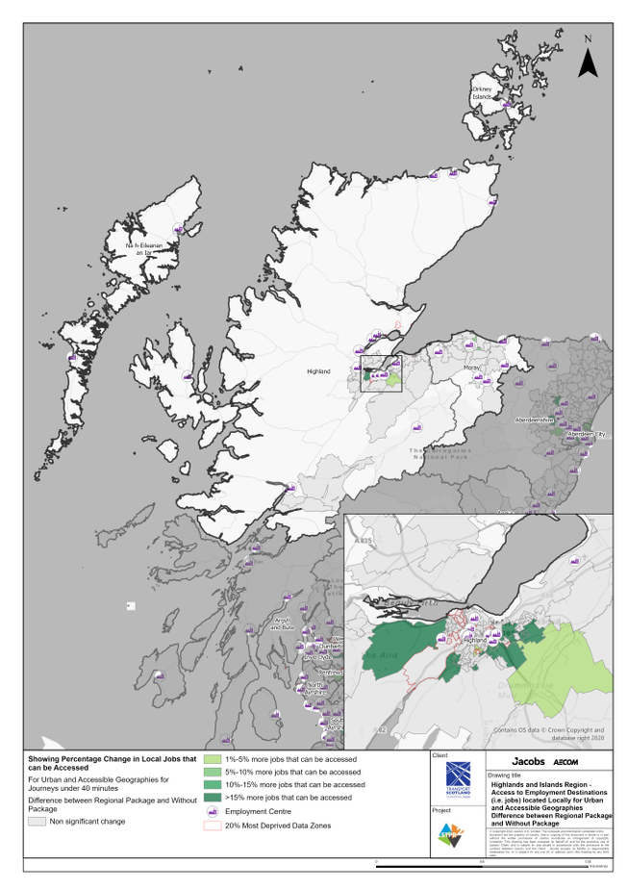
Highlands and Islands Region – Access to Employment Destinations (i.e. jobs) located Locally for Urban and Accessible Geographies for journeys under 40 minutes Difference between Regional Package and Without Package
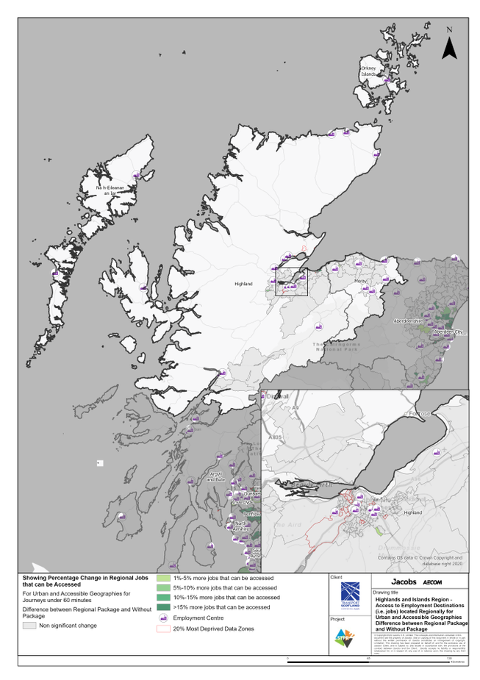
Highlands and Islands Region – Access to Employment Destinations (i.e. jobs) located Regionally for Urban and Accessible Geographies for journeys under 60 minutes Difference between Regional Package and Without Package
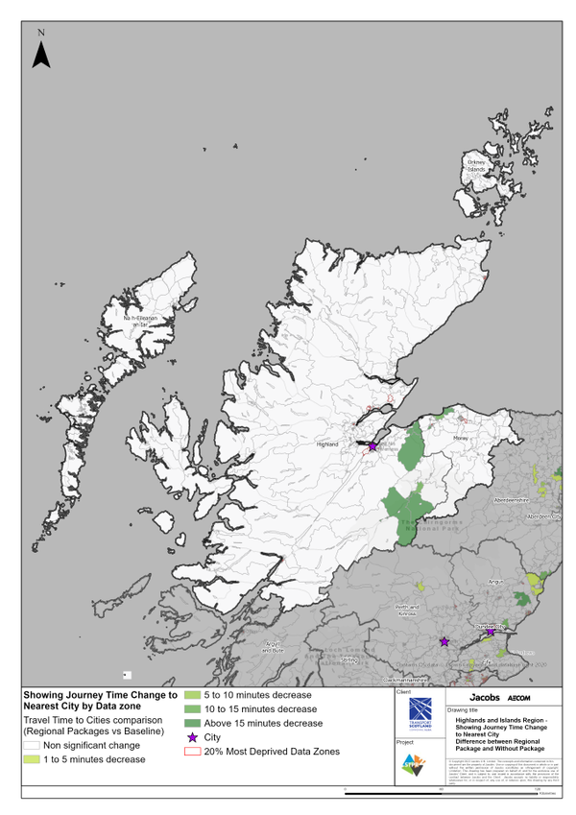
Highlands and Islands Region – Showing Journey Time Change to Nearest City Difference between Regional Package and Without Package
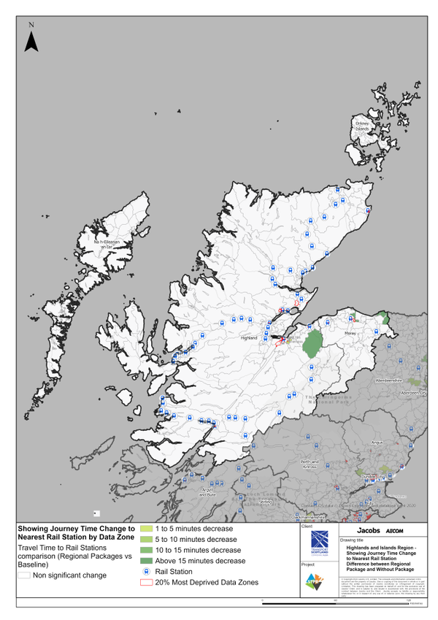
Highlands and Islands Region – Showing Journey Time Change to Nearest Rail Station Difference between Regional Package and Without Package
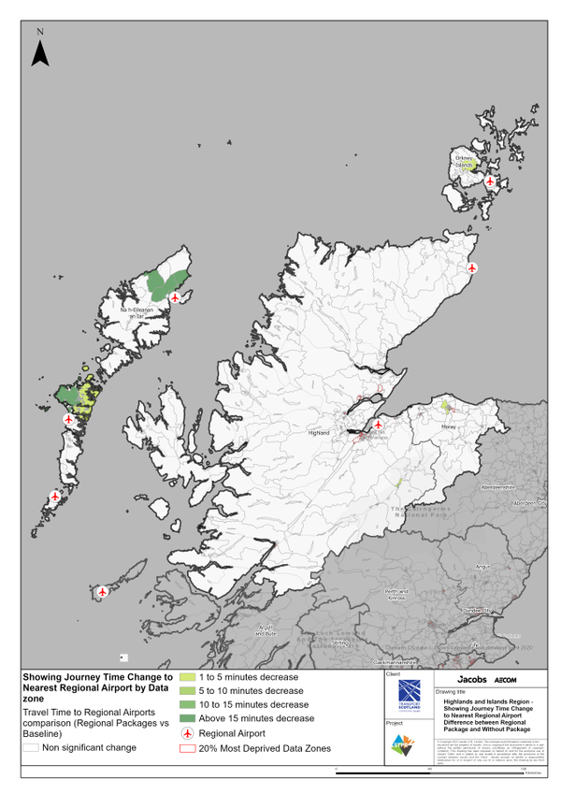
Highlands and Islands Region – Showing Journey Time Change to Nearest Regional Airport Difference between Regional Package and Without Package

Annex B: Traffic Modelling Outputs
