Appendix H: Detailed Packaging - Appraisal Summary Tables

December 2022

Contents
1. Regional Context 5
1.1. Geographic Context 5
1.2. Social Context 5
1.3. Economic Context 6
1.4. Environmental Context 6
2. Problems and Opportunities 8
2.1. Problems 8
2.2. Opportunities 9
3. Regional Recommendations 10
4. Fit with Established Policy 12
5. STPR2 Transport Planning Objectives (TPOs) Assessment 14
6. STAG Assessment 24
6.1. Environment 24
6.2. Climate Change 25
6.3. Health, Safety & Wellbeing 26
6.4. Economy 28
6.5. Equality & Accessibility 29
7. Deliverability 32
7.1. Feasibility 32
7.2. Affordability 32
7.3. Public Acceptability 32
8. Statutory Impact Assessment Criteria 33
8.1. Strategic Environmental Assessment (SEA) 33
8.2. Equalities Impact Assessment (EqIA) 34
8.3. Island Communities Impact Assessment (ICIA) 34
8.4. Child Rights and Wellbeing Impact Assessment (CRWIA) 35
8.5. Fairer Scotland Duty Assessment (FSDA) 35
Annexes 36
Annex A: NAPTAT Mapping 37
Annex B: Traffic Modelling Outputs 44

Glasgow City Region Appraisal Summary Table
An Appraisal Summary Table (AST) has been developed for each of the eleven STPR2 Regions alongside the National AST. The ASTs are set out to provide:
- Regional Context, Problems and Opportunities – drawing on data presented in the Initial Appraisal: Case for Change reports this summarises geographic, social, economic, environmental and transport matters in the region as well as the identified problems and opportunities. In line with STAG, appraisals are expected to explore location-specific problems and opportunities. Local problems and opportunities have been considered to gain a full understanding of the regional and national issues, however some of these may not be within the scope of this strategic study.
- Regional Recommendations – this presents the package of recommendations that were included in the detailed appraisal for the region.
- Fit with Policy – provides a summary of how well the appraised packages fit with key national policies including the second National Transport Strategy, Climate Change Plan Update, the Revised Draft Fourth National Planning Framework (Revised Draft NPF4) and relevant regional policies.
- Transport Planning Objectives (TPO) Assessment – An assessment against each of the five TPOs is provided with quantified metrics, where appropriate, under the Low growth sensitivity with a 20% reduction policy ambition on car kilometres scenario (hereafter referred to as Low scenario) and High growth sensitivity with no policy ambition on car kilometres scenario (hereafter referred to as High scenario) (further information about these scenarios is provided in Appendix F of the Technical Report). A seven point scoring scale is adopted for each TPO which is:
  - + + + = major positive (3 plus signs)
  - + + = moderate positive
  - + = minor positive
  - 0 = neutral
  - - = minor negative
  - - - = moderate negative
  - - - - = major negative (3 minus signs)
- STAG Criteria assessment – as above for the TPO assessment, key points regarding the performance of the package against each of the STAG criteria is presented with quantified metrics provided where appropriate.
- Deliverability – commentary is provided on the assessment of the package in terms of its feasibility, affordability and public acceptability. Note that due to the nature of a number of the STPR2 interventions, and the stage in the business case process STPR2 is at, it has not been possible to derive cost estimates on a regional basis. However, broad capital spending ranges have been estimated over the period 2022 to 2042 at a national level.
- Statutory Impact Assessment Criteria – a summary of the performance of the packages against the Strategic Environment Assessment (SEA), the Equalities Impact Assessment (EqIA), Island Communities Impact Assessment (ICIA), Fairer Scotland Duty Act (FSDA) and Child Rights and Wellbeing Impact Assessment (CRWIA) is provided. The seven point scoring scale is adopted in these assessments where appropriate.

Summary of Assumptions
Quantification of the costs and benefits in the packages has been provided through a modelling exercise. Further information is provided in Appendix F of the Technical Report on the modelling scenarios that have informed the assessment of the STPR2 interventions. A summary of the key assumptions is provided here:
- Population projections are based on the NRS Population Projections (2018-based).
- Economic projections are a combination of projections by Oxford Economics, 2019, the Scottish Fiscal Commission forecasts and more recently the OBR post-COVID estimates.
- Land-use plans are based on data collected for Transport Scotland’s Assembly of Planning Policy Inputs in 2018 from Scotland’s 34 Planning Authorities.
- Permitting of vacant office and retail floorspace to be converted or redeveloped as housing post 2030.
- Working age is taken to be 16-64 (as a constant) to avoid difficulties with changing state pension age (and to reflect non-mandatory retirement)
- The economic results are presented, as is standard within appraisal as discounted values in 2010 prices.

Modelling Tools
For the purposes of modelling accessibility by public transport, NaPTAT (National Public Transport Accessibility Tool) has been used. This allows an assessment of journey time to be compared between the with and without STPR2 package.
Due to the strategic and national nature of STPR2, the national Transport Model for Scotland (TMfS) has been used. TMfS is a national scale model with a focus on inter-urban trips. Whilst TMfS provides a suitable level of robustness at this stage of the appraisal for most of the larger infrastructure based interventions, there are limitations associated with the modelling of smaller/discrete interventions and some of the larger infrastructure interventions that involve changes to the existing road network and those that are more urban in nature. Therefore, separate forecasts of the potential impacts of active travel recommendations on walking and cycling mode share have been made. As the recommended interventions are developed through the business case process, more detailed modelling will be undertaken using regional and / or local models as appropriate.
When considering the outputs presented in this AST, please note the following metrics with respect to the model outputs:
- CO₂ emissions: Likely to underestimate the benefits associated with public transport interventions due to the more limited representation of transport systems in urban areas and a degree of insensitivity to mode shift in TMfS.
- Mode Share: Likely shift to public transport modes underestimated in urban areas due to the more limited representation of urban transport systems and a degree of insensitivity to mode shift in TMfS.
- Change in vehicle kilometres travelled: Likely to underestimate the benefits of reducing vehicle kilometres travelled particularly for short distance journeys due to the more limited representation of urban transport systems and the relative coarseness of the model zone system.
- Lost Time due to congestion: Likely to underestimate the benefits associated with interventions that would reduce roadspace due to the under-representation of the local/secondary road network in TMfS.
- Change in accidents: Likely to underestimate the benefits associated with mode shift to public transport interventions due to the more limited representation of urban transport systems and a degree of insensitivity to mode shift in TMfS.
- Present Value of Benefits: Likely to underestimate the benefits to public transport users due to the more limited representation of urban transport systems. Likely to overestimate the dis-benefits to car-based trips due to the under-representation of the junctions and local/secondary road network in TMfS.

- Regional Context
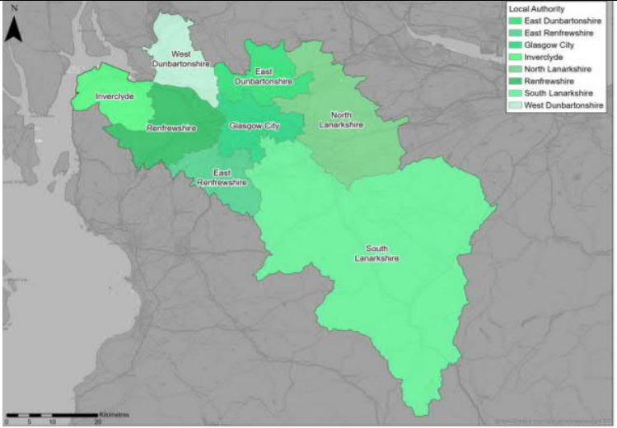
  - Geographic Context
The Glasgow City Region (herein referred to as ‘the Region’) comprises the eight local authorities of East Dunbartonshire, East Renfrewshire, Glasgow City, Inverclyde, North Lanarkshire, Renfrewshire, South Lanarkshire and West Dunbartonshire, and is a mix of urban and rural settlements and areas.
The Scottish Government Urban Rural Six-Fold Classification identifies the regional population residing in each category as follows: Large Urban Areas (55%), Other Urban Areas (35%), Accessible Small Towns (6%), Accessible Rural (4%) and Remote Rural (>1%). This demonstrates that whilst the Region is dominated by the large densely populated urban area of Glasgow City and the immediate adjacent areas, there are also areas of geographical remoteness and of rural nature within the Region. A number of ‘accessible small towns’ are spread across the Region, for example Lanark, Strathaven, Moodiesburn, Bridge of Weir, Kilmalcolm, Bishopton and Lennoxtown.
The region has an extensive transport network, including active travel, rail, subway, bus and road networks, park and ride facilities, ferry links to Dunoon, Bute, Kilcreggan and the internal ferry route between Renfrew and Yoker, as well as Glasgow International Airport. It has two major ports at Greenock and Gourock McInroy’s Point.
  - Social Context
According to the National Records of Scotland’s Mid-year Population Estimates Scotland, the total population in the Region was 1,845,020 in 2019 (34% of the total Scotland population). The Regional population has increased by 3.2% since 2011 Scottish Government Census. Glasgow is the largest settlement with approximately one-third of the Region’s population. In terms of age structure (2019 mid-year estimate), 17.2% of regional residents were children (15 and under), 65.6% were of working age (aged 16 to 64), and 17.2% were 65 and over. The proportion of people aged 65 and over within the Region was 1.9 percentage points lower than the national benchmark, whilst the proportion of people within working age was 1.6 percentage points higher than the national benchmark.
Performance against socio-economic indicators varies across the Region. Overall, the proportion of households with access to a car is lower in the Region compared to Scotland as a whole (62.5% compared to 69.5%, based on 2011 Census), however travel to work by car is the dominant mode with over 60% of people commuting by car. Driving to work makes up 45.2% of trips less than 5 kilometres. Bus carries a total of 11.6% of commuting trips, and rail carries 6.7%, whilst 8.1% of people walk and less than 1% of people cycle. Travel for work within the Region tends to be within the local authority area or into Glasgow City from the surrounding areas. Movements between the other seven local authorities is also noted.
Within the Region 13.2% of people had no qualifications in 2019; which was 3.3 percentage points higher than the national benchmark stated in NOMIS Local Authority Profile. There are pockets of deprivation across the Region, most notably in Glasgow City and Inverclyde. Within the whole Region, 32.0% (747) of SIMD data zones are within the 20% most deprived and 18.2% (425) are within the 10% most deprived. SIMD Health rankings indicate that health quality throughout the Region is varied: in Glasgow City, 48% of data zones are ranked within the lowest quintile (20% most deprived) for health in Scotland, whilst in contrast East Renfrewshire and East Dunbartonshire respectively have 7% and 8% of data zones within the lowest quintile.
  - Economic Context
The Region has approximately one-third of the Scottish population and contributes approximately one-third of the Scottish Gross Value Added (GVA) but also suffers from high levels of deprivation including transport poverty, higher number of benefit claimants, lower educational attainment relative to other regions and high levels of economic inactivity. Economic activity refers to an estimation of whether usual residents aged 16 to 64 were in work or actively looking for work. Economic activity was 75.3% in 2019, compared to 77.5% nationally, and the Region had a slightly higher rate of unemployment (4.0% compared to 3.5% nationally). The Region accounted for 40.5% of Scotland’s total benefits claimants despite making up 33.7% of the country’s population. The Region’s economy has a wide spread of activity with high levels of employment in human health and social work, and administration and defence.
  - Environmental Context
Within the Region, there are many areas classified as environmentally sensitive, with varying levels of statutory protection. Environmental designations include biodiversity, landscape and heritage which fall either wholly or partly within the Region. In addition, according to Historic Environment Scotland, the Region contains a significant number of historic assets, including two designated World Heritage Sites (the Antonine Wall World Heritage Site located at the northern extent of the Region and the village of New Lanark in South Lanarkshire) as well as 8,209 Category A-C Listed buildings. The city of Glasgow has a high concentration of designated cultural heritage assets as expected of a large urban area. Data from the Scottish Government’s Scotland Noise Map shows that the greatest modelled noise levels are located around Glasgow City, primarily associated with the strategic road corridors and Glasgow Airport, together with the rail routes through this area. Settlements at greatest risk of coastal flooding are located along the Firth of Clyde, River Leven and River Clyde. Areas at medium and high risk of river flooding are predominantly located in the vicinity of the River Endrick, River Kelvin, North Calder Water, River Clyde, White Cart Water, Black Cart Water and Gryfe Water. Areas at high and medium risk of surface water flooding are scattered throughout the Region. These are typically associated with surface water features, such as lochs, and are located predominantly within less populated areas of the Region. There are 15 Air Quality Management Areas (AQMAs) within the Region and Low Emission Zone in Glasgow City Centre. In 2018, CO₂ emissions from transport within the Region equated to 31.1% of Scotland’s total transport emissions overall in data from UK Government’s local authority and regional carbon dioxide emissions national statistics.
- Problems and Opportunities
The following transport-related problems and opportunities have been identified for the Glasgow City region.
  - Problems
- Social Exclusion: the Region has the highest levels of deprivation across the STPR2 regions in Scotland, and a wide variance in deprivation levels. This is contributed to by transport provision which can act as a barrier for people accessing employment. Child poverty is notable in the Region with around 1 in 4 children living in poverty.

- Transport Poverty: the Region demonstrates wide variance in transport poverty and proportion of spend on transport. Those further away from Glasgow City are most at risk of transport poverty. South Lanarkshire has the highest proportion of high-risk data zones in the Region (51%), followed by North Lanarkshire (50%). Glasgow City has the lowest proportion of high-risk data zones in the Region (13%).

- Physical Activity and Health: the SIMD health indicators show that the Region suffers from relatively poor health with a mixed picture across the area. In Glasgow City, 48% of data zones are ranked within the lowest quintile (20% most deprived) for health in Scotland, whilst in contrast East Renfrewshire and East Dunbartonshire respectively have 7% and 8% of data zones within the lowest quintile. Between 32% and 36% of data zones within East Renfrewshire and East Dunbartonshire fall within the top quintile in Scotland, whilst Glasgow City, North Lanarkshire and West Dunbartonshire only have 10%, 4% and 5% respectively.

- Air Pollution: air pollution is a problem and there are a number of AQMAs and a Low Emission Zone in place to tackle this. Particulate concentration is particularly prevalent in Glasgow City and immediately surrounding areas, with highest concentrations along key road links (M8 and M74) and the surrounding area.

- Accessibility: levels of access vary considerably with many parts of the Region in the lowest decile of SIMD Geographic Access, particularly South Lanarkshire and areas of East Renfrewshire, Renfrewshire and North Lanarkshire. During consultation, physical access issues relating mostly to the walking environment were reported by some groups. Bus decline is of concern, with the highest levels of decline experienced in this region when compared to the rest of the UK.

- Connectivity: whilst connectivity into Glasgow City is generally good, cross-regional connections are considered by stakeholders to be poor. This is reported to limit options for people, resulting in car being the mode of choice which in turn leads to higher levels of congestion. A gap exists between Queen Street and Glasgow Central rail stations that acts as a barrier to integrated travel.

- Active Travel: despite relatively good levels of possible penetration of the Region by bicycle, cycling is poorly represented in the mode share for the Region. Reasons given for this in the consultation were largely down to safety concerns. Walking is also slightly lower in this region when compared to other relevant benchmarks which is backed up by physical activity data.

- Safety: despite safety across road-based modes improving in the Region, targets for the reduction in serious casualties were not met. Additionally, accident statistics from Department for Transport show an 18% increase in annual average accidents in the Region involving a bicycle in the 2014 to 2018 period compared to the 2004 to 2008 period although anecdotal reports suggest the level of cycling has increased.

- Capacity constraints: key points on the trunk road and motorway network have capacity issues. This is reported to cause problems for bus operators and make bus travel less attractive. Pre-Covid-19 overcrowding on peak time rail services was identified within Network Rail’s Scotland Route Study and echoed through consultation. This serves to deter mode shift to public transport.

  - Opportunities
- Climate Emergency: the Climate Emergency is considered to provide a base upon which sustainable interventions that do not favour private car use would be more publicly acceptable.

- Economic Base: the Region has a strong economic base that offers a solid asset to build upon.

- Technology: technology offers potential for better ways to work, connect and inform people of transport choices, alongside advances in lower emission fuels.

- Night Time Economy: the night-time economy in the Region offers a good base of economic activity that could benefit from improved access.

- Transport (Scotland) Act 2019: the Transport (Scotland) Act 2019 alters the powers available to Local Authorities allowing them the opportunity to address some transport problems in their area.

- Clyde Mission: Clyde Mission is a Government-supported aspect of the 2019-20 Economic Action Plan to encourage investment in the Clyde area, has the potential to have an impact on large numbers of people and businesses within the Region. This is also identified in NPF4 as a national development.

- Regional Recommendations
The following list of interventions forms a package of recommendations that are relevant to this Region.
Regional Recommendations
- Connected neighbourhoods (Recommendation 1)
- Active freeways and cycle parking hubs (Recommendation 2)
- Village-town active travel connections (Recommendation 3)
- Connecting towns by active travel (Recommendation 4)
- Long-distance active travel network (Recommendation 5)
- Behavioural change initiatives (Recommendation 6)
- Changing road user behaviour (Recommendation 7)
- Increasing active travel to school (Recommendation 8)
- Improving access to bikes (Recommendation 9)
- Expansion of 20mph limits and zones (Recommendation 10)
- Clyde Metro (Recommendation 11)
- Provision of strategic bus priority measures (Recommendation 14)
- Edinburgh/Glasgow-Perth/Dundee Rail Corridor Enhancements (Recommendation 17)
- Supporting integrated journeys at ferry terminals (Recommendation 18)
- Infrastructure to provide access for all at railway stations (Recommendation 19)
- Investment in Demand Responsive Transport and Mobility as a Service (Recommendation 20)
- Improved public transport passenger interchange facilities (Recommendation 21)
- Framework for the delivery of mobility hubs (Recommendation 22)
- Smart, integrated public transport ticketing (Recommendation 23)
- Ferry vessel renewal and replacement and progressive decarbonisation (Recommendation 24)
- Decarbonisation of the rail network (Recommendation 25)
- Decarbonisation of the bus network (Recommendation 26)
- Behavioural change and modal shift for freight (Recommendation 27)
- Zero emission vehicles and infrastructure transition (Recommendation 28)
- Trunk road and motorway safety improvements to progress towards ‘Vision Zero’ (Recommendation 30)
- Trunk road and motorway network climate change adaptation and resilience (Recommendation 31)
- Trunk road and motorway network renewal for reliability, resilience and safety (Recommendation 32)
- Future Intelligent Transport Systems (Recommendation 33)
- Traffic Scotland System Renewal (Recommendation 34)
- Intelligent Transport System renewal and replacement (Recommendation 35)
- Strategy for improving rest and welfare facilities for hauliers (Recommendation 36)
- Improving active travel on trunk roads through communities (Recommendation 37)
- Speed Management Plan (Recommendation 38)
- Investment in port infrastructure to support vessel renewal and replacement, and progressive decarbonisation (Recommendation 42)
- Major station masterplans (Recommendation 43)
- Rail freight terminals and facilities (Recommendation 44)
- High speed and cross-border rail enhancements (Recommendation 45)

- Fit with Established Policy
The interventions included within this package support a wide range of national, regional and local policy documents in which transport improvements play a key role in both the enabling and delivery of outcomes.
Key policies supported include the Programme for Government, Infrastructure Investment Plan, NTS2, the Climate Change Plan Update 2018 – 2032, SPT’s Regional Transport Strategy including the objectives set out in their Case for Change for the Regional Transport Strategy currently in development and due for publication 2022, the Strategic Development Plan ‘Clydeplan’, and SPT’s Freight Strategy, as well as non transport-specific plans, such as the Glasgow City Region Economic Strategy and Action Plan, and the Glasgow City Region Tourism Strategy 2018-2023.
Interventions included in this package will also support more resilient connections to the Revised Draft Fourth National Planning Framework (Revised Draft NPF4) national development at Clyde Mission as well as supporting development of a low carbon mass transit system for the Region.
The policy framework for the Region has a strong emphasis on improved connectivity, addressing inequality, and addressing barriers to employment, to help deliver well-connected, sustainable communities, promote modal shift away from private car, increase walking and cycling opportunities, and provide an attractive place for visitors and for businesses to invest and grow. Therefore, the package closely aligns with established policy directives.

Package Performance Against NTS2 Priorities and Outcomes:

Reduce inequalities
Will provide fair access to services we need: Major Positive
Will be easy to use for all: Major Positive
Will be affordable for all: Minor Positive

Takes climate action
Will help deliver our net-zero target: Major Positive
Will adapt to the effects of climate change: Minor Positive
Will promote greener, cleaner choices: Major Positive

Helps deliver inclusive economic growth
Will get people and goods where they need to get to: Major Positive
Will be reliable, efficient and high quality: Major Positive
Will use beneficial innovation: Major Positive

Improves our Health and Wellbeing
Will be safe and secure for all: Major Positive
Will enable us to make healthy travel choices: Major Positive
Will help make our communities great places to live: Major Positive

- STPR2 Transport Planning Objectives (TPOs) Assessment

TPO1 A sustainable strategic transport system that contributes significantly to the Scottish Government’s net-zero emissions target

TPO Performance Summary
Carbon dioxide equivalent (CO₂eq) is treated as a nationally important pollutant. As such, although it can be appraised at the national level (commentary below), it has not been appraised for individual regions.
The national and all regional packages will contribute significantly to the net-zero emissions target by:
- Enabling more passenger journeys to be made by active modes and public transport.
- Decarbonising most if not all public transport operations.
- Facilitating uptake of electric vehicles.
- Enabling road freight to switch to rail or other low carbon modes.
Further commentary is provided below.
Carbon dioxide equivalent (CO₂eq) is treated as a nationally important pollutant. As such, although it can be appraised at the national level (commentary below), it has not been appraised for individual regions.
National CO₂eq emissions are forecasted to decrease year-on year. This is due to decreasing vehicle exhaust (non-traded) emissions as the number of internal combustion engine vehicles reduces. This is reflected in the volume of traded grid emissions from charging increased numbers of battery-electric vehicles, and specifically in the Low scenario. It is noted that traded emissions of CO₂eq are associated with electrical generation to supply plug-in vehicles, both BEV (battery electric vehicles) and PHEV (plug-in hybrid vehicles).
The electricity grid is expected to be using predominantly renewable sources in the future and so increasing adoption of electric vehicles and a shift from direct, non-traded, emission to traded grid based technology (i.e. battery) will support reducing CO₂eq emissions.
Across both Low and High scenarios the interventions would reduce emissions of CO₂eq.
Significantly higher overall emissions are predicted in the High scenario, either with, or without, the national and all regional packages. There is a relatively smaller overall reduction of emissions due to the interventions in the Low scenario due to the lower overall emissions. The economic impacts associated with air quality were assessed using the Department for Environment Food & Rural Affairs (DEFRA) Damage Costs Appraisal Toolkit. The larger economic benefit from the High scenario is due to the greater overall emissions with, or without, the package, although the proportional change in emissions is lower.
Overall Scoring:
Low and High Scenarios: Major Positive

Metric 1: Change in CO₂eq (non-traded and traded emissions from regional road transport inc. grid emissions from charging light-duty vehicles)- Figures below are a National calculation
Low Scenario Commentary:
- 0.5% decrease (27,700 tonnes CO₂eq) in 2030.
- 2.8% decrease (21,600 tonnes CO₂eq) in 2045.
- 1.3 million tonnes reduction, of which 1.1 million were traded, for the 60-year appraisal period from 2030 to 2089.
- The net economic benefits for the 60-year appraisal period in 2010 prices and values would be in the range £10 million to £25 million for the Low scenario.
High Scenario Commentary:
- 0.4% decrease (31,300 tonnes CO₂eq) in 2030.
- 1.3% decrease (65,300 tonnes CO₂eq) in 2045.
- 3.7 million tonnes reduction, of which 452,000 were traded, for the 60-year appraisal period from 2030 to 2089.
- The net economic benefits for the 60-year appraisal period in 2010 prices and values would be in the range £100 million to £250 million for the High scenario.

Metric 2: Change in mode share by active travel for all journeys
Low and High Scenarios Commentary:
- Potential increase in walking from 21% mode share to 27% mode share (6 percentage points).
- Potential increase in cycling from 0.6% mode share to 20% (over 19 percentage points).
The package will increase significantly the proportions of journeys undertaken by active modes. If all the active travel and behaviour change interventions were fully implemented in every relevant location in the Region, rates of walking and cycling are anticipated to increase as shown below.
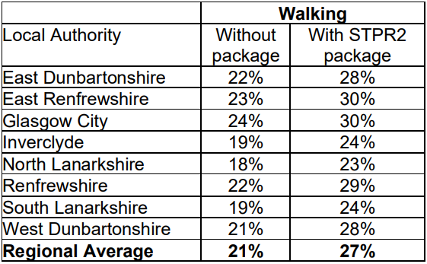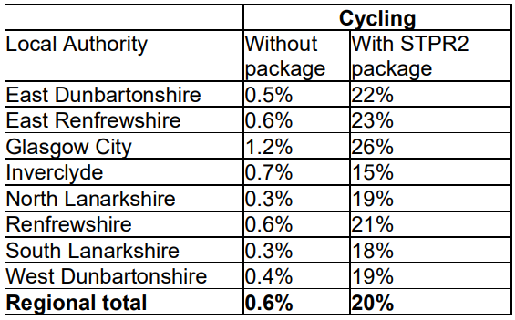
Note that the cycling and walking growth forecasts have been developed independently. Growth in use of one active mode is likely to abstract at least some trips from the other, but this effect is not accounted for within these forecasts.

Metric 3: Change in motorised vehicle kilometres travelled
Low Scenario Commentary:
- Reduction of 222 million motorised vehicle kilometres (3% decrease) (see Annex B).
High Scenario Commentary:
- Reduction of 245 million motorised vehicle kilometres (2% decrease) (see Annex B).

TPO2 An inclusive strategic transport system that improves the affordability and accessibility of public transport

TPO Performance Summary
The package will improve the inclusiveness of the transport system by:
- Improving conditions for people walking, wheeling and cycling, the most inclusive transport modes, with particular benefits for people most often excluded (including children, older and disabled people, and people on low incomes)
- Providing a step changes in improved inclusive accessibility to public transport stops/stations through the delivery of Clyde Metro
- Seeking to promote public transport use and reduce operating costs, hence enhancing network sustainability
- Provision of Clyde Metro will greatly enhance accessibility and connectivity in the Region providing a high level of service and significantly improved interchange opportunities providing greater ease for cross region movements as well as better access to Glasgow City Centre.
Overall Scoring:
Low and High Scenarios: Major Positive

Metric 1: Change in transport poverty risk
Low and High Scenarios Commentary:
Although the STPR2 interventions don’t impact on the direct costs of travel (e.g. fares, fuel price), the package of interventions would see small reduction in transport poverty, due to the overall improvements to access and connectivity between modes.

Metric 2: Change in Accessibility - population catchments increases to key services by journey time by public transport
Low and High Scenarios Commentary:
The largest change in population accessibility of all the destination types considered was to accident and emergency hospital, whereby an additional 64,200 of the population in the Region are forecast to be able to access the nearest site in a journey time of 30 minutes or less by public transport with the STPR2 package compared to the without package assessment. This represents a 4.2 percentage point increase in accessibility levels from 57.0% in the without package assessment to 61.2% with the package in place. The improvements are shown across several parts of the Region, particularly in the northwest, including Erskine which had an increase of 100 percentage points, and a population of 14,000. This is shown by the map output in Annex A.

There are also population accessibility improvements forecast in the Region for accessing certain key destinations within the same time period (under 30 minutes) using public transport, which included higher education, major shopping centres, large food store, secondary schools and GP surgeries. The accessibility improvements and the corresponding additional population that are able to access those destinations within a journey time of 30 minutes in the with STPR2 package assessment compared to the without package assessment are summarised below:

- 47,200 additional people are forecast to be able to access the nearest higher education site by public transport, as shown by the map output in Annex A, which represents a 3.1 percentage point increase in accessibility levels from 79.0% in the without package assessment to 82.1% with the package in place.
- 16,300 additional people are forecast to be able to access a major shopping centre by public transport, which represents a 1.1 percentage point increase in accessibility levels from 87.1% in the without package assessment to 88.2% with the package in place.
- 4,400 additional people are forecast to be able to access a large food store by public transport, which represents a 0.3 percentage point increase in accessibility levels from 94.6% in the without package assessment to 94.9% with the package in place.
- 1,800 additional children (aged 11 to 18) are forecast to be able to access the nearest secondary school by public transport, which represents a 1.2 percentage point increase in accessibility levels from 91.4% in the without package assessment to 92.6% with the package in place.
- 600 additional people are forecast to be able to access the nearest GP surgery by public transport, which represents a less than 0.1 percentage point increase in accessibility levels from 98.1% in the without package assessment to 98.1% with the package in place.

In terms of additional destinations (cities, rail stations and airports) considered in the model:
- 55,600 additional people are able to access Glasgow City Centre within a 30 minute public transport journey, which represents a 3.7 percentage point increase in accessibility levels from 44.1% in the without package to 47.8% with the package in place.
- 4,600 additional people are able to access their closest rail station within a 30 minute public transport journey, which represents a 0.3 percentage point increase in accessibility levels from 96.7% in the without package to 97.0% with the package in place.
- 78,400 additional people are able to access their closest international airport within a 30 minute public transport journey, which represents a 5.1 percentage point increase in accessibility levels from 3.0% in the without package to 8.1% with the package in place.
- 162,000 additional people are able to access their closest international airport within a 60 minute public transport journey, which represents a 10.6 percentage point increase in accessibility levels from 50.4% in the without package to 61.0% with the package in place.

Mapping outputs are shown in in Annex A.

TPO3 A cohesive strategic transport system that enhances communities as places, supporting health and wellbeing

TPO Performance Summary
The package will improve communities as places, supporting health and wellbeing by enabling more journeys to be made by active and sustainable modes, and by improving road safety. This will:
- Improve many people’s physical health and mental wellbeing, with particular benefits for people most often excluded (including children, older and disabled people, and people on low incomes).
- Reduce the adverse impacts of car use on communities and health (including reduced air pollution, noise, accident risk and perceived road danger).
The analysis shows that through improved uptake of walking and cycling, there would be a forecast annual reduction of around 100 premature deaths due to the health benefits arising from active travel.
Overall Scoring:
Low and High Scenarios: Major Positive

Metric 1 Change in mode share by active travel for all journeys
Low and High Scenarios Commentary:
- Potential increase in walking from 21% mode share to 27% mode share (6 percentage points).
- Potential increase in cycling from 0.6% mode share to 20% (over 19 percentage points).
These forecasts are subject to all active travel interventions being delivered in all relevant areas of the Region.
Cycling and walking growth forecasts have been developed independently. Growth in use of one active mode is likely to abstract at least some trips from the other, but this effect is not accounted for within these forecasts.

Metric 2 Potential for Change in 'Place'
Low and High Scenarios Commentary:
The package will tend to improve the quality of the Region’s places by improving local accessibility and reducing the adverse impacts of road traffic.
Particular benefits may arise through Connected Neighbourhoods where active travel allows easier walking and cycling conditions in more pleasant and secure conditions. Development around Clyde Metro should be considered to ensure the transport provision enhances the sense of place.

Metric 3 Change in Health Benefits
Low and High Scenarios Commentary:
The health benefits of increased rates of active travel as a result of the package have been quantified using the WHOs Health Economic Assessment Tool (HEAT). HEAT estimates the health and economic impacts of increased walking and cycling, providing assessments of the health and economic impacts of walking and cycling on premature mortality and on exposure to air pollution. Outputs from the tool shows the following benefits by Local Authority:
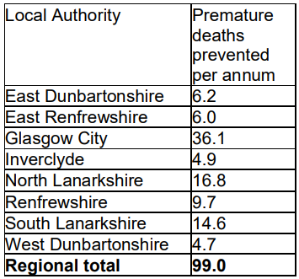

TPO4 An integrated strategic transport system that contributes towards sustainable inclusive growth in Scotland

TPO Performance Summary
The package will contribute to sustainable inclusive growth in Scotland by:
- Improving integration of transport modes (especially between active modes and public transport) and between transport and major developments.
- Improving journey time reliability.
- Enabling more people to travel by improving the accessibility and affordability of the transport system,so enabling more people to access local retail and services, and opportunities for employment and education/training.
Encouraging modal shift to sustainable modes and reducing the volume of vehicles on the road network is anticipated to improve journey time reliability for all vehicles, whilst this is likely to provide benefits to businesses across the Region under the high growth scenario where traffic volumes are higher, a negligible reduction in business and commercial vehicle hours is anticipated under the low growth scenario as levels of congestion are not as great under the without package scenario. A reduction in vehicles hours of approximately 212,000 hours is anticipated in the high growth scenario for business and commercial travel contributing towards sustainable inclusive growth in Scotland.
Overall Scoring:
Low and High Scenarios: Moderate Positive

Metric 1: Increased labour catchment by sustainable travel (PT/Active Travel)
Low and High Scenarios Commentary:
Access to local employment, which represents the accessibility of key employment opportunities located in the surrounding area within a 40 minute public transport journey time, showed improvements in all Local Authority areas but particularly in Renfrewshire, Glasgow City and East Renfrewshire, where at least an additional 10,900 existing jobs are able to be reached. This is shown by the map output in Annex A.
Access to regional employment, which represents the accessibility of key employment opportunities located in Glasgow City within a 60 minute journey time using public transport, improved in the Region with the package on average enabling an additional 20,200 of existing jobs to be accessed. This is shown by the map output in Annex A. The modelling showed an improvement in all Local Authorities with the package enabling on average an additional 5,900 to 29,800 of existing jobs to be accessed from authorities within 60 minutes by public transport. North Lanarkshire, Renfrewshire, East Dunbartonshire and East Renfrewshire observed the highest increases, whereby an additional 23,500, 24,100, 24,800, and 29,800 of existing jobs located in Glasgow City are able to be accessed respectively. This is shown by the map output in Annex A.
The rural population observed little change in journey times to the nearest employment site by public transport.

Metric 2: Change in lost time due to congestion (for business/ commercial transport)
Low Scenario Commentary:
- Negligible impact on vehicle hours.
High Scenario Commentary:
- 1% decrease (equivalent to reduction of 212,000 hours) in lost time due to congestion.

TPO5 A reliable and resilient strategic transport system that is safe and secure for users

TPO Performance Summary
The package will improve reliability, safety and personal security on the transport system by:
- Improving journey time reliability, including through reduced likelihood of significant network disruptions.
- Reducing the risk of road accidents at hotspot locations on the Trunk Road network.
- Reducing perceived risks to road safety and to personal security, so enabling more people (particularly children, women and older people) to travel independently.
- Changing attitudes of road users, through behavioural change campaigns. This is anticipated to increase awareness of interactions with those walking, wheeling and cycling
- Improving active travel provision and providing more dedicated and segregated routes for walking, cycling and wheeling.
Overall Scoring:
Low and High Scenarios: Moderate Positive

Metric 1 Change in accidents (PIA and ‘damage-only’)
Low Scenario Commentary:
- Accident reduction related to motorised vehicle kilometres is forecast to be 3%.
High Scenario Commentary:
- Accident reduction related to motorised vehicle kilometres is forecast to be 2%.
Low and High Scenarios Commentary:
Whilst the number of accidents involving motorised vehicles is anticipated to reduce following the introduction of the interventions within this package, it is anticipated that it would increase walking and cycling journeys. The number of accidents involving these modes is therefore anticipated to increase, although each individual journey is anticipated to be significantly safer.

Metric 2 Percentage accident change for Targeted Infrastructure Improvements over 60 years, using default accident rate (PIA only)
Low and High Scenarios Commentary:
Accident benefits were estimated using the Department for Transport (DfT) recommended software programme COBA-LT (Cost and Benefit to Accidents – Light Touch) for targeted road safety improvements, based on default parameters, but using Scotland specific accident rates. A range of accident benefits were calculated for the various improvement options being considered. This provided the upper and lower bound of estimated percentage change in accidents, respectively. These ranges are shown below and provide the anticipated upper and lower bounds of impact on accidents that would be anticipated from typical interventions of this type:
- Sections of Realignment/Widening - reduction of 23% to 59%.
- Sections of Overtaking Opportunities - reduction of 35% to 73%.
- Locations of Junction Improvements - change of 42% (increase) to 64% (decrease).

It should be noted that junction accidents are forecast to increase in the event that a junction is upgraded from a priority to a signalised junction. This is due to an increase in the number of slight accidents that are likely to occur as a result of shunts in queuing traffic on the mainline approach to the traffic signals, which could previously travel unopposed. However, the accident severity can be expected to reduce as a result of this type of improvement. Any improvement scheme would be subject to further consideration.

Metric 3 Change in lost time due to congestion
Low Scenario Commentary:
- 4% decrease (490,000 hours) in time lost due to congestion (see Annex B).
High Scenario Commentary:
- 4% decrease (2.1 million hours) in time lost due to congestion (see in Annex B).

Metric 4 Journey Time Reliability /Availability of alternatives (modes/routes)
Low and High Scenarios Commentary:
This package is forecast to reduce overall motorised vehicle kilometres by 3% and 2% under the Low and High scenarios respectively. This reduces the risk of accidents occurring as a result of reducing travel, whilst improving resilience by reducing the number of road closures associated with accidents.
Targeted improvements on the trunk road and motorway network where safety is a problem is forecast to reduce accidents and the associated reduction in road closures from such incidents would also help improve reliability. Improvements in terms of renewals and climate change adaptation to protect the operation of the trunk road and motorway network would also positively impact on the reliability of the network.
Bus priority and Clyde Metro interventions are anticipated to provide greater reliability to public transport journeys particularly at peak times when current bus services are often hampered by congestion.
Encouraging modal shift to sustainable modes and reducing the volume of vehicles on the network is anticipated to improve journey time reliability, as indicated by reducing time lost to congestion of 490,000 and 2,130,000 hours in the Low and High scenarios respectively.

- STAG Assessment
  - Environment

Environment

Air Quality
Performance Summary:
Total emissions of NO_{X} (a group of gases that are mainly formed during the combustion of fossil fuels) were predicted to decrease in future in both the High and Low scenario.
Total emissions of NO_{X} were predicted to be effectively zero in 2045 in the Low scenario, and 2052 in the High scenario either with, or without, the proposed package. It is the change brought about by the projected transition of the vehicle fleet to zero-emission vehicles that contribute to the majority of air quality benefits, and in this instance outweighs the positive mode change contributions from the regional package.
Total emissions of Particulate Matter (PM), which is made up of a collection of solid and / or liquid materials, were predicted to increase in future predominantly due to non-exhaust emissions from road, tyre and brake-wear.
However, the package will reduce harmful emissions slightly. Over the 60-year appraisal period there was a predicted 100% reduction in NO_{X}, 2.6% reduction in PM10 and 2.7% reduction in PM2.5 in the Low scenario, and a 4.7% reduction in PM10 and a 4.8% reduction in PM2.5 in the High scenario.
Low Scenario Scoring: Minor Positive
High Scenario Scoring: Minor Positive

Noise and Vibration
Performance Summary:
The anticipated modal shift is also expected to reduce levels of noise and vibration associated with the transport network. There is potential for a localised negative effect on noise and vibration due to the construction and operation of specific interventions including Clyde Metro and High speed and cross border rail enhancements however the magnitude of effect will depend on the design and location of the intervention.
Low Scenario Scoring: Minor Positive
High Scenario Scoring: Minor Positive

Biodiversity and Habitats: Geology and Soils; Land Use (including Agriculture and Forestry); Water, Drainage and Flooding; Historic Environment; and Landscape
Low and High Scenarios Commentary:
Please refer to SEA performance summary text in the ‘Statutory Impact Assessment Criteria’ section below. Please note the scoring has been based on the SEA methodology for scoring, which has been agreed with the SEA Consultation Authorities.
  - Climate Change

Climate Change

Performance Summary (applicable to all Climate Change Sub-Criteria)
Carbon dioxide equivalent (CO₂eq) is treated as a nationally important pollutant. As such, although it can be appraised at the national level (commentary below), it has not been appraised for individual regions.
National CO₂eq emissions are forecasted to decrease year-on year, with decreasing direct (non-traded) emissions and increasing traded grid emissions with increased adoption of battery-electric vehicles, and specifically in the Low scenario. It is noted that traded emissions of CO₂eq are associated with electrical generation to supply plug-in vehicles, both BEV (battery electric vehicles) and PHEV (plug-in hybrid vehicles).
Across both scenarios the package will reduce emissions of CO₂eq, although the change is greater in the High scenario due to overall higher emissions.
Key recommendations within the package have a focus on identifying vulnerabilities to the effects of climate change on the transport system, as well as identifying measures to assist in the adaptation to the effects of climate change, including unplanned events, such as flooding, landslides and high winds. Climate change adaptation and network resilience would address existing and predicted climate change impacts and support the changes that are necessary to reach the Scottish Government’s net zero target for greenhouse gas emissions. Improving the climate resilience of the transport network will also align with the Scottish Government’s commitment to develop Scotland’s next statutory climate adaptation programme.
The above summary is applicable across all the sub-criteria, as outlined below. The specific performance against each sub-criteria is scored against both the Low and High scenarios.

Greenhouse Gas Emissions
Low Scenario Scoring: Major Positive
High Scenario Scoring: Major Positive

Vulnerability to Effects of Climate Change
Low Scenario Scoring: Minor Positive
High Scenario Scoring: Minor Positive

Potential to Adapt to Effects of Climate Change
Low Scenario Scoring: Minor Positive
High Scenario Scoring: Minor Positive
  - Health, Safety & Wellbeing

Health, Safety & Wellbeing

Performance Summary (applicable to all Health, Safety & Wellbeing Sub-Criteria)
The package will reduce the number and severity of accidents through targeted infrastructure improvements and by encouraging modal shift away from private car, resulting in reduced accident risk due to reduced conflicts. Whilst the number of accidents involving motorised vehicles is anticipated to reduce following the introduction of the interventions within this package, it is anticipated that the package would increase walking and cycling journeys. The number of accidents involving these modes is therefore anticipated to increase, although each individual journey is anticipated be significantly safer
Mode shift to sustainable modes will, by improving natural surveillance, make paths, stops, stations and services less isolated and this, accompanied by improved quality of facilities will improve perceived security.
The package will improve communities as places, supporting health and wellbeing, by encouraging modal shift away from private car and towards active travel. This will improve placemaking through reduced noise and better air quality due to reduced traffic, and reduced accident risk. It will also benefit many people’s physical health and mental wellbeing.

Accidents (PIA and ‘damage-only’)
Low Scenario Commentary:
- Accident reduction related to motorised vehicle kilometres is forecast to be 4%.
High Scenario Commentary:
- Accident reduction related to motorised vehicle kilometres is forecast to be 3%.

Percentage accident change for Targeted Infrastructure Improvements over 60 years using default accident rate (PIA only)
Low and High Scenarios Commentary:
Accident benefits were estimated using the Department for Transport (DfT) recommended software programme COBA-LT (Cost and Benefit to Accidents – Light Touch) for targeted road safety improvements, based on default parameters, but using Scotland specific accident rates. A range of accident benefits were calculated for the various improvement options being considered. This provided the upper and lower bound of estimated percentage change in accidents, respectively. These ranges are shown below and provide the anticipated upper and lower bounds of impact on accidents that would be anticipated from typical interventions of this type:
- Sections of Realignment/Widening – reduction of 23% to 59%.
- Sections of Overtaking Opportunities – reduction of 35% to 73%.
- Locations of Junction Improvements – change of 42% (increase) to 64% (decrease).

It should be noted that junction accidents are forecast to increase in the event that a junction is upgraded from a priority to a signalised junction. This is due to an increase in the number of slight accidents that are likely to occur as a result of shunts in queuing traffic on the mainline approach to the traffic signals, which could previously travel unopposed. However, the accident severity can be expected to reduce as a result of this type of improvement. Any improvement scheme would be subject to further consideration.

Security
Low and High Scenarios Commentary:
The package will, by increasing the number of people travelling actively and by public transport, tend to improve natural surveillance and will, through improvements to lighting and urban realm, tend to reduce the number of locations at which security is a concern. Clyde Metro would consider security as part of station design and may provide improved security through higher frequency services than that currently provided by rail.

Health Outcomes
Low and High Scenarios Commentary:
The package will improve both health and wellbeing outcomes by increasing rates of active travel and hence physical activity. The estimated value of health benefits to the Region’s population, appraised over a 60-year period, is in the range £5 billion to £10 billion.
The package will also tend to improve local air quality, by encouraging car journeys to switch to less polluting modes, and hence health outcomes. This would be of particular benefit In those areas with identified AQMAs

Access to Health and Wellbeing Infrastructure
Low and High Scenarios Commentary:
An additional 64,200 of the population in the Region are forecast to be able to access an accident and emergency hospital in a journey time of under 30 minutes by public transport with the package in place compared to the without package assessment. This represents a 4.2 percentage point increase in accessibility levels from 57.0% in the without package assessment to 61.2% with the package in place. This is shown by the map output in Annex A.

These accessibility to accident and emergency hospital improvements were reported in all Local Authority areas within the Region though particularly in Glasgow City, Renfrewshire and South Lanarkshire, with all reporting an increase in excess of 10,000 people (22,700, 16,500 and 10,300 respectively).

Visual Amenity
Low and High Scenarios Commentary:
The package should have a positive impact on visual amenity through improvements to walking and cycling infrastructure and an improved sense of ‘place’. Clyde Metro would require to be designed to enhance the sense of place and not act as a visual barrier.
Care would be required in the development of any rail freight facilities to ensure they did not detrimentally impact nearby communities.
  - Economy

Economy

Performance Summary
The majority of economic benefits that accrue are as a result of the sustainable transport interventions in the Region’s package to enable and encourage mode shift to public transport modes. The Clyde Metro mass transit intervention, in conjunction with the Bus Priority Infrastructure, Interchange and Rail interventions are the main contributors to the public transport user benefits total in the Low scenario. The remainder of the benefits are largely due to the increase in public transport operator revenue as a result of the increased patronage levels arising from the mode shift away from car.
The level of public transport user benefits reduces in the High motorised demand scenario. The High scenario also has a slight reduction in public transport operator revenue.
In terms of accident savings, the level of benefits is larger in the High scenario. The benefits arise as a result of the reduction in road-based vehicle kilometres travelled in the Region, with the mass transit, active travel and public transport interventions encouraging a mode shift away from private car. As the absolute reduction in vehicle kilometres as a result of the interventions is larger in the High scenario, this directly equates to the increase in the value of accident benefits.
Note that due to the nature of a number of the STPR2 interventions it has not been possible to derive indicative cost estimates on a regional basis.

User Benefits (2010 prices and values for a 60 year appraisal period)
Low Scenario Commentary:
- Present Value of Benefits (PVB) of approximately £1 billion to £5 billion.
- Accidents Present Value of Benefits (PVB) of approximately £50 million to £100 million.
High Scenario Commentary:
- Present Value of Benefits (PVB) of approximately £1 billion to £5 billion.
- Accidents Present Value of Benefits (PVB) of approximately £50 million to £100 million.
  - Equality & Accessibility

Equality & Accessibility

Performance Summary (applicable to all Equality & Accessibility Sub-Criteria)
The package will significantly improve accessibility to public transport by improving the coverage of the walking, cycling and public transport networks. This will provide particular benefits for people often excluded from transport, including older and young people, women, disabled people, and people living in more deprived communities.
The package will also improve affordability by reducing car ownership, and situations where taxi is the only viable mode for people without access to a car.
By encouraging modal shift to more sustainable modes, the package has the potential to increase demand for public transport and improve commercial performance/viability.

Public Transport Network Coverage
Low and High Scenarios Commentary:
The Region is expected to see major benefits from public transport coverage through the provision of Clyde Metro. This will extend Public Transport to areas not currently served or not well served and provide connections to key services including hospitals and higher education as well as better connections for employment. This will also free up capacity on the heavy rail network which will facilitate better services for those areas as well as potential high speed connections south.

Active Travel Network Coverage
Low and High Scenarios Commentary:
Improvements to the Region’s active travel network, both within and between settlements, mean that many more people will have convenient, high-quality and safe infrastructure for walking, wheeling and cycling journeys.

Comparative Access by People Group
Low and High Scenarios Commentary:
Improvements to active travel networks and public transport will provide positive impacts on groups who are less likely to have access to car and more likely rely on public transport, walking and cycling for their journeys. This includes women, children and young people, older people, some ethnic minority groups and disabled people.

Comparative Access by Geographic Location
Low and High Scenarios Commentary:
For deprived areas in the Region, (identified as part of the 20% most deprived areas in Scotland), an additional 15,200 people can now access the nearest accident and emergency hospital under 30 minutes by public transport in the with STPR2 package assessment compared to that in the without package assessment. This represents a 3.3 percentage point increase in accessibility levels from 67.1% in the without package assessment to 70.4% with the package in place.
Similarly, an improvement in the accessibility to higher education from deprived areas in the Region was forecast, whereby an additional 10,800 people would be able to access the nearest site by public transport within 30 minutes journey time. This represents a 2.4 percentage point increase in accessibility levels from 86.0% in the without package assessment to 88.4% with the STPR2 package in place.
For access to local employment, which represents the accessibility of key employment opportunities located nearby in the surrounding area within a 40 minute public transport journey time, the package is forecast to, on average, enable an additional 12,800 of existing jobs to be accessed in the Region from areas categorised within the 20% most deprived. Particular improvement was forecast in deprived areas within Renfrew, whereby an additional 67,800 of existing jobs are forecast to be able to be accessed within 40 minutes by public transport.
The access to regional employment, which represents the accessibility of key employment opportunities located in Glasgow City within a 60 minute journey time using public transport, improved from deprived areas (20% most deprived in Scotland) in the Region with the package forecast, on average, enabling an additional 19,900 of existing jobs located in Glasgow City to be accessed. There were significant improvements in access to additional existing jobs by public transport for many suburbs containing deprived areas. Particular improvements were forecast in deprived areas to the North and East within Carfin, Kirkintilloch and Bellshill, whereby an additional 58,300, 49,100 and 40,900 of existing jobs located in Glasgow City are forecast to be able to be accessed within 60 minutes journey time by public transport.
All results are shown in the mapping outputs found in Annex A.

Affordability
Low and High Scenarios Commentary:
Although the STPR2 interventions don’t impact on the direct costs of travel (e.g. fares, fuel price), the package of interventions would see small reduction in transport poverty, due to the overall improvements to access and connectivity between modes.

- Deliverability
  - Feasibility

Feasibility
Summary Assessment:
The package has been developed with feasibility considerations in mind. The package mostly makes use of existing, proven technology and would generally be expected to largely operate inside existing design standards. There will be further work required on the feasibility of larger infrastructure provision including Clyde Metro and High Speed Rail Connections. Additionally, road space allocation across modes will need consideration if multiple modes are competing for similar road space.
  - Affordability

Affordability
Summary Assessment:
The package would require substantial capital and operational funding. Some aspects of the package may generate revenue, which could be used to offset some of these costs. However, whilst the funding of this package is likely to be substantial, it has to be considered in the context of the scale of the interventions being delivered as well as the number of likely users.
  - Public Acceptability

Public Acceptability
Summary Assessment:
Public acceptability of the package is likely to be mixed. The package is expected to improve accessibility, connectivity, and choice and to make transport cleaner, more efficient and more attractive and would be positively received. There may be acceptability concerns in areas of congestion where road space reallocation or priority interventions are proposed, however the behavioural change elements of the package should also help to mitigate this. There may also be acceptability concerns where construction works are expected to cause disruption or require land-take.

- Statutory Impact Assessment Criteria
  - Strategic Environmental Assessment (SEA)

SEA
Performance Summary:
The package supports modal shift to more sustainable modes of transport.
Rail interventions including Clyde Metro increase resilience to climate change effects and promoting a modal shift to more sustainable transport options. As a result, there is an expected reduction in air pollution and carbon emissions. The creation of mobility hubs/interchanges and improved passenger facilities would also support a modal shift.
The decarbonisation of bus and rail networks and freight deliveries will help reduce greenhouse gas emissions and improve air quality.
Positive effects are anticipated for the population and health due to an expected increase in sustainable access to essential services, increased travel choice and improved connectivity and planning for the future capacity of public transport.
There is potential for negative environmental effects during construction and operation of the interventions particularly Clyde Metro and High Speed 2 on population and human health (noise and vibration, public realm, safety), the water environment, biodiversity, soil, cultural heritage and landscape and visual amenity.
In addition, significant quantities of materials and construction related trips would be required. Depending on the source and type of materials/natural resources used, there is the potential for negative effects on natural resource requirements.
Road interventions are anticipated to result in minor negative effects on air quality as some of the interventions proposed have the potential to increase capacity for the number of vehicles on the trunk road network, thus increasing associated transport emissions and potentially reducing air quality. Additionally, the improvement to the South West Trunk Road and Motorway Network considered within the Region would be anticipated to result in minor negative effects on population and human health with the potential for an increase in noise and vibration during construction and operation and minor negative effects on material assets due to the natural resources required for construction. Positive effects on safety are anticipated from the road interventions.
Many of the interventions in this region, particularly the active travel ones, will have positive outcomes for health - for example, through expected improvements in air quality and increased uptake of physical exercise through walking, wheeling and cycling.
As the design and development of interventions in this region progresses, further environmental assessments will determine the magnitude of the different positive and negative environmental effects and mitigation measures will be developed where appropriate.

  - Equalities Impact Assessment (EqIA)

EqIA
Performance Summary:
The package would improve public transport and active travel accessibility to key destinations and services including employment, education, healthcare and shopping for people living in the area. This will have a major positive impact on certain protected characteristic groups who are less likely to have access to a car and more likely to depend on public transport and active travel to make their journeys. This includes women, children and young people, older people, disabled people and people from certain ethnic minority groups.
By encouraging modal shift to more sustainable modes, this package would also contribute to improving local air quality. Improved health outcomes, as a result of better air quality, are of particular benefit to those who are more vulnerable to air pollution, including children, older people, disabled people and pregnant women.
The package will reduce the severity of accidents through targeted infrastructure improvements and by encouraging modal shift away from private car, resulting in reduced accident risk due to reduced conflicts. Whilst the number of accidents involving motorised vehicles is anticipated to reduce following the introduction of the interventions within this package, it is anticipated that it would increase walking and cycling journeys. The number of accidents involving these modes is therefore anticipated to increase, although each individual journey is anticipated to be significantly safer. Some protected characteristic groups are more likely to be involved in road accidents, for example, children as pedestrian casualties and young males involved as car drivers and as such would have positive impacts on these groups.
Mode shift to sustainable modes will reduce the perception of isolation on paths, bus stops, stations and services, accompanied by improved quality of facilities will improve perceived security. This is likely to provide some benefit to those for whom security is of particular concern including women, the LGBTQ+ community and those from religious backgrounds most subject to hate crime.
The package would therefore be anticipated to have a moderate positive impact on this criterion.
  - Island Communities Impact Assessment (ICIA)

ICIA
Performance Summary:
The package is not relevant to islands and would therefore have an overall negligible impact on addressing this criterion.
  - Child Rights and Wellbeing Impact Assessment (CRWIA)

CRWIA
Performance Summary:
By encouraging modal shift to more sustainable modes, this package could contribute to improving local air quality. Improved health outcomes as a result of better air quality are of particular benefit to those who are more vulnerable to air pollution, including children.
The package could also improve public transport and active travel accessibility to higher education institutions and employment opportunities for young people living in the area.
Safety is a key issue for children with regards to transport with child pedestrian casualties recorded in Scotland in 2019, accounting for 44% of all pedestrian casualties. In particular children from deprived areas and certain ethnic groups are more at risk.
The package will reduce the severity of accidents through targeted infrastructure improvements and by encouraging modal shift away from private car, resulting in reduced accident risk due to reduced conflicts.
The package would therefore be anticipated to have a minor positive impact on this criterion.
  - Fairer Scotland Duty Assessment (FSDA)

FSDA
Performance Summary:
The Glasgow City Region has the highest percentage of deprived areas in Scotland. The package is expected to improve public transport connectivity and can therefore support regeneration and economic development and reduce inequalities caused by socioeconomic disadvantage by improving accessibility for deprived communities or communities where transport options are limited.
For access to employment, the package would improve the access to employment opportunities by public transport from the 20% most deprived areas in Scotland. The package would enable on average an additional 12,800 of existing jobs to be accessible within 40 minutes (referred to as local) in the Region, and on average an additional 19,900 of existing jobs found in Glasgow City, which is the key urban area within the Region, to be accessible within an hour (referred to as regional) from areas categorised within this deprived group.
The package would therefore be expected to have a major positive impact on this criterion.

Annexes

Annex A: NAPTAT Mapping
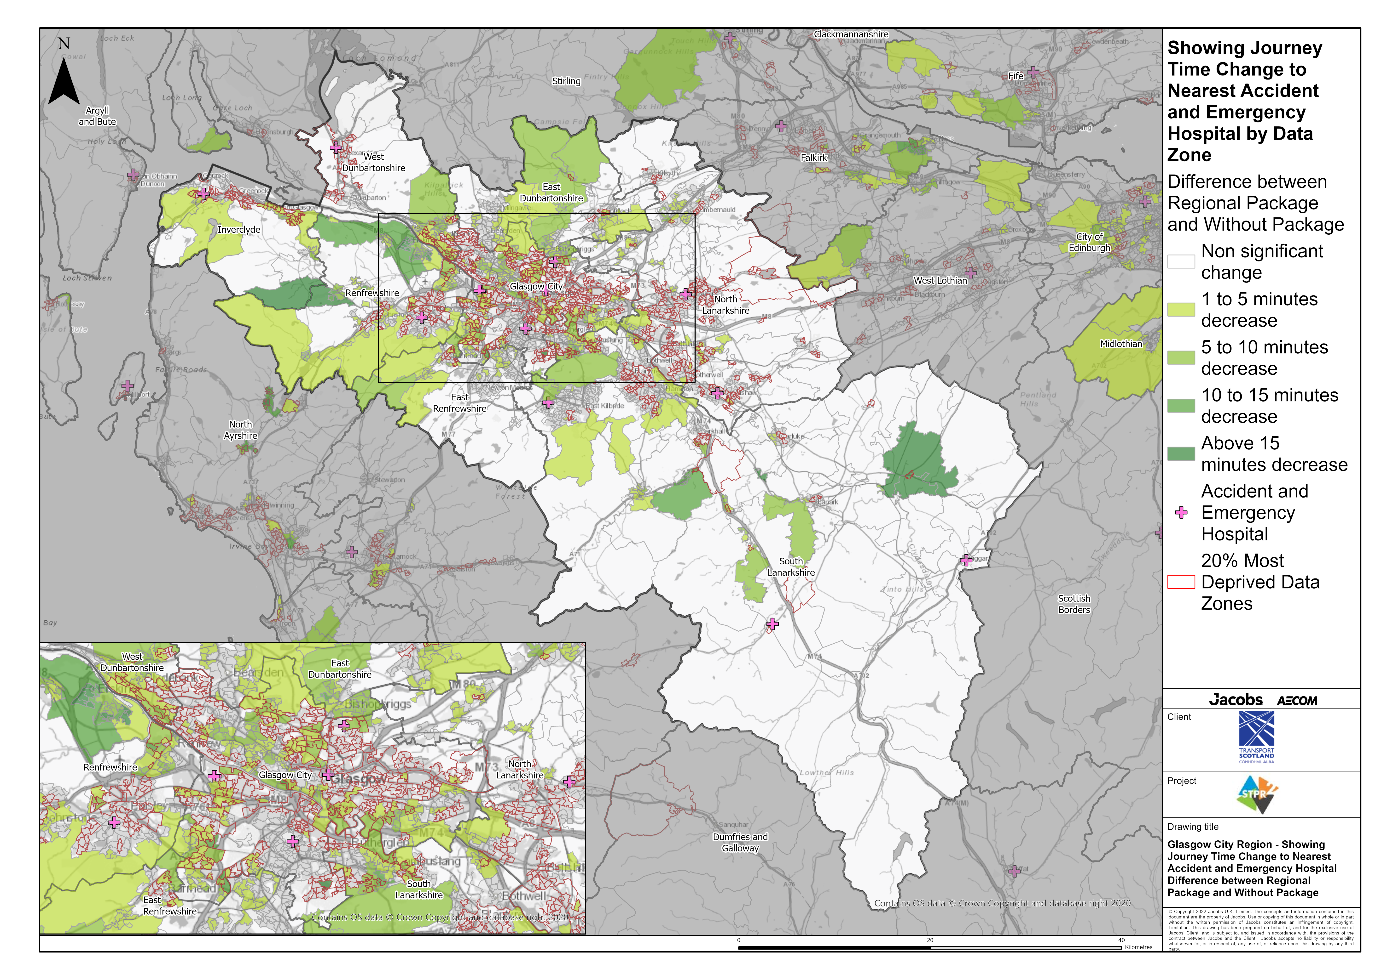
Glasgow City Region – Showing Journey Time Change to Nearest Accident and Emergency Hospital Difference between Regional Package and Without Package
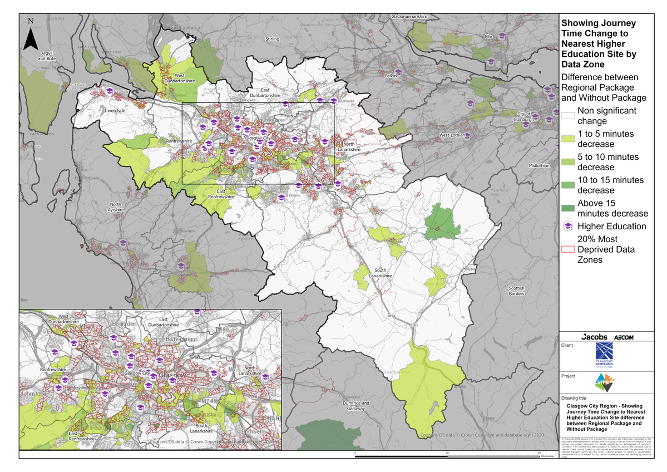
Glasgow City Region – Showing Journey Time Change to Nearest Higher Education Site Difference between Regional Package and Without Package
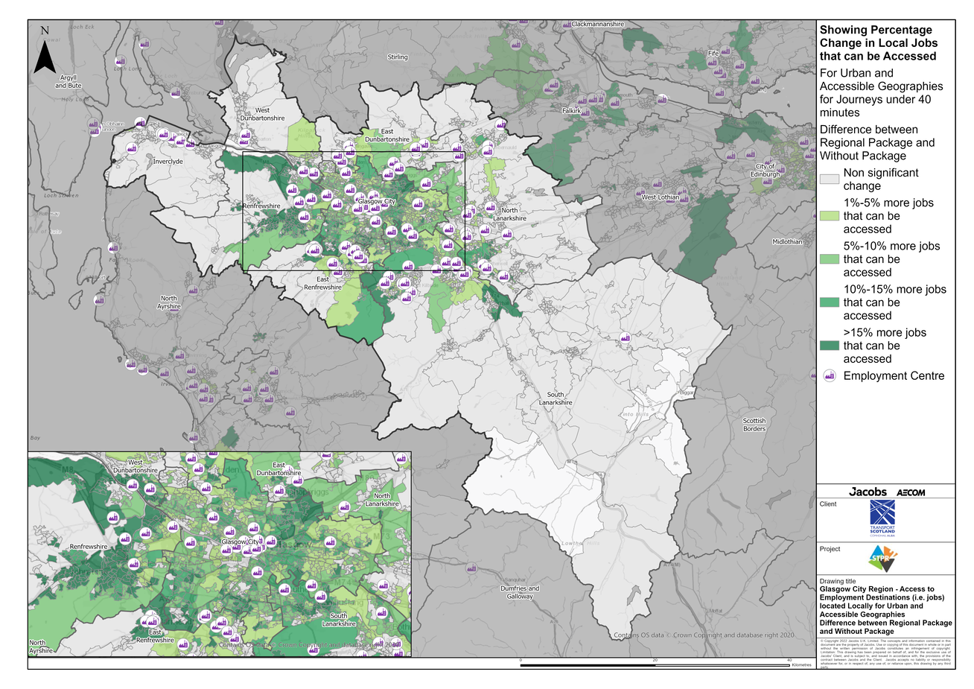
Glasgow City Region – Access to Employment Destinations (i.e. jobs) located Locally for Urban and Accessible Geographies for journeys under 40 minutes Difference between Regional Package and Without Package
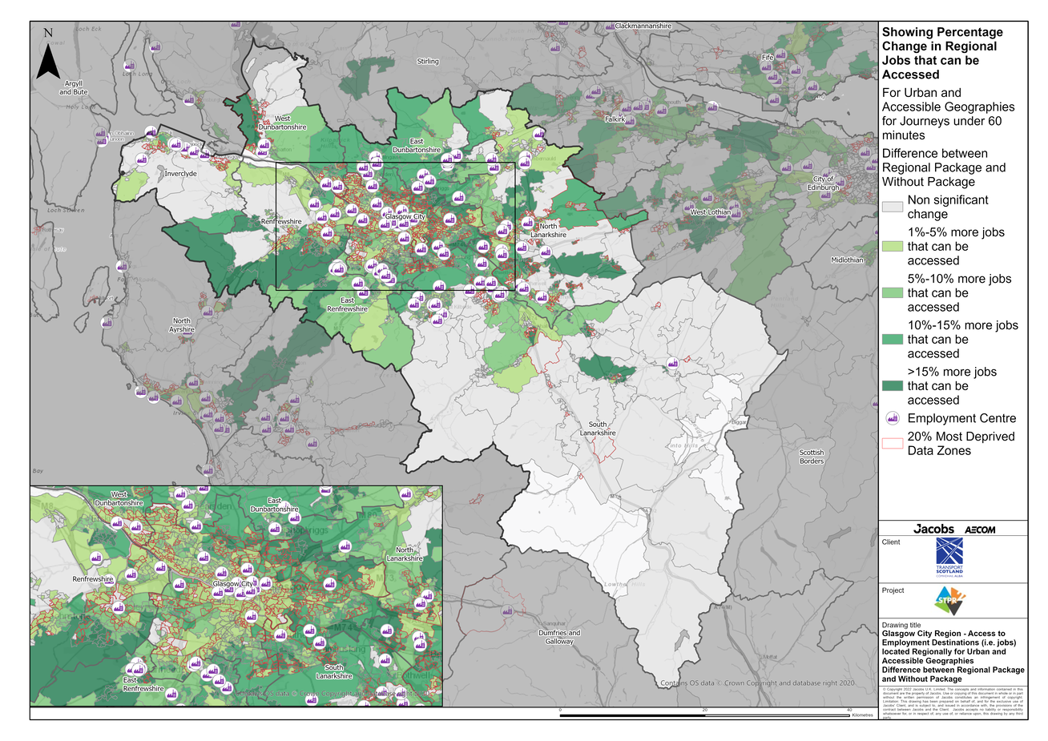
Glasgow City Region – Access to Employment Destinations (i.e. jobs) located Regionally for Urban and Accessible Geographies for journeys under 60 minutes Difference between Regional Package and Without Package
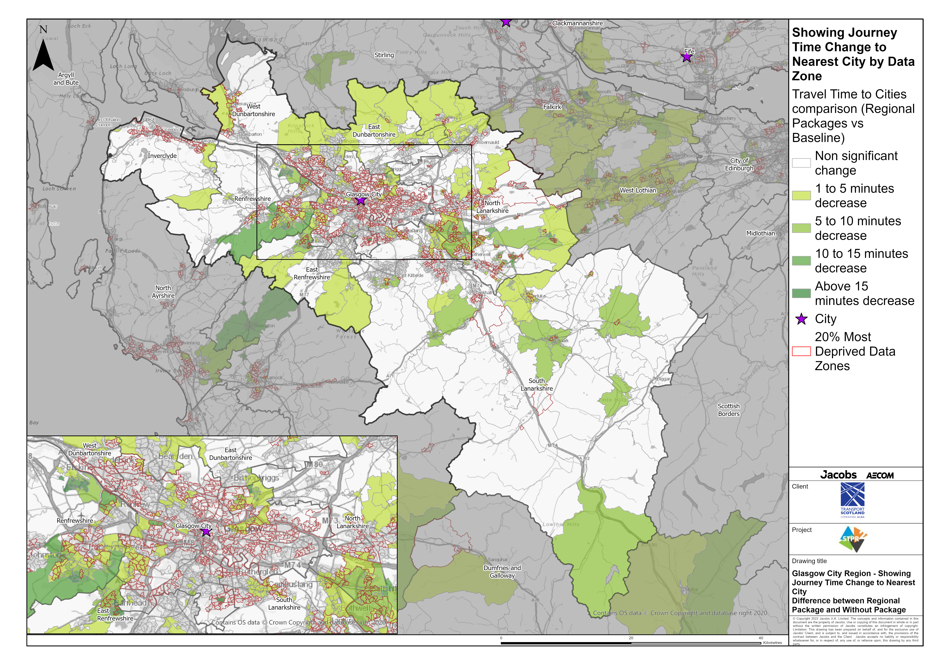
Glasgow City Region – Showing Journey Time Change to Nearest City Difference between Regional Package and Without Package
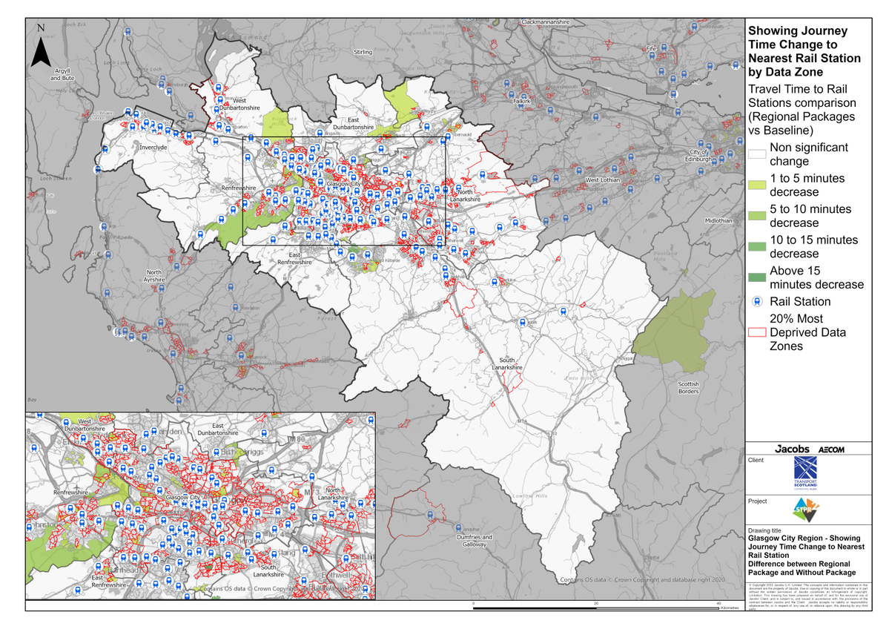
Glasgow City Region – Showing Journey Time Change to Nearest Rail Station Difference between Regional Package and Without Package
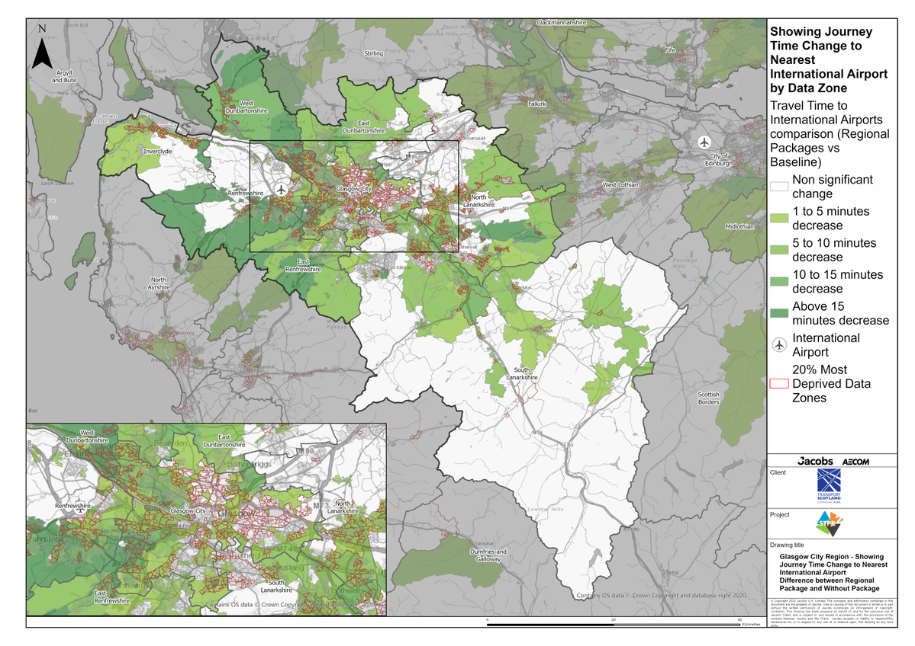
Glasgow City Region – Showing Journey Time Change to Nearest International Airport Difference between Regional Package and Without Package

Annex B: Traffic Modelling Outputs
