Appendix H: Detailed Packaging - Appraisal Summary Tables

December 2022
Contents
1. Regional Context 5
1.1. Geographic Context 5
1.2. Social Context 5
1.3. Economic Context 6
1.4. Environmental Context 7
2. Problems and Opportunities 8
2.1. Problems 8
2.2. Opportunities 9
3. Regional Recommendations 10
4. Fit with Established Policy 11
5. STPR2 Transport Planning Objectives (TPOs) Assessment 12
6. STAG Assessment 20
6.1. Environment 20
6.2. Climate Change 21
6.3. Health, Safety & Wellbeing 22
6.4. Economy 23
6.5. Equality & Accessibility 24
7. Deliverability 26
7.1. Feasibility 26
7.2. Affordability 26
7.3. Public Acceptability 26
8. Statutory Impact Assessment Criteria 27
8.1. Strategic Environmental Assessment (SEA) 27
8.2. Equalities Impact Assessment (EqIA) 28
8.3. Island Communities Impact Assessment (ICIA) 29
8.4. Child Rights and Wellbeing Impact Assessment (CRWIA) 30
8.5. Fairer Scotland Duty Assessment (FSDA) 31
Annexes 32
Annex A: NAPTAT Mapping 33
Annex B: Traffic Modelling Outputs 37

Argyll and Bute Region Appraisal Summary Table
An Appraisal Summary Table (AST) has been developed for each of the eleven STPR2 Regions alongside the National AST. The ASTs are set out to provide:
- Regional Context, Problems and Opportunities – drawing on data presented in the Initial Appraisal: Case for Change reports this summarises geographic, social, economic, environmental and transport matters in the Region as well as the identified problems and opportunities. In line with STAG, appraisals are expected to explore location-specific problems and opportunities. Local problems and opportunities have been considered to gain a full understanding of the regional and national issues, however some of these may not be within the scope of this strategic study.
- Regional Recommendations – this presents the package recommendations that were included in the detailed appraisal for the Region.
- Fit with Policy – provides a summary of how well the appraised packages fit with key national policies including the second National Transport Strategy, Climate Change Plan Update, the Revised Draft Fourth National Planning Framework 4 (Revised Draft NPF4) and relevant regional policies.
- Transport Planning Objectives (TPO) Assessment – An assessment against each of the five TPOs is provided with quantified metrics, where appropriate, under the Low growth sensitivity with a 20% reduction policy ambition on car kilometres scenario (hereafter referred to as Low scenario) and High growth sensitivity with no policy ambition on car kilometres scenario (hereafter referred to as High scenario) (further information about these scenarios is provided in Appendix F of the Technical Report). A seven point scoring scale is adopted for each TPO which is:
  - + + + = major positive (3 plus signs)
  - + + = moderate positive
  - + = minor positive
  - 0 = neutral
  - - = minor negative
  - - - = moderate negative
  - - - - = major negative (3 minus signs)
- STAG Criteria assessment – as above for the TPO assessment, key points regarding the performance of the package against each of the STAG criteria is presented with quantified metrics provided where appropriate.
- Deliverability – commentary is provided on the assessment of the package in terms of its feasibility, affordability and public acceptability. Note that due to the nature of a number of the STPR2 interventions, and the stage in the business case process STPR2 is at, it has not been possible to derive cost estimates on a regional basis. However, broad capital spending ranges have been estimated over the period 2022 to 2042 at a national level.
- Statutory Impact Assessment Criteria – a summary of the performance of the packages against the Strategic Environment Assessment (SEA), the Equalities Impact Assessment (EqIA), Island Communities Impact Assessment (ICIA), Fairer Scotland Duty Act (FSDA) and Child Rights and Wellbeing Impact Assessment (CRWIA) is provided. The seven point scoring scale is adopted in these assessments where appropriate.

Summary of Assumptions
Quantification of the costs and benefits in the packages has been provided through a modelling exercise. Further information has been provided in Appendix F of the Technical Report on the modelling scenarios that have informed the assessment of the STPR2 interventions. A summary of key assumptions is provided here:
- Population projections are based on the NRS Population Projections (2018-based).
- Economic projections are a combination of projections by Oxford Economics, 2019, the Scottish Fiscal Commission forecasts and more recently the OBR post-COVID estimates.
- Land-use plans are based on data collected for Transport Scotland’s Assembly of Planning Policy Inputs in 2018 from Scotland’s 34 Planning Authorities.
- Permitting of vacant office and retail floorspace to be converted or redeveloped as housing post 2030.
- Working age is taken to be 16-64 (as a constant) to avoid difficulties with changing state pension age (and to reflect non-mandatory retirement).
- The economic results are presented, as is standard within appraisal as discounted values in 2010 prices.

Modelling Tools
For the purposes of modelling accessibility by public transport, NaPTAT (National Public Transport Accessibility Tool) has been used. This allows an assessment of journey time to be compared between with and without STPR package.
Due to the strategic and national nature of STPR2, the national Transport Model for Scotland (TMfS) has been used. TMfS is a national scale model with a focus on inter-urban trips. As such, whilst TMfS provides a suitable level of robustness at this stage of the appraisal for most of the larger infrastructure based interventions, there are limitations associated with the modelling of smaller/discrete interventions and also some of the larger infrastructure interventions that involve changes to the existing road network and are more urban in nature. Separate forecasts of the potential impacts of active travel recommendations on walking and cycling mode share have therefore been made. As the recommended interventions are developed through the business case process, more detailed modelling will be undertaken using regional and / or local models as appropriate.
When considering the outputs presented in this AST, please note the following metrics with respect to the model outputs:
- CO₂ emissions: Likely to underestimate the benefits associated with public transport interventions due to the more limited representation of transport systems in urban areas and a degree of insensitivity to mode shift in TMfS.
- Mode Share: Likely shift to public transport modes underestimated in the urban areas due to the more limited representation of urban transport systems and a degree of insensitivity to mode shift mode in TMfS.
- Change in vehicle kilometres travelled: Likely to underestimate the benefits of reducing vehicle-kilometres travelled particularly for short distance journeys due to the more limited representation of urban transport systems and the relative coarseness of the model zone system.
- Lost Time due to congestion: Likely to underestimate the benefits associated with interventions that would reduce roadspace due to the under-representation of the local/secondary road network in TMfS.
- Change in accidents: Likely to underestimate the benefits associated with mode shift to public transport interventions due to the more limited representation of urban transport systems and a degree of insensitivity to mode shift in TMfS.
- Present Value of Benefits: Likely to underestimate the benefits to public transport users due to the more limited representation of urban transport systems. Likely to overestimate the dis-benefits to car-based trips due to the under-representation of the junctions and local/secondary road network in TMfS.

- Regional Context
  - Geographic Context
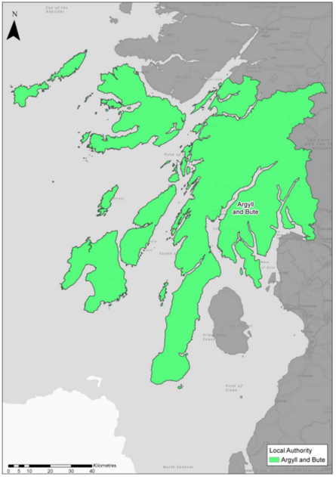
The Argyll & Bute Region consists of a mixture of rural and urban areas in the west of Scotland. The Region follows the boundaries of the Argyll & Bute local authority area and is the second largest local authority area, following Highland. It covers 6,900 square kilometres, which equates to 9% of the total Scottish land area.
The landscape of the area varies significantly, with mountainous upland terrain in the northeast, the highly scenic area of Loch Lomond and the Trossachs National Park in the east, numerous sea and inland lochs that form peninsulas, and an extensive coastline with a variety of islands, 23 of which are inhabited. The transport network is wide ranging, including active travel, rail, bus, road and ferry networks as well as airports. For the purposes of STPR2, major ports in the region are considered to be Rothesay, Dunoon (Hunters Quay), Oban and Kennacraig.
Based on The Scottish Government Urban Rural Six-Fold Classification almost three quarters (73%) of the total population in the Region live in areas considered ‘remote’ (i.e. Remote Rural and Remote Small Towns). Due to Helensburgh and Lomond administrative area being relatively close to the central belt, it is classified as a combination of ‘Accessible Rural’ and ‘Remote Rural’. Within this area, Garelochhead is classified as an ‘Accessible Small Town’ with the area around Helensburgh and Rhu classified as ‘Other Urban’.
  - Social Context
According to the National Records of Scotland’s Mid-year Population Estimates Scotland, the Region’s population in 2019 was 85,870 (1.6% of the total population of Scotland). Argyll & Bute has an average population density of 12 persons per square kilometres and is the third sparsest population of the 32 Scottish local authority areas. The Scottish average population density is 70 persons per square kilometres. The Region’s population has been in decline for over a decade, against a backdrop of a population increase at the national level.
Argyll & Bute consists of 125 data zones. Thirteen data zones (10%) were identified as amongst the 20% most overall deprived data zones in Scotland on the SIMD (Scottish Index of Multiple Deprivation). These are located in the Region’s 5 main towns -Helensburgh, Oban, Dunoon, Campbeltown and Rothesay. According to the Office for National Statistics, one in 5 children in Argyll & Bute live in poverty (after housing costs) and during the period 2014-2016, approximately 12% of children were in families with limited resources.
The Region has 23 inhabited islands, more than any other local authority in Scotland, and 17% of the Regions’ population inhabit these islands. The age profile of many island populations in the 2011 Scottish Government Census was different to the mainland, with higher proportions of people aged over 65 (e.g. over 30% on Lismore and Luing) and smaller proportions of children.
Key factors for population decline include poor mobile and broadband connectivity, a lack of affordable housing and a lack of reliable and resilient transport for the movement of goods and people. Outward migration is being driven by a combination of older individuals leaving to be nearer their families, health facilities or into care and younger people moving out of the Region to pursue higher education and employment opportunities. According to the National Records of Scotland’s Mid-year Population Estimates Scotland, over 1 in 4 (25.9%) of the Region’s population is aged 65 or over, which is the highest proportion in Scotland. Conversely, the proportion of both the under 15s and the working age population is lower than the national level.
  - Economic Context
The principal towns of Helensburgh, Oban, Dunoon, Campbeltown and Rothesay play an important role as centres of economic activity within the Region. Lochgilphead is the formal administrative centre for the Region and is the home of Argyll & Bute Council headquarters.
The Region’s economy is predominantly service-based, with over 85% of employee jobs in the area being provided within the service sector. The location of Her Majesty’s Naval Base Clyde continues to provide impetus to the regional labour market, with a high number of highly-skilled and highly paid jobs reliant on the naval base. Within Argyll & Bute, the largest industry employer (in 2018) was Administration & Defence, which employed approximately 18% of the Region’s working population, followed by both Human Health & Social Work and Accommodation & Food Service activities, at approximately 13%. Tourism is increasingly forming a significant part of the Argyll & Bute economy, with almost 2.7 million visitors to the Region in 2017 – an increase of almost 38% on 2010 levels. Evidence from ONS (Regional GDP) indicates that Argyll & Bute contributed £1.91 billion to the Scottish Gross Value Added (GVA), equivalent to 1.3% of the national total.
  - Environmental Context
The Region of Argyll & Bute is renowned for its outstanding natural and built environment, both of which are significant attractors of people, business, and investment to the area. The Argyll & Bute Region, which includes part of the Loch Lomond and the Trossachs National Park, has many areas classified as environmentally sensitive, with varying levels of statutory protection.
Designated biodiversity sites can be found throughout the Argyll & Bute Region, with the highest concentrations in coastal areas and on the islands of the Inner Hebrides. There are no Ramsar sites or Regional Parks within the Region. In addition, the Region contains a significant number of historic assets, including 2,812 Category A-C Listed buildings, 32 Conservation Areas, 24 Gardens and Designed Landscapes and over 800 Scheduled Monuments according to Historic Environment Scotland. Undesignated cultural heritage assets can be found throughout the Region. There are no Battlefields or World Heritage Sites within the Region.

- Problems and Opportunities
The following transport-related problems and opportunities have been identified for the Argyll & Bute Region.
  - Problems
Connectivity: Transport and digital connectivity for the movement of goods, people and transfer of information is vital in Argyll & Bute and is a key contributor to developing a thriving economic climate for its communities. The lack of a good standard of transport infrastructure and public transport provision is considered to be constraining growth in the Region. Rail, ferry and road connections are key aspects of the transport network and the impact of disruption on residents, visitors and businesses tend to be more severe due to the lack of alternative transport options. The transport options for taking residents and visitors from the bus stop, rail station, ferry port or airport to the final mile of their destination is also considered to be poor.
Travel times and reliability: Travel times to/from, within and through Argyll & Bute under normal conditions (i.e. with no disruption due to accident or incidents) can be long and/or unreliable. The long journey times are a function of the Region’s geography, the quality of its transport infrastructure and the reliability of public transport services. There is potential for travel conditions on the transport network (such as on roads and/or ferries) to stagnate given the increase in slower moving traffic generated by the anticipated growth in key sectors including Marine Sciences, Forestry, Tourism, Aquaculture, and the wider Food and Drink sector.
Resilience: When there is disruption, i.e. accidents, incidents (related to weather, operational issues, etc) on the transport network, the lack of alternative travel options and/or routes with comparable journey times in the absence of the disruption, can have a significant impact on residents, businesses and visitors when it occurs (e.g. through missed connections, cancelled appointments and spoiling of perishables such as seafood). Data from NHS Highland estimates that there are 26,000 referrals for Argyll & Bute patients each year, of which 44% are to hospitals within the Region and 56% are to hospitals in the NHS Greater Glasgow and Clyde area for required treatment/services. Disruption on the transport network can lead to missed appointments and adversely affect patients’ health and wellbeing.
Road Safety: The trunk road network in Argyll & Bute is predominantly single carriageway. There are conflicts between fast and slower vehicles (particularly during the peak summer period when there is an increase of caravans and motorhomes on the roads). Based on DfT data, during the 5-year period 2014 to 2018 inclusive, 418 accidents occurred on the key trunk routes within Argyll & Bute. Almost a third of accidents (approx. 32%, equating to 132 accidents), resulted in a person being killed or sustaining a serious injury (KSI).
  - Opportunities
Sustainable travel and the environment: There are opportunities for Argyll & Bute to contribute positively to the country’s ambitious statutory targets to tackle the global climate emergency by reducing emissions generated by the transport sector. There is the potential for reducing emissions through a combination of reducing the need to travel, supporting a shift towards more sustainable modes of transport and decarbonising the transport system. Tourism forms a significant part of the Argyll & Bute economy and opportunities exist to help encourage low carbon travel for visitors. Argyll & Bute has an abundance of wind, water and wave energy, which if harnessed and managed correctly, could be used to support sustainable transport. Improving connectivity could support the growth of the renewable energy industry.

- Regional Recommendations
The following is a list of interventions that form a package of recommendations that are relevant to this Region.

Regional Recommendations
- Connected neighbourhoods (Recommendation 1)
- Village-town active travel connections (Recommendation 3)
- Connecting towns by active travel (Recommendation 4)
- Long-distance active travel network (Recommendation 5)
- Behavioural change initiatives (Recommendation 6)
- Changing road user behaviour (Recommendation 7)
- Increasing active travel to school (Recommendation 8)
- Improving access to bikes (Recommendation 9)
- Expansion of 20mph limits and zones (Recommendation 10)
- Provision of strategic bus priority measures (Recommendation 14)
- Supporting integrated journeys at ferry terminals (Recommendation 18)
- Infrastructure to provide access for all at railway stations (Recommendation 19)
- Investment in Demand Responsive Transport and Mobility as a Service (Recommendation 20)
- Improved public transport passenger interchange facilities (Recommendation 21)
- Framework for the delivery of mobility hubs (Recommendation 22)
- Smart, integrated public transport ticketing (Recommendation 23)
- Ferry vessel renewal and replacement and progressive decarbonisation (Recommendation 24)
- Decarbonisation of the rail network (Recommendation 25)
- Decarbonisation of the bus network (Recommendation 26)
- Behavioural change and modal shift for freight (Recommendation 27)
- Zero emission vehicles and infrastructure transition (Recommendation 28)
- Access to Argyll (A83) (Recommendation 29)
- Trunk road and motorway safety improvements to progress towards ‘Vision Zero’ (Recommendation 30)
- Trunk road and motorway network climate change adaptation and resilience (Recommendation 31)
- Trunk road and motorway network renewal for reliability, resilience and safety (Recommendation 32)
- Future Intelligent Transport Systems (Recommendation 33)
- Traffic Scotland System Renewal (Recommendation 34)
- Intelligent Transport System renewal and replacement (Recommendation 35)
- Strategy for improving rest and welfare facilities for hauliers (Recommendation 36)
- Improving active travel on trunk roads through communities (Recommendation 37)
- Speed Management Plan (Recommendation 38)
- Potential sound of Harris, sound of Barra fixed link and fixed link between Mull and Scottish mainland (Recommendation 41)
- Investment in port infrastructure to support vessel renewal and replacement, and progressive decarbonisation (Recommendation 42)
- Rail freight terminals and facilities (Recommendation 44)
- Fit with Established Policy
The interventions included within this package support a wide range of national, regional and local policy documents in which transport improvements play a key role in both the enabling and delivery of outcomes.
Key policies supported include the Programme for Government, Infrastructure Investment Plan, NTS2, the Climate Change Plan Update 2018 - 2032, HITRANS’ Regional Transport Strategy and SPT’s Regional Transport Strategy, as well as non-transport-specific plans, such as the Highlands and Islands Enterprise Strategy, and the Argyll & Bute Council Regional Economic Strategy.
Measures included in this package will also support more resilient connections to Revised Draft NPF4 pumped hydro storage schemes in the Region which support a net zero economy.
The policy framework for the Argyll & Bute Region has a strong emphasis on addressing inequality, and addressing barriers to employment, to help deliver well-connected, sustainable communities, promote modal shift away from private car, increase walking and cycling opportunities, and provide an attractive place for visitors and for businesses to invest and grow. Therefore, the package closely aligns with established policy directives.

Package Performance Against NTS2 Priorities and Outcomes:

Reduce inequalities
Will provide fair access to services we need: Major Positive
Will be easy to use for all: Moderate Positive
Will be affordable for all: Minor Positive

Takes climate action
Will help deliver our net-zero target: Major Positive
Will adapt to the effects of climate change: Moderate Positive
Will promote greener, cleaner choices: Major Positive

Helps deliver inclusive economic growth
Will get people and goods where they need to get to: Major Positive
Will be reliable, efficient and high quality: Moderate Positive
Will use beneficial innovation: Minor Positive

Improves our Health and Wellbeing
Will be safe and secure for all: Moderate Positive
Will enable us to make healthy travel choices: Moderate Positive
Will help make our communities great places to live: Moderate Positive
- STPR2 Transport Planning Objectives (TPOs) Assessment

TPO1 A sustainable strategic transport system that contributes significantly to the Scottish Government’s net-zero emissions target

TPO Performance Summary
Carbon dioxide equivalent (CO₂eq) is treated as a nationally important pollutant. As such, although it can be appraised at the national level (commentary below), it has not been appraised for individual regions.
The national and all regional packages will contribute to the net-zero emissions target by:
- Enabling more passenger journeys to be made by active modes and public transport
- Decarbonising public transport operations.
- Facilitating uptake of electric vehicles.
- Enabling some road freight to switch to rail or other low carbon modes.
Further commentary is provided below.
National CO₂eq emissions are forecasted to decrease year-on year. This is due to decreasing vehicle exhaust (non-traded) emissions as the number of internal combustion engine vehicles reduces. This is reflected in the volume of traded grid emissions from charging increased numbers of battery-electric vehicles, and specifically in the Low scenario. It is noted that traded emissions of Carbon Dioxide equivalence (CO₂eq) are associated with electrical generation to supply plug-in vehicles, both BEV (battery electric vehicles) and PHEV (plug-in hybrid vehicles).
The electricity grid is expected to be using predominantly renewable sources in the future and so increasing adoption of electric vehicles and a shift from direct, non-traded, emission to traded grid-based technology (i.e. battery) will support reducing CO₂eq emissions.
Across both Low and High scenarios, the interventions would reduce emissions of CO₂eq.
Significantly higher overall emissions are predicted in the High scenario, either with, or without, the national and all regional packages. There is a relatively smaller overall reduction of emissions due to the interventions in the Low scenario due to the lower overall emissions. The economic impacts associated with air quality were assessed using the Department for Environment Food & Rural Affairs (DEFRA) Damage Costs Appraisal Toolkit. The larger economic benefit from the High scenario is due to the greater overall emissions with, or without, the package, although the proportional change in emissions is lower.
Overall Scoring:
Low and High Scenarios: Moderate Positive

Metric 1: Change in CO₂eq (non-traded and traded emissions from regional road transport inc. grid emissions from charging light-duty vehicles)- Figures below are a national calculation
Low Scenario Commentary:
- 0.5% decrease (27,700 tonnes CO₂eq) in 2030.
- 2.8% decrease (21,600 tonnes CO₂eq) in 2045.
- 1.3 million tonnes reduction, of which 1.1 million were traded, for the 60-year appraisal period from 2030 to 2089.
- The net economic benefits for the 60-year appraisal period in 2010 prices and values would be in the range £10 million to £25 million for the Low scenario.
High Scenario Commentary:
- 0.4% decrease (31,300 tonnes CO₂eq) in 2030.
- 1.3% decrease (65,300 tonnes CO₂eq) in 2045.
- 3.7 million tonnes reduction, of which 452,000 were traded, for the 60-year appraisal period from 2030 to 2089.
- The net economic benefits for the 60-year appraisal period in 2010 prices and values would be in the range £100 million to £250 million for the High scenario.

Metric 2: Change in mode share by active travel for all journeys
Low and High Scenarios Commentary:
The package will increase the proportions of journeys undertaken by active modes. If all the active travel and behaviour change interventions were fully implemented in every relevant location in the Region, the following change in mode shares of walking and cycling is forecast:
- Potential increase in walking from 18% mode share to 22% mode share (4 percentage points).
- Potential increase in cycling from 0.8% to 13% (12 percentage points).

Note that the cycling and walking growth forecasts have been developed independently of each other. Growth in use of one active mode is likely to abstract at least some trips from the other, but this effect is not accounted for within these forecasts.

Metric 3: Change in motorised vehicle kilometres travelled
Low Scenario Commentary:
- Reduction of 8.4 million motorised vehicle kilometres (2% decrease) (See Annex B).
High Scenario Commentary:
- Reduction of 7.0 million motorised vehicle kilometres (1% decrease) (See Annex B).

TPO2 An inclusive strategic transport system that improves the affordability and accessibility of public transport

TPO Performance Summary
The package will improve the inclusiveness of the transport system by:
- Improving accessibility to public transport stops/stations by people walking, wheeling and cycling, the most inclusive transport modes – with particular benefits for people most often excluded (including children, older and disabled people, and people on low incomes).
- Seeking to promote public transport use and reduce operating costs, enhancing network sustainability.
Overall Scoring:
Low and High Scenarios: Minor Positive

Metric 1: Change in transport poverty risk
Low and High Scenarios Commentary:
Although the STPR2 interventions don’t impact on the direct costs of travel (e.g. fares, fuel price), the package of interventions would see a small reduction in transport poverty due to the overall improvements in public transport availability.

Metric 2: Change in Accessibility - population catchments increase to key services by journey time by public transport
Low and High Scenarios Commentary:
The package is forecast to improve the accessibility to higher education by public transport, whereby an additional 1,300 of the population in the Region would be able to access the nearest site in a journey time of under 60 minutes or less compared to the without package assessment. This represents a 1.7 percentage point increase in accessibility levels to higher education from 27.3% in the without package assessment to 29.0% with the package in place. These improvements were observed in Helensburgh although other minor journey time benefits were observed in Dunoon, Garelochhead and Kilcreggan. This is shown by the map output in Annex A.
In terms of additional destinations considered in the model:
- No changes were observed in relation to population accessibility to the closest city or rail stations.
- 4,500 additional people are able to access their closest international airport within a 90-minute public transport journey, which represents a 6.1 percentage point increase in accessibility levels from 10.1% in the without package to 16.2% with the package in place.
- 4,300 additional people are able to access their closest international airport within a 120-minute public transport journey, which represents a 5.9 percentage point increase in accessibility levels from 30.3% in the without package to 36.2% with the package in place.
Mapping outputs are shown in in Annex A.

TPO3 A cohesive strategic transport system that enhances communities as places, supporting health and wellbeing

TPO Performance Summary
The package will improve communities as places, supporting health and wellbeing by enabling more journeys to be made by active and sustainable modes, and by improving road safety. This will:
- Improve many people’s physical health and mental wellbeing, with particular benefits for people most often excluded (including children, older and disabled people, and people on low incomes).
- Reduce the adverse impacts of car use on communities and health (including reduced air pollution, noise, accident risk and perceived road danger).

The analysis shows that through improved uptake of walking and cycling, there would be a forecast reduction of around 3 premature deaths due to the health benefits arising from active travel.
Overall Scoring:
Low and High Scenarios: Minor Positive

Metric 1 Change in mode share by active travel for all journeys
Low and High Scenarios Commentary:
- Potential increase in walking from 18% mode share to 22% mode share (4 percentage points).
- Potential increase in cycling from 0.8% to 13% (12 percentage points).
Assumes all active travel and behaviour change interventions are fully implemented in every relevant location in the Region.
Cycling and walking growth forecasts have been developed independently. Growth in use of one active mode is likely to abstract at least some trips from the other, but this effect is not accounted for within these forecasts.

Metric 2 Potential for Change in 'Place'
Low and High Scenarios Commentary:
The package will improve the quality of the Region’s places by improving local accessibility and reducing the adverse effects of traffic on active travel in communities that have a trunk road passing through them.

Metric 3 Change in Health Benefits
Low and High Scenarios Commentary:
The health benefits of increased rates of active travel as a result of the package have been quantified using the WHOs Health Economic Assessment Tool (HEAT). HEAT estimates the health and economic impacts of increased walking and cycling, providing assessments of the health and economic impacts of walking and cycling on premature mortality and on exposure to air pollution. This shows that approximately 3 premature deaths would be prevented per annum.

TPO4 An integrated strategic transport system that contributes towards sustainable inclusive growth in Scotland

TPO Performance Summary
The package will contribute to sustainable inclusive growth in Scotland by:
- Improving the coverage of the walking and cycling network.
- Reducing disruption to road users caused by accidents and/or weather-related events, which will help remove socio-economic barriers and increase competitive transport access for businesses.
Overall Scoring:
Low and High Scenarios: Minor Positive

Metric 1: Increased labour catchment by sustainable travel (PT/Active Travel)
Low and High Scenarios Commentary:
The package would create small benefits for accessibility to key employment opportunities located in the cities by public transport in some parts of the Region.
Access to regional employment, which represents the accessibility of key employment opportunities located in Glasgow City within a 60-minute journey time using public transport, showed some improvements to the South East of the Region. It should be noted that Argyll and Bute is predominately rural in nature and therefore this metric is only applicable to areas categorised as urban and accessible, within the Region this includes Helensburgh along to the coastline to Garelochhead. For this area in the Region, the modelling shows that the package on average enables an additional 5,200 of existing jobs located in Glasgow City can be accessed within 60 minutes by public transport, while an additional 8,300 of existing jobs can be accessed within a two-hour journey. This is shown by the map output in Annex A.

Metric 2: Change in lost time due to congestion (for business/ commercial transport)
Low and High Scenarios Commentary:
No significant change in vehicle hours forecast during normal operating conditions.

TPO5 A reliable and resilient strategic transport system that is safe and secure for users

TPO Performance Summary
The package will improve reliability, safety and personal security on the transport system by:
- Reducing overall motorised vehicle kilometres through mode shift – reductions in travel of 2% and 1% under the Low and High scenarios respectively reduces the risk of accidents occurring, improving resilience through a reduced number of road closures.
- Changing attitudes of road users – behavioural change campaigns are anticipated to increase awareness of interactions with those walking, wheeling and cycling as well as changing attitudes towards speed, making the network a safer place for all.
- Facilitating a shift to sustainable modes – by improving the quality of sustainable mode facilities (including improving natural surveillance), paths, stops, stations and services will be less isolated - improving perceived safety and security and enabling more people (particularly children, women, and older people) to travel independently. This is likely to be most effective in the more populated areas.
- The provision of targeted infrastructure improvements – carriageway realignment and widening, the provision of overtaking opportunities and junction improvements, for example, are anticipated to reduce the accident and severity rate on the trunk road network and the associated reduction in road closures from such incidents would also help improve reliability. Improvements in terms of renewals and climate change adaptation to protect the operation of the trunk road and motorway network would also positively impact on the reliability of the network.
- Improving active travel provision and providing more dedicated and segregated routes for walking, cycling and wheeling.

Replacing a priority junction with a signalised junction could increase the overall number of accidents, however the severity of accidents occurring should reduce. Reducing the likelihood of accidents and weather-related events will improve journey time reliability on the trunk road network.

Overall Scoring:
Low and High Scenarios: Moderate Positive

Metric 1 Change in accidents (PIA and ‘damage-only’)
Low and High Scenarios Commentary:
- Accident reduction related to motorised vehicle kilometres is forecast to be 1% to 2%.
Low and High Scenarios Commentary:
Whilst the number of accidents involving motorised vehicles is anticipated to reduce following the introduction of the interventions within this package, it is anticipated that, walking and cycling journeys would increase. The number of accidents involving these active travel modes are therefore anticipated to increase, although each individual journey is anticipated to be significantly safer.

Metric 2 Percentage accident change for Targeted Infrastructure Improvements over 60 years, using default accident rate (PIA only)
Low and High Scenarios Commentary:
Accident benefits were estimated using the Department for Transport (DfT) recommended software programme COBA-LT (Cost and Benefit to Accidents – Light Touch) for targeted road safety improvements, based on default parameters, but using Scotland specific accident rates. A range of accident benefits were calculated for the various improvement options being considered. This provided the upper and lower bound of estimated percentage change in accidents, respectively. These ranges are shown below and provide the anticipated upper and lower bounds of impact on accidents that would be anticipated from typical interventions of this type:
- Sections of Realignment/Widening – reduction of 23% to 59%.
- Sections of Overtaking Opportunities – reduction of 35% to 73%.
- Locations of Junction Improvements – change of 42% (increase) to 64% (decrease).

It should be noted that junction accidents are forecast to increase in the event that a junction is upgraded from a priority to a signalised junction. This is due to an increase in the number of slight accidents that are likely to occur as a result of shunts in queuing traffic on the mainline approach to the traffic signals, which could previously travel unopposed. However, the accident severity can be expected to reduce as a result of this type of improvement. Any improvement scheme would be subject to further consideration.

Metric 3 Change in lost time due to congestion
Low Scenario Commentary:
- 5% decrease (3,700 hours) in lost time due to congestion (see Annex B).
High Scenario Commentary:
- 2% decrease (5,400 hours) in lost time due to congestion (see Annex B).

Metric 4 Journey Time Reliability /Availability of alternatives (modes/routes)
Low and High Scenarios Commentary:
The package will improve journey time reliability on the trunk road network by reducing the likelihood and/or impact of significant network disruptions.
- STAG Assessment
  - Environment

Environment

Air Quality
Performance Summary:
Total emissions of NO_{X} (a group of gases that are mainly formed during the combustion of fossil fuels) were predicted to decrease in future in both the High and Low scenarios.
Total emissions of NO_{X} were predicted to be effectively zero in 2045 in the Low scenario, and 2051 in the High scenario either with, or without, the proposed package. It is the change brought about by the projected transition of the vehicle fleet to zero-emission vehicles that contribute to the majority of air quality benefits, and in this instance outweighs the positive mode change contributions from the regional package.
Total emissions of Particulate Matter (PM), which is made up of a collection of solid and / or liquid materials, were predicted to increase in future predominantly due to non-exhaust emissions from road, tyre and brake-wear.
However, the package will reduce harmful emissions slightly. Over the 60-year appraisal period there was a predicted 100% reduction in NO_{X}, 2.3% reduction in PM10 and 2.5% reduction in PM2.5 in the Low scenario, and a 2.5% reduction in PM10 and a 2.7% reduction in PM2.5 in the High scenario.
Low Scenario Scoring: Minor Positive
High Scenario Scoring: Minor Positive

Noise and Vibration
Performance Summary:
The anticipated modal shift is also expected to reduce levels of noise and vibration associated with the transport network. There is potential for a localised negative effect on noise and vibration due to the construction and operation of specific interventions. The magnitude of effect will depend on the design and location of the intervention.
Low Scenario Scoring: Minor Positive
High Scenario Scoring: Minor Positive

Biodiversity and Habitats: Geology and Soils; Land Use (including Agriculture and Forestry); Water, Drainage and Flooding; Historic Environment; and Landscape
Low and High Scenarios Commentary:
Please refer to SEA performance summary text in the ‘Statutory Impact Assessment Criteria’ section below. Please note the scoring has been based on the SEA methodology for scoring, which has been agreed with the SEA Consultation Authorities.
  - Climate Change

Climate Change

Performance Summary (applicable to all Climate Change Sub-Criteria)
Carbon dioxide equivalent (CO₂eq) is treated as a nationally important pollutant. As such, although it can be appraised at the national level (commentary below), it has not been appraised for individual regions.
National CO₂eq emissions are forecasted to decrease year-on year, with decreasing direct (non-traded) exhaust emissions and increasing traded grid emissions associated with increased adoption and charging of battery/electric vehicles, and specifically in the Low scenario. It is noted that traded emissions of CO₂eq are associated with electrical generation to supply plug-in vehicles, both BEV (battery electric vehicles) and PHEV (plug-in hybrid vehicles).
Across both Low and High scenarios, the package will reduce emissions of CO₂eq, although the change is greater in the High scenario due to overall higher emissions.
Key recommendations within the package have a focus on identifying vulnerabilities to the effects of climate change on the transport system, as well as identifying measures to assist in the adaptation to the effects of climate change, including unplanned events, such as flooding, landslides and high winds. Climate change adaptation and network resilience would address existing and predicted climate change impacts and support the changes that are necessary to reach the Scottish Government’s net zero target for greenhouse gas emissions. Improving the climate resilience of the transport network will also align with the Scottish Government’s commitment to develop Scotland’s next statutory climate adaptation programme.
The above summary is applicable across all the sub-criteria, as outlined below. The specific performance against each sub-criteria is scored against both the Low and High scenarios.

Greenhouse Gas Emissions
Low Scenario Scoring: Major Positive
High Scenario Scoring: Major Positive

Vulnerability to Effects of Climate Change
Low Scenario Scoring: Minor Positive
High Scenario Scoring: Minor Positive

Potential to Adapt to Effects of Climate Change
Low Scenario Scoring: Minor Positive
High Scenario Scoring: Minor Positive
  - Health, Safety & Wellbeing

Health, Safety & Wellbeing

Performance Summary (applicable to all Health, Safety & Wellbeing Sub-Criteria)
The package will reduce the number and severity of accidents through targeted infrastructure improvements, such as carriageway realignment and widening, the provision of overtaking opportunities and junction improvements for the trunk road network in the Region. Encouraging modal shift away from private car, resulting in reduced accident risk due to reduced distance travelled on the network. Replacing a priority junction with a signalised junction could increase the overall number of accidents, however the severity of accidents occurring should reduce.
Whilst the number of accidents involving motorised vehicles is anticipated to reduce following the introduction of the interventions within this package, it is anticipated that the package would increase walking and cycling journeys. The number of accidents involving these modes is therefore anticipated to increase, although each individual journey is anticipated to be significantly safer.

Accidents (PIA and ‘damage-only’)
Low and High Scenarios Commentary:
- Accident reduction related to motorised vehicle kilometres is forecast to be 1% to 2%.

Percentage accident change for Targeted Infrastructure Improvements over 60 years using default accident rate (PIA only)
Low and High Scenarios Commentary:
Accident benefits were estimated using the Department for Transport (DfT) recommended software programme COBA-LT (Cost and Benefit to Accidents – Light Touch) for targeted road safety improvements, based on default parameters, but using Scotland specific accident rates. A range of accident benefits were calculated for the various improvement options being considered. This provided the upper and lower bound of estimated percentage change in accidents, respectively. These ranges are shown below and provide the anticipated upper and lower bounds of impact on accidents that would be anticipated from typical interventions of this type:
- Sections of Realignment/Widening – reduction of 23% to 59%.
- Sections of Overtaking Opportunities – reduction of 35% to 73%.
- Locations of Junction Improvements – change of 42% (increase) to 64% (decrease).

It should be noted that junction accidents are forecast to increase in the event that a junction is upgraded from a priority to a signalised junction. This is due to an increase in the number of slight accidents that are likely to occur as a result of shunts in queuing traffic on the mainline approach to the traffic signals, which could previously travel unopposed. However, the accident severity can be expected to reduce as a result of this type of improvement. Any improvement scheme would be subject to further consideration.

Security
Low and High Scenarios Commentary:
The package will, by increasing the number of people travelling actively, tend to improve natural surveillance and will, through improvements to lighting and urban realm, tend to reduce the number of locations at which security is a concern.

Health Outcomes
Low and High Scenarios Commentary:
The package will, by increasing rates of active travel and hence physical activity, improve both health and wellbeing outcomes. The estimated value of health benefits to the Region’s population, appraised over a 60-year period, is in the range £100 million to £250 million.
The package will also, by encouraging car journeys to switch to less polluting modes, improve local air quality, and hence health outcomes.

Access to Health and Wellbeing Infrastructure
Low and High Scenarios Commentary:
No significant change in accessibility to the nearest accident and emergency hospital site by public transport is forecast with the package in place.
Overall, across the Region as a whole, average public transport journey times to an accident and emergency hospital site showed no significant change. There are, however, some localised journey time improvements forecast, for example: savings of up to 9 minutes are forecast for some settlements on the southern part of the Rosneath peninsula.
This is shown by the map output in Annex A.

Visual Amenity
Low and High Scenarios Commentary:
The package should have a positive impact on visual amenity through improvements to walking and cycling infrastructure and an improved sense of ‘place’.
Care would be required in the development of rail freight facilities to ensure they did not detrimentally impact nearby communities.
  - Economy

Economy

Performance Summary
The modest economic benefits that accrue are as a result of the sustainable transport interventions in the Region’s package to enable and encourage mode shift to public transport modes. The Bus Priority Infrastructure intervention, and to a lesser extent the Interchange intervention, are the main contributors to the public transport user benefits in the Low scenario. The remainder of the benefits are largely due to the increase in public transport operator revenue as a result of the increased patronage levels arising from the mode shift away from car.
The level of public transport user benefits are reduced slightly in the High scenario, although this is offset by an increase in road user benefits. Nevertheless, even under this High scenario the sustainable transport interventions contribute to the majority of user benefits.
In terms of accident savings, the level of benefits is similar in both the Low and High scenarios. This is due to the reduction in road-based vehicle kilometres travelled in the Region, as a result of the active travel and public transport interventions encouraging a mode shift away from private car.
Note that due to the nature of a number of the STPR2 interventions it has not been possible to derive indicative cost estimates on a regional basis.

User Benefits (2010 prices and values for a 60 year appraisal period)
Low Scenario Commentary:
- Present Value of Benefits (PVB) of approximately £10 million to £25 million.
- Accidents Present Value of Benefits (PVB) of approximately £1 million to £10 million.
High Scenario Commentary:
- Present Value of Benefits (PVB) of approximately £25 million to £50 million.
- Accidents Present Value of Benefits (PVB) of approximately £1 million to £10 million.
  - Equality & Accessibility

Equality & Accessibility

Performance Summary (applicable to all Equality & Accessibility Sub-Criteria)
The package will improve accessibility to public transport by improving the coverage of the walking and cycling networks. This will provide particular benefits for people often excluded from transport, including older and young people, women, disabled people, and people living in more deprived communities.
The package will also improve affordability by reducing forced car ownership, and situations where taxi is the only viable mode for people without access to a car.

Public Transport Network Coverage
Low and High Scenarios Commentary:
No significant change forecast.

Active Travel Network Coverage
Low and High Scenarios Commentary:
Improvements to the Region’s active travel network, both within and between settlements, mean that many more people will have convenient, high-quality and safe infrastructure for walking, wheeling and cycling journeys.

Comparative Access by People Group
Low and High Scenarios Commentary:
Improvements to active travel networks and public transport (including ferries) will provide positive impacts on groups who are less likely to have access to car and more likely rely on public transport, walking and cycling for their journeys. This includes women, children and young people, older people, some ethnic minority groups and disabled people.

Comparative Access by Geographic Location
Low and High Scenarios Commentary:
The access to regional employment, which represents the accessibility of key employment opportunities located in Glasgow City within a 60 minute and 120 journey time using public transport, improved from deprived areas (20% most deprived in Scotland) in the Region with the package on average enabling an additional 6,400 jobs within 60 minutes and 4,800 jobs within 120 minutes located in Glasgow City to be accessed. It should be noted that Argyll and Bute is predominately rural in nature and therefore this metric is only applicable to SIMD areas categorised as urban and accessible, within the Region this includes Helensburgh.
No changes in accessibility to accident and emergency hospitals, education, and retail from the most deprived areas were observed.
All results are shown in the mapping outputs found in Annex A.

Affordability
Low and High Scenarios Commentary:
No significant change forecast.

- Deliverability
  - Feasibility

Feasibility
Summary Assessment:
The package has been developed with feasibility considerations in mind. The package mostly makes use of existing, proven technology and would generally be expected to largely operate inside existing design standards.
  - Affordability

Affordability
Summary Assessment:
The package would require substantial capital and operational funding. Some aspects of the package may generate revenue, which could be used to offset some of these costs.
  - Public Acceptability

Public Acceptability
Summary Assessment:
Public acceptability of the package is likely to be mixed. The package is expected to improve accessibility, connectivity, and choice and to make transport cleaner, more efficient and more attractive. There may be acceptability concerns in areas where road space reallocation or priority measures are proposed, however the behavioural change elements of the package should also help to mitigate this. There may also be acceptability concerns where construction works are expected to cause disruption or require land-take.
- Statutory Impact Assessment Criteria
  - Strategic Environmental Assessment (SEA)

SEA
Performance Summary:
The package supports modal shift to more sustainable modes of transport. Improved access to airports and ports and the creation of mobility hubs/interchanges, rail improvements and the improvements to passengers’ services and facilities seeks to encourage modal shift, and, as a result, reduce levels of transport related air pollution and carbon emissions. The decarbonisation of the ferry, rail and bus network and freight deliveries will also help reduce greenhouse gas emissions and improve air quality.
Positive effects are anticipated on population and human health due to an expected increase in sustainable access to essential services, increased travel choice and improved connectivity and planning for the future capacity of public transport.
Active travel interventions will have positive outcomes for health - for example, through expected improvements in air quality and increased uptake of physical exercise through walking, wheeling and cycling.
Road interventions are anticipated to have positive effects on safety. Trunk road improvements which are focused on junction improvements, realignment / widening and overtaking opportunities are also not anticipated to have a notable impact on traffic volumes or mode share and subsequently transport-based emissions in the majority of locations. The construction and operation of these interventions may result in result in minor negative effects due to a potential increase in noise and vibration during construction and operation. This is dependent on the location and design of individual schemes. There is also potential for a negative effect on natural resource requirements.
The Freight interventions are anticipated to result in minor negative effects on material assets as several interventions proposed involve enhancements to rail freight, terminals and facilities and therefore will require the use of natural resources.
The creation of fixed links will help adapt the transport network to the direct / indirect risks associated with climate change, and maintain / improve access to and within isolated island communities at risk from climate change effects. However it is anticipated that there is the potential for negative effects on biodiversity, soil, landscape, water, historic environment and material assets.
Where other new infrastructure is required, including, harbour upgrade requirements and road and rail interventions this could result in negative effects on biodiversity, soil, landscape, water, historic environment and material assets however the magnitude of effect is uncertain at this stage and will be determined by the design (and physical footprint) of the interventions.
As the design and development of interventions in this region progresses, further environmental assessments will determine the magnitude of the different positive and negative environmental effects and mitigation measures will be developed where appropriate.
  - Equalities Impact Assessment (EqIA)

EqIA
Performance Summary:
The package would improve public transport and active travel accessibility to key destinations and services including employment, education, healthcare and shopping for people living in the area. This will have a major positive impact on certain protected characteristic groups who are less likely to have access to a car and more likely to depend on public transport and active travel to make their journeys. This includes women, children and young people, older people, disabled people and people from certain ethnic minority groups.
By encouraging modal shift to more sustainable modes, this package could also contribute to improving local air quality. Improved health outcomes as a result of better air quality are of particular benefit to those who are more vulnerable to air pollution, including children, older people, disabled people and pregnant women.
The package will reduce the severity of accidents through targeted infrastructure improvements and by encouraging modal shift away from private car, resulting in reduced accident risk due to reduced conflicts. Some protected characteristic groups are more likely to be involved in road accidents, for example, children as pedestrian casualties and young males involved as car drivers and as such would have positive impacts on these groups.
Mode shift to sustainable modes will make paths, stops, stations and services less isolated and this, accompanied by improved quality of facilities will improve perceived security. This is likely to provide some benefit to those for whom security is of particular concern including women, the LGBTQ+ community and those from religious backgrounds most subject to hate crime.
The package would therefore be anticipated to have a minor positive impact on addressing this criterion.
  - Island Communities Impact Assessment (ICIA)

ICIA
Performance Summary:
The Island Connectivity interventions are likely to result in positive effects related to population and human health as the enhancements seek to improve accessibility, reduce severance and increase transport choice. They will also have positive effects on material assets as the intervention supports plans for increasing the future capacity of the public transport network, taking demographic and other societal changes into account. Positive effects may also be related to climatic factors, air quality and water environment, particularly in relation to the achievement of a reduction in transport related emissions as it seeks to reduce emissions from ferries through decarbonisation and use of alternative fuels (electric, hydrogen). This would also have a positive effect on material assets as decarbonisation will promote a more sustainable use and management of the existing transport network.
The Island Connectivity interventions are also anticipated to have a minor negative effect on population and human health, material assets, water environment, biodiversity, cultural heritage and landscape and visual amenity. The effects relate to existing ferry network expansions which may result in potential increases in noise and vibration, increased usage of natural resources and direct impacts on the water environment, such as increased pollution risk from ferry traffic. The Argyll & Bute Region has a large area of coastline identified as being at medium and high likelihood of flooding by SEPA. Existing ferry network expansions may also have a direct impact on biodiversity, including potential damage to, or loss of, designated and undesignated wildlife or geological sites. The Argyll & Bute Region includes many internationally and nationally designated biodiversity sites, including Special Areas of Conservation Special Areas of Conservation (SACs), Special Protection Areas (SPAs) and Nature Conservation Marine Protected Areas (MPAs). These could be affected by land-take for construction of interventions, or indirectly through pollution or disturbance to designated species. The new fixed link and harbour infrastructure proposed could result in negative effects on designated and undesignated archaeological sites and other culturally and historically important features. New infrastructure could also affect key views to, and from, heritage assets. Key designations in the coastal region are likely to be threatened by the construction of any new infrastructure, including A-C Listed Buildings and a Historic Marine Protected Area. New links could affect national, regional and local landscape designations. Key designations in Argyll & Bute that are likely to be affected include National Scenic Areas.
Further to the overall benefits of the package, the investment into decarbonisation of the ferry network would drive island connectivity improvements across the Clyde and Hebrides Ferry Service (CHFS) leading to a beneficial impact on island communities served by these routes. This could lead to a reduction in poor air quality for island communities within close proximity to ports and harbours. Further benefits may be realised through the procurement of new ferry vessels and infrastructure which would potentially be designed to increase accessibility standards than currently. The potential for capital funding investment into Demand Responsive Transport (DRT) would be likely to have a positive impact on island communities by providing more flexible public transport services meeting the needs of dispersed and remote island communities. The option for a potential fixed link between Mull and the Scottish mainland will increase connectivity and access to services as well as potentially supporting job growth on the islands. This enables residents of island communities to have more equitable and fairer access to opportunities and facilities and as such reduce the socio-economic disadvantages that are a consequence of living on islands compared to the Scottish mainland, or in urban areas for example. The reconfiguration of ferry services following the installation of Fixed Links may also support other island communities who will not benefit directly from Fixed Links but from increased or improved ferry connectivity.
The package would therefore be anticipated to have a minor positive impact on this criterion overall.
  - Child Rights and Wellbeing Impact Assessment (CRWIA)

CRWIA
Performance Summary:
By encouraging modal shift to more sustainable modes, this package could contribute to improving local air quality. Improved health outcomes as a result of better air quality are of particular benefit to those who are more vulnerable to air pollution, including children.
The package could also improve public transport and active travel accessibility to higher education institutions and employment opportunities for young people living in the area.
Safety is a key issue for children with regards to transport with child pedestrian casualties recorded in Scotland in 2019, accounting for 44% of all pedestrian casualties.
The package will reduce the severity of accidents through targeted infrastructure improvements and by encouraging modal shift away from private car, resulting in reduced accident risk due to reduced conflicts.
The package would therefore be anticipated to have a minor positive impact on this criterion.
  - Fairer Scotland Duty Assessment (FSDA)

FSDA
Performance Summary:
The Region currently experiences poor transport connectivity which exacerbate socio-economic disadvantage for low income groups and those living in remote areas. The improved public transport and active travel interventions contained in the package alongside climate change adaptation, resilience and safety measures for road and rail, have the potential to improve accessibility to employment opportunities and therefore support economic development and reduce inequalities caused by socio-economic disadvantage in the Region.
The package would therefore be expected to have a minor positive impact on this criterion.

Annexes

Annex A: NAPTAT Mapping
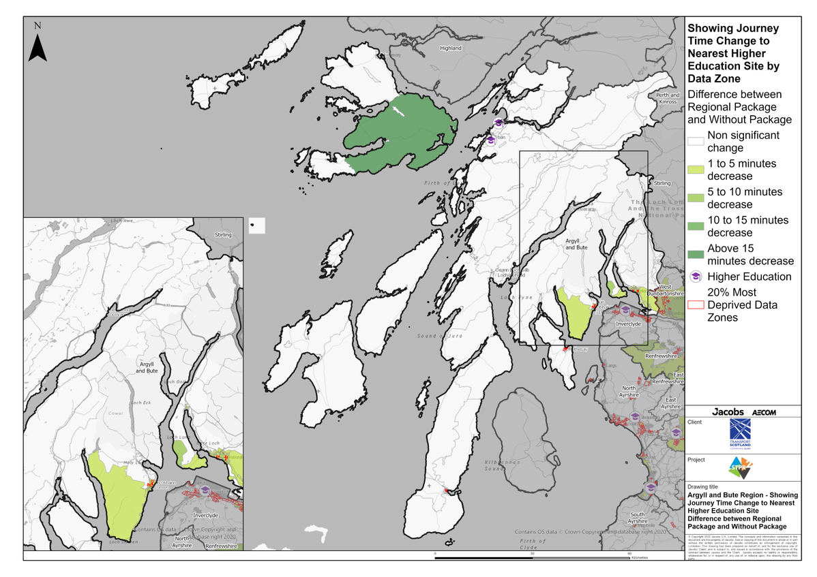
Argyll & Bute Region – Showing Journey Time Change to Nearest Higher Education Site Difference between Regional Package and Without Package
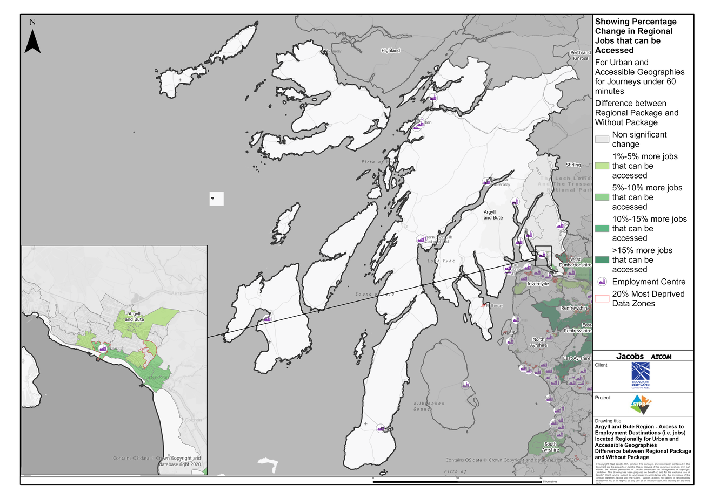
Argyll & Bute Region – Access to Employment Destinations (i.e. jobs) located Regionally for Urban and Accessible Geographies for journeys under 60 minutes. Difference between Regional Package and Without Package
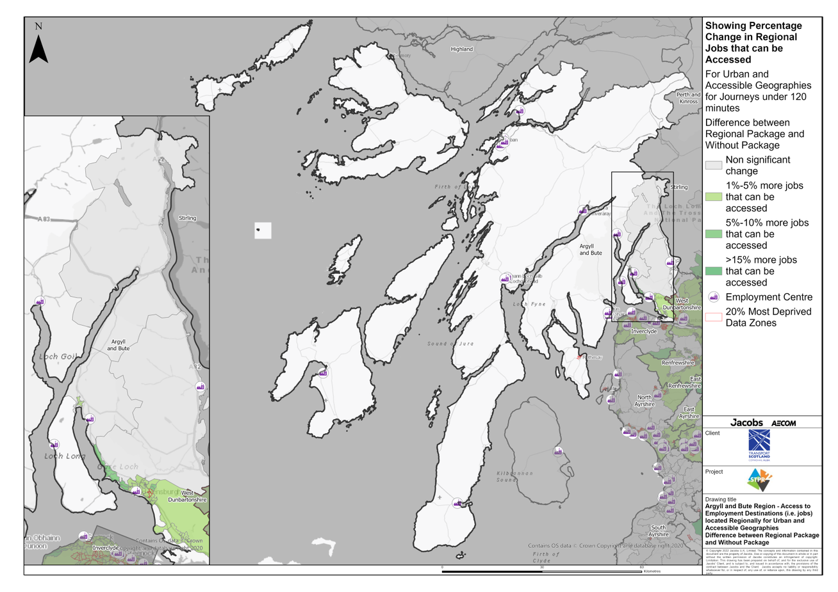
Argyll & Bute Region – Access to Employment Destinations (i.e. jobs) located Regionally for Urban and Accessible Geographies for journeys under 120 minutes. Difference between Regional Package and Without Package
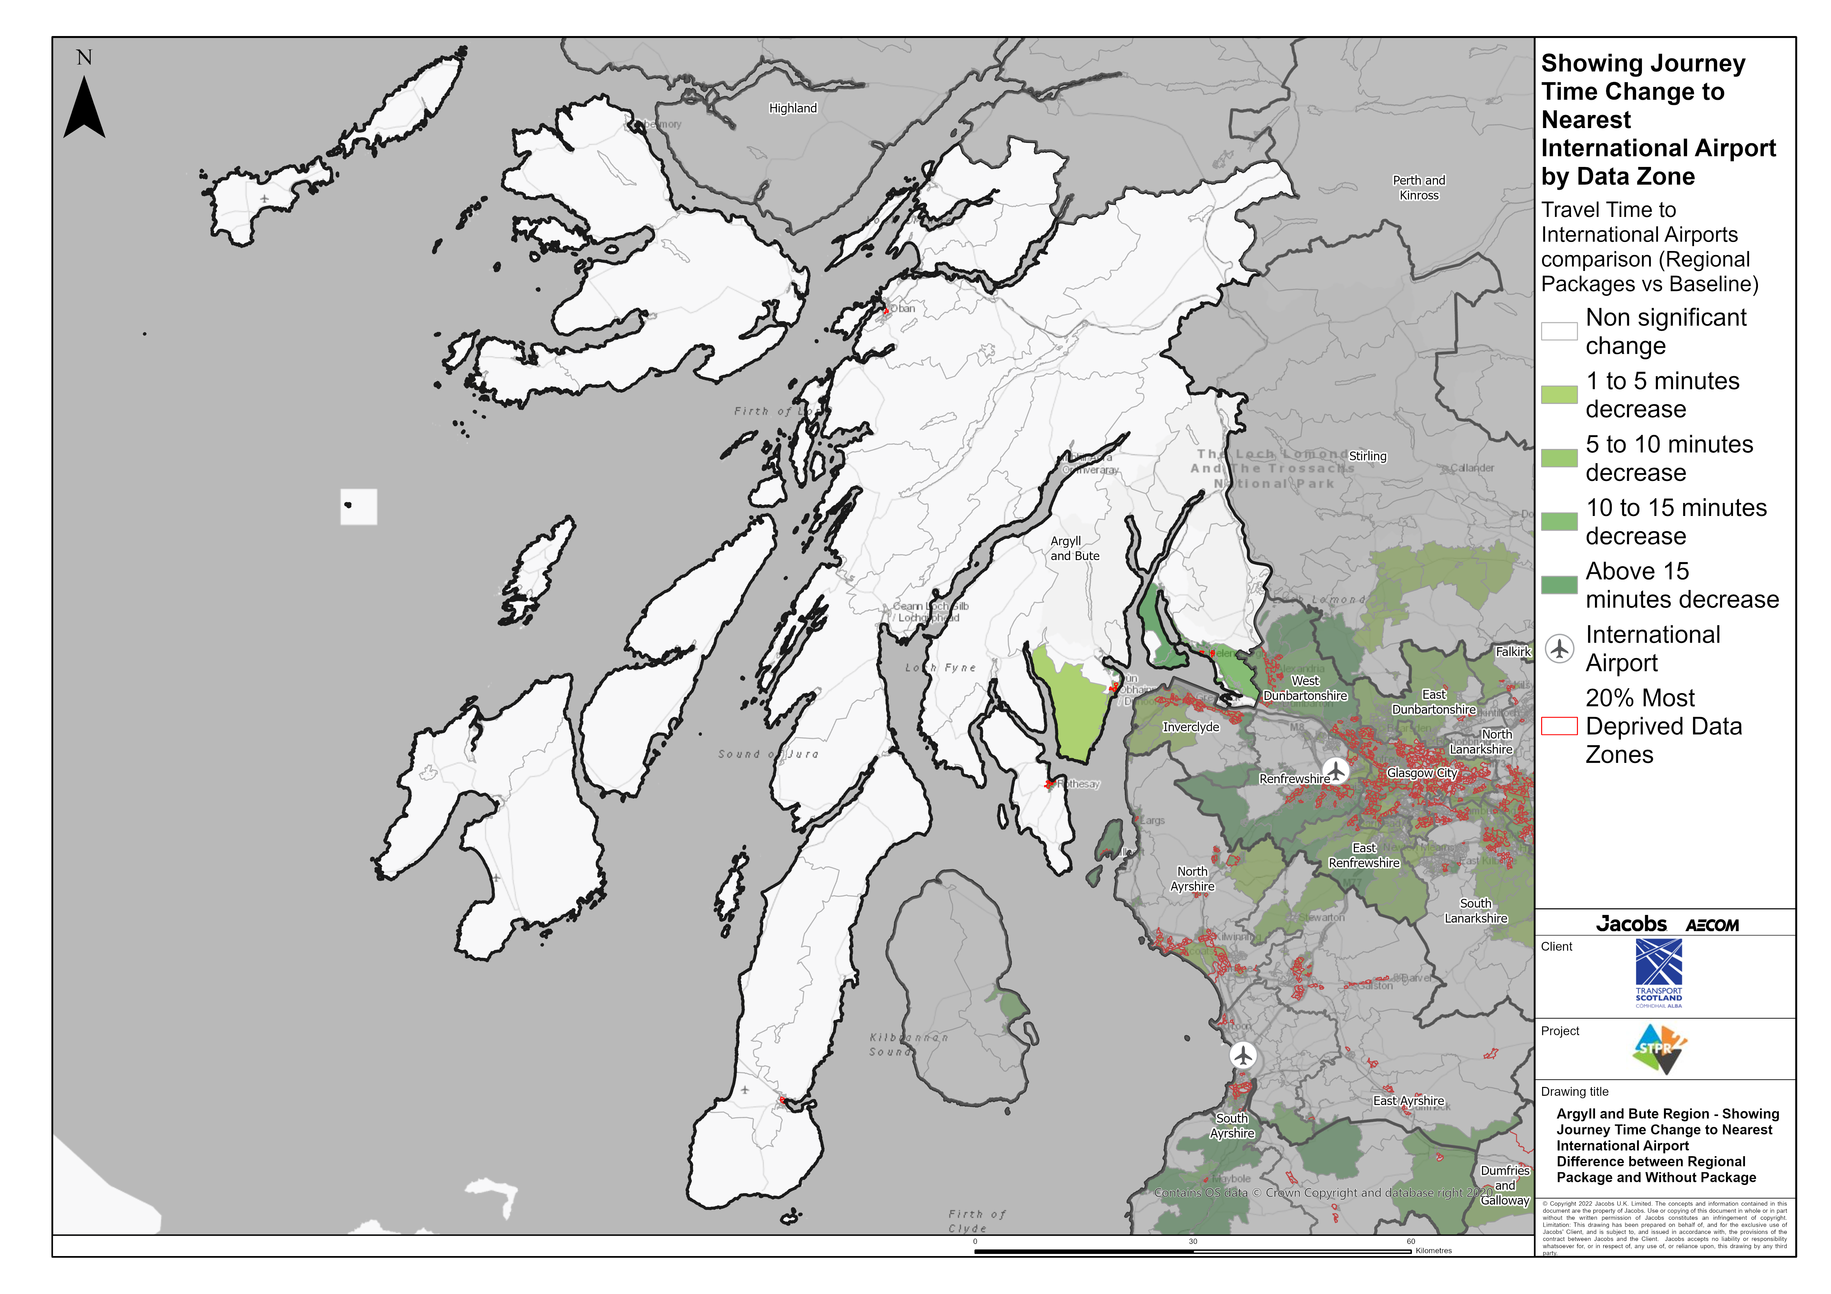
Argyll & Bute – Showing Journey Time Change to Nearest International Airport Difference between Regional Package and Without Package

Annex B: Traffic Modelling Outputs
