et

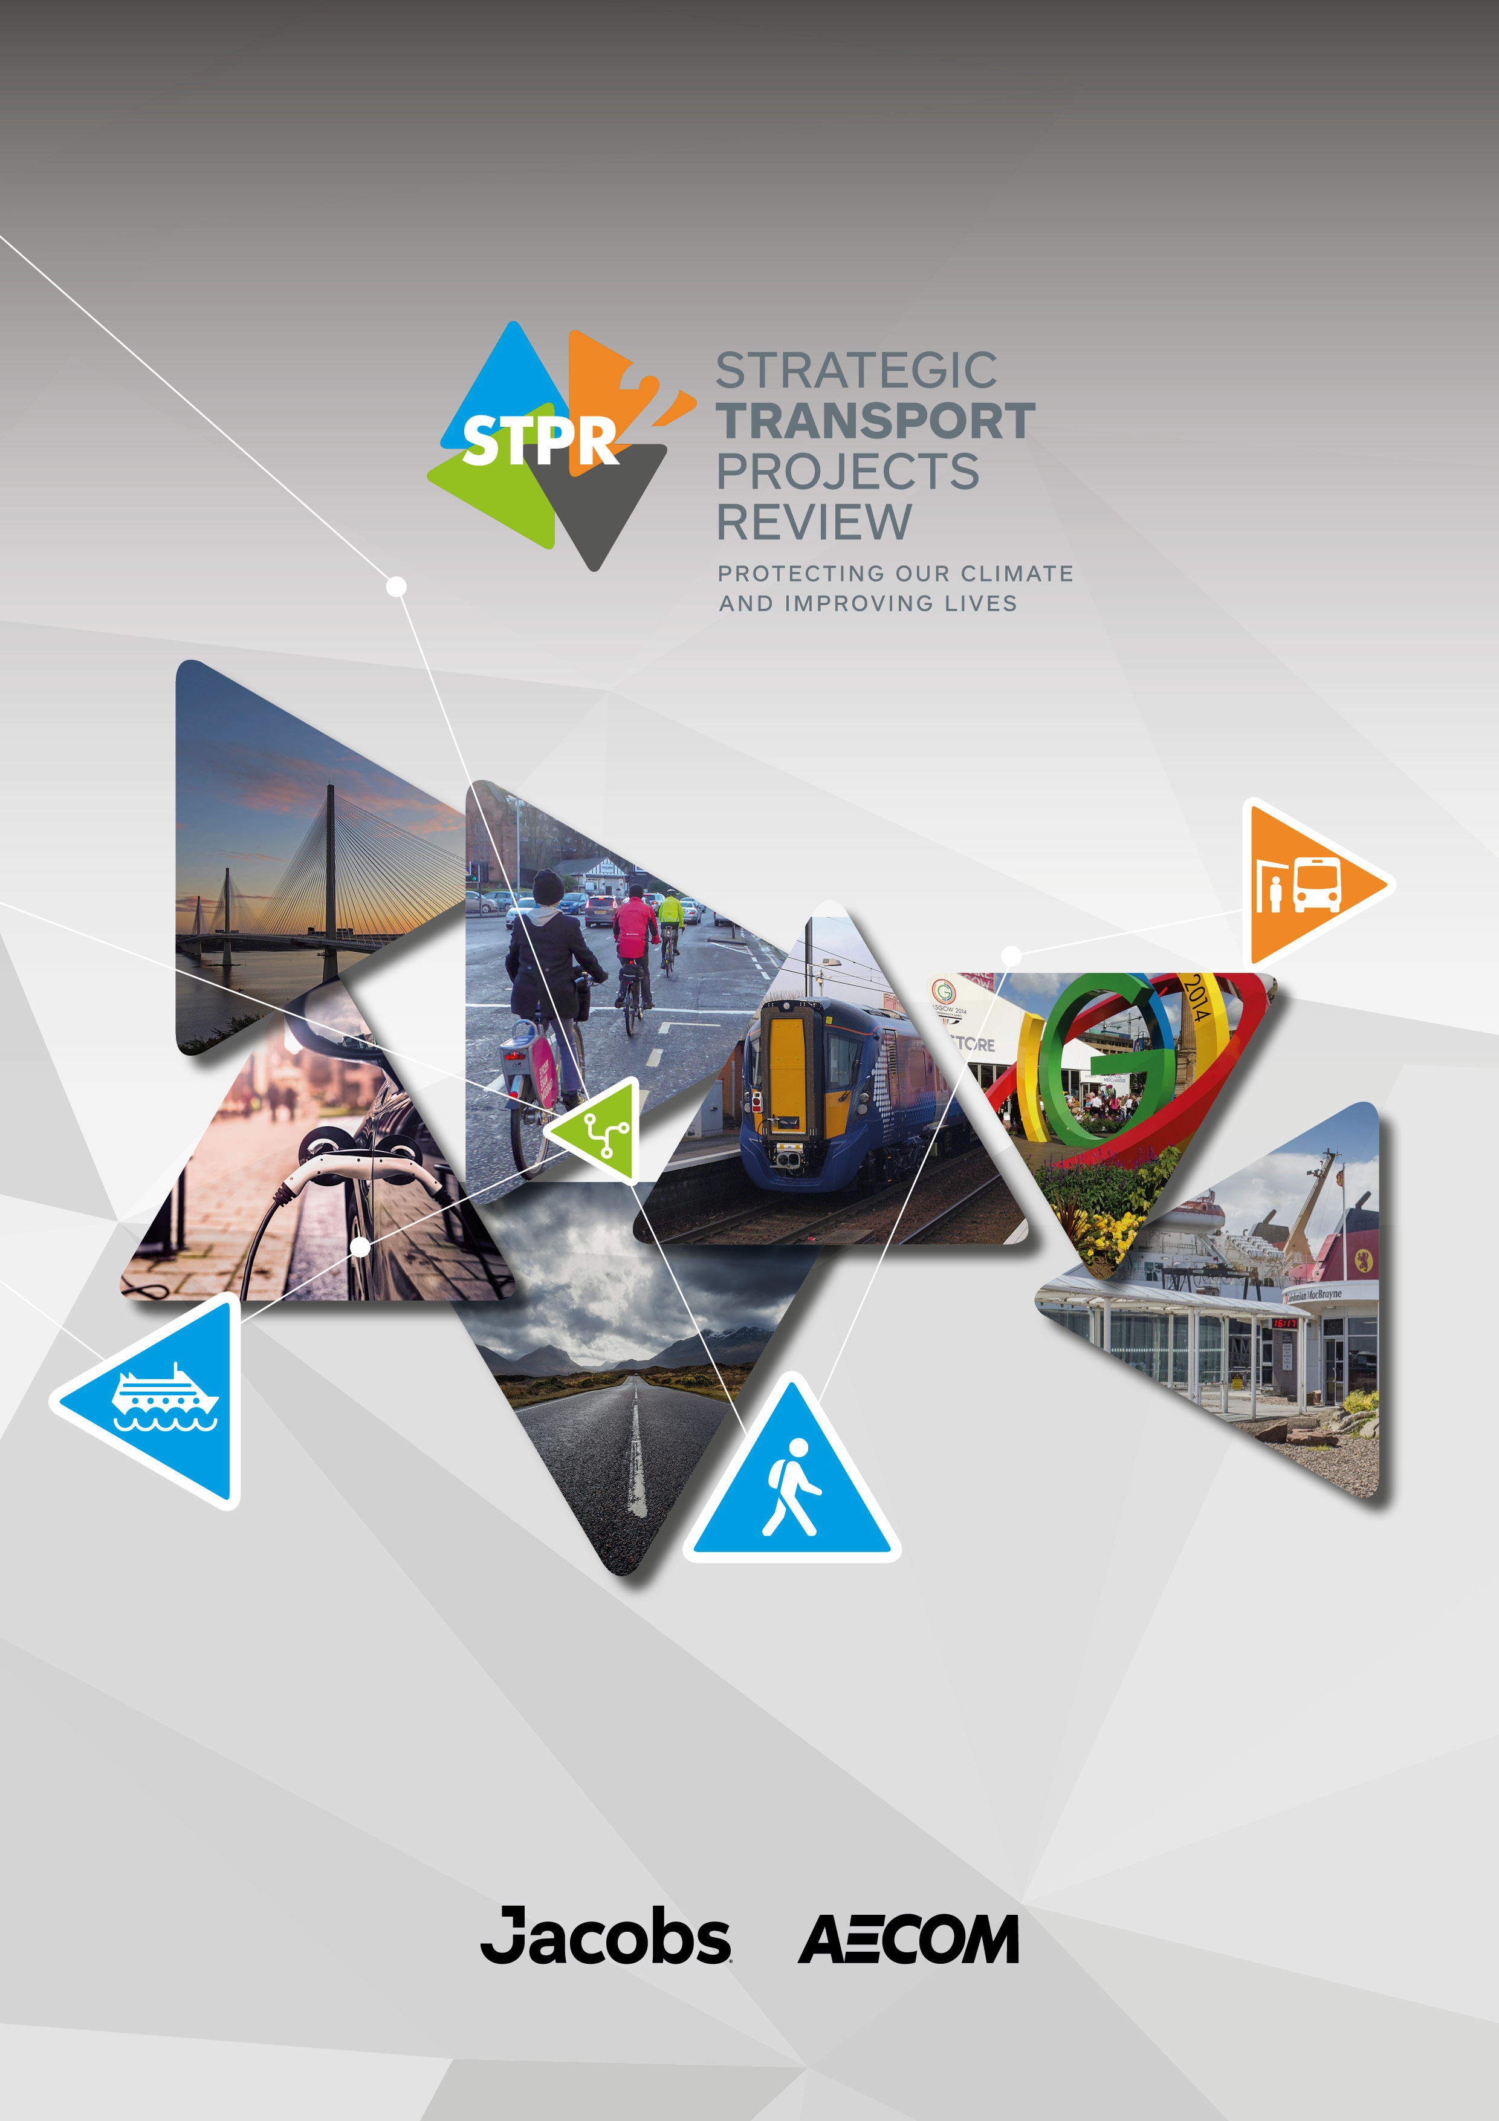
Consultation Summary Report
December 2022

Contents

1. Introduction 2
2. Main Findings 4

Introduction

Background
On 20 January 2022, Transport Scotland published the draft second Strategic Transport Projects Review (STPR2) and commenced a 12-week consultation. This report summarises the activities undertaken as part of the consultation. It also outlines the key findings from the analysis of responses to the consultation on the draft reports published on 20 January 2022.
A more detailed analysis of the consultation is contained in the STPR2 Consultation Analysis Report.

The Consultation
The consultation was hosted on the Scottish Government’s web-based platform Citizen Space. EasyRead and Gaelic language versions of the draft STPR2 summary report and a Gaelic language questionnaire were also made available on this website, as well as on the Transport Scotland website. A webpage version of the draft STPR2 summary report was also made available to further increase accessibility. The public consultation was publicised through emails to a comprehensive list of organisations and local and regional authorities across Scotland, as well as via the Transport Scotland website and proactive media coverage. Organisations were also requested to publicise the consultation through their own channels and a printable poster was also provided to assist with this. A dedicated telephone number was provided to allow those without good internet access to call and request a printed copy, large print or editable version of the questionnaire to return by post or email. This was highlighted on the poster and in the emails to organisations.
During the 12-week consultation period, 30 Information sessions were undertaken. These were designed to promote the consultation exercise, providing an overview of STPR2 and the 45 draft recommendations and further details on how stakeholders could feed into the consultation process.
In line with the proactive approach to engagement that has been taken throughout the review to ensure that all stakeholders have an equal opportunity to access information on STPR2, British Sign Language (BSL) interpreters attended three of the information sessions for wider stakeholders and Equalities groups.
Figure 1 below presents a summary of the information sessions undertaken and these are also listed below:
- 8 Presentations
- 10 Regional Transport Working Group (RTWG) Sessions
- 3 Business Information Sessions
- 3 Wider Stakeholder Information Sessions (one BSL interpreted)
- 1 MSP Information Session
- 5 Environmental and Equalities Information Sessions
  - Strategic Environmental Assessment (SEA) Statutory Consultees Technical session
  - Equalities Impact Assessment and Fairer Scotland Duty Assessment
  - Island Communities Impact Assessment
  - 2 SEA & Equalities Impact Assessments (both BSL Interpreted)

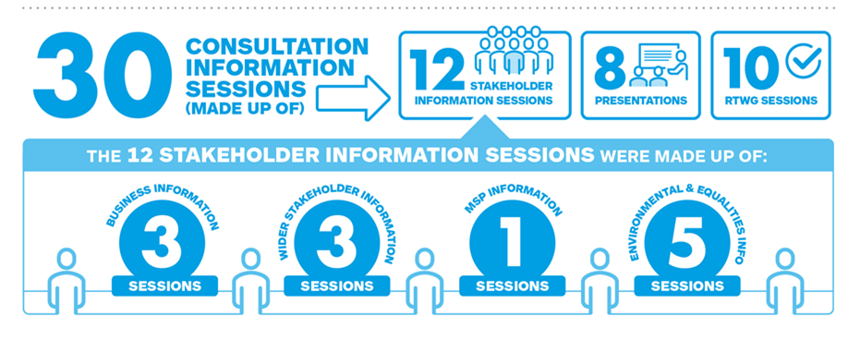
Figure 1: Overview of STPR2 Engagement Process throughout the Consultation period
Over 160 individuals representing organisations across Scotland attended these sessions with all participants encouraged to respond to the consultation hosted on Citizen Space.

Main Findings

Number of Responses
A total of 454 responses to the consultation were received. Organisations that responded broadly fall into the following categories:
- Regional Transport Partnerships (RTPs)
- Local Authorities
- Professional / trade bodies such as the Chartered Institution for Highways and Transportation, and Logistics UK
- Charity groups / organisations such as Cycling Scotland and Living Streets Scotland
- Single issue campaign groups such as Campaign for North East Rail and Thornhill Station Action Group
- Community Councils and other local groups with an interest in transport
Three distinct mechanisms were used to capture all consultation responses, these were:
- Consultation questionnaire responses completed via Citizen Space
- Consultation questionnaire responses completed offline to Citizen Space and submitted to dedicated email and postal addresses then manually uploaded to Citizen Space
- General consultation responses which did not directly answer the questionnaire, submitted to dedicated email and postal addresses
The Citizen Space platform allowed respondents to self-identify as either an organisation or an individual. As email and written responses did not contain similar self-identification, they were not broken down into individual and organisation categories.
The breakdown of respondents is as below:
- Organisations – 126 responses
- Individuals – 256 responses
- Not Disclosed – 72 responses
- Total – 454 responses
As noted in section 1.1, the following provides a summary of the consultation findings, with more detailed analysis contained in the STPR2 Consultation Analysis Report.
Responses were also sought regarding the draft Strategic Environmental Assessment and the various draft Impact Assessments (Equalities Impact Assessment, Island Communities Impact Assessment, Fairer Scotland Duty Assessment, Child Rights and Wellbeing Impact Assessment). Full details of this are provided in the STPR2 Consultation Analysis Report.
Sections 2.2 to 2.4 provide a summary of the responses received via Citizen Space and section 2.5 provides a summary of email and written responses.

View of the STPR2 Process
Noting that STPR2 is one of the mechanisms for delivering the vision, priorities and outcomes of the second National Transport Strategy (NTS2), respondents were asked to consider if the recommendations from STPR2 reflected the NTS2 priorities and outcomes. The responses are shown in Figure 2

Figure 2: Does STPR2 reflect the NTS2 priorities and outcomes (%)
Base: Individuals (n=250); Organisations (n=124)
A smaller proportion of individuals (54% of individuals compared to 75% of organisations) either strongly agreed or agreed that the STPR2 process reflects the NTS2 priorities and outcomes. Furthermore, 24% of individuals either disagreed (14%) or strongly disagreed (10%) with this statement which is considerably higher than organisations (5% disagreed and 2% strongly disagreed), and 6% of both individuals and organisations stated don’t know / no opinion.
Respondents were asked to give an opinion on whether it was correct to take both a regional and national approach to STPR2. The responses are shown in Figure 3.

Figure 3: Correct approach to STPR2 is both a regional and national approach (%)Base: Individuals (n=247); Organisations (n=125)
Three quarters of individuals either strongly agreed (34%) or agreed (42%) that a correct approach to STPR2 was both regional and national. Over four fifths of respondents from organisations strongly agreed (34%) or agreed (52%) that it was the correct approach and 2% of each individuals and organisations stated don’t know / no opinion.
Respondents were asked if the engagement approach has allowed them to contribute to STPR2. The responses are shown in Figure 4.

Figure 4: Engagement approach has allowed respondents to contribute to STPR2 (%)
Base: Individuals (n=243); Organisations (n=125)
Less than half (48%) of individuals either strongly agreed (11%) or agreed (37%) that this approach allowed them to contribute to STPR2 whilst just over two thirds of organisations (67%) stated they strongly agreed (12%) or agreed (55%). Furthermore, 4% of both individual and organisation respondents stated don’t know / no opinion.

Responses to the Themes and Approach
As part of the consultation, respondents were asked to consider the following themes that the STPR2 recommendations have been grouped into:
- Improving active travel infrastructure
- Influencing travel choices and behaviours
- Enhancing access to affordable public transport
- Decarbonising transport
- Increasing safety and resilience on the strategic transport network
- Strengthening strategic connections
Of these themes, respondents were asked to consider which are their top and lowest priorities. The responses are shown in Figure 5 and Figure 6 respectively.

Figure 5: Top Priority Theme (%)Base: Individuals (n=253); Organisations (n=119)
Figure 5 shows that 37% of the individuals put enhancing access to affordable public transport as their top priority whilst 24% of organisations stated improving active travel infrastructure was their top priority.

Figure 6: Lowest Priority Theme (%)
Base: Individuals (n=250); Organisations (n=113)
Figure 6 shows that a number of respondents stated they don’t know or have no opinion on which was the lowest priority, with 31% of individuals and 43% of organisations stating this. Just over a fifth (23% of individuals and 22% of organisations) stated that strengthening strategic connections was the lowest priority.

Response to the Recommendations
Respondents were asked to consider the recommendations within each theme and whether they considered that these would contribute to that theme and have an impact addressing transport needs in their local area. They were also asked to consider the priority of each recommendation using the following categories:
- High priority
- Medium priority
- Low priority
- Do not support this recommendation
- Don’t know
The following sections present a summary of the recommendations considered to be high and low priority. Full details of this are provided in the STPR2 Consultation Analysis Report.
    - Improving Active Travel Infrastructure
Respondents were asked what they think about the recommendations under the ‘Improving Active Travel Infrastructure’ theme. This included five recommendations:
- Connected Neighbourhoods
- Active freeways
- Village-town active travel connections
- Connecting towns by active travel
- Long distance active travel network
When asked which recommendations were priorities for improving active travel infrastructure, 64% of individuals and 67% of organisations said that recommendation 1: Connected neighbourhoods was a high priority whilst 23% of individuals and 21% of organisations stated that the recommendation 5: Long distance active travel network was a low priority.
    - Influencing Travel Choices and Behaviours
Respondents were asked what they think about the recommendations under the ‘Influencing Travel Choices and Behaviours’ theme. This included five recommendations:
- Behaviour change initiatives
- Changing road user behaviour
- Increasing active travel to school
- Improving access to bikes
- Expansion of 20mph limits and zones
The majority of individuals (58%) stated that recommendation 8: Increasing active travel to school was a high priority recommendation compared to 55% of organisations. 15% of individuals and 12% of organisations stated that recommendation 9: Improving access to bikes was a low priority, with 15% of individuals also stating recommendation 10: Expansion of 20mph limits and zones was a low priority.
    - Enhancing Access to Affordable Public Transport
Respondents were asked what they think about the recommendations under the ‘Enhancing Access to Affordable Public Transport’ theme. This included 13 themes:
- Clyde Metro
- Edinburgh & South East Scotland Mass Transit
- Aberdeen Rapid Transit
- Provision of strategic bus priority measures
- Highland Mainline rail corridor enhancements
- Perth-Dundee-Aberdeen rail corridor enhancement
- Edinburgh/Glasgow – Perth/Dundee rail corridor enhancement
- Supporting integrated journeys at ferry terminals
- Infrastructure to provide access for all at railway stations
- Investment in DRT and MaaS
- Improved public transport passenger interchange facilities
- Framework for delivery of mobility hubs
- Smart, integrated public transport ticketing
The highest proportion of individuals and organisations stated the same three recommendations as being high priority:

- 67% of individuals and 61% of organisations saying that recommendation 23: Smart, Integrated public transport ticketing was the highest priority
- 57% of individuals and 64% of organisations saying that recommendation 19: Infrastructure to provide access for all at railway stations was a high priority
- 54% of individuals and 58% of organisations saying that recommendation 21: Improved public transport passenger interchange facilities was a high priority
17% of individuals stated recommendation 20: Investment in DRT and MaaS was a low priority whilst recommendation 22: Framework for delivery of mobility hubs, recommendation 11: Clyde Metro and recommendation 13: Aberdeen Rapid Transit were respectively considered a low priority by 10% of organisations.
    - Decarbonising Transport
Respondents were asked what they think about the recommendations under the ‘Decarbonising Transport’ theme. This included five recommendations:
- Ferry vessel renewal and replacement and decarbonisation
- Rail decarbonisation
- Decarbonisation of bus network
- Behaviour change and modal shift for freight
- Zero emissions vehicles and infrastructure transition
When asked which recommendations are the priority for decarbonising transport, 70% of individuals said recommendation 26: Decarbonisation of the bus network was a high priority whilst 64% of organisations said the same.
Both individuals and organisations had the largest proportion of respondents who said that recommendation 24: Ferry vessel renewal and replacement and decarbonisation was a low priority (16% of individuals and 11% of organisations).
    - Increasing Safety and Resilience on the Strategic Transport Network
Respondents were asked what they think about the recommendations under the ‘Increasing Safety and Resilience on the Strategic Transport Network’ theme. This included eight recommendations:
- Access to Argyll A83
- Trunk road and motorway safety Improvements
- Trunk road and motorway network climate change adaption and resilience
- Trunk road and motorway network renewal for reliability, resilience and safety
- 34, 35 Enhancing Intelligent Transport Systems
- Strategy for improving rest and welfare facilities for hauliers
- Improving active travel on trunk roads through communities
- Speed management plan
Individuals and organisations showed similarly high support for recommendation 38: Speed management plan (45% high priority respectively) and recommendation 37: Improving active travel on trunk roads through communities (43% high priority). 25% of individuals and 17% of organisations stated that recommendation 33, 34, 35: Enhancing Intelligent Transport Systems was a low priority.
    - Strengthening Strategic Connections
Respondents were asked what they think about the recommendations under the ‘Strengthening Strategic Connections’ theme. This included seven recommendations:
- Sustainable access to Grangemouth Investment Zone
- Access to Stranraer and ports at Cairnryan
- Potential fixed links in Outer Hebrides and Mull
- Investment in port infrastructure
- Major station masterplans
- Rail freight terminals
- High speed and cross Border rail enhancements
Recommendation 44: Rail freight terminals was stated as being high priority by 53% of individuals and 46% of organisations. Furthermore, 20% of individuals and 9% of organisations considered each of recommendation 39: Sustainable access to Grangemouth Investment Zone and recommendation 41: Potential fixed links to the Outer Hebrides and Mull to be a low priority.

Additional Responses
In addition to the responses provided direct into the Citizen Space portal, a further 72 responses were provided direct to the STPR2 team via e-mail, and letter.
A number of these responses (n=10) were handwritten / annotated versions of the Citizen Space questionnaire and therefore were entered into the portal once received so their answers were added to the remaining portal responses. However, the remaining responses, either were standalone responses to the consultation or were supplementary responses to a Citizen Space portal response, to be taken into consideration.
In addition, they were reviewed to check for any issues raised that had not been considered through STPR2 or that might have a bearing on the final recommendations. Below is a list highlighting the most frequently mentioned themes from the additional responses.
- Rail - Specific lines / areas mentioned: 29% (19 comments)
- Reference to economy in relation to transport / STPR2: 22% (14 comments)
- Should be more focus on rural areas in the priorities / recommendations of STPR2: 20% (13 comments)
- Support decarbonising public transport: 20% (13 comments)
- Improvement needed to information and ticketing systems: 19% (12 comments)
- Improvements needed to current road network / criticism of existing road infrastructure: 17% (11 comments)
- Reference to environment / climate emergency in relation to transport / STPR2: 17% (11 comments)
- Focus needed on integrated transport networks: 17% (11 comments)
- Reference to social inequalities in relation to transport / STPR2: 15% (10 comments)
- Suggests restoring railways / opening lines: 15% (10 comments)
- Suggest that mass transit should be included in the expansion of Scotland's rail network: 14% (9 comments)
- Comment about integration between Scotland and England (e.g. cross-border travel/schemes) : 14% (9 comments)
- Comment about low-emission vehicles/electric vehicles / infrastructure: 14% (9 comments)
- Comment on port infrastructure: 14% (9 comments)
- Support decarbonising transport: 14% (9 comments)
- Comment about improved connectivity of islands: 14% (9 comments)
- Support STPR2 process / it reflects the NTS2 priorities and outcomes: 12% (8 comments)
- Improvements needed to road network / infrastructure between urban and rural areas (e.g. connectivity) : 12% (8 comments)
- Rail should be prioritised more in STPR2 plans: 12% (8 comments)
- Comment about tunnels and bridges: 12% (8 comments)
- Changing behaviours is fundamental: 12% (8 comments)

Summary
This report has presented a summary of the consultation activities following the publication of the draft STRP2 reports in January 2022. Transport Scotland has considered the inputs through this process. The feedback to the consultation indicated general levels of support for both the recommendations and the process and this has informed the updates to the final STPR2 reports published in December 2022.

